PySpark Tutorial

What is Apache Spark?
Apache Spark Tutorial – Apache Spark is an Open source analytical processing engine for large-scale powerful distributed data processing and machine learning applications. Spark was Originally developed at the University of California, Berkeley’s, and later donated to the Apache Software Foundation. In February 2014, Spark became a Top-Level Apache Project and has been contributed by thousands of engineers making Spark one of the most active open-source projects in Apache.
Apache Spark 3.5 is a framework that is supported in Scala, Python, R Programming, and Java. Below are different implementations of Spark.
- Spark – Default interface for Scala and Java
- PySpark – Python interface for Spark
- SparklyR – R interface for Spark.
Examples explained in this Spark tutorial are with Scala, and the same is also explained with PySpark Tutorial (Spark with Python) Examples. Python also supports Pandas which also contains Data Frame but this is not distributed.

Features of Apache Spark
- In-memory computation
- Distributed processing using parallelize
- Can be used with many cluster managers (Spark, Yarn, Mesos e.t.c)
- Fault-tolerant
- Immutable
- Lazy evaluation
- Cache & persistence
- Inbuild-optimization when using DataFrames
- Supports ANSI SQL

Advantages of Apache Spark
- Spark is a general-purpose, in-memory, fault-tolerant, distributed processing engine that allows you to process data efficiently in a distributed fashion.
- Applications running on Spark are 100x faster than traditional systems.
- You will get great benefits from using Spark for data ingestion pipelines.
- Using Spark we can process data from Hadoop HDFS, AWS S3, Databricks DBFS, Azure Blob Storage, and many file systems.
- Spark also is used to process real-time data using Streaming and Kafka.
- Using Spark Streaming you can also stream files from the file system and also stream from the socket.
- Spark natively has machine learning and graph libraries.
- Provides connectors to store the data in NoSQL databases like MongoDB.

What Versions of Java & Scala Spark 3.5 Supports?
Apache Spark 3.5 is compatible with Java versions 8, 11, and 17, Scala versions 2.12 and 2.13, Python 3.8 and newer, as well as R 3.5 and beyond. However, it’s important to note that support for Java 8 versions prior to 8u371 has been deprecated starting from Spark 3.5.0.
LANGUAGE | SUPPORTED VERSION
Python | 3.8
Java | Java 8, 11, 13, 17, and the latest versions  Java 8 versions prior to 8u371 have been deprecated
Scala | 2.12 and 2.13
R | 3.5
Apache Spark Tutorial – Versions Supported

Apache Spark Architecture
Spark works in a master-slave architecture where the master is called the “Driver” and slaves are called “Workers”. When you run a Spark application, Spark Driver creates a context that is an entry point to your application, and all operations (transformations and actions) are executed on worker nodes, and the resources are managed by Cluster Manager.
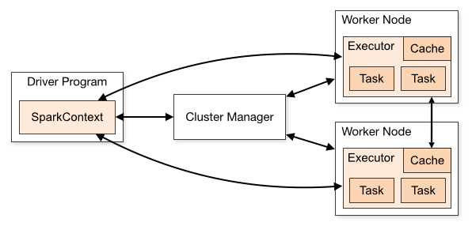Source: https://spark.apache.org/
For additional learning on this topic, I would recommend reading the following.
- What is Spark Job
- What is the Spark Stage? Explained
- What is Spark Executor
- What is Apache Spark Driver?
- What is DAG in Spark or PySpark
- What is a Lineage Graph in Spark?
- How to Submit a Spark Job via Rest API?

Cluster Manager Types
As of writing this Apache Spark Tutorial, Spark supports below cluster managers:
- Standalone – a simple cluster manager included with Spark that makes it easy to set up a cluster.
- Apache Mesos – Mesons is a Cluster manager that can also run Hadoop MapReduce and Spark applications.
- Hadoop YARN – the resource manager in Hadoop 2. This is mostly used, a cluster manager.
- Kubernetes – an open-source system for automating deployment, scaling, and management of containerized applications.
local – which is not really a cluster manager but still I wanted to mention that we use “local” for master() in order to run Spark on our laptop/computer.

Spark Installation
In order to run the Apache Spark examples mentioned in this tutorial, you need to have Spark and its needed tools to be installed on your computer. Since most developers use Windows for development, I will explain how to install Spark on Windows in this tutorial. you can also Install Spark on a Linux server if needed.
Related: Spark Installation on Mac (macOS)
Download Apache Spark by accessing the Spark Download page and selecting the link from “Download Spark (point 3)”. If you want to use a different version of Spark & Hadoop, select the one you wanted from dropdowns, and the link on point 3 changes to the selected version and provides you with an updated link to download.
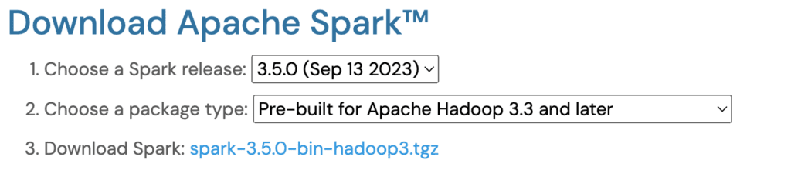
After downloading, untar the binary using 7zip and copy the underlying folder spark-3.5.0-bin-hadoop3 to c:\apps
Now set the following environment variables.

SPARK_HOME = C:\apps\spark-3.5.0-bin-hadoop3
HADOOP_HOME = C:\apps\spark-3.5.0-bin-hadoop3
PATH=%PATH%;C:\apps\spark-3.0.5-bin-hadoop3\bin

Setup winutils.exe
Download wunutils.exe file from winutils, and copy it to %SPARK_HOME%\bin folder. Winutils are different for each Hadoop version hence download the right version from https://github.com/steveloughran/winutils

spark-shell
Spark binary comes with an interactive spark-shell. In order to start a shell, go to your SPARK_HOME/bin directory and type “spark-shell“. This command loads the Spark and displays what version of Spark you are using.
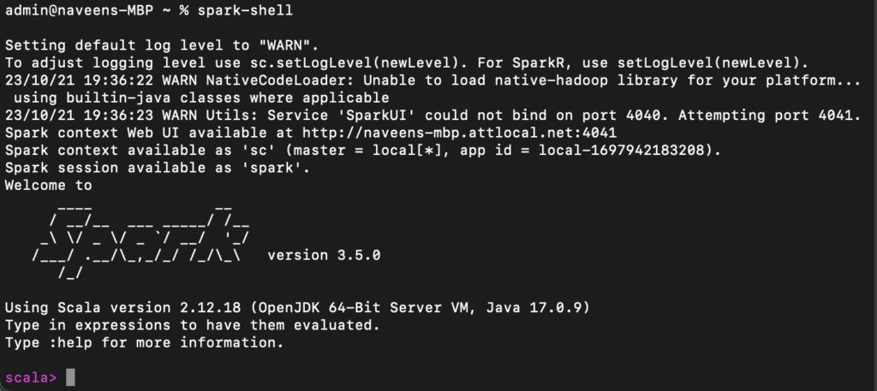spark-shell
By default, spark-shell provides with spark (SparkSession) and sc (SparkContext) objects to use. Let’s see some examples.
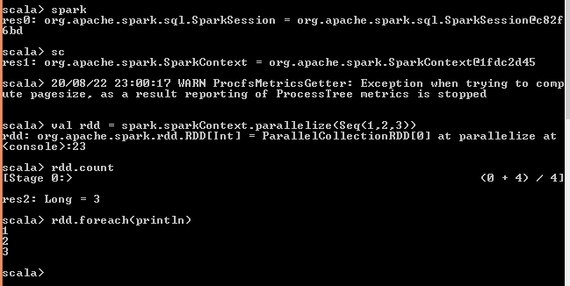spark-shell create RDD
Spark-shell also creates a Spark context web UI and by default, it can access from http://localhost:4041.

Spark-submit
The spark-submit command is a utility to run or submit a Spark or PySpark application program (or job) to the cluster by specifying options and configurations, the application you are submitting can be written in Scala, Java, or Python (PySpark) code. You can use this utility in order to do the following.
- Submitting Spark applications on different cluster managers like Yarn, Kubernetes, Mesos, and Stand-alone.
- Submitting Spark application on client or cluster deployment modes

./bin/spark-submit \
--master <master-url> \
--deploy-mode <deploy-mode> \
--conf <key<=<value> \
--driver-memory <value>g \
--executor-memory <value>g \
--executor-cores <number of cores> \
--jars <comma separated dependencies>
--class <main-class> \
<application-jar> \
[application-arguments]

Spark Web UI
Apache Spark provides a suite of Web UIs (Jobs, Stages, Tasks, Storage, Environment, Executors, and SQL) to monitor the status of your Spark application, resource consumption of the Spark cluster, and Spark configurations. On Spark Web UI, you can see how the operations are executed.
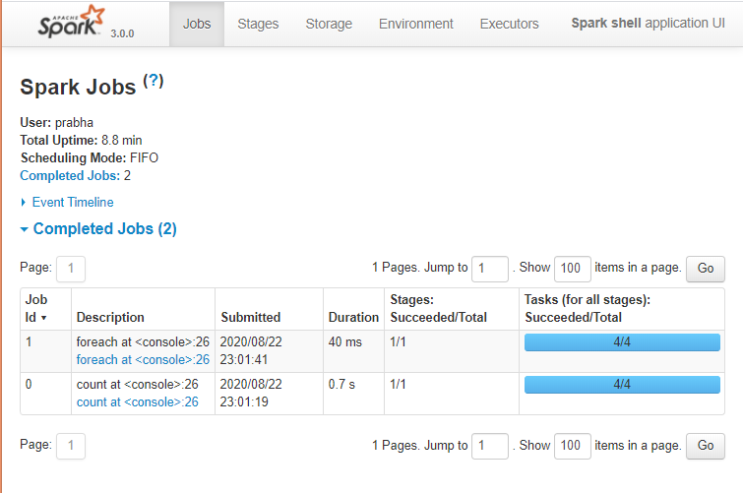Spark Web UI

Spark History Server
Spark History server, keep a log of all completed Spark application you submit by spark-submit, spark-shell. before you start, first you need to set the below config on spark-defaults.conf

spark.eventLog.enabled true
spark.history.fs.logDirectory file:///c:/logs/path
Now, start the Spark history server on Linux or Mac by running.

$SPARK_HOME/sbin/start-history-server.sh
If you are running Spark on Windows, you can start the history server by starting the below command.

$SPARK_HOME/bin/spark-class.cmd org.apache.spark.deploy.history.HistoryServer
By default, the History server listens at 18080 port and you can access it from the browser using http://localhost:18080/
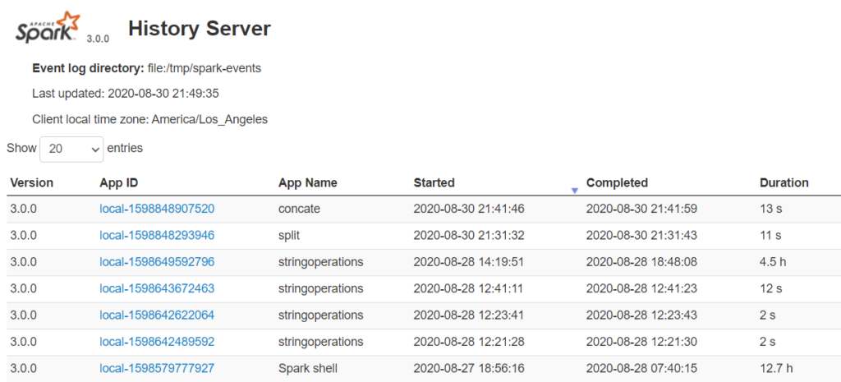Spark History Server
By clicking on each App ID, you will get the details of the application in Spark web UI.
The history server is very helpful when you are doing Spark performance tuning to improve spark jobs where you can cross-check the previous application run with the current run.

Spark Modules
- Spark Core
- Spark SQL
- Spark Streaming
- Spark MLlib
- Spark GraphX
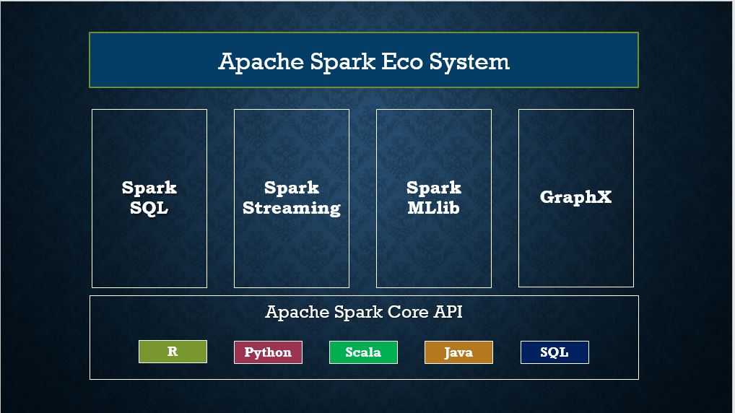Spark Modules

Spark Core
In this section of the Apache Spark Tutorial, you will learn different concepts of the Spark Core library with examples in Scala code. Spark Core is the main base library of Spark which provides the abstraction of how distributed task dispatching, scheduling, basic I/O functionalities etc.
Before getting your hands dirty on Spark programming, have your Development Environment Setup to run Spark Examples using IntelliJ IDEA

SparkSession
SparkSession introduced in version 2.0, is an entry point to underlying Spark functionality in order to programmatically use Spark RDD, DataFrame, and Dataset. It’s object spark is default available in spark-shell.
Creating a SparkSession instance would be the first statement you would write to the program with RDD, DataFrame and Dataset. SparkSession will be created using SparkSession.builder() builder pattern.

// Create SparkSession
import org.apache.spark.sql.SparkSession
val spark:SparkSession = SparkSession.builder()
.master("local[1]")
.appName("SparkByExamples.com")
.getOrCreate()

Spark Context
SparkContext is available since Spark 1.x (JavaSparkContext for Java) and is used to be an entry point to Spark and PySpark before introducing SparkSession in 2.0. Creating SparkContext was the first step to the program with RDD and to connect to Spark Cluster. It’s object sc by default available in spark-shell.
Since Spark 2.x version, When you create SparkSession, SparkContext object is by default created and it can be accessed using spark.sparkContext
Note that you can create just one SparkContext per JVM but can create many SparkSession objects.

RDD Spark Tutorial
RDD (Resilient Distributed Dataset) is a fundamental data structure of Spark and it is the primary data abstraction in Apache Spark and the Spark Core. RDDs are fault-tolerant, immutable distributed collections of objects, which means once you create an RDD you cannot change it. Each dataset in RDD is divided into logical partitions, which can be computed on different nodes of the cluster.
This Apache Spark RDD Tutorial will help you start understanding and using Apache Spark RDD (Resilient Distributed Dataset) with Scala code examples. All RDD examples provided in this tutorial were also tested in our development environment and are available at GitHub spark scala examples project for quick reference.
In this section of the Apache Spark tutorial, I will introduce the RDD and explain how to create them and use their transformation and action operations. Here is the full article on Spark RDD in case you want to learn more about it and get your fundamentals strong.

RDD creation
RDDs are created primarily in two different ways, first parallelizing an existing collection and secondly referencing a dataset in an external storage system (HDFS, HDFS, S3 and many more).

sparkContext.parallelize()
sparkContext.parallelize is used to parallelize an existing collection in your driver program. This is a basic method to create RDD.

//Create RDD from parallelize
val dataSeq = Seq(("Java", 20000), ("Python", 100000), ("Scala", 3000))
val rdd=spark.sparkContext.parallelize(dataSeq)

sparkContext.textFile()
Using textFile() method we can read a text (.txt) file from many sources like HDFS, S#, Azure, local e.t.c into RDD.

//Create RDD from external Data source
val rdd2 = spark.sparkContext.textFile("/path/textFile.txt")

RDD Operations
On Spark RDD, you can perform two kinds of operations.

RDD Transformations
Spark RDD Transformations are lazy operations meaning they don’t execute until you call an action on RDD. Since RDDs are immutable, When you run a transformation(for example map()), instead of updating a current RDD, it returns a new RDD.
Some transformations on RDDs are flatMap(), map(), reduceByKey(), filter(), sortByKey() and all these return a new RDD instead of updating the current.

RDD Actions
RDD Action operation returns the values from an RDD to a driver node. In other words, any RDD function that returns non RDD[T] is considered as an action. RDD operations trigger the computation and return RDD in a List to the driver program.
Some actions on RDDs are count(), collect(), first(), max(), reduce() and more.

RDD Examples
- Read CSV file into RDD
- RDD Pair Functions
- Generate DataFrame from RDD

DataFrame Spark Tutorial with Basic Examples
DataFrame definition is very well explained by Databricks hence I do not want to define it again and confuse you. Below is the definition I took from Databricks.
DataFrame is a distributed collection of data organized into named columns. It is conceptually equivalent to a table in a relational database or a data frame in R/Python, but with richer optimizations under the hood. DataFrames can be constructed from a wide array of sources such as structured data files, tables in Hive, external databases, or existing RDDs.
– Databricks

DataFrame creation
The simplest way to create a Spark DataFrame is from a seq collection. Spark DataFrame can also be created from an RDD and by reading files from several sources.
Related: Spark Word Count Explained with Example

using createDataFrame()
By using createDataFrame() function of the SparkSession you can create a DataFrame.

// Create DataFrame
val data = Seq(('James','','Smith','1991-04-01','M',3000),
('Michael','Rose','','2000-05-19','M',4000),
('Robert','','Williams','1978-09-05','M',4000),
('Maria','Anne','Jones','1967-12-01','F',4000),
('Jen','Mary','Brown','1980-02-17','F',-1)
)

val columns = Seq("firstname","middlename","lastname","dob","gender","salary")
df = spark.createDataFrame(data), schema = columns).toDF(columns:_*)
Since DataFrames are structure format that contains names and column, we can get the schema of the DataFrame using the df.printSchema()
df.show() shows the 20 elements from the DataFrame.

+---------+----------+--------+----------+------+------+
|firstname|middlename|lastname|dob |gender|salary|
+---------+----------+--------+----------+------+------+
|James | |Smith |1991-04-01|M |3000 |
|Michael |Rose | |2000-05-19|M |4000 |
|Robert | |Williams|1978-09-05|M |4000 |
|Maria |Anne |Jones |1967-12-01|F |4000 |
|Jen |Mary |Brown |1980-02-17|F |-1 |
+---------+----------+--------+----------+------+------+
In this Apache Spark SQL DataFrame Tutorial, I have explained several mostly used operation/functions on DataFrame & DataSet with working Scala examples.
- Spark DataFrame – Rename nested column
- How to add or update a column on DataFrame
- How to drop a column on DataFrame
- Spark when otherwise usage
- How to add literal constant to DataFrame
- Spark Data Types explained
- How to change column data type
- How to Pivot and Unpivot a DataFrame
- Create a DataFrame using StructType & StructField schema
- How to select the first row of each group
- How to sort DataFrame
- How to union DataFrame
- How to drop Rows with null values from DataFrame
- How to split single to multiple columns
- How to concatenate multiple columns
- How to replace null values in DataFrame
- How to remove duplicate rows on DataFrame
- How to remove distinct on multiple selected columns
- Spark map() vs mapPartitions()

Spark DataFrame Advanced concepts
- Spark Partitioning, Repartitioning and Coalesce
- How does Spark shuffle work?
- Spark Cache and Persistence
- Spark Persistance Storage levels
- Spark Broadcast shared variable
- Spark Accumulator shared variable
- Spark UDF

Spark Array and Map operations
- How to create an Array (ArrayType) column on DataFrame
- How to create a Map (MapType) column on DataFrame
- How to convert an Array to columns
- How to create an Array of struct column
- How to explode an Array and map columns
- How to explode an Array of structs
- How to explode an Array of map columns to rows
- How to create a DataFrame with nested Array
- How to explode nested Arrays to rows
- How to flatten nested Array to single Array
- Spark – Convert array of String to a String column

Spark Aggregate
- How to group rows in DataFrame
- How to get Count distinct on DataFrame
- How to add row number to DataFrame
- How to select the first row of each group

Spark SQL Joins
- Spark SQL Join

Spark Performance
- Spark Performance Improvement

Other Helpful topics on DataFrame
- How to stop DEBUG & INFO log messages
- Print DataFrame full column contents
- Unstructured vs semi-structured vs structured files

Spark SQL Schema & StructType
- How to convert case class to a schema
- Spark Schema explained with examples
- How to create array of struct column
- Spark StructType & StructField
- How to flatten nested column

Spark SQL Functions
Spark SQL provides several built-in functions, When possible try to leverage the standard library as they are a little bit more compile-time safe, handle null, and perform better when compared to UDF. If your application is critical on performance try to avoid using custom UDF at all costs as these are not guaranteed on performance.
In this section, we will see several Spark SQL functions Tutorials with Scala examples.
- Spark Date and Time Functions
- Spark String Functions
- Spark Array Functions
- Spark Map Functions
- Spark Aggregate Functions
- Spark Window Functions
- Spark Sort Functions

Spark Data Source with Examples
Spark SQL supports operating on a variety of data sources through the DataFrame interface. This section of the tutorial describes reading and writing data using the Spark Data Sources with Scala examples. Using Data source API we can load from or save data to RDMS databases, Avro, parquet, XML etc.

Text
- Spark process Text file
- How to process JSON from a Text file

CSV
- How to process CSV file
- How to convert Parquet file to CSV file
- How to process JSON from a CSV file
- How to Convert Avro file to CSV file
- How to convert CSV file to Avro, Parquet & JSON

JSON
JSON’s readability, flexibility, language-agnostic nature, and support for semi-structured data make it a preferred choice in big data Spark applications where diverse sources, evolving schemas, and efficient data interchange are common requirements.
Key characteristics and reasons why JSON is used in big data include Human-Readable Format, Language-Agnostic, Semi-Structured Data, Schema Evolution e.t.c
- JSON Example (Read & Write)
- How to Read JSON from multi-line
- How to read JSON file with custom schema
- How to process JSON from a CSV file
- How to process JSON from a Text file
- How to convert Parquet file to JSON file
- How to convert Avro file to JSON file
- How to convert JSON to Avro, Parquet, CSV file

Parquet
- Parquet Example (Read and Write)
- How to convert Parquet file to CSV file
- How to convert Parquet file to Avro file
- How to convert Avro file to Parquet file

Avro
- Avro Example (Read and Write)
- Spark 2.3 – Apache Avro Example
- How to Convert Avro file to CSV file
- How to convert Parquet file to Avro file
- How to convert Avro file to JSON file
- How to convert Avro file to Parquet file

ORC
- Spark Read & Write ORC

XML
- Processing Nested XML structured files
- How to validate XML with XSD

Hive & Tables
- Spark Save DataFrame to Hive Table
- Spark JDBC Parallel Read
- Read JDBC Table to Spark DataFrame
- Spark saveAsTable() with Examples
- Spark Query Table using JDBC
- Spark Read and Write MySQL Database Table
- Spark with SQL Server – Read and Write Table
- Spark spark.table() vs spark.read.table()

SQL Spark Tutorial
Spark SQL is one of the most used Spark modules which is used for processing structured columnar data format. Once you have a DataFrame created, you can interact with the data by using SQL syntax. In other words, Spark SQL brings native RAW SQL queries on Spark meaning you can run traditional ANSI SQL on Spark Dataframe. In the later section of this Apache Spark tutorial, you will learn in detail using SQL select, where, group by, join, union e.t.c
In order to use SQL, first, we need to create a temporary table on DataFrame using createOrReplaceTempView() function. Once created, this table can be accessed throughout the SparkSession and it will be dropped along with your SparkContext termination.
On a table, SQL query will be executed using sql() method of the SparkSession and this method returns a new DataFrame.

df.createOrReplaceTempView("PERSON_DATA")
val df2 = spark.sql("SELECT * from PERSON_DATA")
df2.printSchema()
df2.show()
Let’s see another example using group by.

val groupDF = spark.sql("SELECT gender, count(*) from PERSON_DATA group by gender")
groupDF.show()
This yields the below output

+------+--------+
|gender|count(1)|
+------+--------+
| F| 2|
| M| 3|
+------+--------+
Similarly, you can run any traditional SQL queries on DataFrames using Spark SQL.

Spark HDFS & S3 Tutorial
- Processing files from Hadoop HDFS (TEXT, CSV, Parquet, Avro, JSON)
- Processing TEXT files from Amazon S3 bucket
- Processing JSON files from Amazon S3 bucket
- Processing CSV files from Amazon S3 bucket
- Processing Parquet files from Amazon S3 bucket
- Processing Avro files from Amazon S3 bucket

Spark Streaming Tutorial & Examples
Spark Streaming is a scalable, high-throughput, fault-tolerant streaming processing system that supports both batch and streaming workloads. It is used to process real-time data from sources like file system folders, TCP sockets, S3, Kafka, Flume, Twitter, and Amazon Kinesis to name a few. The processed data can be pushed to databases, Kafka, live dashboards e.t.c
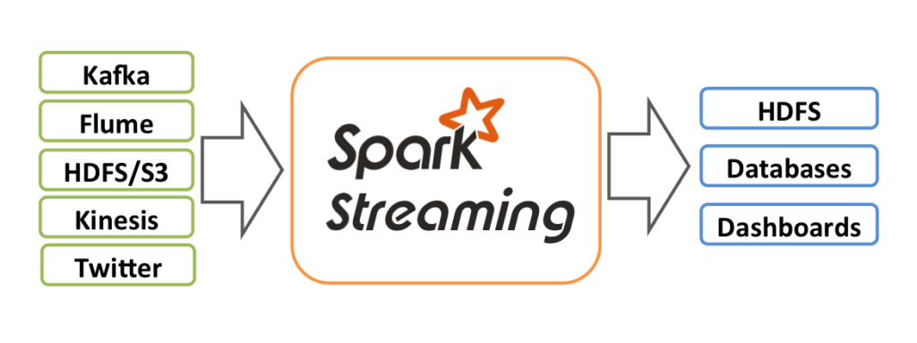source: https://spark.apache.org/
- Spark Streaming – OutputModes Append vs Complete vs Update
- Spark Streaming – Read JSON Files From Directory with Scala Example
- Spark Streaming – Read data From TCP Socket with Scala Example
- Spark Streaming – Consuming & Producing Kafka messages in JSON format
- Spark Streaming – Consuming & Producing Kafka messages in Avro format
- Using from_avro and to_avro functions
- Reading Avro data from Kafka topic using from_avro() and to_avro()
- Spark Batch Processing using Kafka Data Source

Spark with Kafka Tutorials
- Spark Streaming – Consuming & Producing Kafka messages in JSON format
- Spark Streaming – Consuming & Producing Kafka messages in Avro format
- Using from_avro and to_avro functions
- Reading Avro data from Kafka topic using from_avro() and to_avro()
- Spark Batch Processing using Kafka Data Source

Spark – HBase Tutorials & Examples
In this section of the Spark Tutorial, you will learn several Apache HBase spark connectors and how to read an HBase table to a Spark DataFrame and write DataFrame to HBase table.
Apache HBase is an open-source, distributed, and scalable NoSQL database that runs on top of the Hadoop Distributed File System (HDFS). It provides real-time read and write access to large datasets and is designed for handling massive amounts of unstructured or semi-structured data, making it suitable for big data applications.
- Spark HBase Connectors explained
- Writing Spark DataFrame to HBase table using shc-core Hortonworks library
- Creating Spark DataFrame from Hbase table using shc-core Hortonworks library

Spark – Hive Tutorials
In this section, you will learn what is Apache Hive and several examples of connecting to Hive, creating Hive tables, reading them into DataFrame
Apache Hive is a data warehousing and SQL-like query language tool built on top of Hadoop. It facilitates querying and managing large datasets stored in Hadoop Distributed File System (HDFS) using a familiar SQL syntax. Hive translates SQL-like queries into MapReduce or Apache Tez jobs, enabling users without extensive programming skills to analyze big data. It supports schema-on-read, allowing flexible data structures, and integrates with HBase and other Hadoop ecosystem components. Hive is particularly useful for batch processing, data summarization, and analysis tasks, making big data analytics accessible to a broader audience within the Apache Hadoop ecosystem.
- Start HiveServer2 and connect to hive beeline

Spark GraphX and GraphFrames
Spark GraphFrames are introduced in Spark 3.0 version to support Graphs on DataFrames. Prior to 3.0, Spark had GraphX library which ideally runs on RDD, and lost all Data Frame capabilities.
GraphFrames is a graph processing library for Apache Spark that provides high-level abstractions for working with graphs and performing graph analytics. It extends Spark’s DataFrame API to support graph operations, allowing users to express complex graph queries using familiar DataFrame operations.
Below is an example of how to create and use Spark GraphFrame.

// Import necessary libraries
import org.apache.spark.sql.SparkSession
import org.graphframes.GraphFrame

// Create a Spark session
val spark = SparkSession.builder.appName("GraphFramesExample").getOrCreate()

// Define vertices and edges as DataFrames
val vertices = spark.createDataFrame(Seq(
(1, "Scott", 30),
(2, "David", 40),
(3, "Mike", 45)
)).toDF("id", "name", "age")

val edges = spark.createDataFrame(Seq(
(1, 2, "friend"),
(2, 3, "follow")
)).toDF("src", "dst", "relationship")

// Create a GraphFrame
val graph = GraphFrame(vertices, edges)

// Display vertices and edges
graph.vertices.show()
graph.edges.show()

// Perform Graph Queries
val aliceFriends = graph.edges.filter("src = 1").join(graph.vertices, "dst").select("dst", "name")
aliceFriends.show()

// Graph Analytics - In-degrees
val inDegrees = graph.inDegrees
inDegrees.show()

// Subgraph Creation
val subgraph = graph.filterVertices("age >= 40").filterEdges("relationship = 'friend'")
subgraph.vertices.show()
subgraph.edges.show()

// Graph Algorithms - PageRank
val pageRankResults = graph.pageRank.resetProbability(0.15).maxIter(10).run()
pageRankResults.vertices.show()
pageRankResults.edges.show()

// Stop the Spark session
spark.stop()

What are the key features and improvements released in Spark 3.5.0
Following are some of the key features and improvements in Spark 3.5
- Spark Connect: This release extends the general availability of Spark Connect with support for Scala and Go clients, distributed training and inference support, and enhanced compatibility for Structured streaming.
- PySpark and SQL Functionality: New functionality has been introduced in PySpark and SQL, including the SQL IDENTIFIER clause, named argument support for SQL function calls, SQL function support for HyperLogLog approximate aggregations, and Python user-defined table functions.
- Distributed Training with DeepSpeed: The release simplifies distributed training with DeepSpeed, making it more accessible.
- Structured Streaming: It introduces watermark propagation among operators and dropDuplicatesWithinWatermark operations in Structured Streaming, enhancing its capabilities.
- English SDK: Apache Spark for English SDK integrates the extensive expertise of Generative AI in Apache Spark.

References:
- https://spark.apache.org/
- https://databricks.com/spark/about
- https://github.com/apache/spark

Home » PySpark 3.5 Tutorial For Beginners with Examples

PySpark Tutorial: PySpark is a powerful open-source framework built on Apache Spark, designed to simplify and accelerate large-scale data processing and analytics tasks. It offers a high-level API for Python programming language, enabling seamless integration with existing Python ecosystems.
Advertisements
PySpark revolutionizes traditional computing with its distributed computing model, capable of processing massive datasets across clusters of machines with remarkable speed and efficiency. Its key advantages lie in its ability to handle diverse data formats, support for complex analytics operations, and fault tolerance. By leveraging PySpark, users can unlock unparalleled scalability, faster processing times, and enhanced performance, making it an indispensable tool for modern data-driven applications.

PySpark Tutorial Introduction
In this PySpark tutorial, you’ll learn the fundamentals of Spark, how to create distributed data processing pipelines, and leverage its versatile libraries to transform and analyze large datasets efficiently with examples. I will also explain what is PySpark, its features, advantages, modules, packages, and how to use RDD & DataFrame with simple and easy examples from my working experience in Python.
All examples explained in this PySpark (Spark with Python) tutorial are basic, simple, and easy to practice for beginners who are enthusiastic to learn PySpark and advance their careers in Big Data, Machine Learning, Data Science, and Artificial intelligence.

Note: If you can’t locate the PySpark examples you need on this beginner’s tutorial page, I suggest utilizing the Search option in the menu bar. This website offers numerous articles in Spark, Scala, PySpark, and Python for learning purposes.
If you are working with a smaller Dataset and don’t have a Spark cluster, but still want to get benefits similar to Spark DataFrame, you can use Python Pandas DataFrames. The main difference is Pandas DataFrame is not distributed and runs on a single node.
Table of Contents –
- PySpark Introduction
- PySpark Features & Advantages
- PySpark Architecture
- Installation on Windows
- Spyder IDE & Jupyter Notebook
- RDD
- DataFrame
- SQL
- Streaming
- MLlib
- GraphFrames

What is PySpark
PySpark is the Python API for Apache Spark. PySpark enables developers to write Spark applications using Python, providing access to Spark’s rich set of features and capabilities through Python language. With its rich set of features, robust performance, and extensive ecosystem, PySpark has become a popular choice for data engineers, data scientists, and developers working with big data and distributed computing.
source: https://databricks.com/
Apache Spark is an open-source unified analytics engine used for large-scale data processing, hereafter referred it as Spark. Spark is designed to be fast, flexible, and easy to use, making it a popular choice for processing large-scale data sets. Spark runs operations on billions and trillions of data on distributed clusters 100 times faster than traditional applications.
Spark can run on single-node machines or multi-node machines(Cluster). It was created to address the limitations of MapReduce, by doing in-memory processing. Spark reuses data by using an in-memory cache to speed up machine learning algorithms that repeatedly call a function on the same dataset. This lowers the latency making Spark multiple times faster than MapReduce, especially when doing machine learning, and interactive analytics. Apache Spark can also process real-time streaming.
It is also a multi-language engine, that provides APIs (Application Programming Interfaces) and libraries for several programming languages like Java, Scala, Python, and R, allowing developers to work with Spark using the language they are most comfortable with.
- Scala: Spark’s primary and native language is Scala. Many of Spark’s core components are written in Scala, and it provides the most extensive API for Spark.
- Java: Spark provides a Java API that allows developers to use Spark within Java applications. Java developers can access most of Spark’s functionality through this API.
- Python: Spark offers a Python API, called PySpark, which is popular among data scientists and developers who prefer Python for data analysis and machine learning tasks. PySpark provides a Pythonic way to interact with Spark.
- R: Spark also offers an R API, enabling R users to work with Spark data and perform distributed data analysis using their familiar R language.

Who uses PySpark?
PySpark is very well used in the Data Science and Machine Learning community as there are many widely used data science libraries written in Python including NumPy, and TensorFlow. Also used due to its efficient processing of large datasets. PySpark has been used by many organizations like Walmart, Trivago, Sanofi, Runtastic, and many more.
Additionally, for development, you can use the Anaconda distribution (widely used in the Machine Learning community). The Anaconda distribution is a comprehensive platform for data science and machine learning tasks. It includes a collection of popular open-source software packages and libraries, such as Python, Jupyter Notebooks, NumPy, pandas, scikit-learn, and many others.
In real-time, PySpark has been used a lot in the machine learning and data scientists community; thanks to vast Python machine learning libraries. In this PySpark tutorial for beginners, I have explained several topics that cover vast concepts of this framework.
Related: How to run Pandas DataFrame on Apache Spark (PySpark)?

What Version of Python PySpark Supports
PySpark 3.5 supports Python versions 3.8 and newer, along with R version 3.5, Java versions 8, 11, and 17, as well as Scala versions 2.12 and 2.13, and later. However, it’s worth mentioning that starting from Spark 3.5.0, support for Java 8 versions before 8u371 has been deprecated.

PySpark Features & Advantages
The following are the main features of PySpark.
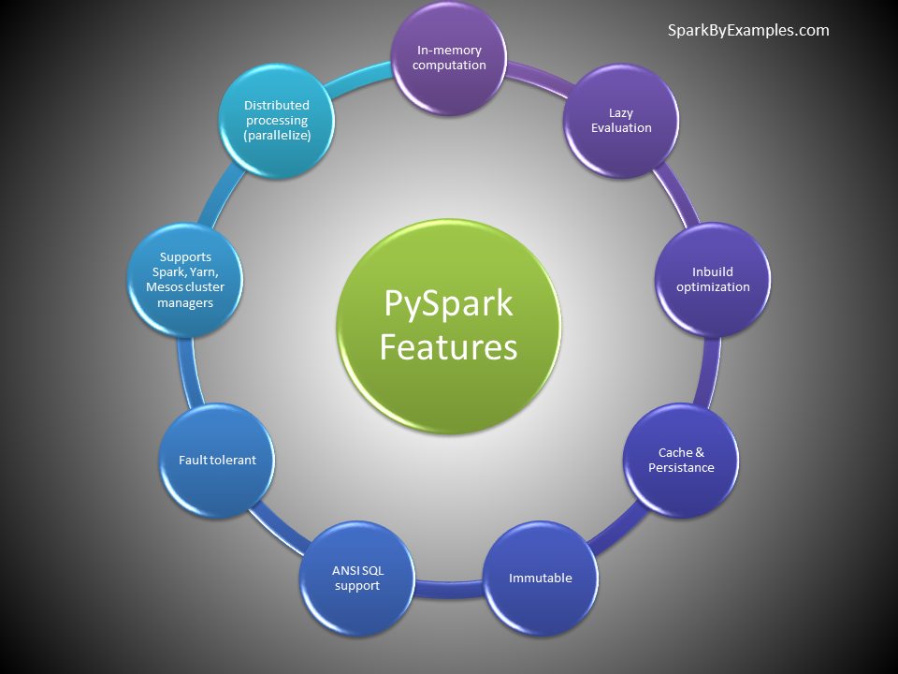PySpark Features
- Python API: Provides a Python API for interacting with Spark, enabling Python developers to leverage Spark’s distributed computing capabilities.
- Distributed Computing: PySpark utilizes Spark’s distributed computing framework to process large-scale data across a cluster of machines, enabling parallel execution of tasks.
- Fault Tolerance: Automatically handles fault tolerance by maintaining resilient distributed datasets (RDDs), which allows it to recover from failures gracefully.
- Lazy Evaluation: PySpark employs lazy evaluation, meaning transformations on data are not executed immediately but rather stored as a directed acyclic graph (DAG) of computations until an action is triggered.
- Integration with Python Ecosystem: Seamlessly integrates with the Python ecosystem, allowing users to leverage popular Python libraries such as pandas, NumPy, and scikit-learn for data manipulation and machine learning tasks.
- Interactive Data Analysis: PySpark is well-suited for interactive data analysis and exploration, thanks to its integration with Jupyter Notebooks and interactive Python shells.
- Machine Learning: PySpark includes MLlib, Spark’s scalable machine learning library, which provides a wide range of machine learning algorithms for classification, regression, clustering, and more.
- Streaming Processing: Supports streaming processing through Spark Streaming, enabling real-time data processing and analysis on continuous data streams.
- SQL Support: Allows users to perform SQL queries on distributed datasets using Spark SQL, providing a familiar interface for working with structured data.

PySpark Advantages
The most important advantages of using PySpark include:
- Scalability: PySpark harnesses the power of distributed computing, enabling processing of large-scale datasets across clusters of machines, thus accommodating growing data needs.
- Performance: By leveraging in-memory computing and parallel processing, PySpark achieves high performance, enabling faster data processing and analysis compared to traditional single-node processing.
- Ease of Use: Provides a user-friendly Python API, making it accessible to Python developers familiar with the language syntax and ecosystem. It also integrates well with popular Python libraries for data analysis and machine learning.
- Fault Tolerance: Automatically handles fault tolerance through resilient distributed datasets (RDDs), ensuring data reliability and recovery from failures without manual intervention.
- Unified Platform: Offers a unified platform for various data processing tasks, including batch processing, interactive data analysis, streaming processing, and machine learning, simplifying development and deployment workflows.
- Real-time Processing: With Streaming and Structured Streaming, PySpark enables real-time processing of data streams, facilitating timely insights and responses to changing data.
- Machine Learning Capabilities: Includes MLlib, machine learning library, providing scalable implementations of popular machine learning algorithms, allowing for large-scale model training and deployment.
- Community and Ecosystem: PySpark benefits from a vibrant community and ecosystem, offering extensive documentation, tutorials, and third-party packages, as well as continuous development and support from the community.

PySpark Architecture
PySpark architecture consists of a driver program that coordinates tasks and interacts with a cluster manager to allocate resources. The driver communicates with worker nodes, where tasks are executed within an executor’s JVM. SparkContext manages the execution environment, while the DataFrame API enables high-level abstraction for data manipulation. SparkSession provides a unified entry point for Spark functionality. Underneath, the cluster manager oversees resource allocation and task scheduling across nodes, facilitating parallel computation for processing large-scale data efficiently.
source: https://spark.apache.org/
To get in-depth knowledge of PySpark Architecture, read the following topics.
- Explain Job
- Explain Stage
- Explain Executor
- Explain Spark Driver
- What is DAG?
- What is a Lineage Graph?

Cluster Managers
Cluster managers in PySpark are responsible for resource allocation and task scheduling across nodes in a distributed computing environment. Here’s a brief overview of the different types:
- Standalone: The standalone cluster manager is a simple, standalone solution bundled with Spark that manages resources for applications. It’s suitable for small to medium-sized clusters and doesn’t require additional software installation.
- Mesos: Mesos is a distributed systems kernel that abstracts CPU, memory, storage, and other compute resources across a cluster. PySpark can leverage Mesos as a cluster manager, allowing efficient resource sharing among multiple frameworks like Spark, Hadoop, and others.
- Hadoop YARN (Yet Another Resource Negotiator): YARN is Hadoop’s resource management layer, responsible for managing and scheduling resources across a Hadoop cluster. PySpark can run on YARN, enabling seamless integration with existing Hadoop ecosystems and leveraging YARN’s resource management capabilities.
- Kubernetes: Kubernetes is a container orchestration platform that automates deployment, scaling, and management of containerized applications. PySpark can run on Kubernetes, enabling dynamic resource allocation and efficient utilization of resources in containerized environments.
local – “local” is a special value used for the master parameter when initializing a SparkContext or SparkSession. When you specify local as the master, it means that Spark will run in local mode, utilizing only a single JVM (Java Virtual Machine) on the local machine where your Python script is executed. This mode is primarily used for development, testing, and debugging purposes
Each cluster manager type offers unique features and benefits, catering to different deployment scenarios and infrastructure requirements. The choice of cluster manager depends on factors such as scalability, resource isolation, integration with existing infrastructure, and ease of management.

PySpark Modules & Packages
In Apache Spark, the PySpark module enables Python developers to interact with Spark, leveraging its powerful distributed computing capabilities. It provides a Python API that exposes Spark’s functionality, allowing users to write Spark applications using Python programming language.
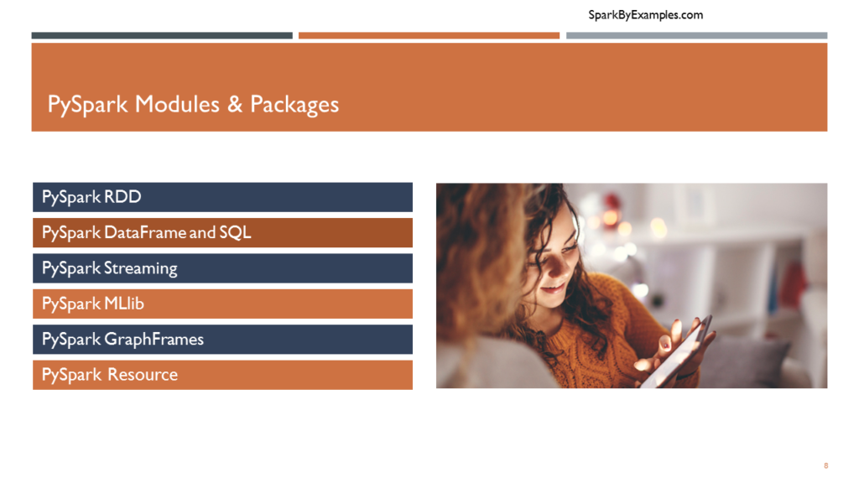Modules & packages
- RDD (pyspark.RDD)
- DataFrame and SQL (pyspark.sql)
- Streaming (pyspark.streaming)
- MLib (pyspark.ml, pyspark.mllib)
- GraphFrames (GraphFrames)
- Resource (pyspark.resource) It’s new in PySpark 3.0
Besides these, if you want to use third-party libraries, you can find them at https://spark-packages.org/ . This page is kind of a repository of all third-party libraries.

Download & Install PySpark
Follow the below steps to install PySpark on the Anaconda distribution on Windows.
Related: PySpark Install on Mac

Install Python or Anaconda distribution
I would recommend using Anaconda to Install Python as it is popular and used by the Machine Learning and Data Science community. Follow the instructions to Install Anaconda Distribution and Jupyter Notebook. Alternatively, you can also Python from Python.org.

Install Java
PySpark is built on top of the Spark framework, which itself is implemented in Scala and runs on the Java Virtual Machine (JVM). Hence, you need to install a compatible Java version for your Spark version. You can download and Install Java from Oracle or openJDK from openlogic.com.
Once JDK installation is complete, set JAVA_HOME and PATH variable. I have installed Java at location c:\apps\Java\openJDK17; hence, you see I am setting the path below.

# Download JDK 17
JAVA_HOME = c:\apps\Java\openjdk17
PATH = %PATH%;c:\apps\Java\openjdk17\bin

Install Apache Spark
Go to the Spark Download page, choose the Spark version you want to use, and then choose the package type. The URL on point 3 changes to the selected version. Click on the link from point 3 to download.
Once the binary package downloaded, untar the binary using 7zip or any extract tool and copy the folder spark-3.5.0-bin-hadoop3 to c:\apps
Set the below environment variables.

# Set windows environment variables
SPARK_HOME = C:\apps\spark-3.5.0-bin-hadoop3
HADOOP_HOME = C:\apps\spark-3.5.0-bin-hadoop3
PATH = %PATH%;C:\apps\spark-3.0.5-bin-hadoop3\bin

Install winutils.exe
Hadoop is not natively supported on Windows, but Spark expects certain Hadoop components, including the Hadoop Distributed File System (HDFS), to be present to run. Winutils provides a set of native libraries and executables that emulate Hadoop’s file system API on Windows, allowing Spark to interact with the file system correctly. Without winutils, Spark may encounter errors or fail to perform file system operations on Windows platforms.
Download the appropriate version of winutils.exe from the Winutils GitHub repository and place it into the %SPARK_HOME%\bin directory.

Validate PySpark Install
To validate if the PySpark has been installed correctly. Open the command prompt and type pyspark command to run the PySpark shell.
The shell is an interactive environment for running PySpark code. It is a CLI tool that provides a Python interpreter with access to Spark functionalities, enabling users to execute commands, perform data manipulations, and analyze results interactively.

# Run pyspark shell
$SPARK_HOME/sbin/pyspark
You should see the below output.
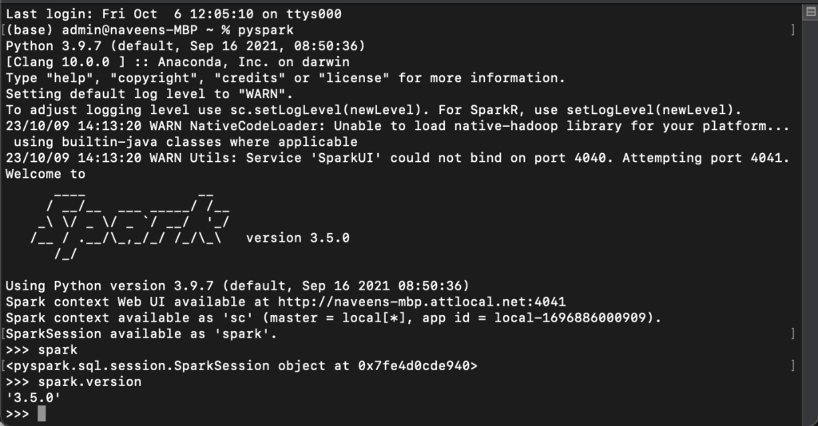
Shell creates a Spark context web UI, which can be accessed by default from http://localhost:4040.
Note: Spark Web UI typically uses port 4040 by default. However, if port 4040 is already in use, Spark will automatically attempt the next available port (4041, 4042, and so on). You can access the Spark Web UI in a web browser by navigating to http://localhost:4040 (or the respective port number if it’s different).

Spark Web UI
The Spark Web UI is a user interface provided to monitor and debug Spark applications. It displays information about job progress, task execution, resource utilization, and system metrics, allowing users to optimize performance, diagnose issues, and gain insights into their Spark jobs.
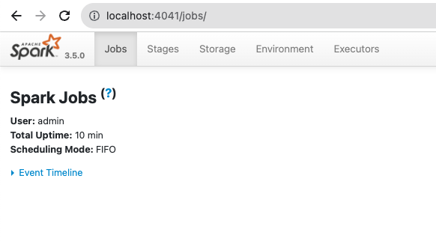

Access Spark History Server
The Spark History Server stores information about completed Spark applications (spark-submit, spark-shell), including logs, metrics, and event timelines. It allows users to view detailed information about past job executions, such as tasks, stages, and configurations, through a web-based user interface.
It serves as a centralized repository for historical job data, promoting transparency, reproducibility, and continuous improvement in Spark application development and operations. Before you start the history server, make sure you set the below config on spark-defaults.conf

spark.eventLog.enabled true
spark.history.fs.logDirectory file:///c:/logs/path
On Mac or Linux, run start-history-server.sh to start the history server.

# Start history server on linux/mac
$SPARK_HOME/sbin/start-history-server.sh
On Windows, this command is not available hence, run the below command to start in Windows.

# Start history server on windows
$SPARK_HOME/bin/spark-class.cmd org.apache.spark.deploy.history.HistoryServer
You can access the History server by accessing http://localhost:18080/
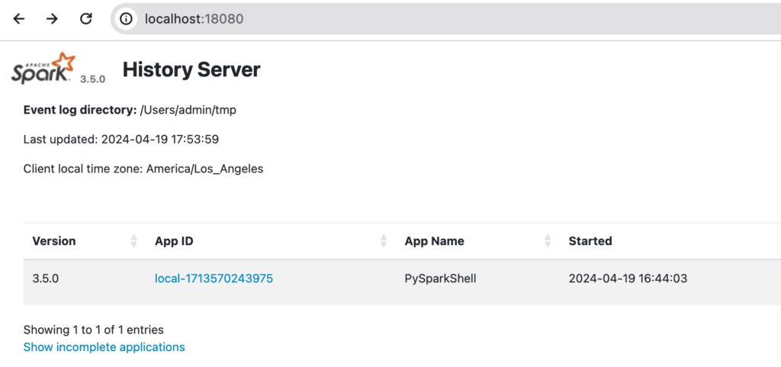Spark History Server
It will list all the application IDs you ran in the past. By clicking on each ID, you will get its details.

Spyder IDE & Jupyter Notebook
To create PySpark applications, you would need an IDE like Visual Studio Code, PyCharm, Spyder, etc. In this tutorial, I chose to use Spyder IDE and Jupyter Notebook to run PySpark applications. Follow Install PySpark with Anaconda & Jupyter
Once PySpark installation completes, set the following environment variable.

# Set environment variable
PYTHONPATH => %SPARK_HOME%/python;$SPARK_HOME/python/lib/py4j-0.10.9-src.zip;%PYTHONPATH%
In Spyder IDE, run the following program. You should see 5 in output. This creates an RDD and gets you the number of elements in the RDD.
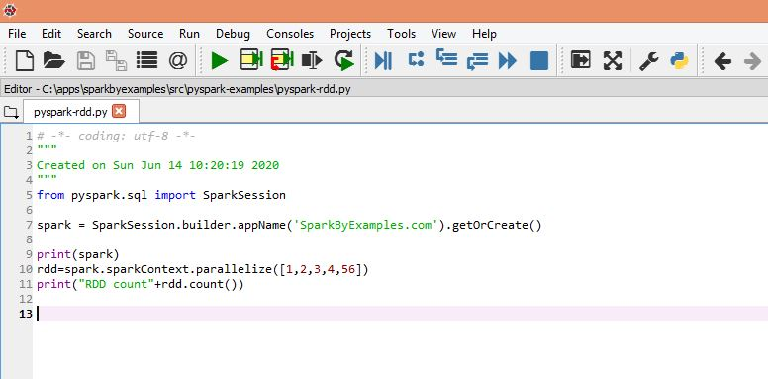Run PySpark on Spyder IDE
Now, let’s start the Jupyter Notebook
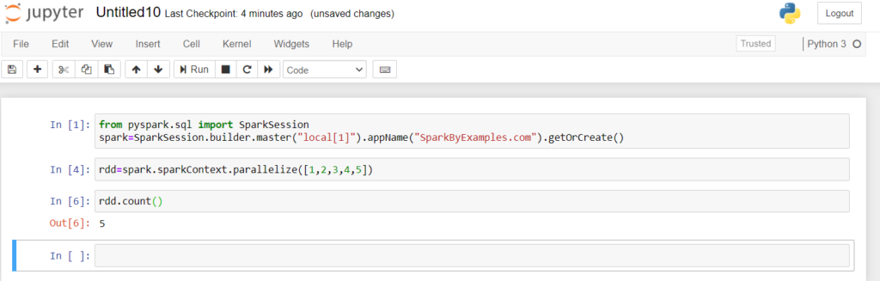PySpark statements running on Jupyter Interface

PySpark RDD – Resilient Distributed Dataset
PySpark RDD (Resilient Distributed Dataset) is a fundamental data structure that is fault-tolerant, immutable, and distributed collections of objects. RDDs are immutable, meaning they cannot be changed once created. Any transformation on an RDD results in a new RDD. Each dataset in RDD is divided into logical partitions, which can be computed on different nodes of the cluster.

RDD Creation
In order to create an RDD, first, you need to create a SparkSession which is an entry point to the PySpark application. SparkSession can be created using a builder() or newSession() methods of the SparkSession.
Spark session internally creates a sparkContext variable of SparkContext. You can create multiple SparkSession objects but only one SparkContext per JVM. In case you want to create another new SparkContext, you should stop the existing Sparkcontext (using stop()) before creating a new one.
Let’s create an RDD from a text file using textFile() function of the SparkContext.

# Import SparkSession
from pyspark.sql import SparkSession

# Create SparkSession
spark = SparkSession.builder \
.master("local[1]") \
.appName("SparkByExamples.com") \
.getOrCreate()

# Create RDD from external Data source
rdd2 = spark.sparkContext.textFile("/path/test.txt")
Once you have an RDD, you can perform transformation and action operations. Any operation you perform on RDD runs in parallel.

RDD Operations
You can perform two types of operations on RDD; Transformations and Actions.
RDD transformations in PySpark are lazy operations and they execute only when an action is called on RDD.
Transformation operations are map, filter, flatMap, groupByKey, reduceByKey, join, union, sortByKey, distinct, sample, mapPartitions, and aggregateByKey. These functions transform RDDs by applying computations in a distributed manner across a cluster of machines and return a new RDD
RDD actions in PySpark trigger computations and return results to the Spark driver. Key actions include collect, count, take, reduce, foreach, first, takeOrdered, takeSample, countByKey, saveAsTextFile, saveAsSequenceFile, saveAsObjectFile, foreachPartition, collectAsMap, aggregate, and fold. These actions initiate execution and materialize RDD data. Remember any RDD operation that returns non RDD is considered as an action.

PySpark DataFrame Tutorial
A DataFrame is a distributed dataset comprising data arranged in rows and columns with named attributes. It shares similarities with relational database tables or R/Python data frames but incorporates sophisticated optimizations.
If you come from a Python background, I would assume you already know what Pandas DataFrame is. PySpark DataFrame is mostly similar to Pandas DataFrame, with the exception that DataFrames are distributed in the cluster (meaning the data in data frames are stored in different machines in a cluster), and any operations in PySpark execute in parallel on all machines, whereas Panda Dataframe stores and operates on a single machine.
If you have no Python background, don’t worry and you can learn about it from Python Pandas Tutorial.

Is PySpark faster than pandas?
PySpark is a distributed computing framework well-suited for processing large-scale datasets that exceed the memory capacity of a single machine. It can leverage parallel processing across a cluster of machines, enabling faster computations on massive datasets.
On the other hand, pandas, being a single-machine library, is optimized for smaller to medium-sized datasets that can fit into memory. It typically performs well for data manipulation and analysis tasks on small to medium datasets.
To know more read at Pandas DataFrame vs PySpark Differences with Examples.

Creating DataFrame
Using a list is one of the simplest ways to create a DataFrame. If you already have an RDD, you can easily convert it to DataFrame. Use createDataFrame() from the SparkSession to create a DataFrame.

# Create DataFrame
data = [('James','','Smith','1991-04-01','M',3000),
('Michael','Rose','','2000-05-19','M',4000),
('Robert','','Williams','1978-09-05','M',4000),
('Maria','Anne','Jones','1967-12-01','F',4000),
('Jen','Mary','Brown','1980-02-17','F',-1)
]

columns = ["firstname","middlename","lastname","dob","gender","salary"]
df = spark.createDataFrame(data=data, schema = columns)
Since DataFrame is a tabular format that has names and data types in columns, use df.printSchema() to get the schema of the DataFrame.
To display the DataFrame use df.show() which shows the 20 rows by default.

# Output:
+---------+----------+--------+----------+------+------+
|firstname|middlename|lastname|dob |gender|salary|
+---------+----------+--------+----------+------+------+
|James | |Smith |1991-04-01|M |3000 |
|Michael |Rose | |2000-05-19|M |4000 |
|Robert | |Williams|1978-09-05|M |4000 |
|Maria |Anne |Jones |1967-12-01|F |4000 |
|Jen |Mary |Brown |1980-02-17|F |-1 |
+---------+----------+--------+----------+------+------+

DataFrame Operations
Similar to RDD, Transformations and Actions operations are also available in DataFrame. Below are some examples to learn more about them.
- Rename column on DataFrame
- Add column to DataFrame
- Filter rows from DataFrame
- Sort DataFrame Rows
- Using xplode array and map columns to rows
- Explode nested array into rows

Using External Data Sources
In real-time applications, Data Frames are created from external sources, such as files from the local system, HDFS, S3 Azure, HBase, MySQL table, etc.

Supported file formats
Apache Spark, by default, supports a rich set of APIs to read and write several file formats.
- Text Files (.txt)
- CSV Files (.csv)
- TSV Files (.tsv)
- Avro Files (.avro)
- JSON Files (.json)
- Parquet (.parquet)
- ORC Files (.orc)
- XML Files and many other formats
For example, to read a CSV file, use the following.

# Create DataFrame from CSV file
df = spark.read.csv("/tmp/resources/zipcodes.csv")
df.printSchema()
Following are some resources to learn how to read and write to external data sources
- Read CSV file into DataFrame
- Write DataFrame to CSV file
- Read & Write Parquet File
- Read & Write JSON file
- Read Hive Table
- Read and Write SQL Server
- Read JDBC in Parallel
- Read and Write MySQL
- Read JDBC Table

DataFrame Examples
Following are several PySpark examples that can help you understand more about DataFrame.
- Different Ways to Create DataFrame in PySpark
- PySpark Groupby Explained with Examples
- PySpark Aggregate Functions with Examples
- PySpark Joins Explained with Examples

PySpark SQL
PySpark SQL is a module in Spark that provides a higher-level abstraction for working with structured data and can be used SQL queries.
SQL enables you to write SQL queries against structured data, leveraging standard SQL syntax and semantics. This familiarity with SQL allows users with SQL proficiency to transition to Spark for data processing tasks easily.
First, you should create a temporary table or view on DataFrame to use SQL queries. Once the table is created, you can be accessed throughout the SparkSession using sql().
These tables and views are scoped to the SparkSession that created them. Once the SparkSession is terminated, either by closing the Spark application or ending the Spark session explicitly, the temporary views are removed from memory.
To run SQL queries, use sql() method of the SparkSession object. Note that this function returns a DataFrame.

# Create temporary table
df.createOrReplaceTempView("PERSON_DATA")

# Run SQL query
df2 = spark.sql("SELECT * from PERSON_DATA")
df2.printSchema()
df2.show()
Use group by clause to run aggregate queries.

# Using groupby
groupDF = spark.sql("SELECT gender, count(*) from PERSON_DATA group by gender")
groupDF.show()
This yields the below output

# Output:
+------+--------+
|gender|count(1)|
+------+--------+
| F| 2|
| M| 3|
+------+--------+

PySpark with English SDK
Below is a snippet of how to use English SDK using GenAI to write SQL queries. For details on how to install and use it, refer to PySpark AI (pyspark-ai) – English SDK Comprehensive Guide

# Rename columns using AI
df2 = df.ai.transform("rename column name from firstname to first_name and lastname to last_name")
df2.printSchema()
df2.show()

PySpark Streaming Tutorial
Spark Streaming is a real-time data processing framework in Apache Spark that enables developers to process and analyze streaming data from various sources like file system folders, TCP sockets, S3, Flume, Kafka, Twitter, and Amazon Kinesis in near real-time. It allows you to ingest continuous streams of data, such as log files, sensor data, social media feeds, and more, and perform real-time analytics on them.
source: https://spark.apache.org/

Streaming from TCP Socket
To create a Spark Streaming application that reads data from a TCP socket, you can use the readStream.format("socket") from Spark session object. Use the option() to specify the TCP host and port number to read.

# Spark streaming from socket
df = spark.readStream
.format("socket")
.option("host","localhost")
.option("port","9090")
.load()
Spark reads the data from the socket and represents it in a “value” column of DataFrame. df.printSchema() outputs

# Output:
root
|-- value: string (nullable = true)
After processing, you can stream the dataframe to the console. In real-time, we ideally stream it to either Kafka, database e.t.c

# Write to console
query = count.writeStream
.format("console")
.outputMode("complete")
.start()
.awaitTermination()

Streaming from Kafka
Using Spark Streaming we can read from Kafka topic and write to Kafka topic in TEXT, CSV, AVRO and JSON formats
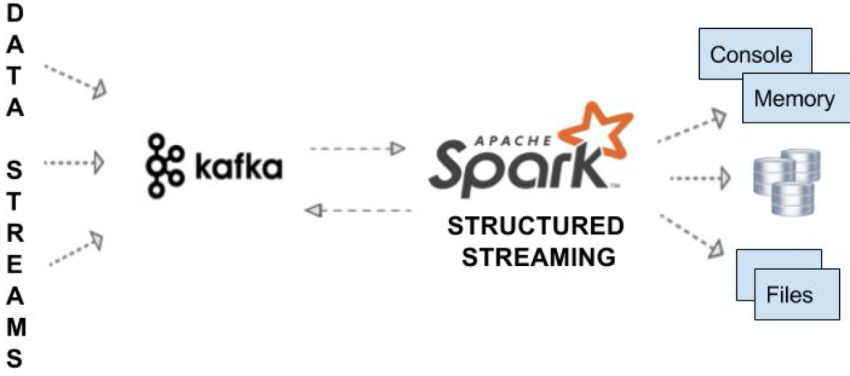

# Stream from Kafka
df = spark.readStream
.format("kafka")
.option("kafka.bootstrap.servers", "192.168.1.100:9092")
.option("subscribe", "json_topic")
.option("startingOffsets", "earliest") // From starting
.load()
Write a message to another topic in Kafka using writeStream()

# Stream write to kafka
df.selectExpr("CAST(id AS STRING) AS key", "to_json(struct(*)) AS value")
.writeStream
.format("kafka")
.outputMode("append")
.option("kafka.bootstrap.servers", "192.168.1.100:9092")
.option("topic", "josn_data_topic")
.start()
.awaitTermination()

PySpark MLlib Tutorial
PySpark MLlib is Apache Spark’s scalable machine learning library, offering a suite of algorithms and tools for building, training, and deploying machine learning models. It provides implementations of popular algorithms for classification, regression, clustering, collaborative filtering, and more.
MLlib is designed for distributed computing, allowing it to handle large-scale datasets across clusters efficiently. It offers both high-level APIs for ease of use and low-level APIs for fine-grained control over model training and evaluation.
MLlib seamlessly integrates with Spark’s ecosystem, enabling end-to-end machine learning workflows, including data preprocessing, feature engineering, model training, and deployment in production environments.
Here’s a simple example using Spark MLlib in Python to train a linear regression model:

# Import
from pyspark.ml.regression import LinearRegression
from pyspark.ml.feature import VectorAssembler

# Sample training data
data = [(1.0, 2.0), (2.0, 3.0), (3.0, 4.0), (4.0, 5.0), (5.0, 6.0)]
df = spark.createDataFrame(data, ["features", "label"])

# Define a feature vector assembler
assembler = VectorAssembler(inputCols=["features"], outputCol="features_vec")

# Transform the DataFrame with the feature vector assembler
df = assembler.transform(df)

# Create a LinearRegression model
lr = LinearRegression(featuresCol="features_vec", labelCol="label")

# Fit the model to the training data
model = lr.fit(df)

# Print the coefficients and intercept of the model
print("Coefficients: " + str(model.coefficients))
print("Intercept: " + str(model.intercept))

# Stop the SparkSession
spark.stop()
This is a simple example to demonstrate the usage of Spark MLlib for linear regression. In practice, you would typically use larger datasets and more complex models for real-world machine learning tasks.

PySpark GraphFrames
PySpark GraphFrames were introduced since Spark 3.0 to enable Graphs on Data Frames. Prior to 3.0, Spark had a GraphX library that supported only RDD.
Spark GraphFrames is a graph processing library built on top of Apache Spark that allows developers to work with graph data structures in a distributed and scalable manner. In simple terms, GraphFrames enables you to analyze and manipulate relationships between entities, represented as vertices (nodes) and edges (connections), using the power of Spark’s distributed computing engine.
To make GraphFrames work, you need to install graphframes library. And, download the graphframes.jar from the Maven repository and upload it to Python.

# Install graphframes
pip install graphframes
Example

# Import
from graphframes import GraphFrame

# Define vertices DataFrame
vertices = spark.createDataFrame([
("a", "Raman", 34),
("b", "Bob", 36),
("c", "Naveen", 30),
("d", "Kumar", 29)
], ["id", "name", "age"])

# Define edges DataFrame
edges = spark.createDataFrame([
("a", "b", "friend"),
("b", "c", "follow"),
("c", "d", "friend"),
("d", "a", "follow")
], ["src", "dst", "relationship"])

# Create a GraphFrame
g = GraphFrame(vertices, edges)

# Query the graph
g.vertices.show()
g.edges.show()

# Find the shortest path between two vertices
results = g.shortestPaths(landmarks=["a", "d"])
results.select("id", "distances").show()

# Stop the SparkSession
spark.stop()

Conclusion
Apache Spark is a powerful open-source data processing framework that provides high-speed, distributed computing for big data analytics. In this PySpark tutorial for beginners, I hope you have learned the fundamentals of PySpark, how to create distributed data processing pipelines, and how to leverage its versatile libraries to transform and analyze large datasets efficiently.

Related Articles
- Apache Spark 3.5 Tutorial with Scala examples
- Apache Spark 3.5.0 features
- Spark Streaming with Kafka Example
- DataFrame Tutorial with Examples
- Spark DataFrame Tutorial with Examples

References
Below are some of the articles/tutorials I’ve referred to complete this Tutorial.
- https://spark.apache.org/docs/latest/api/python/pyspark.html
- https://spark.apache.org/docs/latest/rdd-programming-guide.html
- https://en.wikipedia.org/wiki/Machine_learning

- PySpark Tutorial For Beginners
- PySpark – Features
- PySpark – Advantages
- PySpark – Modules & Packages
- PySpark – Cluster Managers
- PySpark – Install on Windows
- PySpark – Install on Mac
- PySpark – Web/Application UI
- PySpark – SparkContext
- PySpark – RDD
- PySpark – Parallelize
- PySpark – repartition() vs coalesce()
- PySpark – Broadcast Variables
- PySpark – Accumulator

PySpark DataFrame
- PySpark – Create an empty DataFrame
- PySpark – Convert RDD to DataFrame
- PySpark – Convert DataFrame to Pandas
- PySpark – show()
- PySpark – StructType & StructField
- PySpark – Column Class
- PySpark – select()
- PySpark – collect()
- PySpark – withColumn()
- PySpark – withColumnRenamed()
- PySpark – where() & filter()
- PySpark – drop() & dropDuplicates()
- PySpark – orderBy() and sort()
- PySpark – groupBy()
- PySpark – join()
- PySpark – union() & unionAll()
- PySpark – unionByName()
- PySpark – UDF (User Defined Function)
- PySpark – transform()
- PySpark – apply()
- PySpark – map()
- PySpark – flatMap()
- PySpark – foreach()
- PySpark – sample() vs sampleBy()
- PySpark – fillna() & fill()
- PySpark – pivot() (Row to Column)
- PySpark – partitionBy()
- PySpark – MapType (Map/Dict)

PySpark SQL Functions
- PySpark – Aggregate Functions
- PySpark – Window Functions
- PySpark – Date and Timestamp Functions
- PySpark – JSON Functions

PySpark Datasources
- PySpark – Read & Write CSV File
- PySpark – Read & Write Parquet File
- PySpark – Read & Write JSON file
- PySpark – Read Hive Table
- PySpark – Save to Hive Table
- PySpark – Read JDBC in Parallel
- PySpark – Query Database Table
- PySpark – Read and Write SQL Server
- PySpark – Read and Write MySQL

PySpark Built-in Functions
- PySpark – when()
- PySpark – expr()
- PySpark – lit()
- PySpark – split()
- PySpark – concat_ws()
- Pyspark – substring()
- PySpark – translate()
- PySpark – regexp_replace()
- PySpark – overlay()
- PySpark – to_timestamp()
- PySpark – to_date()
- PySpark – date_format()
- PySpark – datediff()
- PySpark – months_between()
- PySpark – explode()
- PySpark – array_contains()
- PySpark – array()
- PySpark – collect_list()
- PySpark – collect_set()
- PySpark – create_map()
- PySpark – map_keys()
- PySpark – map_values()
- PySpark – struct()
- PySpark – countDistinct()
- PySpark – sum(), avg()
- PySpark – row_number()
- PySpark – rank()
- PySpark – dense_rank()
- PySpark – percent_rank()
- PySpark – typedLit()
- PySpark – from_json()
- PySpark – to_json()
- PySpark – json_tuple()
- PySpark – get_json_object()
- PySpark – schema_of_json()

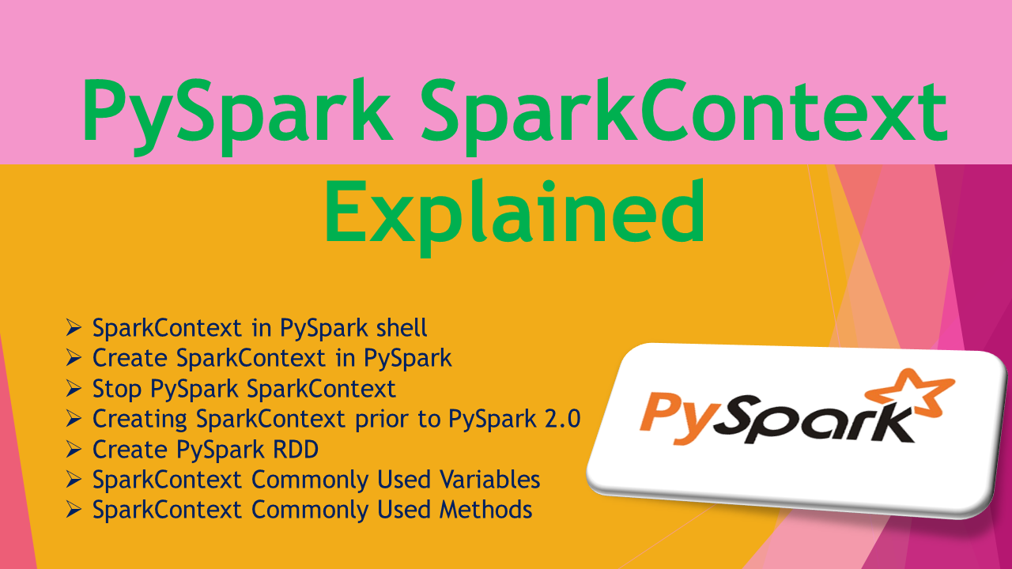
pyspark.SparkContext is an entry point to the PySpark functionality that is used to communicate with the cluster and to create an RDD, accumulator, and broadcast variables. In this article, you will learn how to create PySpark SparkContext with examples. Note that you can create only one SparkContext per JVM, in order to create another first you need to stop the existing one using stop() method.
Advertisements
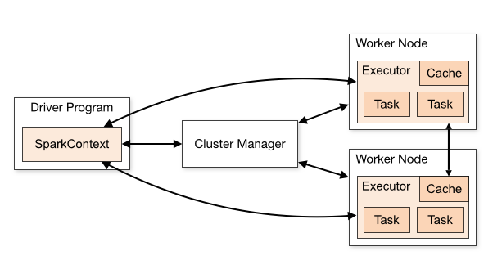Source: spark.apache.org
The Spark driver program creates and uses SparkContext to connect to the cluster manager to submit PySpark jobs, and know what resource manager (YARN, Mesos, or Standalone) to communicate to. It is the heart of the PySpark application.
Related: How to get current SparkContext & its configurations in Spark

1. SparkContext in PySpark shell
By default, PySpark shell creates and provides sc object, which is an instance of the SparkContext class. We can directly use this object where required without the need to create.

>>sc.appName
Similar to the PySpark shell, in most of the tools, notebooks, and Azure Databricks, the environment itself creates a default SparkContext object for us to use so you don’t have to worry about creating a PySpark context.

2. Create SparkContext in PySpark
Since PySpark 2.0, Creating a SparkSession creates a SparkContext internally and exposes the sparkContext variable to use.
At any given time only one SparkContext instance should be active per JVM. In case you want to create another you should stop existing SparkContext using stop() before creating a new one.

# Create SparkSession from builder
from pyspark.sql import SparkSession
spark = SparkSession.builder.master("local[1]") \
.appName('SparkByExamples.com') \
.getOrCreate()
print(spark.sparkContext)
print("Spark App Name : "+ spark.sparkContext.appName)

# Outputs
#<SparkContext master=local[1] appName=SparkByExamples.com>
#Spark App Name : SparkByExamples.com
As I explained in the SparkSession article, you can create any number of SparkSession objects however, for all those objects underlying there will be only one SparkContext.

3. Stop PySpark SparkContext
You can stop the SparkContext by calling the stop() method. As explained above you can have only one SparkContext per JVM. If you wanted to create another, you need to shutdown it first by using stop() method and create a new SparkContext.

# SparkContext stop() method
spark.sparkContext.stop()
When PySpark executes this statement, it logs the message INFO SparkContext: Successfully stopped SparkContext to console or to a log file.
When you try to create multiple SparkContext you will get the below error.
ValueError: Cannot run multiple SparkContexts at once;

4. Creating SparkContext prior to PySpark 2.0
You can create SparkContext by programmatically using its constructor, and pass parameters like master and appName at least as these are mandatory params. The below example creates context with a master as local and app name as Spark_Example_App.

# Create SparkContext
from pyspark import SparkContext
sc = SparkContext("local", "Spark_Example_App")
print(sc.appName)
You can also create it using SparkContext.getOrCreate(). It actually returns an existing active SparkContext otherwise creates one with a specified master and app name.

# Create Spark Context
from pyspark import SparkConf, SparkContext
conf = SparkConf()
conf.setMaster("local").setAppName("Spark Example App")
sc = SparkContext.getOrCreate(conf)
print(sc.appName)

5. Create PySpark RDD
Once you have a SparkContext object, you can create a PySpark RDD in several ways, below I have used the range() function.

# Create RDD
rdd = spark.sparkContext.range(1, 5)
print(rdd.collect())

# Output
#[1, 2, 3, 4]

6. SparkContext Commonly Used Variables
applicationId – Returns a unique ID of a PySpark application.
version – Version of PySpark cluster where your job is running.
uiWebUrl – Provides the Spark Web UI url that started by SparkContext.

7. SparkContext Commonly Used Methods
accumulator(value[, accum_param]) – It creates an pyspark accumulator variable with initial specified value. Only a driver can access accumulator variables.
broadcast(value) – read-only PySpark broadcast variable. This will be broadcast to the entire cluster. You can broadcast a variable to a PySpark cluster only once.
emptyRDD() – Creates an empty RDD
getOrCreate() – Creates or returns a SparkContext
hadoopFile() – Returns an RDD of a Hadoop file
newAPIHadoopFile() – Creates an RDD for a Hadoop file with a new API InputFormat.
sequenceFile() – Get an RDD for a Hadoop SequenceFile with given key and value types.
setLogLevel() – Change log level to debug, info, warn, fatal, and error
textFile() – Reads a text file from HDFS, local or any Hadoop supported file systems and returns an RDD
union() – Union two RDDs
wholeTextFiles() – Reads a text file in the folder from HDFS, local or any Hadoop supported file systems and returns an RDD of Tuple2. The first element of the tuple consists file name and the second element consists context of the text file.

8. Conclusion
In this PySpark Context article, you have learned what is SparkContext, how to create it, stop it, and usage with a few basic examples. As you learned SparkContext is an entry point to the PySpark execution engine which communicates with the cluster. Using this you can create a RDD, Accumulators and Broadcast variables.

Related Articles
- How to add Multiple Jars to PySpark
- PySpark Read and Write SQL Server Table
- PySpark Read and Write MySQL Database Table
- PySpark createOrReplaceTempView() Explained
- PySpark cache() Explained.
- PySpark repartition() – Explained with Examples
- PySpark Create RDD with Examples
- PySpark printSchema() Example

Reference
- https://github.com/apache/spark/blob/master/core/src/main/scala/org/apache/spark/SparkContext.scala
Happy Learning !!

RDD Introduction
RDD (Resilient Distributed Dataset) is a core building block of PySpark. It is a fault-tolerant, immutable, distributed collection of objects. Immutable means that once you create an RDD, you cannot change it. The data within RDDs is segmented into logical partitions, allowing for distributed computation across multiple nodes within the cluster.
Advertisements
This PySpark RDD Tutorial will help you understand what is RDD (Resilient Distributed Dataset) , its advantages, and how to create an RDD and use it, along with GitHub examples. You can find all RDD Examples explained in that article at GitHub PySpark examples project for quick reference.
By the end of this PySpark RDD tutorial, you will have a better understanding of PySpark RDD, how to apply transformations and actions, and how to operate on pair RDD.
- What is PySpark RDD?
- PySpark RDD Benefits
- PySpark RDD Limitations
- Creating RDD
  - Using parallelize()
  - Using textFile()
  - Using wholeTextFiles()
  - create empty RDD
- RDD Parallelize
- Repartition and Coalesce
- RDD Operations
  - RDD Transformations
  - RDD Actions
- RDD Types
- Shuffle Operations
- RDD Persistence
  - RDD cache()
  - RDD persist()
  - RDD unpersist()
- PySpark Shared Variables
  - Broadcast Variables
  - Accumulators
- Advanced API – DataFrame & DataSet

1. What is RDD (Resilient Distributed Dataset)?
RDD, or Resilient Distributed Dataset, serves as a core component within PySpark, offering a fault-tolerant, distributed collection of objects. This foundational element boasts immutability, ensuring that once an RDD is created, it remains unchanged. Furthermore, RDDs are partitioned logically, facilitating parallel computation across various nodes within the cluster.

RDDs are collections of objects similar to a list in Python; the difference is that RDD is computed on several processes scattered across multiple physical servers, also called nodes in a cluster, while a Python collection lives and processes in just one process.
By leveraging RDDs, PySpark users benefit from fault tolerance, scalability, and parallel processing capabilities, enabling efficient handling of large-scale data processing tasks. With RDDs, users can confidently tackle complex data analysis challenges while enjoying the flexibility and resilience offered by this robust distributed computing framework.
Additionally, RDDs provide data abstraction of partitioning and distribution of the data designed to run computations in parallel on several nodes, while doing transformations on RDD we don’t have to worry about the parallelism as PySpark by default provides.
Note: RDDs can have a name and unique identifier (id)

2. PySpark RDD Benefits
PySpark is widely adopted in the Machine learning and Data science community due to its advantages over traditional Python programming.

In-Memory Processing
PySpark loads the data from disk and processes it in memory, and keeps the data in memory; this is the main difference between PySpark and MapReduce (I/O intensive). In between the transformations, we can also cache/persists the RDD in memory to reuse the previous computations.

Immutability
PySpark RDDs are immutable in nature meaning, once RDDs are created you cannot modify them. When we apply transformations on RDD, PySpark creates a new RDD and maintains the RDD Lineage.

Fault Tolerance
PySpark operates on fault-tolerant data stores on HDFS, S3 e.t.c. Hence, if any RDD operation fails, it automatically reloads the data from other partitions. Also, when PySpark applications running on a cluster, PySpark task failures are automatically recovered for a certain number of times (as per the configuration) and finish the application seamlessly.

Lazy Evolution
PySpark does not evaluate the RDD transformations as they appear/encountered by Driver instead it keeps the all transformations as it encounters(DAG) and evaluates the all transformation when it sees the first RDD action.

Partitioning
When you create RDD from a data, It by default partitions the elements in a RDD. By default it partitions to the number of cores available.

3. PySpark RDD Limitations
PySpark RDDs are not much suitable for applications that make updates to the state store such as storage systems for a web application. For these applications, it is more efficient to use systems that perform traditional update logging and data checkpointing, such as databases. The goal of RDD is to provide an efficient programming model for batch analytics and leave these asynchronous applications.

4. RDD Creation
You can create RDD by parallelizing the existing collection and reading data from a disk.
- parallelizing an existing collection and
- referencing a dataset in an external storage system (HDFS, S3 and many more).
Before we look into examples, first let’s initialize SparkSession using the builder pattern method defined in SparkSession class. While initializing, we need to provide the master and application name as shown below. In real-time application, you will pass master from spark-submit instead of hardcoding.

# Imports
from pyspark.sql import SparkSession

# Create SparkSession
spark = SparkSession.builder
.master("local[1]")
.appName("SparkByExamples.com")
.getOrCreate()
master() – If you are running it on the cluster you need to use your master name as an argument to master(). usually, it would be either yarn (Yet Another Resource Negotiator) or mesos depends on your cluster setup.
- local[x] : When operating in Standalone mode, specify ‘local[x]’, where ‘x’ is an integer greater than 0, to determine the number of partitions for RDDs. Ideally, set ‘x’ to match the number of CPU cores available on your system for optimal performance.
appName() – Used to set your application name.
getOrCreate() – This returns a SparkSession object if already exists, and creates a new one if not exist.
Note: Creating SparkSession object, internally creates one SparkContext per JVM.

Using sparkContext.parallelize()
By using parallelize() function of SparkContext (sparkContext.parallelize() ) you can create an RDD. This function loads the existing collection from your driver program into parallelizing RDD. This method of creating an RDD is used when you already have data in memory that is either loaded from a file or from a database. and all data must be present in the driver program prior to creating RDD.
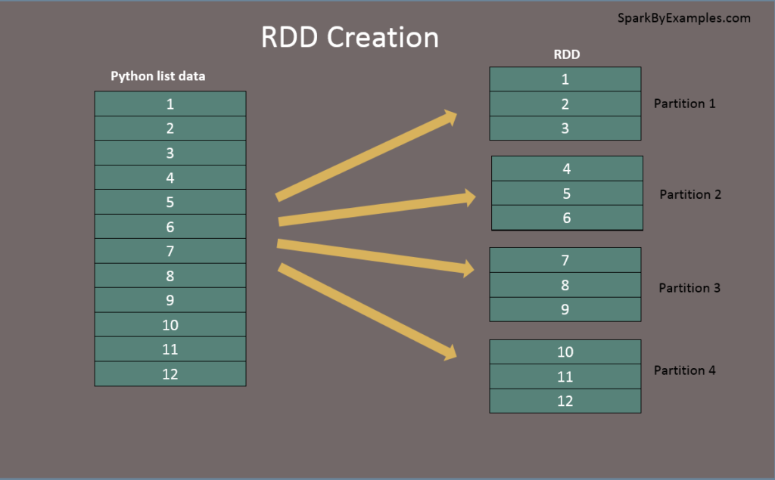RDD from list

# Create RDD from parallelize
data = [1,2,3,4,5,6,7,8,9,10,11,12]
rdd = spark.sparkContext.parallelize(data)
For production applications, we mostly create RDD by using external storage systems like HDFS, S3, HBase e.t.c. To make it simple for this PySpark RDD tutorial we are using files from the local system or loading it from the python list to create RDD.

Using sparkContext.textFile()
Use the textFile() method to read a .txt file into RDD.

# Create RDD from external Data source
rdd2 = spark.sparkContext.textFile("/path/textFile.txt")

Using sparkContext.wholeTextFiles()
wholeTextFiles() function returns a PairRDD with the key being the file path and the value being file content.

# Read entire file into a RDD as single record.
rdd3 = spark.sparkContext.wholeTextFiles("/path/textFile.txt")
Besides using text files, we can also create RDD from CSV file, JSON, and more formats.

Create empty RDD using sparkContext.emptyRDD
Using emptyRDD() method on sparkContext we can create an RDD with no data. This method creates an empty RDD with no partition.

# Create an empty RDD with no partition
rdd = spark.sparkContext.emptyRDD

# Output:
# rddString = spark.sparkContext.emptyRDD[String]

Creating empty RDD with partition
Sometimes we may need to write an empty RDD to files by partition, In this case, you should create an empty RDD with partition.

# Create empty RDD with partition
rdd2 = spark.sparkContext.parallelize([],10) #This creates 10 partitions

5. RDD Partitions
When we use parallelize(), textFile() or wholeTextFiles() methods of SparkContxt to initiate RDD, it automatically splits the data into partitions based on resource availability. When you run it on a laptop, it creates partitions as the same number of cores available on your system.
getNumPartitions() – This is an RDD function that returns a number of partitions your dataset split into.

# Get partition count
print("Initial partition count:"+str(rdd.getNumPartitions()))

# Outputs: Initial partition count:2
Set parallelize manually – We can also set a number of partitions manually, all we need is to pass a number of partitions as the second parameter to these functions for example;

# Set partitions manually
sparkContext.parallelize([1,2,3,4,56,7,8,9,12,3], 10)

6. Repartition and Coalesce
Sometimes, we may need to repartition the RDD, PySpark provides two ways to repartition; first using repartition() method, which shuffles data from all nodes also called full shuffle and second coalesce() method which shuffles data from minimum nodes, for examples if you have data in 4 partitions and doing coalesce(2) moves data from just 2 nodes.
Both of these functions take the number of partitions to repartition RDD as shown below. Note that repartition() method is a very expensive operation as it shuffles data from all nodes in a cluster.

# Repartition the RDD
reparRdd = rdd.repartition(4)
print("re-partition count:"+str(reparRdd.getNumPartitions()))

# Outputs:
re-partition count:4
Note: repartition() or coalesce() methods also return a new RDD.

7. PySpark RDD Operations
RDD operations are the core transformations and actions performed on RDDs
RDD transformations – Transformations are lazy operations; instead of updating an RDD, these operations return another RDD.
RDD actions – operations that trigger computation and return RDD values.

RDD Transformations with example
Transformations on PySpark RDD return another RDD, and transformations are lazy, meaning they don’t execute until you call an action on RDD. Some transformations on RDDs are flatMap(), map(), reduceByKey(), filter(), sortByKey() and return a new RDD instead of updating the current.
Let’s use some of the most common transformations to perform word count example.
First, by using textFile(), read the text file into RDD. The text file used in this example is available at the GitHub project.

# Read data from text file
rdd = spark.sparkContext.textFile("/tmp/test.txt")
flatMap – The flatMap() transformation in the RDD API flattens the resulting RDD after applying a function to each element, producing a new RDD. In the provided example below, each record is initially split by space within an RDD, and subsequently, the transformation flattens it. The resulting RDD comprises individual records, each containing a single word.”

# split the data by spact and flatten it.
rdd2 = rdd.flatMap(lambda x: x.split(" "))
map – The map() transformation is used to perform various complex operations, such as adding or updating an element. The result of map transformations retains the same number of records as the input.
In our word count illustration, a new column with a value of 1 is added to each word. The resulting RDD is transformed into PairRDDFunctions, comprising key-value pairs. Each key, representing a word of type String, is associated with a value of 1, type Int.”

# Apply the mpa() transformation
# Add a new element with value 1 to each word
rdd3 = rdd2.map(lambda x: (x,1))
reduceByKey – The reduceByKey() combines the values associated with each key using the provided function. In our scenario, it aggregates the word strings by using the sum function on the corresponding values. The result of our RDD outcome comprises distinct words along with their respective counts.

# Use reduceByKey()
rdd4 = rdd3.reduceByKey(lambda a,b: a+b)
sortByKey – The sortByKey() transformation arranges the elements of an RDD based on their keys. In our scenario, we initially convert the RDD from (String, Int) to (Int, String) using the map transformation. Subsequently, sortByKey() sorts the RDD primarily based on integer values.

# Using sortByKey()
rdd5 = rdd4.map(lambda x: (x[1],x[0])).sortByKey()

# Print rdd5 result to console
print(rdd5.collect())
Please refer to this page for the full list of RDD transformations.

RDD Actions with example
RDD Action operations trigger the execution of transformations on RDDs (Resilient Distributed Datasets) and produce a result that can be either returned to the driver program or saved to an external storage system.
We will continue to use our word count example and perform some actions on it.
count() – Returns the number of records in an RDD

# Action - count
print("Count : "+str(rdd6.count()))
first() – Returns the first record.

# Action - first
firstRec = rdd6.first()
print("First Record : "+str(firstRec[0]) + ","+ firstRec[1])
max() – Returns max record.

# Action - max
datMax = rdd6.max()
print("Max Record : "+str(datMax[0]) + ","+ datMax[1])
reduce() – Reduces the records to single, we can use this to count or sum.

# Action - reduce
totalWordCount = rdd6.reduce(lambda a,b: (a[0]+b[0],a[1]))
print("dataReduce Record : "+str(totalWordCount[0]))
take() – Returns the record specified as an argument.

# Action - take
data3 = rdd6.take(3)
for f in data3:
print("data3 Key:"+ str(f[0]) +", Value:"+f[1])
collect() – Returns all data from RDD as an array. Be careful when you use this action when you are working with huge RDD with millions and billions of data as you may run out of memory on the driver.

# Action - collect
data = rdd6.collect()
for f in data:
print("Key:"+ str(f[0]) +", Value:"+f[1])
saveAsTextFile() – Using saveAsTestFile action, we can write the RDD to a text file.

rdd6.saveAsTextFile("/tmp/wordCount")
Note: Please refer to this page for a full list of RDD actions.

8. Types of RDD
PairRDDFunctions or PairRDD – Pair RDD is a key-value pair This is mostly used RDD type,
ShuffledRDD –
DoubleRDD –
SequenceFileRDD –
HadoopRDD –
ParallelCollectionRDD –

9. Shuffle Operations
Shuffling, in PySpark, serves as a means to redistribute data among various executors and potentially across multiple machines. It occurs when specific transformation operations like groupByKey(), reduceByKey(), and join() are applied to RDDs.
PySpark’s shuffling process incurs significant costs due to the following factors:
- Disk I/O activities
- Involvement of data serialization and deserialization
- Network I/O operations
When creating an RDD, PySpark doesn’t necessarily store the data for all keys in a partition since at the time of creation there is no way we can set the key for data set.
Hence, when we run the reduceByKey() operation to aggregate the data on keys, PySpark does the following. needs to first run tasks to collect all the data from all partitions and
For example, when we perform reduceByKey() operation, PySpark does the following
- PySpark first runs map tasks on all partitions which groups all values for a single key.
- The results of the map tasks are kept in memory.
- When results do not fit in memory, PySpark stores the data into a disk.
- PySpark shuffles the mapped data across partitions, some times it also stores the shuffled data into a disk for reuse when it needs to recalculate.
- Run the garbage collection
- Finally runs reduce tasks on each partition based on key.
PySpark RDD triggers shuffle and repartition for several operations like repartition() and coalesce(), groupByKey(), reduceByKey(), cogroup() and join() but not countByKey() .

Shuffle partition size & Performance
Depending on your dataset size, the number of cores, and the memory available, PySpark shuffling can either optimize or harm your job performance. When dealing with smaller datasets, it’s advisable to reduce the shuffle partitions to avoid ending up with numerous partitioned files containing fewer records per partition. This situation leads to running many tasks with minimal data to process.
Conversely, excessive data with fewer partitions results in longer-running tasks and may even lead to out-of-memory errors. Determining the optimal shuffle partition size is challenging and often requires multiple iterations with different values to achieve the desired optimization. This parameter is crucial to address when encountering performance issues in PySpark jobs.

10. Persist RDD
PySpark Cache and Persist are optimization techniques to improve the performance of the RDD jobs that are iterative and interactive. In this PySpark RDD Tutorial section, I will explain how to use persist() and cache() methods on RDD with examples.
Although PySpark boasts computation speeds up to 100 times faster than traditional MapReduce jobs, performance degradation may occur when jobs fail to leverage repeated computations, particularly when handling massive datasets in the billions or trillions. Hence, optimizing computations becomes imperative to enhance performance.
PySpark offers optimization techniques such as the cache() and persist() methods. These mechanisms enable the storage of intermediate RDD computations, facilitating their reuse in subsequent actions.
Upon persisting or caching an RDD, each worker node stores its partitioned data in memory or on disk, allowing for reuse in subsequent RDD actions. Moreover, Spark’s persisted data on nodes exhibit fault tolerance, ensuring that any lost partitions are automatically recomputed using the original transformations that generated them.

RDD Cache
PySpark RDD cache() method by default saves RDD computation to storage level `MEMORY_ONLY` meaning it will store the data in the JVM heap as unserialized objects.
PySpark cache() method in RDD class internally calls persist() method which in turn uses sparkSession.sharedState.cacheManager.cacheQuery to cache the result set of RDD. Let’s look at an example.

# cache()
cachedRdd = rdd.cache()

RDD Persist
Using persist() method, you can store the RDD in one of the storage levels
MEMORY_ONLY, MEMORY_ONLY_SER, MEMORY_AND_DISK, MEMORY_AND_DISK_SER, DISK_ONLY, MEMORY_ONLY_2, MEMORY_AND_DISK_2 and more.

# persist()
import pyspark
dfPersist = rdd.persist(pyspark.StorageLevel.MEMORY_ONLY)
dfPersist.show(false)

RDD Unpersist
PySpark systematically monitors each invocation of persist() and cache(), scrutinizing usage across every node. It automatically discards persisted data that remains unused or employs the least-recently-used (LRU) algorithm. Additionally, users can manually remove persisted data using the unpersist() method. This action marks the RDD as non-persistent and eradicates all associated blocks from both memory and disk.

# unpersist()
rddPersist2 = rddPersist.unpersist()

11. RDD Shared Variables
In this section of the PySpark RDD tutorial, let’s learn what are the different types of PySpark Shared variables and how they are used in PySpark transformations.
When PySpark executes transformation using map() or reduce() operations, It executes the transformations on a remote node by using the variables that are shipped with the tasks and these variables are not sent back to PySpark Driver hence there is no capability to reuse and sharing the variables across tasks. PySpark shared variables solve this problem using the below two techniques. PySpark provides two types of shared variables.
- Broadcast variables (read-only shared variable)
- Accumulator variables (updatable shared variables)

Broadcast read-only Variables
Broadcast variables are shared, read-only variables cached and accessible across all nodes in a cluster for use by tasks. Rather than transmitting this data with every task, PySpark employs efficient broadcast algorithms to distribute broadcast variables to machines, thereby reducing communication costs.
A prime application of PySpark RDD Broadcast is with lookup data, such as zip codes, states, or country lookups.
When executing a PySpark RDD job utilizing Broadcast variables, PySpark undertakes the following steps:
- PySpark partitions the job into stages, each with distributed shuffling, and executes actions within each stage.
- Subsequently, later stages are subdivided into tasks.
- PySpark broadcasts common data required by tasks within each stage.
- The broadcasted data is cached in serialized format and deserialized prior to executing each task.
The PySpark Broadcast is created using the broadcast(v) method of the SparkContext class. This method takes the argument v that you want to broadcast.

# Create broadcast variable
broadcastVar = sc.broadcast([0, 1, 2, 3])
broadcastVar.value
Note that broadcast variables are not sent to executors with sc.broadcast(variable) call instead, they will be sent to executors when they are first used.
Refer to PySpark RDD Broadcast shared variable for more detailed example.

Accumulators
PySpark Accumulators represent another form of shared variable exclusively “added” via an associative and commutative operation. They serve to perform counters similar to MapReduce counters.
By default, PySpark supports the creation of accumulators of any numeric type and offers the flexibility to incorporate custom accumulator types. Programmers can generate the following types of accumulators:
- Named accumulators
- Unnamed accumulators
Creating a named accumulator becomes visible on the PySpark web UI under the “Accumulator” tab. Within this tab, two tables are present: the initial table, labeled “accumulable,” encompasses all named accumulator variables alongside their respective values. Meanwhile, the subsequent table, labeled “Tasks,” showcases the value of each accumulator altered by a task.
On the other hand, unnamed accumulators do not appear on the PySpark web UI. For pragmatic purposes, it is advisable to utilize named accumulators in most scenarios.
Accumulator variables are created using SparkContext.longAccumulator(v)

# Create accumulator variable
accum = sc.longAccumulator("SumAccumulator")
sc.parallelize([1, 2, 3]).foreach(lambda x: accum.add(x))

12. Advanced API – DataFrame & DataSet

Creating RDD from DataFrame and vice-versa
Though we have more advanced API’s over RDD, we would often need to convert DataFrame to RDD or RDD to DataFrame. Below are several examples.

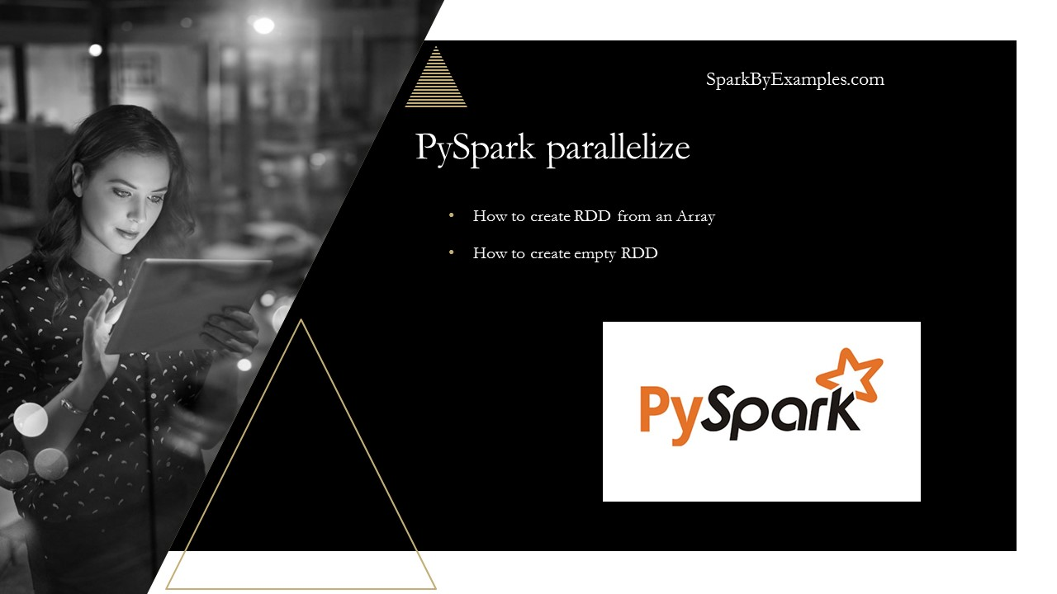
PySpark parallelize() is a function in SparkContext and is used to create an RDD from a list collection. In this article, I will explain the usage of parallelize to create RDD and how to create an empty RDD with a PySpark example.
Advertisements
Before we start let me explain what is RDD, Resilient Distributed Datasets (RDD) is a fundamental data structure of PySpark, It is an immutable distributed collection of objects. Each dataset in RDD is divided into logical partitions, which may be computed on different nodes of the cluster.
- PySpark is parallelizing an existing collection in your driver program.
Below is an example of how to create an RDD using a parallelize method from Sparkcontext. sparkContext.parallelize([1,2,3,4,5,6,7,8,9,10]) creates an RDD with a list of Integers.

Using sc.parallelize on PySpark Shell or REPL
PySpark shell provides SparkContext variable “sc”, use sc.parallelize() to create an RDD.

rdd = sc.parallelize([1,2,3,4,5,6,7,8,9,10])

Using PySpark sparkContext.parallelize() in application
Since PySpark 2.0, First, you need to create a SparkSession which internally creates a SparkContext for you.

import pyspark
from pyspark.sql import SparkSession

spark = SparkSession.builder.appName('SparkByExamples.com').getOrCreate()
sparkContext=spark.sparkContext
Now, use sparkContext.parallelize() to create rdd from a list or collection.

rdd=sparkContext.parallelize([1,2,3,4,5])
rddCollect = rdd.collect()
print("Number of Partitions: "+str(rdd.getNumPartitions()))
print("Action: First element: "+str(rdd.first()))
print(rddCollect)
By executing the above program you should see below output.

Number of Partitions: 4
Action: First element: 1
[1, 2, 3, 4, 5]
parallelize() function also has another signature which additionally takes integer argument to specifies the number of partitions. Partitions are basic units of parallelism in PySpark.
Remember, RDDs in PySpark are a collection of partitions.

create empty RDD by using sparkContext.parallelize
Some times we may need to create empty RDD and you can also use parallelize() in order to create it.

emptyRDD = sparkContext.emptyRDD()
emptyRDD2 = rdd=sparkContext.parallelize([])

print("is Empty RDD : "+str(emptyRDD2.isEmpty()))
The complete code can be downloaded from GitHub – PySpark Examples project

Related Articles
- PySpark Create RDD with Examples
- PySpark Replace Column Values in DataFrame
- PySpark repartition() – Explained with Examples
- What is PySpark DataFrame?
- PySpark RDD Actions with examples
- PySpark RDD Transformations with examples
- Convert PySpark RDD to DataFrame
- PySpark Row using on DataFrame and RDD
- PySpark RDD Actions with examples
Tags: emptyRDD, parallelize, RDD

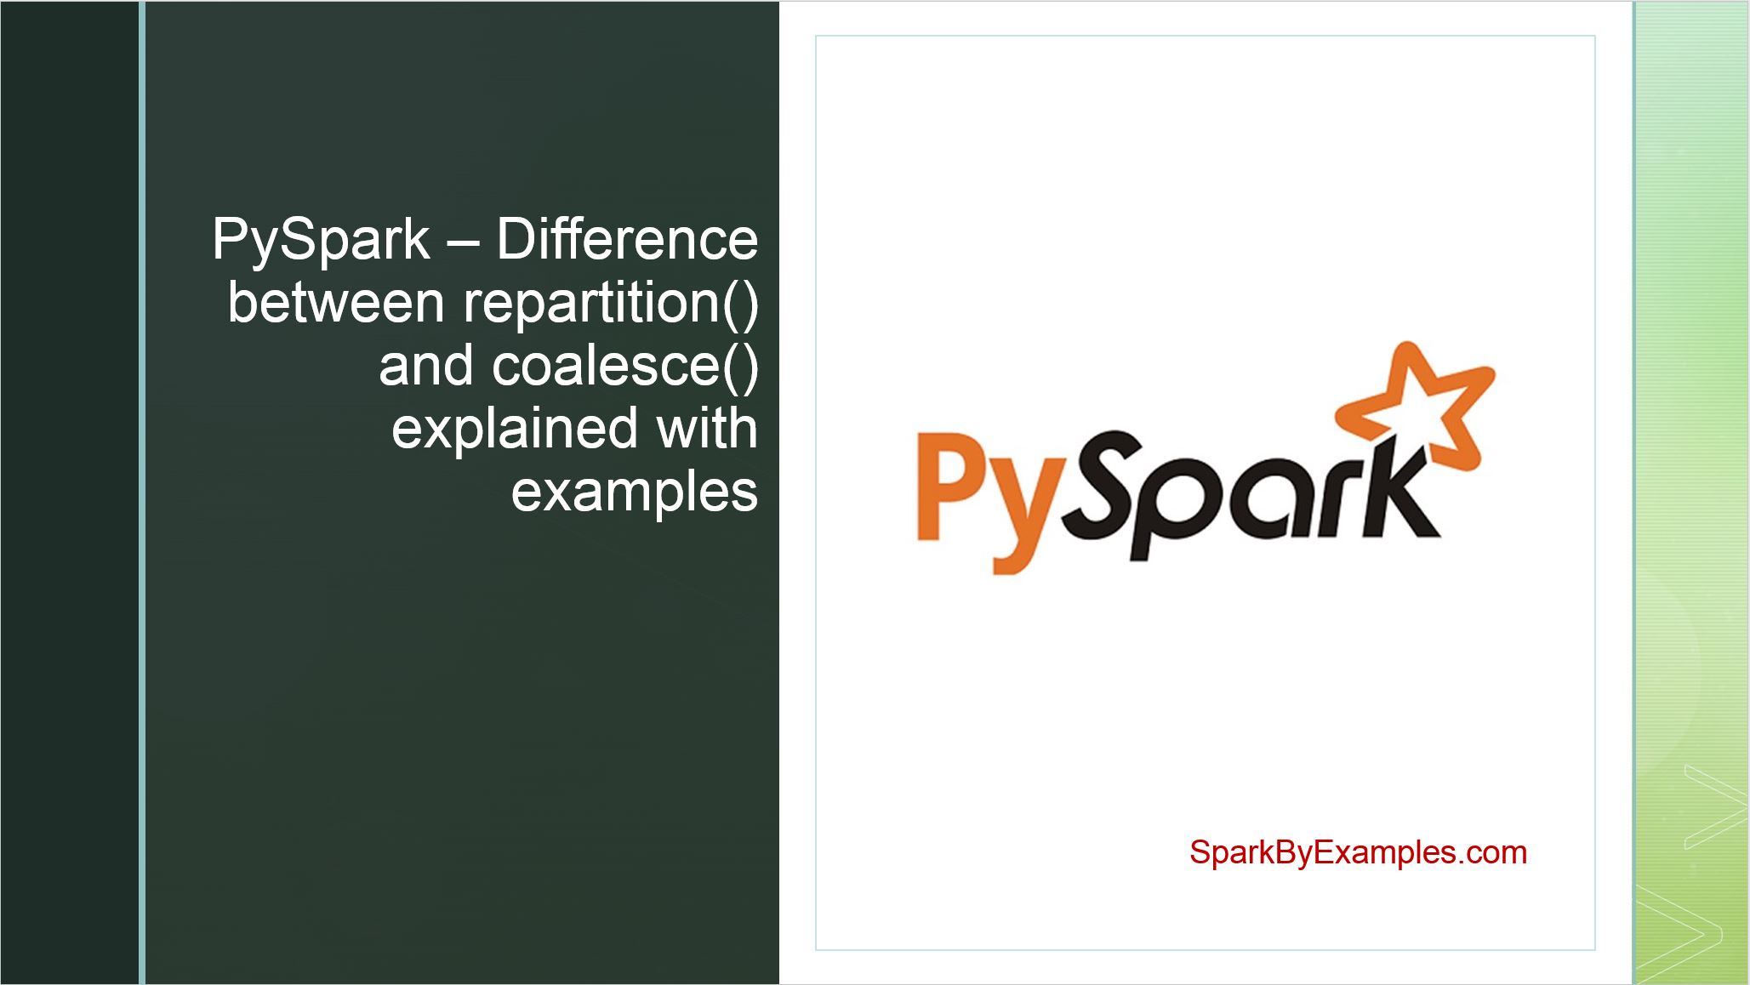
In PySpark, the choice between repartition() and coalesce() functions carries importance in optimizing performance and resource utilization. These methods play pivotal roles in reshuffling data across partitions within a DataFrame, yet they differ in their mechanisms and implications.
Advertisements
In simple words, repartition() increases or decreases the partitions, whereas coalesce() only decreases the number of partitions efficiently. In this article, you will learn the difference between PySpark repartition vs coalesce with examples.
- RDD Partition
  - RDD repartition
  - RDD coalesce
- DataFrame Partition
  - DataFrame repartition
  - DataFrame coalesce
One important point to note is PySpark repartition() and coalesce() are very expensive operations as they shuffle the data across many partitions; hence, try to minimize using these as much as possible.

1. PySpark RDD Repartition() vs Coalesce()
Let’s create an RDD with partitions and will use this to repartition() and coalesce()

# Create spark session with local[5]
rdd = spark.sparkContext.parallelize(range(0,20))
print("From local[5] : "+str(rdd.getNumPartitions()))

# Use parallelize with 6 partitions
rdd1 = spark.sparkContext.parallelize(range(0,25), 6)
print("parallelize : "+str(rdd1.getNumPartitions()))

rddFromFile = spark.sparkContext.textFile("src/main/resources/test.txt",10)
print("TextFile : "+str(rddFromFile.getNumPartitions()))
The above example yields the below output.

# Output:
From local[5] : 5
Parallelize : 6
TextFile : 10
The sparkContext.parallelize() method in PySpark is used to parallelize a collection into a resilient distributed dataset (RDD). In the given example, Range(0,20) creates a range of numbers from 0 to 19 (inclusive). The second argument, 6, specifies the number of partitions into which the data should be divided.
Let’s write this to the file and check the data. Note that your partitions might have different records.

rdd1.saveAsTextFile("/tmp/partition")

#Writes 6 part files, one for each partition
Partition 1 : 0 1 2
Partition 2 : 3 4 5
Partition 3 : 6 7 8 9
Partition 4 : 10 11 12
Partition 5 : 13 14 15
Partition 6 : 16 17 18 19

1.1 RDD repartition()
repartition() is a transformation method available on RDDs (Resilient Distributed Datasets) that redistributes data across a specified number of partitions. When you call repartition(n), where n is the desired number of partitions, Spark reshuffles the data in the RDD into exactly n partitions.
If you increase/decrease the number of partitions using repartition(), Spark will perform a full shuffle of the data across the cluster, which can be an expensive operation, especially for large datasets.

# Using repartition
rdd2 = rdd1.repartition(4)
print("Repartition size : "+str(rdd2.getNumPartitions()))
rdd2.saveAsTextFile("/tmp/re-partition")
The result shows a “Repartition size” of 4, indicating that the data has been redistributed across partitions. This operation involves a full shuffle, which can be quite costly, especially when handling extremely large datasets in the billions or trillions.

# Output:
Partition 1 : 1 6 10 15 19
Partition 2 : 2 3 7 11 16
Partition 3 : 4 8 12 13 17
Partition 4 : 0 5 9 14 18

1.2 RDD coalesce()
In PySpark, coalesce() is a transformation method available on RDDs (Resilient Distributed Datasets) that reduces the number of partitions without shuffling data across the cluster. When you call coalesce(n), where n is the desired number of partitions, Spark merges existing partitions to create n partitions.

# Using coalesce()
rdd3 = rdd1.coalesce(4)
print("Repartition size : "+str(rdd3.getNumPartitions()))
rdd3.saveAsTextFile("/tmp/coalesce")
If we compare the following output with section 1, it becomes apparent that partition 3 has been relocated to partition 2, and partition 6 has been relocated to partition 5. This data movement has occurred between only two partitions.

# Output:
Partition 1 : 0 1 2
Partition 2 : 3 4 5 6 7 8 9
Partition 4 : 10 11 12
Partition 5 : 13 14 15 16 17 18 19

2. PySpark DataFrame repartition() vs coalesce()
Like RDD, you can’t specify the partition/parallelism while creating DataFrame. DataFrame by default internally uses the methods specified in Section 1 to determine the default partition and splits the data for parallelism.
If you are not familiar with DataFrame, I will recommend learning it by following PySpark DataFrame Tutorial before proceeding further with this article.

# DataFrame example
import pyspark
from pyspark.sql import SparkSession
spark = SparkSession.builder.appName('SparkByExamples.com') \
.master("local[5]").getOrCreate()

df=spark.range(0,20)
print(df.rdd.getNumPartitions())

df.write.mode("overwrite").csv("c:/tmp/partition.csv")
The above example creates 5 partitions as specified in master("local[5]") and the data is distributed across all these 5 partitions.

# Output:
Partition 1 : 0 1 2 3
Partition 2 : 4 5 6 7
Partition 3 : 8 9 10 11
Partition 4 : 12 13 14 15
Partition 5 : 16 17 18 19

2.1 DataFrame repartition()
The DataFrame repartition() method in PySpark redistributes (increase or decrease partitions) data evenly across a specified number of partitions, optimizing parallelism and resource usage. It triggers a full shuffle of data and is useful for adjusting the partitioning scheme for downstream operations like joins and aggregations.
This example expands the number of partitions from 5 to 6 by redistributing data across all partitions.

# DataFrame repartition
df2 = df.repartition(6)
print(df2.rdd.getNumPartitions())
Just increasing 1 partition results in data movements from all partitions.

# Output:
Partition 1 : 14 1 5
Partition 2 : 4 16 15
Partition 3 : 8 3 18
Partition 4 : 12 2 19
Partition 5 : 6 17 7 0
Partition 6 : 9 10 11 13
And, even decreasing the partitions also results in moving data from all partitions. hence when you wanted to decrease the partition recommendation is to use coalesce()/

2.2 DataFrame coalesce()
Spark DataFrame coalesce() is used only to decrease the number of partitions. This is an optimized or improved version of repartition() where the movement of the data across the partitions is fewer using coalesce.

# DataFrame coalesce
df3 = df.coalesce(2)
print(df3.rdd.getNumPartitions())
This yields output 2 and the resultant partition looks like

# Output:
Partition 1 : 0 1 2 3 8 9 10 11
Partition 2 : 4 5 6 7 12 13 14 15 16 17 18 19
Since we are reducing 5 to 2 partitions, the data movement happens only from 3 partitions and it moves to remain 2 partitions.

3. Default Shuffle Partition
In PySpark, the default shuffle partition refers to the number of partitions that Spark uses when performing shuffle operations, such as joins, group-bys, and aggregations. Shuffle operations involve redistributing data across different nodes in the cluster, which can be computationally expensive and affect performance.
By default, Spark sets the number of shuffle partitions to 200. This default value is controlled by the configuration parameter spark.sql.shuffle.partitions. You can adjust this setting based on the size of your data and the resources of your cluster to optimize performance.

# Default shuffle partition count
df4 = df.groupBy("id").count()
print(df4.rdd.getNumPartitions())
Post shuffle operations, you can change the partitions either using coalesce() or repartition().

4. PySpark repartition vs coalesce
Following are differences in a table format.
Feature | Repartition | Coalesce
Description | Adjusts the number of partitions, redistributing data across the specified number of partitions. | Reduces the number of partitions without shuffling data, merging existing partitions.
Full Shuffle | Yes | No
Expensiveness | Can be expensive, especially for large datasets, as it involves a full shuffle of data. | Less expensive than repartitioning, as it minimizes data movement by only combining partitions when possible.
Data Movement | Distributes data across partitions evenly, potentially leading to balanced partition sizes. | May result in imbalanced partition sizes, especially when reducing the number of partitions.
Use Cases | Useful when changing the number of partitions or evenly distributing data across partitions. | Useful when decreasing the number of partitions without incurring the cost of a full shuffle.

Conclusion
In this PySpark repartition() vs coalesce() article, you have learned how to create an RDD with partition, repartition the RDD using coalesce(), repartition DataFrame using repartition() and coalesce() methods, and learned the difference between repartition and coalesce.

Related Articles
- PySpark partitionBy() Explained with Examples
- PySpark Parallelize | Create RDD
- PySpark repartition() vs partitionBy() with Examples
- PySpark repartition() – Explained with Examples
- PySpark repartition() vs partitionBy()
- PySpark Query Database Table using JDBC
- PySpark Read and Write SQL Server Table
- PySpark Read JDBC Table to DataFrame

Reference
- https://spark.apache.org/docs/latest/configuration.html
- https://spark.apache.org/docs/latest/rdd-programming-guide.html
Happy Learning !!


In PySpark RDD and DataFrame, Broadcast variables are read-only shared variables that are cached and available on all nodes in a cluster in-order to access or use by the tasks. Instead of sending this data along with every task, PySpark distributes broadcast variables to the workers using efficient broadcast algorithms to reduce communication costs.
Advertisements

Use case
Let me explain with an example when to use broadcast variables, assume you are getting a two-letter country state code in a file and you wanted to transform it to full state name, (for example CA to California, NY to New York e.t.c) by doing a lookup to reference mapping. In some instances, this data could be large and you may have many such lookups (like zip code e.t.c).
Instead of distributing this information along with each task over the network (overhead and time consuming), we can use the broadcast variable to cache this lookup info on each machine and tasks use this cached info while executing the transformations.

How does PySpark Broadcast work?
Broadcast variables are used in the same way for RDD, DataFrame.

When you run a PySpark RDD, DataFrame applications that have the Broadcast variables defined and used, PySpark does the following.
- PySpark breaks the job into stages that have distributed shuffling and actions are executed with in the stage.
- Later Stages are also broken into tasks
- Spark broadcasts the common data (reusable) needed by tasks within each stage.
- The broadcasted data is cache in serialized format and deserialized before executing each task.
You should be creating and using broadcast variables for data that shared across multiple stages and tasks.
Note that broadcast variables are not sent to executors with sc.broadcast(variable) call instead, they will be sent to executors when they are first used.

How to create Broadcast variable
The PySpark Broadcast is created using the broadcast(v) method of the SparkContext class. This method takes the argument v that you want to broadcast.

In PySpark shell

broadcastVar = sc.broadcast(Array(0, 1, 2, 3))
broadcastVar.value

PySpark RDD Broadcast variable example
Below is a very simple example of how to use broadcast variables on RDD. This example defines commonly used data (states) in a Map variable and distributes the variable using SparkContext.broadcast() and then use these variables on RDD map() transformation.

import pyspark
from pyspark.sql import SparkSession

spark = SparkSession.builder.appName('SparkByExamples.com').getOrCreate()

states = {"NY":"New York", "CA":"California", "FL":"Florida"}
broadcastStates = spark.sparkContext.broadcast(states)

data = [("James","Smith","USA","CA"),
("Michael","Rose","USA","NY"),
("Robert","Williams","USA","CA"),
("Maria","Jones","USA","FL")
]

rdd = spark.sparkContext.parallelize(data)

def state_convert(code):
return broadcastStates.value[code]

result = rdd.map(lambda x: (x[0],x[1],x[2],state_convert(x[3]))).collect()
print(result)
Yields below output

PySpark DataFrame Broadcast variable example
Below is an example of how to use broadcast variables on DataFrame, similar to above RDD example, This also uses commonly used data (states) in a Map variable and distributes the variable using SparkContext.broadcast() and then use these variables on DataFrame map() transformation.
If you are not familiar with DataFrame, I will recommend to learn the DataFrame before proceeding further on this article.

import pyspark
from pyspark.sql import SparkSession

spark = SparkSession.builder.appName('SparkByExamples.com').getOrCreate()

states = {"NY":"New York", "CA":"California", "FL":"Florida"}
broadcastStates = spark.sparkContext.broadcast(states)

data = [("James","Smith","USA","CA"),
("Michael","Rose","USA","NY"),
("Robert","Williams","USA","CA"),
("Maria","Jones","USA","FL")
]

columns = ["firstname","lastname","country","state"]
df = spark.createDataFrame(data = data, schema = columns)
df.printSchema()
df.show(truncate=False)

def state_convert(code):
return broadcastStates.value[code]

result = df.rdd.map(lambda x: (x[0],x[1],x[2],state_convert(x[3]))).toDF(columns)
result.show(truncate=False)
Above example first creates a DataFrame, transform the data using broadcast variable and yields below output.
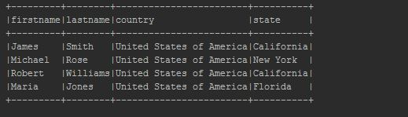
You can also use the broadcast variable on the filter and joins. Below is a filter example.

# Broadcast variable on filter
filteDf= df.where((df['state'].isin(broadcastStates.value)))

Conclusion
In this PySpark Broadcast variable article, you have learned what is Broadcast variable, it’s advantage and how to use in RDD and Dataframe with Pyspark example.

Related Articles
- PySpark SparkContext Explained
- Dynamic way of doing ETL through Pyspark
- PySpark Shell Command Usage with Examples
- PySpark Accumulator with Example
- PySpark distinct vs dropDuplicates
- PySpark Get Number of Rows and Columns
- Pyspark Select Distinct Rows

Reference
- https://spark.apache.org/docs/2.2.0/rdd-programming-guide.html#broadcast-variables
Happy Learning !!

The PySpark Accumulator is a shared variable that is used with RDD and DataFrame to perform sum and counter operations similar to Map-reduce counters. These variables are shared by all executors to update and add information through aggregation or computative operations.
Advertisements
In this article, I’ve explained what is PySpark Accumulator, how to create, and using it on RDD and DataFrame with an example.
What is PySpark Accumulator?
Accumulators are write-only and initialize once variables where only tasks that are running on workers are allowed to update and updates from the workers get propagated automatically to the driver program. But, only the driver program is allowed to access the Accumulator variable using the value property.
How to create Accumulator variable in PySpark?
Using accumulator() from SparkContext class we can create an Accumulator in PySpark programming. Users can also create Accumulators for custom types using AccumulatorParam class of PySpark.

Some points to note..
- sparkContext.accumulator() is used to define accumulator variables.
- add() function is used to add/update a value in accumulator
- value property on the accumulator variable is used to retrieve the value from the accumulator.
We can create Accumulators in PySpark for primitive types int and float. Users can also create Accumulators for custom types using AccumulatorParam class of PySpark.

Creating Accumulator Variable
Below is an example of how to create an accumulator variable “accum” of type int and using it to sum all values in an RDD.

from pyspark.sql import SparkSession
spark=SparkSession.builder.appName("accumulator").getOrCreate()

accum=spark.sparkContext.accumulator(0)
rdd=spark.sparkContext.parallelize([1,2,3,4,5])
rdd.foreach(lambda x:accum.add(x))
print(accum.value) #Accessed by driver
Here, we have created an accumulator variable accum using spark.sparkContext.accumulator(0) with initial value 0. Later, we are iterating each element in an rdd using foreach() action and adding each element of rdd to accum variable. Finally, we are getting accumulator value using accum.value property.
Note that, In this example, rdd.foreach() is executed on workers and accum.value is called from PySpark driver program.
Let’s see another example of an accumulator, this time will do with a function.

accuSum=spark.sparkContext.accumulator(0)
def countFun(x):
global accuSum
accuSum+=x
rdd.foreach(countFun)
print(accuSum.value)
We can also use accumulators to do a counters.

accumCount=spark.sparkContext.accumulator(0)
rdd2=spark.sparkContext.parallelize([1,2,3,4,5])
rdd2.foreach(lambda x:accumCount.add(1))
print(accumCount.value)

PySpark Accumulator Example
Below is a complete RDD example of using different accumulators that I was able to run on my environment.

import pyspark
from pyspark.sql import SparkSession
spark=SparkSession.builder.appName("accumulator").getOrCreate()

accum=spark.sparkContext.accumulator(0)
rdd=spark.sparkContext.parallelize([1,2,3,4,5])
rdd.foreach(lambda x:accum.add(x))
print(accum.value)

accuSum=spark.sparkContext.accumulator(0)
def countFun(x):
global accuSum
accuSum+=x
rdd.foreach(countFun)
print(accuSum.value)

accumCount=spark.sparkContext.accumulator(0)
rdd2=spark.sparkContext.parallelize([1,2,3,4,5])
rdd2.foreach(lambda x:accumCount.add(1))
print(accumCount.value)

Conclusion
In summary, PySpark Accumulators are shared variables that can be updated by executors and propagate back to driver program. These variables are used to add sum or counts and final results can be accessed only by driver program.

Related Articles
- PySpark withColumn() Usage with Examples
- PySpark When Otherwise | SQL Case When Usage
- PySpark MapType (Dict) Usage with Examples
- PySpark Shell Command Usage with Examples
- PySpark SparkContext Explained
- PySpark Convert String Type to Double Type
- PySpark Broadcast Variables

Reference
- https://spark.apache.org/docs/latest/api/python/_modules/pyspark/accumulators.html

PySpark DataFrame

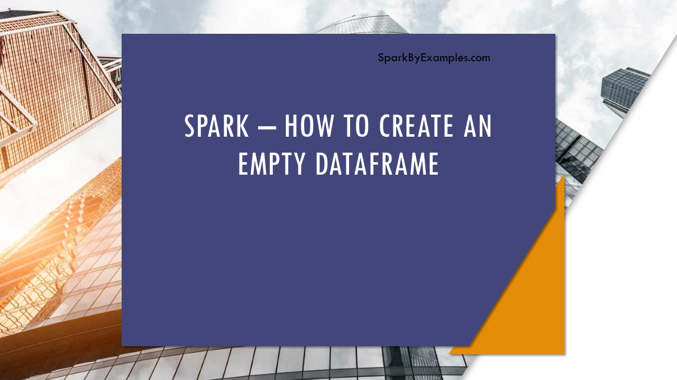
In this article, I will explain how to create an empty PySpark DataFrame/RDD manually with or without schema (column names) in different ways. Below I have explained one of the many scenarios where we need to create an empty DataFrame.
Advertisements
While working with files, sometimes we may not receive a file for processing, however, we still need to create a DataFrame manually with the same schema we expect. If we don’t create with the same schema, our operations/transformations (like union’s) on DataFrame fail as we refer to the columns that may not present.
To handle situations similar to these, we always need to create a DataFrame with the same schema, which means the same column names and datatypes regardless of the file exists or empty file processing.

1. Create Empty RDD in PySpark
Create an empty RDD by using emptyRDD() of SparkContext for example spark.sparkContext.emptyRDD().

from pyspark.sql import SparkSession
spark = SparkSession.builder.appName('SparkByExamples.com').getOrCreate()

#Creates Empty RDD
emptyRDD = spark.sparkContext.emptyRDD()
print(emptyRDD)

#Diplays
#EmptyRDD[188] at emptyRDD
Alternatively you can also get empty RDD by using spark.sparkContext.parallelize([]).

#Creates Empty RDD using parallelize
rdd2= spark.sparkContext.parallelize([])
print(rdd2)

#EmptyRDD[205] at emptyRDD at NativeMethodAccessorImpl.java:0
#ParallelCollectionRDD[206] at readRDDFromFile at PythonRDD.scala:262
Note: If you try to perform operations on empty RDD you going to get ValueError("RDD is empty").

2. Create Empty DataFrame with Schema (StructType)
In order to create an empty PySpark DataFrame manually with schema ( column names & data types) first, Create a schema using StructType and StructField .

#Create Schema
from pyspark.sql.types import StructType,StructField, StringType
schema = StructType([
StructField('firstname', StringType(), True),
StructField('middlename', StringType(), True),
StructField('lastname', StringType(), True)
])
Now use the empty RDD created above and pass it to createDataFrame() of SparkSession along with the schema for column names & data types.

#Create empty DataFrame from empty RDD
df = spark.createDataFrame(emptyRDD,schema)
df.printSchema()
This yields below schema of the empty DataFrame.

root
|-- firstname: string (nullable = true)
|-- middlename: string (nullable = true)
|-- lastname: string (nullable = true)

3. Convert Empty RDD to DataFrame
You can also create empty DataFrame by converting empty RDD to DataFrame using toDF().

#Convert empty RDD to Dataframe
df1 = emptyRDD.toDF(schema)
df1.printSchema()

4. Create Empty DataFrame with Schema.
So far I have covered creating an empty DataFrame from RDD, but here will create it manually with schema and without RDD.

#Create empty DataFrame directly.
df2 = spark.createDataFrame([], schema)
df2.printSchema()

5. Create Empty DataFrame without Schema (no columns)
To create empty DataFrame with out schema (no columns) just create a empty schema and use it while creating PySpark DataFrame.

#Create empty DatFrame with no schema (no columns)
df3 = spark.createDataFrame([], StructType([]))
df3.printSchema()

#print below empty schema
#root
Happy Learning !!

Related Articles
- PySpark Replace Empty Value With None/null on DataFrame
- Create a PySpark DataFrame from Multiple Lists.
- PySpark Create RDD with Examples
- PySpark SparkContext Explained
- PySpark Replace Column Values in DataFrame
- PySpark Retrieve DataType & Column Names of DataFrame
- PySpark Count of Non null, nan Values in DataFrame
- PySpark RDD Actions with examples

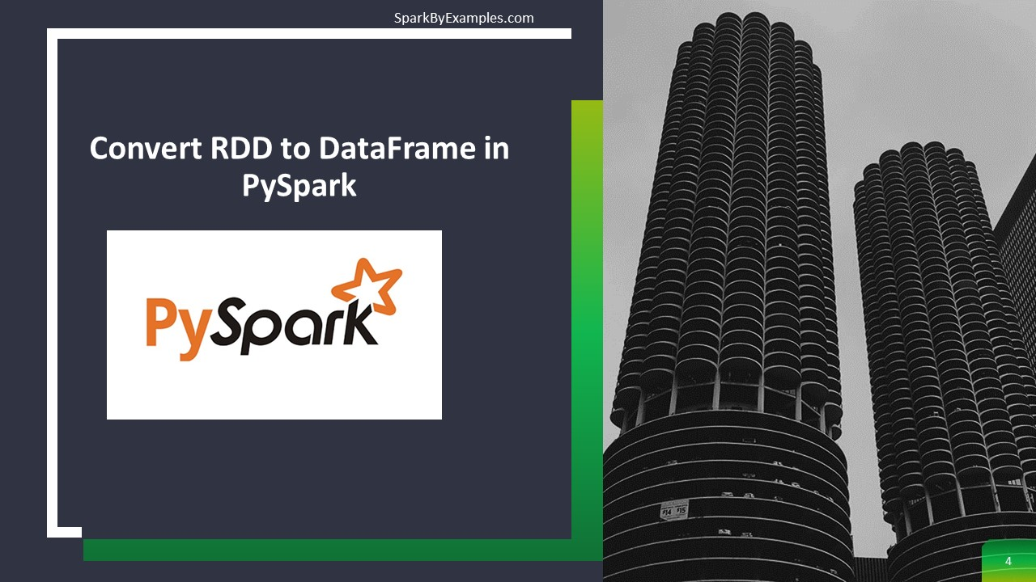
In PySpark, toDF() function of the RDD is used to convert RDD to DataFrame. We would need to convert RDD to DataFrame as DataFrame provides more advantages over RDD. For instance, DataFrame is a distributed collection of data organized into named columns similar to Database tables and provides optimization and performance improvements.
Advertisements
- Create PySpark RDD
- Convert PySpark RDD to DataFrame
  - using toDF()
  - using createDataFrame()
  - using RDD row type & schema

1. Create PySpark RDD
First, let’s create an RDD by passing Python list object to sparkContext.parallelize() function. We would need this rdd object for all our examples below.
In PySpark, when you have data in a list meaning you have a collection of data in a PySpark driver memory when you create an RDD, this collection is going to be parallelized.

from pyspark.sql import SparkSession
spark = SparkSession.builder.appName('SparkByExamples.com').getOrCreate()
dept = [("Finance",10),("Marketing",20),("Sales",30),("IT",40)]
rdd = spark.sparkContext.parallelize(dept)

2. Convert PySpark RDD to DataFrame
Converting PySpark RDD to DataFrame can be done using toDF(), createDataFrame(). In this section, I will explain these two methods.

2.1 Using rdd.toDF() function
PySpark provides toDF() function in RDD which can be used to convert RDD into Dataframe

df = rdd.toDF()
df.printSchema()
df.show(truncate=False)
By default, toDF() function creates column names as “_1” and “_2”. This snippet yields below schema.

root
|-- _1: string (nullable = true)
|-- _2: long (nullable = true)

+---------+---+
|_1 |_2 |
+---------+---+
|Finance |10 |
|Marketing|20 |
|Sales |30 |
|IT |40 |
+---------+---+

toDF() has another signature that takes arguments to define column names as shown below.

deptColumns = ["dept_name","dept_id"]
df2 = rdd.toDF(deptColumns)
df2.printSchema()
df2.show(truncate=False)
Outputs below schema.

root
|-- dept_name: string (nullable = true)
|-- dept_id: long (nullable = true)

+---------+-------+
|dept_name|dept_id|
+---------+-------+
|Finance |10 |
|Marketing|20 |
|Sales |30 |
|IT |40 |
+---------+-------+

2.2 Using PySpark createDataFrame() function
SparkSession class provides createDataFrame() method to create DataFrame and it takes rdd object as an argument.

deptDF = spark.createDataFrame(rdd, schema = deptColumns)
deptDF.printSchema()
deptDF.show(truncate=False)
This yields the same output as above.

2.3 Using createDataFrame() with StructType schema
When you infer the schema, by default the datatype of the columns is derived from the data and set’s nullable to true for all columns. We can change this behavior by supplying schema using StructType – where we can specify a column name, data type and nullable for each field/column.
If you wanted to know more about StructType, please go through how to use StructType and StructField to define the custom schema.

from pyspark.sql.types import StructType,StructField, StringType
deptSchema = StructType([
StructField('dept_name', StringType(), True),
StructField('dept_id', StringType(), True)
])

deptDF1 = spark.createDataFrame(rdd, schema = deptSchema)
deptDF1.printSchema()
deptDF1.show(truncate=False)
This also yields the same output.

3. Complete Example

import pyspark
from pyspark.sql import SparkSession

spark = SparkSession.builder.appName('SparkByExamples.com').getOrCreate()

dept = [("Finance",10),("Marketing",20),("Sales",30),("IT",40)]
rdd = spark.sparkContext.parallelize(dept)

df = rdd.toDF()
df.printSchema()
df.show(truncate=False)

deptColumns = ["dept_name","dept_id"]
df2 = rdd.toDF(deptColumns)
df2.printSchema()
df2.show(truncate=False)

deptDF = spark.createDataFrame(rdd, schema = deptColumns)
deptDF.printSchema()
deptDF.show(truncate=False)

from pyspark.sql.types import StructType,StructField, StringType
deptSchema = StructType([
StructField('dept_name', StringType(), True),
StructField('dept_id', StringType(), True)
])

deptDF1 = spark.createDataFrame(rdd, schema = deptSchema)
deptDF1.printSchema()
deptDF1.show(truncate=False)
The complete code can be downloaded from GitHub

4. Conclusion:
In this article, you have learned how to convert PySpark RDD to DataFrame, we would need these frequently while working in PySpark as these provides optimization and performance over RDD.
Happy Learning !!

Related Articles
- PySpark – Create DataFrame with Examples
- PySpark Convert DataFrame to RDD
- PySpark Create RDD with Examples
- PySpark RDD Actions with examples
- PySpark Row using on DataFrame and RDD
- PySpark – Create an Empty DataFrame & RDD
- PySpark parallelize() – Create RDD from a list data
- PySpark Replace Column Values in DataFrame
- PySpark RDD Actions with examples
- Tags: dataframe, dataset, RDD, spark.createDataFrame, toDF()


(Spark with Python) PySpark DataFrame can be converted to Python pandas DataFrame using a function toPandas(), In this article, I will explain how to create Pandas DataFrame from PySpark (Spark) DataFrame with examples.
Advertisements
Before we start first understand the main differences between the Pandas & PySpark, operations on Pyspark run faster than Pandas due to its distributed nature and parallel execution on multiple cores and machines.
In other words, pandas run operations on a single node whereas PySpark runs on multiple machines. If you are working on a Machine Learning application where you are dealing with larger datasets, PySpark processes operations many times faster than pandas. Refer to pandas DataFrame Tutorial beginners guide with examples
After processing data in PySpark we would need to convert it back to Pandas DataFrame for a further procession with Machine Learning application or any Python applications.

Key Points –
- Use the toPandas() method available in PySpark DataFrame objects to convert them to DataFrames.
- Pandas DataFrames are in-memory data structures, so consider memory constraints when converting large PySpark DataFrames.
- Converting PySpark DataFrames to Pandas DataFrames allows you to leverage Pandas’ extensive functionality for data manipulation and analysis.

Prepare PySpark DataFrame
In order to explain with an example first let’s create a PySpark DataFrame.

import pyspark
from pyspark.sql import SparkSession

spark = SparkSession.builder.appName('SparkByExamples.com').getOrCreate()

data = [("James","","Smith","36636","M",60000),
("Michael","Rose","","40288","M",70000),
("Robert","","Williams","42114","",400000),
("Maria","Anne","Jones","39192","F",500000),
("Jen","Mary","Brown","","F",0)]

columns = ["first_name","middle_name","last_name","dob","gender","salary"]
pysparkDF = spark.createDataFrame(data = data, schema = columns)
pysparkDF.printSchema()
pysparkDF.show(truncate=False)
This yields below schema and result of the DataFrame.

root
|-- first_name: string (nullable = true)
|-- middle_name: string (nullable = true)
|-- last_name: string (nullable = true)
|-- dob: string (nullable = true)
|-- gender: string (nullable = true)
|-- salary: long (nullable = true)

+----------+-----------+---------+-----+------+------+
|first_name|middle_name|last_name|dob |gender|salary|
+----------+-----------+---------+-----+------+------+
|James | |Smith |36636|M |60000 |
|Michael |Rose | |40288|M |70000 |
|Robert | |Williams |42114| |400000|
|Maria |Anne |Jones |39192|F |500000|
|Jen |Mary |Brown | |F |0 |
+----------+-----------+---------+-----+------+------+

Convert PySpark Dataframe to Pandas DataFrame
PySpark DataFrame provides a method toPandas() to convert it to Python Pandas DataFrame.
toPandas() results in the collection of all records in the PySpark DataFrame to the driver program and should be done only on a small subset of the data. running on larger dataset’s results in memory error and crashes the application. To deal with a larger dataset, you can also try increasing memory on the driver.

pandasDF = pysparkDF.toPandas()
print(pandasDF)
This yields the below panda’s DataFrame. Note that pandas add a sequence number to the result as a row Index. You can rename pandas columns by using rename() function.

first_name middle_name last_name dob gender salary
0 James Smith 36636 M 60000
1 Michael Rose 40288 M 70000
2 Robert Williams 42114 400000
3 Maria Anne Jones 39192 F 500000
4 Jen Mary Brown F 0
I have dedicated Python pandas Tutorial with Examples where I explained pandas concepts in detail.

Convert Spark Nested Struct DataFrame to Pandas
Most of the time data in PySpark DataFrame will be in a structured format meaning one column contains other columns so let’s see how it convert to Pandas. Here is an example with nested struct where we have firstname, middlename and lastname are part of the name column.

# Nested structure elements
from pyspark.sql.types import StructType, StructField, StringType,IntegerType
dataStruct = [(("James","","Smith"),"36636","M","3000"), \
(("Michael","Rose",""),"40288","M","4000"), \
(("Robert","","Williams"),"42114","M","4000"), \
(("Maria","Anne","Jones"),"39192","F","4000"), \
(("Jen","Mary","Brown"),"","F","-1") \
]

schemaStruct = StructType([
StructField('name', StructType([
StructField('firstname', StringType(), True),
StructField('middlename', StringType(), True),
StructField('lastname', StringType(), True)
])),
StructField('dob', StringType(), True),
StructField('gender', StringType(), True),
StructField('salary', StringType(), True)
])
df = spark.createDataFrame(data=dataStruct, schema = schemaStruct)
df.printSchema()

pandasDF2 = df.toPandas()
print(pandasDF2)
Converting structured DataFrame to Pandas DataFrame results below output.

name dob gender salary
0 (James, , Smith) 36636 M 3000
1 (Michael, Rose, ) 40288 M 4000
2 (Robert, , Williams) 42114 M 4000
3 (Maria, Anne, Jones) 39192 F 4000
4 (Jen, Mary, Brown) F -1

FAQ on Convert PySpark DataFrame to Pandas
Why would I want to convert a PySpark DataFrame to a pandas DataFrame?
Converting PySpark DataFrames to Pandas allows you to leverage the extensive functionality and ease of use offered by the Pandas library for data manipulation, analysis, and visualization.
Are there any limitations or considerations when converting PySpark DataFrames to Pandas?
It’s essential to consider memory constraints, especially when dealing with large datasets. Converting large PySpark DataFrames to DataFrames may lead to out-of-memory errors if the data cannot fit into memory.
Can I convert any PySpark DataFrame to a Pandas DataFrame?
You can convert any PySpark DataFrame to a DataFrame using the toPandas() method. However, keep in mind the potential performance implications and ensure compatibility between PySpark and Pandas data types and structures.
How can I optimize the conversion process from PySpark to Pandas for better performance?
Optimizations can include selecting relevant columns before conversion, filtering out unnecessary data, and using appropriate data types to minimize memory usage. Additionally, consider using partitioning and caching in PySpark to optimize performance before converting to Pandas.

Conclusion
In this simple article, you have learned to convert Spark DataFrame to pandas using toPandas() function of the Spark DataFrame. Also have seen a similar example with complex nested structure elements. toPandas() results in the collection of all records in the DataFrame to the driver program and should be done on a small subset of the data.
Happy Learning !!

Related Articles
- PySpark Get Number of Rows and Columns
- Dynamic way of doing ETL through Pyspark
- What is PySpark DataFrame?
- Pandas vs PySpark DataFrame With Examples
- How to Pandas to PySpark DataFrame
- How to Convert Pandas DataFrame to List?
- Pandas Add Column based on Another Column
- pandas rolling() Mean, Average, Sum Examples
- Set Order of Columns in Pandas DataFrame
- Pandas Create New DataFrame By Selecting Specific Columns

References
- https://spark.apache.org/docs/latest/api/python/reference/pyspark.pandas/api/pyspark.pandas.DataFrame.spark.frame.html


PySpark DataFrame show() is used to display the contents of the DataFrame in a Table Row and Column Format. By default, it shows only 20 Rows, and the column values are truncated at 20 characters.
Advertisements

1. Quick Example of show()
Following are quick examples of how to show the contents of DataFrame.

# Default - displays 20 rows and
# 20 charactes from column value
df.show()

#Display full column contents
df.show(truncate=False)

# Display 2 rows and full column contents
df.show(2,truncate=False)

# Display 2 rows & column values 25 characters
df.show(2,truncate=25)

# Display DataFrame rows & columns vertically
df.show(n=3,truncate=25,vertical=True)

2. show() Syntax
Following is the syntax of the show() function.

# Syntax
def show(self, n=20, truncate=True, vertical=False):

3. PySpark show() To Display Contents
Use PySpark show() method to display the contents of the DataFrame and use pyspark printSchema() method to print the schema. show() method by default shows only 20 rows/records from the DataFrame and truncates the column values at 20 characters.

from pyspark.sql import SparkSession
spark = SparkSession.builder.appName('SparkByExamples.com').getOrCreate()
columns = ["Seqno","Quote"]
data = [("1", "Be the change that you wish to see in the world"),
("2", "Everyone thinks of changing the world, but no one thinks of changing himself."),
("3", "The purpose of our lives is to be happy."),
("4", "Be cool.")]
df = spark.createDataFrame(data,columns)
df.show()

# Output
#+-----+--------------------+
#|Seqno| Quote|
#+-----+--------------------+
#| 1|Be the change tha...|
#| 2|Everyone thinks o...|
#| 3|The purpose of ou...|
#| 4| Be cool.|
#+-----+--------------------+
As you see above, values in the Quote column are truncated at 20 characters, Let’s see how to display the full column contents.

#Display full column contents
df.show(truncate=False)

#+-----+-----------------------------------------------------------------------------+
#|Seqno|Quote |
#+-----+-----------------------------------------------------------------------------+
#|1 |Be the change that you wish to see in the world |
#|2 |Everyone thinks of changing the world, but no one thinks of changing himself.|
#|3 |The purpose of our lives is to be happy. |
#|4 |Be cool. |
#+-----+-----------------------------------------------------------------------------+
By default show() method displays only 20 rows from PySpark DataFrame. The below example limits the rows to 2 and full column contents. Our DataFrame has just 4 rows hence I can’t demonstrate with more than 4 rows. If you have a DataFrame with thousands of rows try changing the value from 2 to 100 to display more than 20 rows.

# Display 2 rows and full column contents
df.show(2,truncate=False)

#+-----+-----------------------------------------------------------------------------+
#|Seqno|Quote |
#+-----+-----------------------------------------------------------------------------+
#|1 |Be the change that you wish to see in the world |
#|2 |Everyone thinks of changing the world, but no one thinks of changing himself.|
#+-----+-----------------------------------------------------------------------------+

4. Show() with Truncate Column Values
You can also truncate the column value at the desired length. By default it truncates after 20 characters however, you can display all contents by using truncate=False. If you wanted to truncate at a specific length use truncate=n.

# Display 2 rows & column values 25 characters
df.show(2,truncate=25)

#+-----+-------------------------+
#|Seqno| Quote|
#+-----+-------------------------+
#| 1|Be the change that you...|
#| 2|Everyone thinks of cha...|
#+-----+-------------------------+
#only showing top 2 rows

5. Display Contents Vertically
Finally, let’s see how to display the DataFrame vertically record by record.

# Display DataFrame rows & columns vertically
df.show(n=3,truncate=25,vertical=True)

#-RECORD 0--------------------------
# Seqno | 1
# Quote | Be the change that you...
#-RECORD 1--------------------------
# Seqno | 2
# Quote | Everyone thinks of cha...
#-RECORD 2--------------------------
# Seqno | 3
# Quote | The purpose of our liv...
Happy Learning !!
6. Conclusion
In this article, you have learned how to show the PySpark DataFrame contents to the console and learned to use the parameters to limit the rows and truncate or display the contents of columns.

Related Articles
- PySpark Select First Row of Each Group?
- PySpark Select Nested struct Columns
- PySpark Select Columns From DataFrame
- Dynamic way of doing ETL through Pyspark
- Pyspark Select Distinct Rows
- PySpark Get Number of Rows and Columns
- PySpark count() – Different Methods Explained
- PySpark SQL Self Join With Example


The StructType and StructField classes in PySpark are used to specify the custom schema to the DataFrame and create complex columns like nested struct, array, and map columns. StructType is a collection of StructField objects that define column name, column data type, boolean to specify if the field can be nullable or not, and metadata.
Advertisements
In this article, I will explain different ways to define the structure of DataFrame using StructType with PySpark examples.
Key Points:
- StructType is a collection or list of StructField objects.
- Defining DataFrame Schemas: StructType is commonly used to define the schema when creating a DataFrame, particularly for structured data with fields of different data types.
- Nested Structures: You can create complex schemas with nested structures by nesting StructType within other StructType objects, allowing you to represent hierarchical or multi-level data.
- Enforcing Data Structure: When reading data from various sources, specifying a StructType as the schema ensures that the data is correctly interpreted and structured. This is important when dealing with semi-structured or schema-less data sources.
Related Articles:

- Using PySpark StructType & StructField with DataFrame
- Defining Nested StructType or struct
- Adding & Changing columns of the DataFrame
- Using SQL ArrayType and MapType
- Creating StructType or struct from Json file
- Creating StructType object from DDL string
- Check if a field exists in a StructType

1. StructType – Defines the structure of the DataFrame
PySpark provides StructType class from pyspark.sql.types to define the structure of the DataFrame.
StructType represents a schema, which is a collection of StructField objects. A StructType is essentially a list of fields, each with a name and data type, defining the structure of the DataFrame. It allows for the creation of nested structures and complex data types.
PySpark printSchema() method on the DataFrame shows StructType columns as struct.

2. StructField – Defines the metadata of the DataFrame column
It represents a field in the schema, containing metadata such as the name, data type, and nullable status of the field. Each StructField object defines a single column in the DataFrame, specifying its name and the type of data it holds.
The StructField class is also part of pyspark.sql.types

3. Using PySpark StructType & StructField with DataFrame
Regardless of how you create a DataFrame, you have the option to specify the custom schema using the StructType and StructField classes. As highlighted earlier, StructType is a collection of StructFields; with StuctType you have an option to specify the column names, data types, and whether they’re nullable.
With StructField, you can even incorporate nested struct schemas, ArrayType for arrays, and MapType for key-value pairs.
The following example demonstrates a basic example for creating a StructType and StructField for a DataFrame, along with sample data.

# Imports
import pyspark
from pyspark.sql import SparkSession
from pyspark.sql.types import StructType,StructField, StringType, IntegerType

spark = SparkSession.builder.master("local[1]") \
.appName('SparkByExamples.com') \
.getOrCreate()

data = [("James","","Smith","36636","M",3000),
("Michael","Rose","","40288","M",4000),
("Robert","","Williams","42114","M",4000),
("Maria","Anne","Jones","39192","F",4000),
("Jen","Mary","Brown","","F",-1)
]

schema = StructType([ \
StructField("firstname",StringType(),True), \
StructField("middlename",StringType(),True), \
StructField("lastname",StringType(),True), \
StructField("id", StringType(), True), \
StructField("gender", StringType(), True), \
StructField("salary", IntegerType(), True) \
])

df = spark.createDataFrame(data=data,schema=schema)
df.printSchema()
df.show(truncate=False)
By running the above snippet, it displays the outputs below.

# Output
root
|-- firstname: string (nullable = true)
|-- middlename: string (nullable = true)
|-- lastname: string (nullable = true)
|-- id: string (nullable = true)
|-- gender: string (nullable = true)
|-- salary: integer (nullable = true)

+---------+----------+--------+-----+------+------+
|firstname|middlename|lastname|id |gender|salary|
+---------+----------+--------+-----+------+------+
|James | |Smith |36636|M |3000 |
|Michael |Rose | |40288|M |4000 |
|Robert | |Williams|42114|M |4000 |
|Maria |Anne |Jones |39192|F |4000 |
|Jen |Mary |Brown | |F |-1 |
+---------+----------+--------+-----+------+------+

4. Defining Nested StructType object struct
To define a nested StructType in PySpark, use inner StructTypes within StructFields. Each nested StructType is a collection of StructFields, forming a hierarchical structure for representing complex data within DataFrames.
In the example below, the “name” column is of data type StructType, indicating a nested structure. This means that the “name” column itself is composed of multiple subfields or attributes, forming a hierarchical structure within the DataFrame.

# Defining schema using nested StructType
structureData = [
(("James","","Smith"),"36636","M",3100),
(("Michael","Rose",""),"40288","M",4300),
(("Robert","","Williams"),"42114","M",1400),
(("Maria","Anne","Jones"),"39192","F",5500),
(("Jen","Mary","Brown"),"","F",-1)
]
structureSchema = StructType([
StructField('name', StructType([
StructField('firstname', StringType(), True),
StructField('middlename', StringType(), True),
StructField('lastname', StringType(), True)
])),
StructField('id', StringType(), True),
StructField('gender', StringType(), True),
StructField('salary', IntegerType(), True)
])

df2 = spark.createDataFrame(data=structureData,schema=structureSchema)
df2.printSchema()
df2.show(truncate=False)
This yields the below schema and the DataFrame

# Output
root
|-- name: struct (nullable = true)
| |-- firstname: string (nullable = true)
| |-- middlename: string (nullable = true)
| |-- lastname: string (nullable = true)
|-- id: string (nullable = true)
|-- gender: string (nullable = true)
|-- salary: integer (nullable = true)

+--------------------+-----+------+------+
|name |id |gender|salary|
+--------------------+-----+------+------+
|[James, , Smith] |36636|M |3100 |
|[Michael, Rose, ] |40288|M |4300 |
|[Robert, , Williams]|42114|M |1400 |
|[Maria, Anne, Jones]|39192|F |5500 |
|[Jen, Mary, Brown] | |F |-1 |
+--------------------+-----+------+------+

5. Adding & Changing struct of the DataFrame
Using PySpark SQL function struct(), we can change the struct of the existing DataFrame and add a new StructType to it. The below example demonstrates how to copy the columns from one structure to another and adding a new column. PySpark Column Class also provides some functions to work with the StructType column.

# Updating existing structtype using struct
from pyspark.sql.functions import col,struct,when
updatedDF = df2.withColumn("OtherInfo",
struct(col("id").alias("identifier"),
col("gender").alias("gender"),
col("salary").alias("salary"),
when(col("salary").cast(IntegerType()) < 2000,"Low")
.when(col("salary").cast(IntegerType()) < 4000,"Medium")
.otherwise("High").alias("Salary_Grade")
)).drop("id","gender","salary")

updatedDF.printSchema()
updatedDF.show(truncate=False)
Here, it copies “gender“, “salary” and “id” to the new struct “otherInfo” and add’s a new column “Salary_Grade“.

# Output
root
|-- name: struct (nullable = true)
| |-- firstname: string (nullable = true)
| |-- middlename: string (nullable = true)
| |-- lastname: string (nullable = true)
|-- OtherInfo: struct (nullable = false)
| |-- identifier: string (nullable = true)
| |-- gender: string (nullable = true)
| |-- salary: integer (nullable = true)
| |-- Salary_Grade: string (nullable = false)

6. Using SQL ArrayType and MapType
SQL StructType also supports ArrayType and MapType to define the DataFrame columns for array and map collections, respectively. In the below example, column hobbies defined as ArrayType(StringType) and properties defined as MapType(StringType,StringType) meaning both key and value as String.

# Using SQL ArrayType and MapType
arrayStructureSchema = StructType([
StructField('name', StructType([
StructField('firstname', StringType(), True),
StructField('middlename', StringType(), True),
StructField('lastname', StringType(), True)
])),
StructField('hobbies', ArrayType(StringType()), True),
StructField('properties', MapType(StringType(),StringType()), True)
])
Outputs the below schema. Note that field Hobbies is array type and properties is map type.

# Output
root
|-- name: struct (nullable = true)
| |-- firstname: string (nullable = true)
| |-- middlename: string (nullable = true)
| |-- lastname: string (nullable = true)
|-- hobbies: array (nullable = true)
| |-- element: string (containsNull = true)
|-- properties: map (nullable = true)
| |-- key: string
| |-- value: string (valueContainsNull = true)

7. Creating StructType object struct from JSON file
Alternatively, you can load the SQL StructType schema from JSON file. To make it simple, I will get the current DataFrmae schems using df2.schema.json(), store this in a file, and use it to create a schema from this JSON file.

# Using json() to load StructType
print(df2.schema.json())
Yields below output.

{
"type" : "struct",
"fields" : [ {
"name" : "name",
"type" : {
"type" : "struct",
"fields" : [ {
"name" : "firstname",
"type" : "string",
"nullable" : true,
"metadata" : { }
}, {
"name" : "middlename",
"type" : "string",
"nullable" : true,
"metadata" : { }
}, {
"name" : "lastname",
"type" : "string",
"nullable" : true,
"metadata" : { }
} ]
},
"nullable" : true,
"metadata" : { }
}, {
"name" : "dob",
"type" : "string",
"nullable" : true,
"metadata" : { }
}, {
"name" : "gender",
"type" : "string",
"nullable" : true,
"metadata" : { }
}, {
"name" : "salary",
"type" : "integer",
"nullable" : true,
"metadata" : { }
} ]
}
Alternatively, you could also use df.schema.simpleString(), this will return a relatively simpler schema format.
Now, let’s load the JSON file and use it to create a DataFrame.

# Loading json schema to create DataFrame
import json
schemaFromJson = StructType.fromJson(json.loads(schema.json))
df3 = spark.createDataFrame(
spark.sparkContext.parallelize(structureData),schemaFromJson)
df3.printSchema()

8. Creating StructType object struct from DDL String
To create a StructType object, ‘struct’, from a Data Definition Language (DDL) string in PySpark, use ‘StructType.fromDDL()’. This method parses the DDL string and generates a StructType object that reflects the schema defined in the string.
For example, ‘struct = StructType.fromDDL(“name STRING, age INT”)’ creates a StructType with two fields: ‘name’ of type ‘STRING’ and ‘age’ of type ‘INT’. This allows for dynamic schema creation based on DDL specifications, facilitating seamless integration with external systems or data sources where schema information is defined using DDL.

# Create StructType from DDL String
ddlSchemaStr = "`fullName` STRUCT<`first`: STRING, `last`: STRING,
`middle`: STRING>,`age` INT,`gender` STRING"
ddlSchema = StructType.fromDDL(ddlSchemaStr)
ddlSchema.printTreeString()

9. Check DataFrame Column Exists
To check if a column exists in a PySpark DataFrame, use the ‘contains()’ method on the DataFrame’s ‘columns’ attribute. For example, ‘if “column_name” in df.columns’ checks if the column exists in DataFrame ‘df’. Alternatively, you can use ‘selectExpr()’ with the column name and ‘alias()’ to create a new column with a different name, then check if the new column exists.

# Check if a column exists
if "firstname" in df.columns:
print("Column 'firstname' exists in the DataFrame.")
else:
print("Column 'firstname' does not exist in the DataFrame.")
Alternatively, you can also use.

# Checking Column exists using contains()
print(df.schema.fieldNames.contains("firstname"))
print(df.schema.contains(StructField("firstname",StringType,true)))
This example returns “true” for both scenarios.

10. Complete Example of PySpark StructType & StructField

import pyspark
from pyspark.sql import SparkSession
from pyspark.sql.types import StructType,StructField, StringType, IntegerType,ArrayType,MapType
from pyspark.sql.functions import col,struct,when

spark = SparkSession.builder.master("local[1]") \
.appName('SparkByExamples.com') \
.getOrCreate()

data = [("James","","Smith","36636","M",3000),
("Michael","Rose","","40288","M",4000),
("Robert","","Williams","42114","M",4000),
("Maria","Anne","Jones","39192","F",4000),
("Jen","Mary","Brown","","F",-1)
]

schema = StructType([
StructField("firstname",StringType(),True),
StructField("middlename",StringType(),True),
StructField("lastname",StringType(),True),
StructField("id", StringType(), True),
StructField("gender", StringType(), True),
StructField("salary", IntegerType(), True)
])

df = spark.createDataFrame(data=data,schema=schema)
df.printSchema()
df.show(truncate=False)

structureData = [
(("James","","Smith"),"36636","M",3100),
(("Michael","Rose",""),"40288","M",4300),
(("Robert","","Williams"),"42114","M",1400),
(("Maria","Anne","Jones"),"39192","F",5500),
(("Jen","Mary","Brown"),"","F",-1)
]
structureSchema = StructType([
StructField('name', StructType([
StructField('firstname', StringType(), True),
StructField('middlename', StringType(), True),
StructField('lastname', StringType(), True)
])),
StructField('id', StringType(), True),
StructField('gender', StringType(), True),
StructField('salary', IntegerType(), True)
])

df2 = spark.createDataFrame(data=structureData,schema=structureSchema)
df2.printSchema()
df2.show(truncate=False)

updatedDF = df2.withColumn("OtherInfo",
struct(col("id").alias("identifier"),
col("gender").alias("gender"),
col("salary").alias("salary"),
when(col("salary").cast(IntegerType()) < 2000,"Low")
.when(col("salary").cast(IntegerType()) < 4000,"Medium")
.otherwise("High").alias("Salary_Grade")
)).drop("id","gender","salary")

updatedDF.printSchema()
updatedDF.show(truncate=False)

""" Array & Map"""

arrayStructureSchema = StructType([
StructField('name', StructType([
StructField('firstname', StringType(), True),
StructField('middlename', StringType(), True),
StructField('lastname', StringType(), True)
])),
StructField('hobbies', ArrayType(StringType()), True),
StructField('properties', MapType(StringType(),StringType()), True)
])
Find a complete example at the GitHub project.

Conclusion:
In conclusion, PySpark’s StructType and StructField classes offer powerful tools for defining and managing DataFrame schemas. StructType provides a structured approach to organizing data, enabling precise specification of column names, data types, and nullability. Meanwhile, StructField allows for fine-grained control over individual fields within the schema, including nested structures and complex data types.
By leveraging PySpark’s StructType and StructField, users can effectively structure and manipulate data within DataFrames, ensuring consistency and enabling seamless integration with diverse data processing workflows.
Happy Learning !!

Related Articles
- PySpark Select Nested struct Columns
- PySpark Convert StructType (struct) to Dictionary/MapType (map)
- PySpark alias() Column & DataFrame Examples
- PySpark SparkContext Explained
- PySpark Check Column Exists in DataFrame
- PySpark Parse JSON from String Column | TEXT File
- PySpark MapType (Dict) Usage with Examples
- PySpark Convert DataFrame Columns to MapType (Dict)
- PySpark Create DataFrame From Dictionary (Dict)
Tags: DataType, MapType, pyspark schema, schema, StructField, StructType

- Naveen Nelamali
- Post category:PySpark
- Post last modified:March 27, 2024
- Reading time:17 mins read

pyspark.sql.Column class provides several functions to work with DataFrame to manipulate the Column values, evaluate the boolean expression to filter rows, retrieve a value or part of a value from a DataFrame column, and to work with list, map & struct columns.
Advertisements
In this article, I will cover how to create Column object, access them to perform operations, and finally most used PySpark Column Functions with Examples.
Related Article: PySpark Row Class with Examples
Key Points:

- PySpark Column class represents a single Column in a DataFrame.
- It provides functions that are most used to manipulate DataFrame Columns & Rows.
- Some of these Column functions evaluate a Boolean expression that can be used with filter() transformation to filter the DataFrame Rows.
- Provides functions to get a value from a list column by index, map value by key & index, and finally struct nested column.
- PySpark also provides additional functions pyspark.sql.functions that take Column object and return a Column type.

Note: Most of the pyspark.sql.functions return Column type hence it is very important to know the operation you can perform with Column type.

1. Create Column Class Object
One of the simplest ways to create a Column class object is by using PySpark lit() SQL function, this takes a literal value and returns a Column object.

from pyspark.sql.functions import lit
colObj = lit("sparkbyexamples.com")
You can also access the Column from DataFrame by multiple ways.

data=[("James",23),("Ann",40)]
df=spark.createDataFrame(data).toDF("name.fname","gender")
df.printSchema()
#root
# |-- name.fname: string (nullable = true)
# |-- gender: long (nullable = true)

# Using DataFrame object (df)
df.select(df.gender).show()
df.select(df["gender"]).show()
#Accessing column name with dot (with backticks)
df.select(df["`name.fname`"]).show()

#Using SQL col() function
from pyspark.sql.functions import col
df.select(col("gender")).show()
#Accessing column name with dot (with backticks)
df.select(col("`name.fname`")).show()
Below example demonstrates accessing struct type columns. Here I have use PySpark Row class to create a struct type. Alternatively you can also create it by using PySpark StructType & StructField classes

#Create DataFrame with struct using Row class
from pyspark.sql import Row
data=[Row(name="James",prop=Row(hair="black",eye="blue")),
Row(name="Ann",prop=Row(hair="grey",eye="black"))]
df=spark.createDataFrame(data)
df.printSchema()
#root
# |-- name: string (nullable = true)
# |-- prop: struct (nullable = true)
# | |-- hair: string (nullable = true)
# | |-- eye: string (nullable = true)

#Access struct column
df.select(df.prop.hair).show()
df.select(df["prop.hair"]).show()
df.select(col("prop.hair")).show()

#Access all columns from struct
df.select(col("prop.*")).show()

2. PySpark Column Operators
PySpark column also provides a way to do arithmetic operations on columns using operators.

data=[(100,2,1),(200,3,4),(300,4,4)]
df=spark.createDataFrame(data).toDF("col1","col2","col3")

#Arthmetic operations
df.select(df.col1 + df.col2).show()
df.select(df.col1 - df.col2).show()
df.select(df.col1 * df.col2).show()
df.select(df.col1 / df.col2).show()
df.select(df.col1 % df.col2).show()

df.select(df.col2 > df.col3).show()
df.select(df.col2 < df.col3).show()
df.select(df.col2 == df.col3).show()

3. PySpark Column Functions
Let’s see some of the most used Column Functions, on below table, I have grouped related functions together to make it easy, click on the link for examples.
Column Function | Function Description
alias(*alias, **kwargs)  name(*alias, **kwargs) | Provides alias to the column or expressions  name() returns same as alias().
asc()  asc_nulls_first()  asc_nulls_last() | Returns ascending order of the column.  asc_nulls_first() Returns null values first then non-null values.  asc_nulls_last() – Returns null values after non-null values.
astype(dataType)  cast(dataType) | Used to cast the data type to another type.  astype() returns same as cast().
between(lowerBound, upperBound) | Checks if the columns values are between lower and upper bound. Returns boolean value.
bitwiseAND(other)  bitwiseOR(other)  bitwiseXOR(other) | Compute bitwise AND, OR & XOR of this expression with another expression respectively.
contains(other) | Check if String contains in another string.
desc()  desc_nulls_first()  desc_nulls_last() | Returns descending order of the column.  desc_nulls_first() -null values appear before non-null values.  desc_nulls_last() – null values appear after non-null values.
startswith(other)  endswith(other) | String starts with. Returns boolean expression  String ends with. Returns boolean expression
eqNullSafe(other) | Equality test that is safe for null values.
getField(name) | Returns a field by name in a StructField and by key in Map.
getItem(key) | Returns a values from Map/Key at the provided position.
isNotNull()  isNull() | isNotNull() – Returns True if the current expression is NOT null.  isNull() – Returns True if the current expression is null.
isin(*cols) | A boolean expression that is evaluated to true if the value of this expression is contained by the evaluated values of the arguments.
like(other)  rlike(other) | Similar to SQL like expression.  Similar to SQL RLIKE expression (LIKE with Regex).
over(window) | Used with window column
substr(startPos, length) | Return a Column which is a substring of the column.
when(condition, value)  otherwise(value) | Similar to SQL CASE WHEN, Executes a list of conditions and returns one of multiple possible result expressions.
dropFields(*fieldNames) | Used to drops fields in StructType by name.
withField(fieldName, col) | An expression that adds/replaces a field in StructType by name.

4. PySpark Column Functions Examples
Let’s create a simple DataFrame to work with PySpark SQL Column examples. For most of the examples below, I will be referring DataFrame object name (df.) to get the column.

data=[("James","Bond","100",None),
("Ann","Varsa","200",'F'),
("Tom Cruise","XXX","400",''),
("Tom Brand",None,"400",'M')]
columns=["fname","lname","id","gender"]
df=spark.createDataFrame(data,columns)

4.1 alias() – Set’s name to Column
On below example df.fname refers to Column object and alias() is a function of the Column to give alternate name. Here, fname column has been changed to first_name & lname to last_name.
In the second example I have use PySpark expr() function to concatenate columns and named column as fullName.

#alias
from pyspark.sql.functions import expr
df.select(df.fname.alias("first_name"), \
df.lname.alias("last_name")
).show()

#Another example
df.select(expr(" fname ||','|| lname").alias("fullName") \
).show()

4.2 asc() & desc() – Sort the DataFrame columns by Ascending or Descending order.

#asc, desc to sort ascending and descending order repsectively.
df.sort(df.fname.asc()).show()
df.sort(df.fname.desc()).show()

4.3 cast() & astype() – Used to convert the data Type.

#cast
df.select(df.fname,df.id.cast("int")).printSchema()

4.4 between() – Returns a Boolean expression when a column values in between lower and upper bound.

#between
df.filter(df.id.between(100,300)).show()

4.5 contains() –
Check if a PySpark DataFrame column value contains a string value specified in this function.

#contains
df.filter(df.fname.contains("Cruise")).show()

4.6 startswith() & endswith() –
Checks if the value of the DataFrame Column startsWith() and endsWith() a String. startsWith() filters rows where a specified substring exists at the beginning while endsWith() filter rows where the specified substring presents at the end.

#startswith, endswith()
df.filter(df.fname.startswith("T")).show()
df.filter(df.fname.endswith("Cruise")).show()

4.7 eqNullSafe() –

4.8 isNull & isNotNull() – Checks if the DataFrame column has NULL or non NULL values.
Refer to

#isNull & isNotNull
df.filter(df.lname.isNull()).show()
df.filter(df.lname.isNotNull()).show()

4.9 like() & rlike() – Similar to SQL LIKE expression

#like , rlike
df.select(df.fname,df.lname,df.id) \
.filter(df.fname.like("%om"))

4.10 substr() – Returns a Column after getting sub string from the Column

df.select(df.fname.substr(1,2).alias("substr")).show()

4.11 when() & otherwise() – It is similar to SQL Case When, executes sequence of expressions until it matches the condition and returns a value when match.

#when & otherwise
from pyspark.sql.functions import when
df.select(df.fname,df.lname,when(df.gender=="M","Male") \
.when(df.gender=="F","Female") \
.when(df.gender==None ,"") \
.otherwise(df.gender).alias("new_gender") \
).show()

4.12 isin() – Check if value presents in a List.

#isin
li=["100","200"]
df.select(df.fname,df.lname,df.id) \
.filter(df.id.isin(li)) \
.show()

4.13 getField() – To get the value by key from MapType column and by stuct child name from StructType column
Rest of the below functions operates on List, Map & Struct data structures hence to demonstrate these I will use another DataFrame with list, map and struct columns. For more explanation how to use Arrays refer to PySpark ArrayType Column on DataFrame Examples & for map refer to PySpark MapType Examples

#Create DataFrame with struct, array & map
from pyspark.sql.types import StructType,StructField,StringType,ArrayType,MapType
data=[(("James","Bond"),["Java","C#"],{'hair':'black','eye':'brown'}),
(("Ann","Varsa"),[".NET","Python"],{'hair':'brown','eye':'black'}),
(("Tom Cruise",""),["Python","Scala"],{'hair':'red','eye':'grey'}),
(("Tom Brand",None),["Perl","Ruby"],{'hair':'black','eye':'blue'})]

schema = StructType([
StructField('name', StructType([
StructField('fname', StringType(), True),
StructField('lname', StringType(), True)])),
StructField('languages', ArrayType(StringType()),True),
StructField('properties', MapType(StringType(),StringType()),True)
])
df=spark.createDataFrame(data,schema)
df.printSchema()

#Display's to console
root
|-- name: struct (nullable = true)
| |-- fname: string (nullable = true)
| |-- lname: string (nullable = true)
|-- languages: array (nullable = true)
| |-- element: string (containsNull = true)
|-- properties: map (nullable = true)
| |-- key: string
| |-- value: string (valueContainsNull = true)
getField Example

#getField from MapType
df.select(df.properties.getField("hair")).show()

#getField from Struct
df.select(df.name.getField("fname")).show()

4.14 getItem() – To get the value by index from MapType or ArrayTupe & ny key for MapType column.

#getItem() used with ArrayType
df.select(df.languages.getItem(1)).show()

#getItem() used with MapType
df.select(df.properties.getItem("hair")).show()

4.15 dropFields –

# TO-DO, getting runtime error

4.16 withField() –

# TO-DO getting runtime error

4.17 over() – Used with Window Functions

TO-DO
Happy Learning !!

Related Article
- PySpark JSON Functions with Examples
- PySpark Where Filter Function | Multiple Conditions
- PySpark Groupby on Multiple Columns
- PySpark alias() Column & DataFrame Examples
- PySpark SparkContext Explained
- PySpark Check Column Exists in DataFrame
- PySpark Convert DataFrame Columns to MapType (Dict)

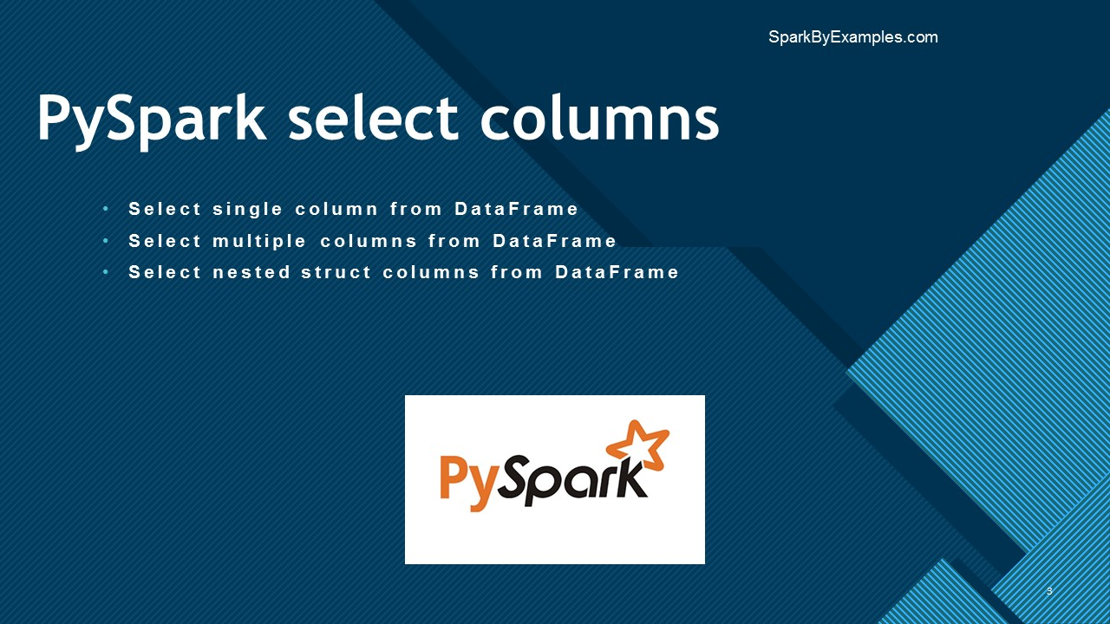
In PySpark, select() function is used to select single, multiple, column by index, all columns from the list and the nested columns from a DataFrame, PySpark select() is a transformation function hence it returns a new DataFrame with the selected columns.
Advertisements
- Select a Single & Multiple Columns from PySpark
- Select All Columns From List
- Select Columns By Index
- Select a Nested Column
- Other Ways to Select Columns
Create a Dataframe.

import pyspark
from pyspark.sql import SparkSession

spark = SparkSession.builder.appName('SparkByExamples.com').getOrCreate()

# Data
data = [("James","Smith","USA","CA"),
("Michael","Rose","USA","NY"),
("Robert","Williams","USA","CA"),
("Maria","Jones","USA","FL")
]

# Column names
columns = ["firstname","lastname","country","state"]

# Create DataFrame
df = spark.createDataFrame(data = data, schema = columns)
df.show(truncate=False)

1. Select Single & Multiple Columns From PySpark
You can select the single or multiple columns of the DataFrame by passing the column names you wanted to select to the select() function. Since DataFrame is immutable, this creates a new DataFrame with selected columns. show() function is used to show the Dataframe contents.
Below are ways to select single, multiple or all columns.

# Select columns by different ways
df.select("firstname","lastname").show()
df.select(df.firstname,df.lastname).show()
df.select(df["firstname"],df["lastname"]).show()

# By using col() function
from pyspark.sql.functions import col
df.select(col("firstname"),col("lastname")).show()

# Select columns by regular expression
df.select(df.colRegex("`^.*name*`")).show()

2. Select All Columns From List
Sometimes you may need to select all DataFrame columns from a Python list. In the below example, we have all columns in the columns list object.

# Select All columns from List
df.select(*columns).show()

# Select All columns
df.select([col for col in df.columns]).show()
df.select("*").show()

3. Select Columns by Index
Using a python list features, you can select the columns by index.

#Selects first 3 columns and top 3 rows
df.select(df.columns[:3]).show(3)

#Selects columns 2 to 4 and top 3 rows
df.select(df.columns[2:4]).show(3)

4. Select Nested Struct Columns from PySpark
If you have a nested struct (StructType) column on PySpark DataFrame, you need to use an explicit column qualifier in order to select. If you are new to PySpark and you have not learned StructType yet, I would recommend skipping the rest of the section or first Understand PySpark StructType before you proceed.
First, let’s create a new DataFrame with a struct type.

# Create DataFrame with nested columns
data = [
(("James",None,"Smith"),"OH","M"),
(("Anna","Rose",""),"NY","F"),
(("Julia","","Williams"),"OH","F"),
(("Maria","Anne","Jones"),"NY","M"),
(("Jen","Mary","Brown"),"NY","M"),
(("Mike","Mary","Williams"),"OH","M")
]

from pyspark.sql.types import StructType,StructField, StringType
schema = StructType([
StructField('name', StructType([
StructField('firstname', StringType(), True),
StructField('middlename', StringType(), True),
StructField('lastname', StringType(), True)
])),
StructField('state', StringType(), True),
StructField('gender', StringType(), True)
])
df2 = spark.createDataFrame(data = data, schema = schema)
df2.printSchema()
df2.show(truncate=False) # shows all columns
Produces the following schema output. If you observe, the column name is of a struct type, containing the columns firstname, middlename, and lastname.

# output:
root
|-- name: struct (nullable = true)
| |-- firstname: string (nullable = true)
| |-- middlename: string (nullable = true)
| |-- lastname: string (nullable = true)
|-- state: string (nullable = true)
|-- gender: string (nullable = true)

+----------------------+-----+------+
|name |state|gender|
+----------------------+-----+------+
|[James,, Smith] |OH |M |
|[Anna, Rose, ] |NY |F |
|[Julia, , Williams] |OH |F |
|[Maria, Anne, Jones] |NY |M |
|[Jen, Mary, Brown] |NY |M |
|[Mike, Mary, Williams]|OH |M |
+----------------------+-----+------+
To select the struct column, just specify the column name in the select().

# Select struct column
df2.select("name").show(truncate=False)
This returns the struct column name as is.

# Output:
+----------------------+
|name |
+----------------------+
|[James,, Smith] |
|[Anna, Rose, ] |
|[Julia, , Williams] |
|[Maria, Anne, Jones] |
|[Jen, Mary, Brown] |
|[Mike, Mary, Williams]|
+----------------------+
In order to select the specific column from a nested struct, you need to explicitly qualify the nested struct column name.

# Select child columns
df2.select("name.firstname","name.lastname").show(truncate=False)
This results the firstname and lastname as two seperate columns from the name struct column.

# Output:
+---------+--------+
|firstname|lastname|
+---------+--------+
|James |Smith |
|Anna | |
|Julia |Williams|
|Maria |Jones |
|Jen |Brown |
|Mike |Williams|
+---------+--------+
To get all columns from the struct column, specify name.*

# Select all child columns
df2.select("name.*").show(truncate=False)
Output:

# Output
+---------+----------+--------+
|firstname|middlename|lastname|
+---------+----------+--------+
|James |null |Smith |
|Anna |Rose | |
|Julia | |Williams|
|Maria |Anne |Jones |
|Jen |Mary |Brown |
|Mike |Mary |Williams|
+---------+----------+--------+

5. Complete Example

import pyspark
from pyspark.sql import SparkSession

spark = SparkSession.builder.appName('SparkByExamples.com').getOrCreate()

data = [("James","Smith","USA","CA"),
("Michael","Rose","USA","NY"),
("Robert","Williams","USA","CA"),
("Maria","Jones","USA","FL")
]

columns = ["firstname","lastname","country","state"]
df = spark.createDataFrame(data = data, schema = columns)
df.show(truncate=False)

df.select("firstname").show()

df.select("firstname","lastname").show()

#Using Dataframe object name
df.select(df.firstname,df.lastname).show()

# Using col function
from pyspark.sql.functions import col
df.select(col("firstname"),col("lastname")).show()

data = [(("James",None,"Smith"),"OH","M"),
(("Anna","Rose",""),"NY","F"),
(("Julia","","Williams"),"OH","F"),
(("Maria","Anne","Jones"),"NY","M"),
(("Jen","Mary","Brown"),"NY","M"),
(("Mike","Mary","Williams"),"OH","M")
]

from pyspark.sql.types import StructType,StructField, StringType
schema = StructType([
StructField('name', StructType([
StructField('firstname', StringType(), True),
StructField('middlename', StringType(), True),
StructField('lastname', StringType(), True)
])),
StructField('state', StringType(), True),
StructField('gender', StringType(), True)
])

df2 = spark.createDataFrame(data = data, schema = schema)
df2.printSchema()
df2.show(truncate=False) # shows all columns

df2.select("name").show(truncate=False)
df2.select("name.firstname","name.lastname").show(truncate=False)
df2.select("name.*").show(truncate=False)
This example is also available at PySpark github project.

6. Conclusion
In this article, you have learned select() is a transformation function of the DataFrame and is used to select single, multiple columns, select all columns from the list, select by index, and finally select nested struct columns, you have also learned how to select nested elements from the DataFrame.

Related Articles
- How to Replace Column Values in PySpark DataFrame
- How to Retrieve DataType & Column Names of PySpark DataFrame
- Pyspark Select Distinct Rows
- PySpark Select Top N Rows From Each Group
- PySpark Replace Empty Value With None/null on DataFrame
- PySpark Groupby on Multiple Columns
- PySpark alias() Column & DataFrame Examples
Happy Learning !!

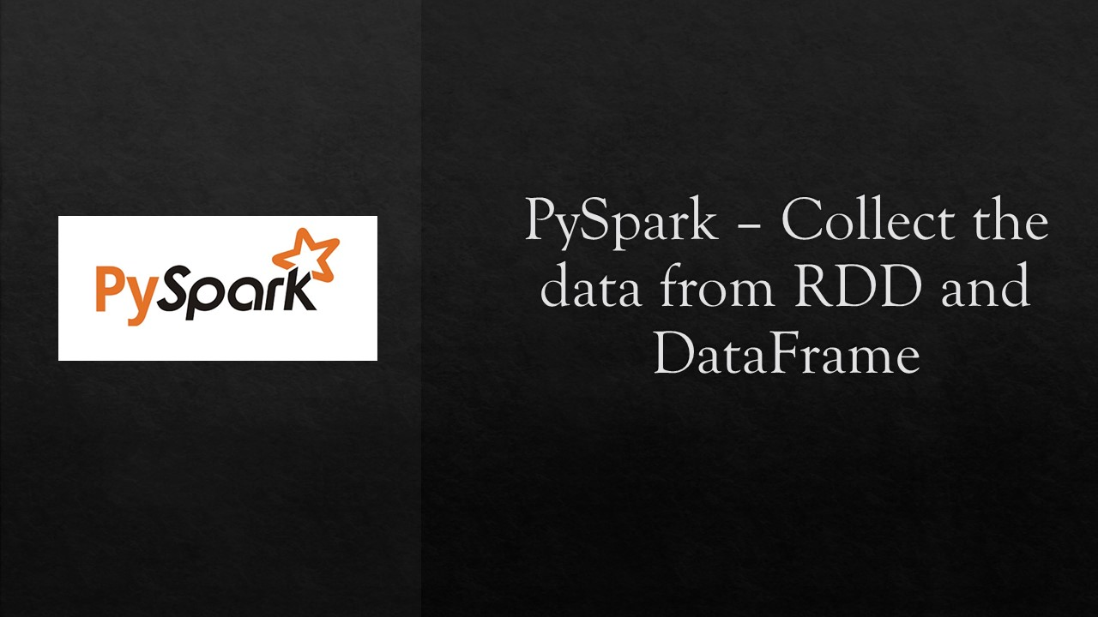
PySpark RDD/DataFrame collect() is an action operation that is used to retrieve all the elements of the dataset (from all nodes) to the driver node. We should use the collect() on smaller dataset usually after filter(), group() e.t.c. Retrieving larger datasets results in OutOfMemory error.
Advertisements
In this PySpark article, I will explain the usage of collect() with DataFrame example, when to avoid it, and the difference between collect() and select().
Related Articles:
- How to Iterate PySpark DataFrame through Loop
- How to Convert PySpark DataFrame Column to Python List
In order to explain with an example, first, let’s create a DataFrame.

import pyspark
from pyspark.sql import SparkSession

spark = SparkSession.builder.appName('SparkByExamples.com').getOrCreate()

dept = [("Finance",10), \
("Marketing",20), \
("Sales",30), \
("IT",40) \
]
deptColumns = ["dept_name","dept_id"]
deptDF = spark.createDataFrame(data=dept, schema = deptColumns)
deptDF.show(truncate=False)
show() function on DataFrame prints the result of DataFrame in a table format. By default, it shows only 20 rows. The above snippet returns the data in a table.

+---------+-------+
|dept_name|dept_id|
+---------+-------+
|Finance |10 |
|Marketing|20 |
|Sales |30 |
|IT |40 |
+---------+-------+
Now, let’s use the collect() to retrieve the data.

dataCollect = deptDF.collect()
print(dataCollect)
deptDF.collect() retrieves all elements in a DataFrame as an Array of Row type to the driver node. printing a resultant array yields the below output.

[Row(dept_name='Finance', dept_id=10),
Row(dept_name='Marketing', dept_id=20),
Row(dept_name='Sales', dept_id=30),
Row(dept_name='IT', dept_id=40)]
Note that collect() is an action hence it does not return a DataFrame instead, it returns data in an Array to the driver. Once the data is in an array, you can use python for loop to process it further.

for row in dataCollect:
print(row['dept_name'] + "," +str(row['dept_id']))
If you wanted to get first row and first column from a DataFrame.

#Returns value of First Row, First Column which is "Finance"
deptDF.collect()[0][0]
Let’s understand what’s happening on above statement.
- deptDF.collect() returns Array of Row type.
- deptDF.collect()[0] returns the first element in an array (1st row).
- deptDF.collect[0][0] returns the value of the first row & first column.
In case you want to just return certain elements of a DataFrame, you should call PySpark select() transformation first.

dataCollect = deptDF.select("dept_name").collect()

When to avoid Collect()
Usually, collect() is used to retrieve the action output when you have very small result set and calling collect() on an RDD/DataFrame with a bigger result set causes out of memory as it returns the entire dataset (from all workers) to the driver hence we should avoid calling collect() on a larger dataset.

collect () vs select ()
select() is a transformation that returns a new DataFrame and holds the columns that are selected whereas collect() is an action that returns the entire data set in an Array to the driver.

Complete Example of PySpark collect()
Below is complete PySpark example of using collect() on DataFrame, similarly you can also create a program using collect() with RDD.

import pyspark
from pyspark.sql import SparkSession

spark = SparkSession.builder.appName('SparkByExamples.com').getOrCreate()

dept = [("Finance",10), \
("Marketing",20), \
("Sales",30), \
("IT",40) \
]
deptColumns = ["dept_name","dept_id"]
deptDF = spark.createDataFrame(data=dept, schema = deptColumns)
deptDF.printSchema()
deptDF.show(truncate=False)

dataCollect = deptDF.collect()

print(dataCollect)

dataCollect2 = deptDF.select("dept_name").collect()
print(dataCollect2)

for row in dataCollect:
print(row['dept_name'] + "," +str(row['dept_id']))
This example is also available at PySpark Github project.

Conclusion
In this PySpark article, you have learned the collect() function of the RDD/DataFrame is an action operation that returns all elements of the DataFrame to spark driver program and also learned it’s not a good practice to use it on the bigger dataset.
Happy Learning !!

Related Articles
- PySpark distinct vs dropDuplicates
- Pyspark Select Distinct Rows
- PySpark cache() Explained.
- PySpark SparkContext Explained
- PySpark JSON Functions with Examples
- AttributeError: ‘DataFrame’ object has no attribute ‘map’ in PySpark
- PySpark Convert DataFrame to RDD
- PySpark – Loop/Iterate Through Rows in DataFrame

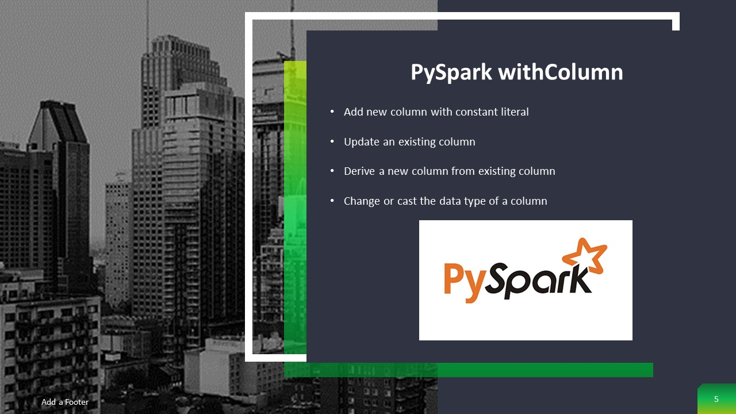
PySpark withColumn() is a transformation function of DataFrame which is used to change the value, convert the datatype of an existing column, create a new column, and many more. In this post, I will walk you through commonly used PySpark DataFrame column operations using withColumn() examples.
Advertisements
- PySpark withColumn – To change column DataType
- Transform/change value of an existing column
- Derive new column from an existing column
- Add a column with the literal value
- Rename column name
- Drop DataFrame column
First, let’s create a DataFrame to work with.

data = [('James','','Smith','1991-04-01','M',3000),
('Michael','Rose','','2000-05-19','M',4000),
('Robert','','Williams','1978-09-05','M',4000),
('Maria','Anne','Jones','1967-12-01','F',4000),
('Jen','Mary','Brown','1980-02-17','F',-1)
]

columns = ["firstname","middlename","lastname","dob","gender","salary"]
from pyspark.sql import SparkSession
spark = SparkSession.builder.appName('SparkByExamples.com').getOrCreate()
df = spark.createDataFrame(data=data, schema = columns)

1. Change DataType using PySpark withColumn()
By using PySpark withColumn() on a DataFrame, we can cast or change the data type of a column. In order to change data type, you would also need to use cast() function along with withColumn(). The below statement changes the datatype from String to Integer for the salary column.

df.withColumn("salary",col("salary").cast("Integer")).show()

2. Update The Value of an Existing Column
PySpark withColumn() function of DataFrame can also be used to change the value of an existing column. In order to change the value, pass an existing column name as a first argument and a value to be assigned as a second argument to the withColumn() function. Note that the second argument should be Column type . Also, see Different Ways to Update PySpark DataFrame Column.

df.withColumn("salary",col("salary")*100).show()
This snippet multiplies the value of “salary” with 100 and updates the value back to “salary” column.

3. Create a Column from an Existing
To add/create a new column, specify the first argument with a name you want your new column to be and use the second argument to assign a value by applying an operation on an existing column. Also, see Different Ways to Add New Column to PySpark DataFrame.

df.withColumn("CopiedColumn",col("salary")* -1).show()
This snippet creates a new column “CopiedColumn” by multiplying “salary” column with value -1.

4. Add a New Column using withColumn()
In order to create a new column, pass the column name you wanted to the first argument of withColumn() transformation function. Make sure this new column not already present on DataFrame, if it presents it updates the value of that column.
On below snippet, PySpark lit() function is used to add a constant value to a DataFrame column. We can also chain in order to add multiple columns.

df.withColumn("Country", lit("USA")).show()
df.withColumn("Country", lit("USA")) \
.withColumn("anotherColumn",lit("anotherValue")) \
.show()

5. Rename Column Name
Though you cannot rename a column using withColumn, still I wanted to cover this as renaming is one of the common operations we perform on DataFrame. To rename an existing column use withColumnRenamed() function on DataFrame.

df.withColumnRenamed("gender","sex") \
.show(truncate=False)

6. Drop Column From PySpark DataFrame
Use “drop” function to drop a specific column from the DataFrame.

df.drop("salary") \
.show()
Note: Note that all of these functions return the new DataFrame after applying the functions instead of updating DataFrame.

7. PySpark withColumn() Complete Example

import pyspark
from pyspark.sql import SparkSession
from pyspark.sql.functions import col, lit
from pyspark.sql.types import StructType, StructField, StringType,IntegerType

spark = SparkSession.builder.appName('SparkByExamples.com').getOrCreate()

data = [('James','','Smith','1991-04-01','M',3000),
('Michael','Rose','','2000-05-19','M',4000),
('Robert','','Williams','1978-09-05','M',4000),
('Maria','Anne','Jones','1967-12-01','F',4000),
('Jen','Mary','Brown','1980-02-17','F',-1)
]

columns = ["firstname","middlename","lastname","dob","gender","salary"]
df = spark.createDataFrame(data=data, schema = columns)
df.printSchema()
df.show(truncate=False)

df2 = df.withColumn("salary",col("salary").cast("Integer"))
df2.printSchema()
df2.show(truncate=False)

df3 = df.withColumn("salary",col("salary")*100)
df3.printSchema()
df3.show(truncate=False)

df4 = df.withColumn("CopiedColumn",col("salary")* -1)
df4.printSchema()

df5 = df.withColumn("Country", lit("USA"))
df5.printSchema()

df6 = df.withColumn("Country", lit("USA")) \
.withColumn("anotherColumn",lit("anotherValue"))
df6.printSchema()

df.withColumnRenamed("gender","sex") \
.show(truncate=False)

df4.drop("CopiedColumn") \
.show(truncate=False)
The complete code can be downloaded from PySpark withColumn GitHub project
Happy Learning !!

Related Articles
- PySpark NOT isin() or IS NOT IN Operator
- PySpark Replace Empty Value With None/null on DataFrame
- PySpark Refer Column Name With Dot (.)
- PySpark SQL expr() (Expression ) Function
- PySpark – Loop/Iterate Through Rows in DataFrame
- PySpark Update a Column with Value
- PySpark Add a New Column to DataFrame
- PySpark Convert String Type to Double Type


Use PySpark withColumnRenamed() to rename a DataFrame column, we often need to rename one column or multiple (or all) columns on PySpark DataFrame, you can do this in several ways. When columns are nested it becomes complicated.
Advertisements
Since DataFrame’s are an immutable collection, you can’t rename or update a column instead when using withColumnRenamed() it creates a new DataFrame with updated column names, In this PySpark article, I will cover different ways to rename columns with several use cases like rename nested column, all columns, selected multiple columns with Python/PySpark examples.
Refer to this page, If you are looking for a Spark with Scala example and rename pandas column with examples
- PySpark withColumnRenamed – To rename DataFrame column name
- PySpark withColumnRenamed – To rename multiple columns
- Using StructType – To rename nested column on PySpark DataFrame
- Using Select – To rename nested columns
- Using withColumn – To rename nested columns
- Using col() function – To Dynamically rename all or multiple columns
- Using toDF() – To rename all or multiple columns
First, let’s create our data set to work with.

dataDF = [(('James','','Smith'),'1991-04-01','M',3000),
(('Michael','Rose',''),'2000-05-19','M',4000),
(('Robert','','Williams'),'1978-09-05','M',4000),
(('Maria','Anne','Jones'),'1967-12-01','F',4000),
(('Jen','Mary','Brown'),'1980-02-17','F',-1)
]
Our base schema with nested structure.

from pyspark.sql.types import StructType,StructField, StringType, IntegerType
schema = StructType([
StructField('name', StructType([
StructField('firstname', StringType(), True),
StructField('middlename', StringType(), True),
StructField('lastname', StringType(), True)
])),
StructField('dob', StringType(), True),
StructField('gender', StringType(), True),
StructField('gender', IntegerType(), True)
])
Let’s create the DataFrame by using parallelize and provide the above schema.

from pyspark.sql import SparkSession
spark = SparkSession.builder.appName('SparkByExamples.com').getOrCreate()
df = spark.createDataFrame(data = dataDF, schema = schema)
df.printSchema()
Below is our schema structure. I am not printing data here as it is not necessary for our examples. This schema has a nested structure.
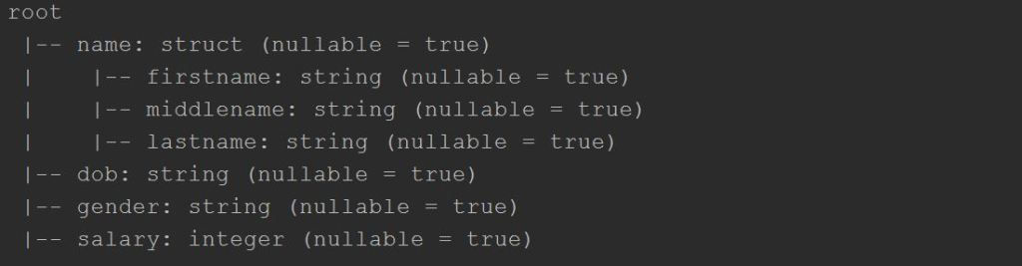

1. PySpark withColumnRenamed – To rename DataFrame column name
PySpark has a withColumnRenamed() function on DataFrame to change a column name. This is the most straight forward approach; this function takes two parameters; the first is your existing column name and the second is the new column name you wish for.
PySpark withColumnRenamed() Syntax:

withColumnRenamed(existingName, newNam)
existingName – The existing column name you want to change
newName – New name of the column
Returns a new DataFrame with a column renamed.
Example

df.withColumnRenamed("dob","DateOfBirth").printSchema()
The above statement changes column “dob” to “DateOfBirth” on PySpark DataFrame. Note that withColumnRenamed function returns a new DataFrame and doesn’t modify the current DataFrame.
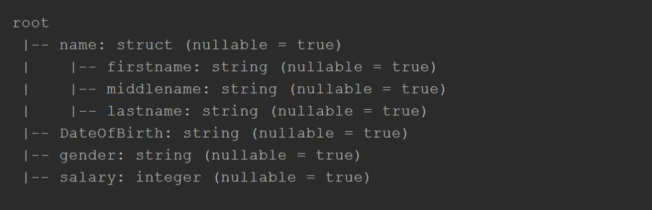

2. PySpark withColumnRenamed – To rename multiple columns
To change multiple column names, we should chain withColumnRenamed functions as shown below. You can also store all columns to rename in a list and loop through to rename all columns, I will leave this to you to explore.

df2 = df.withColumnRenamed("dob","DateOfBirth") \
.withColumnRenamed("salary","salary_amount")
df2.printSchema()
This creates a new DataFrame “df2” after renaming dob and salary columns.

3. Using PySpark StructType – To rename a nested column in Dataframe
Changing a column name on nested data is not straight forward and we can do this by creating a new schema with new DataFrame columns using StructType and use it using cast function as shown below.

schema2 = StructType([
StructField("fname",StringType()),
StructField("middlename",StringType()),
StructField("lname",StringType())])

df.select(col("name").cast(schema2), \
col("dob"), col("gender"),col("salary")) \
.printSchema()
This statement renames firstname to fname and lastname to lname within name structure.
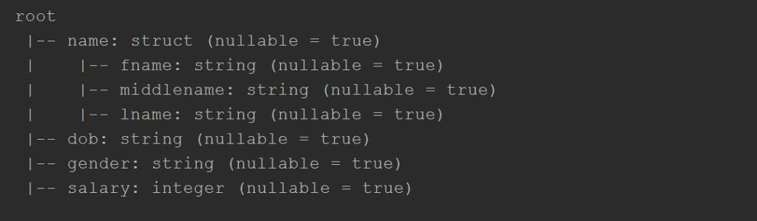

4. Using Select – To rename nested elements.
Let’s see another way to change nested columns by transposing the structure to flat.

from pyspark.sql.functions import *
df.select(col("name.firstname").alias("fname"), \
col("name.middlename").alias("mname"), \
col("name.lastname").alias("lname"), \
col("dob"),col("gender"),col("salary")) \
.printSchema()
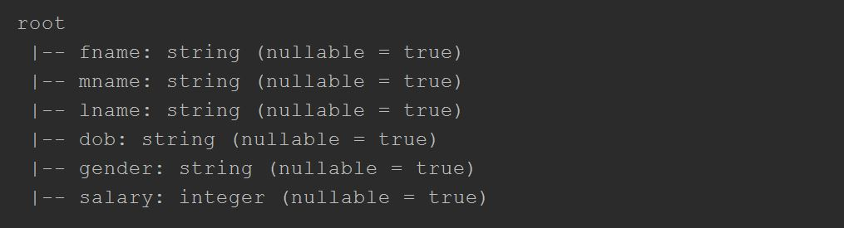

5. Using PySpark DataFrame withColumn – To rename nested columns
When you have nested columns on PySpark DatFrame and if you want to rename it, use withColumn on a data frame object to create a new column from an existing and we will need to drop the existing column. Below example creates a “fname” column from “name.firstname” and drops the “name” column

from pyspark.sql.functions import *
df4 = df.withColumn("fname",col("name.firstname")) \
.withColumn("mname",col("name.middlename")) \
.withColumn("lname",col("name.lastname")) \
.drop("name")
df4.printSchema()

6. Using col() function – To Dynamically rename all or multiple columns
Another way to change all column names on Dataframe is to use col() function.

IN progress

7. Using toDF() – To change all columns in a PySpark DataFrame
When we have data in a flat structure (without nested) , use toDF() with a new schema to change all column names.

newColumns = ["newCol1","newCol2","newCol3","newCol4"]
df.toDF(*newColumns).printSchema()

Source code

import pyspark
from pyspark.sql import SparkSession
from pyspark.sql.types import StructType,StructField, StringType, IntegerType
from pyspark.sql.functions import *

spark = SparkSession.builder.appName('SparkByExamples.com').getOrCreate()

dataDF = [(('James','','Smith'),'1991-04-01','M',3000),
(('Michael','Rose',''),'2000-05-19','M',4000),
(('Robert','','Williams'),'1978-09-05','M',4000),
(('Maria','Anne','Jones'),'1967-12-01','F',4000),
(('Jen','Mary','Brown'),'1980-02-17','F',-1)
]

schema = StructType([
StructField('name', StructType([
StructField('firstname', StringType(), True),
StructField('middlename', StringType(), True),
StructField('lastname', StringType(), True)
])),
StructField('dob', StringType(), True),
StructField('gender', StringType(), True),
StructField('salary', IntegerType(), True)
])

df = spark.createDataFrame(data = dataDF, schema = schema)
df.printSchema()

# Example 1
df.withColumnRenamed("dob","DateOfBirth").printSchema()
# Example 2
df2 = df.withColumnRenamed("dob","DateOfBirth") \
.withColumnRenamed("salary","salary_amount")
df2.printSchema()

# Example 3
schema2 = StructType([
StructField("fname",StringType()),
StructField("middlename",StringType()),
StructField("lname",StringType())])

df.select(col("name").cast(schema2),
col("dob"),
col("gender"),
col("salary")) \
.printSchema()

# Example 4
df.select(col("name.firstname").alias("fname"),
col("name.middlename").alias("mname"),
col("name.lastname").alias("lname"),
col("dob"),col("gender"),col("salary")) \
.printSchema()

# Example 5
df4 = df.withColumn("fname",col("name.firstname")) \
.withColumn("mname",col("name.middlename")) \
.withColumn("lname",col("name.lastname")) \
.drop("name")
df4.printSchema()

#Example 7
newColumns = ["newCol1","newCol2","newCol3","newCol4"]
df.toDF(*newColumns).printSchema()

# Example 6
'''
not working
old_columns = Seq("dob","gender","salary","fname","mname","lname")
new_columns = Seq("DateOfBirth","Sex","salary","firstName","middleName","lastName")
columnsList = old_columns.zip(new_columns).map(f=>{col(f._1).as(f._2)})
df5 = df4.select(columnsList:_*)
df5.printSchema()
'''

The complete code can be downloaded from GitHub

Conclusion:
This article explains different ways to rename all, a single, multiple, and nested columns on PySpark DataFrame.
I hope you like this article!!
Happy Learning.

Related Articles
- PySpark Column alias after groupBy() Example
- PySpark withColumn() Usage with Examples
- PySpark Replace Column Values in DataFrame
- Dynamic way of doing ETL through Pyspark
- PySpark printSchema() to String or JSON
- PySpark Get Number of Rows and Columns
- PySpark Join Multiple Columns
- PySpark Groupby on Multiple Columns
Tags: spark.createDataFrame, StructType, toDF(), withColumn, withColumnRenamed

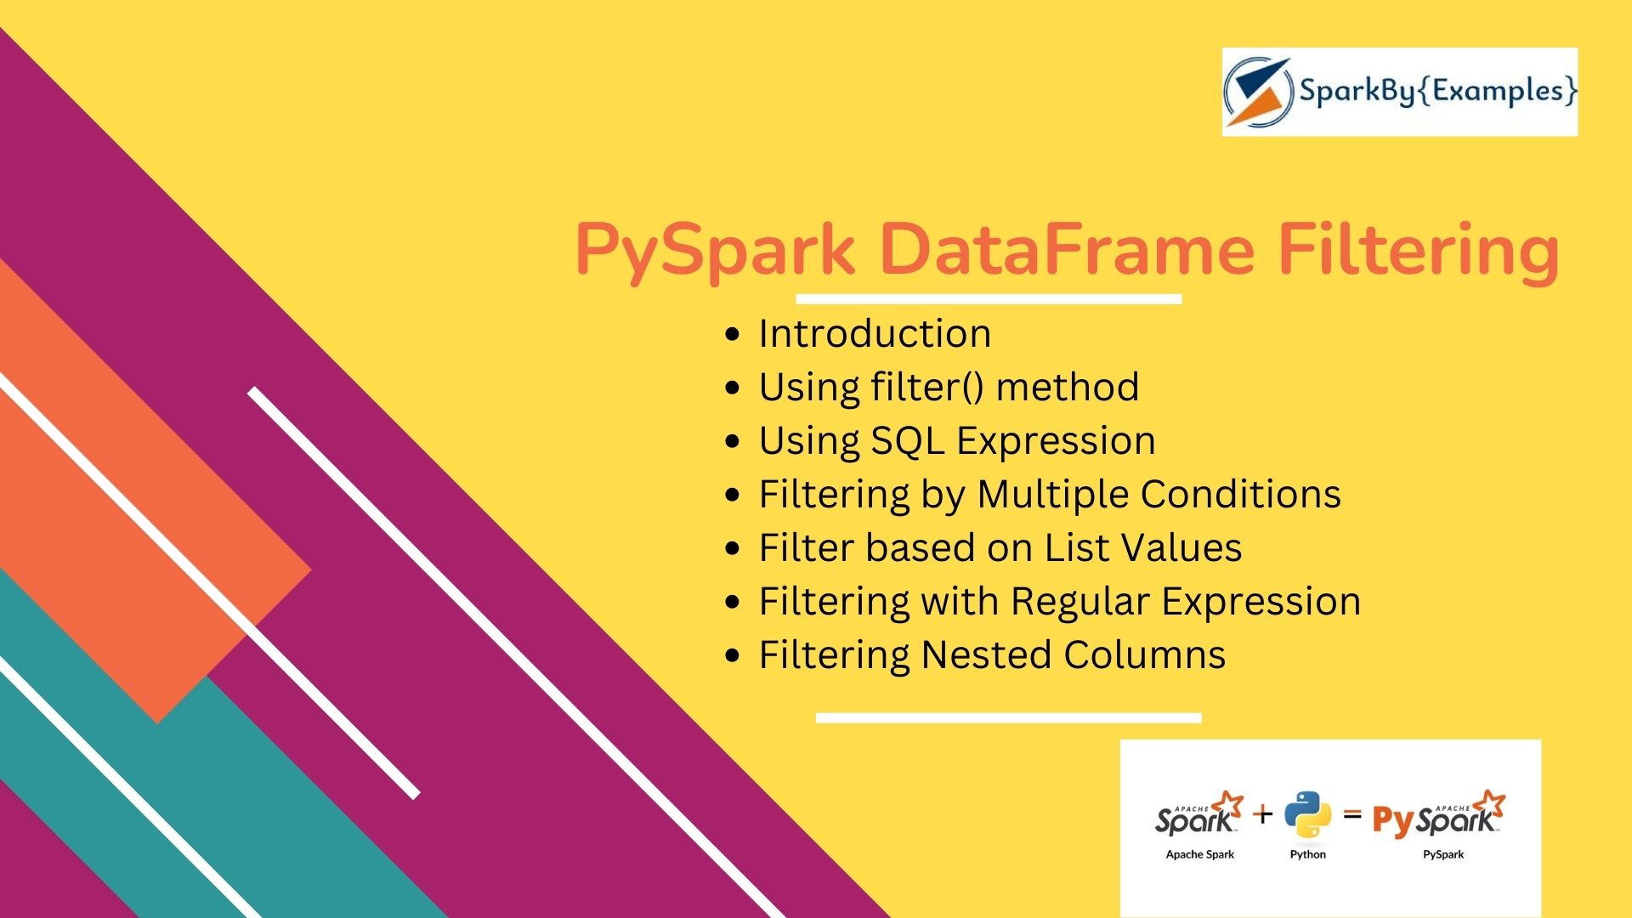
In this PySpark article, you will learn how to apply a filter on DataFrame columns of string, arrays, and struct types by using single and multiple conditions and also using isin() with PySpark (Python Spark) examples.
Advertisements

1. Introduction to PySpark DataFrame Filtering
PySpark filter() function is used to create a new DataFrame by filtering the elements from an existing DataFrame based on the given condition or SQL expression. It is similar to Python’s filter() function but operates on distributed datasets. It is analogous to the SQL WHERE clause and allows you to apply filtering criteria to DataFrame rows.
Alternatively, if you have a background in SQL, you can opt to use the where() function instead of filter(). Both functions work identically. They generate a new DataFrame containing only the rows that satisfy the specified condition.
Related Article:

- How to select Rows with NULL/NONE (IS NULL & IS NOT NULL) in PySpark
- Spark usage of startsWith(), endsWith() Examples
- Spark usage of contains(), like(), rlike() Examples
Note: PySpark Column Functions provides several options that can be used with this function.

filter() Syntax
Following is the syntax.

# Syntax
filter(condition)
Here,
condition: It is the filtering condition or expression. It can be specified using various constructs such as SQL expressions, DataFrame API functions, or user-defined functions (UDFs). The condition evaluates to True for rows that should be retained and False for rows that should be discarded.
For example, let’s say you have the following DataFrame. Here, I am using a DataFrame with StructType and ArrayType columns, as I will also cover examples with struct and array types.

# Imports
from pyspark.sql import SparkSession
from pyspark.sql.types import StructType,StructField
from pyspark.sql.types import StringType, IntegerType, ArrayType

# Create SparkSession object
spark = SparkSession.builder.appName('SparkByExamples.com').getOrCreate()

# Create data
data = [
(("James","","Smith"),["Java","Scala","C++"],"OH","M"),
(("Anna","Rose",""),["Spark","Java","C++"],"NY","F"),
(("Julia","","Williams"),["CSharp","VB"],"OH","F"),
(("Maria","Anne","Jones"),["CSharp","VB"],"NY","M"),
(("Jen","Mary","Brown"),["CSharp","VB"],"NY","M"),
(("Mike","Mary","Williams"),["Python","VB"],"OH","M")
]

# Create schema
schema = StructType([
StructField('name', StructType([
StructField('firstname', StringType(), True),
StructField('middlename', StringType(), True),
StructField('lastname', StringType(), True)
])),
StructField('languages', ArrayType(StringType()), True),
StructField('state', StringType(), True),
StructField('gender', StringType(), True)
])

# Create dataframe
df = spark.createDataFrame(data = data, schema = schema)
df.printSchema()
df.show(truncate=False)
This yields below schema and DataFrame results.

root
|-- name: struct (nullable = true)
| |-- firstname: string (nullable = true)
| |-- middlename: string (nullable = true)
| |-- lastname: string (nullable = true)
|-- languages: array (nullable = true)
| |-- element: string (containsNull = true)
|-- state: string (nullable = true)
|-- gender: string (nullable = true)

+----------------------+------------------+-----+------+
|name |languages |state|gender|
+----------------------+------------------+-----+------+
|[James, , Smith] |[Java, Scala, C++]|OH |M |
|[Anna, Rose, ] |[Spark, Java, C++]|NY |F |
|[Julia, , Williams] |[CSharp, VB] |OH |F |
|[Maria, Anne, Jones] |[CSharp, VB] |NY |M |
|[Jen, Mary, Brown] |[CSharp, VB] |NY |M |
|[Mike, Mary, Williams]|[Python, VB] |OH |M |
+----------------------+------------------+-----+------+

2. DataFrame filter() with Column Condition
When using filter() with column conditions, you typically specify the condition using column expressions. These expressions can involve comparisons, logical operations, or even functions applied to DataFrame columns. In the below example, I am using dfObject.colname to refer to column names.

# Using equal condition
df.filter(df.state == "OH").show(truncate=False)

# Output
#+----------------------+------------------+-----+------+
#|name |languages |state|gender|
#+----------------------+------------------+-----+------+
#|[James, , Smith] |[Java, Scala, C++]|OH |M |
#|[Julia, , Williams] |[CSharp, VB] |OH |F |
#|[Mike, Mary, Williams]|[Python, VB] |OH |M |
#+----------------------+------------------+-----+------+

Using not equal filter condition
To retain rows where the value in the “state” column is not equal to “OH” (Ohio), use the below syntaxes. However, they use slightly different approaches to express the filtering condition.

# Not equals condition
df.filter(df.state != "OH") \
.show(truncate=False)

# Another expression
df.filter(~(df.state == "OH")) \
.show(truncate=False)
Using != operator:
- In this snippet, the != operator is used to compare the values in the “state” column to “OH”. This creates a Boolean column where each row is marked as True if the value in the “state” column is not equal to “OH”, and False otherwise. The filter() function then retains rows where this condition evaluates to True.
Using ~ (Negation) operator:
- In this snippet, the ~ (tilde) operator is used to negate the condition df.state == "OH". This means that rows where the condition df.state == "OH" evaluates to True will be negated to False, and vice versa. So, the ~(df.state == "OH") expression creates a Boolean column where each row is marked as True if the value in the “state” column is not equal to “OH”, and False otherwise. This function then retains rows where this condition evaluates to True.
- This approach negates the condition df.state == "OH" to achieve selecting rows where the value in the “state” column is not equal to “OH”.

Using col() Function
You can also use the col() function to refer to the column name. In order to use this first, you need to import from pyspark.sql.functions import col

# Using SQL col() function
from pyspark.sql.functions import col
df.filter(col("state") == "OH") \
.show(truncate=False)

3. Filtering with SQL Expression
If you have an SQL background, you can use that knowledge in PySpark to filter DataFrame rows with SQL expressions.

# Using SQL Expression
df.filter("gender == 'M'").show()

# For not equal
df.filter("gender != 'M'").show()
df.filter("gender <> 'M'").show()

4. PySpark Filter with Multiple Conditions
In PySpark, you can apply multiple conditions when filtering DataFrames to select rows that meet specific criteria. This can be achieved by combining individual conditions using logical operators like & (AND), | (OR), and ~ (NOT). Let’s explore how to use multiple conditions in PySpark DataFrame filtering:

# Filter multiple conditions
df.filter( (df.state == "OH") & (df.gender == "M") ) \
.show(truncate=False)

# Output
#+----------------------+------------------+-----+------+
#|name |languages |state|gender|
#+----------------------+------------------+-----+------+
#|[James, , Smith] |[Java, Scala, C++]|OH |M |
#|[Mike, Mary, Williams]|[Python, VB] |OH |M |
#+----------------------+------------------+-----+------+
The conditions are combined using the & operator, indicating that both conditions must be true for a row to be retained.
To use the OR operator, replace & with |.

# Filter using OR operator
df.filter( (df.state == "OH") | (df.gender == "M") ) \
.show(truncate=False)

5. Filter Based on List Values
The isin() function from the Python Column class allows you to filter a DataFrame based on whether the values in a particular column match any of the values in a specified list. And, to check not isin() you have to use the not operator (~)

# Filter IS IN List values
li=["OH","CA","DE"]
df.filter(df.state.isin(li)).show()

# Output
#+--------------------+------------------+-----+------+
#| name| languages|state|gender|
#+--------------------+------------------+-----+------+
#| [James, , Smith]|[Java, Scala, C++]| OH| M|
#| [Julia, , Williams]| [CSharp, VB]| OH| F|
#|[Mike, Mary, Will...| [Python, VB]| OH| M|
#+--------------------+------------------+-----+------+

# Filter NOT IS IN List values
# These show all records with NY (NY is not part of the list)
df.filter(~df.state.isin(li)).show()
df.filter(df.state.isin(li)==False).show()

6. Filter Based on Starts With, Ends With, Contains
Use startswith(), endswith() and contains() methods of Column class to select rows starts with, ends with, and contains a value. For more examples on Column class, refer to PySpark Column Functions.

# Using startswith
df.filter(df.state.startswith("N")).show()

# Output
#+--------------------+------------------+-----+------+
#| name| languages|state|gender|
#+--------------------+------------------+-----+------+
#| [Anna, Rose, ]|[Spark, Java, C++]| NY| F|
#|[Maria, Anne, Jones]| [CSharp, VB]| NY| M|
#| [Jen, Mary, Brown]| [CSharp, VB]| NY| M|
#+--------------------+------------------+-----+------+

#using endswith
df.filter(df.state.endswith("H")).show()

#contains
df.filter(df.state.contains("H")).show()

7. Filtering with Regular Expression
If you are coming from SQL background, you must be familiar with like and rlike (regex like). PySpark also provides similar methods in the Column class to filter similar values using wildcard characters. You can use rlike() for case insensitive.

# Prepare Data
data2 = [(2,"Michael Rose"),(3,"Robert Williams"),
(4,"Rames Rose"),(5,"Rames rose")
]
df2 = spark.createDataFrame(data = data2, schema = ["id","name"])

# like - SQL LIKE pattern
df2.filter(df2.name.like("%rose%")).show()

# Output
#+---+----------+
#| id| name|
#+---+----------+
#| 5|Rames rose|
#+---+----------+

# rlike - SQL RLIKE pattern (LIKE with Regex)
# This check case insensitive
df2.filter(df2.name.rlike("(?i)^*rose$")).show()

# Output
#+---+------------+
#| id| name|
#+---+------------+
#| 2|Michael Rose|
#| 4| Rames Rose|
#| 5| Rames rose|

8. Filtering Array column
To filter DataFrame rows based on the presence of a value within an array-type column, you can employ the first syntax. The following example uses array_contains() from PySpark SQL functions. This function examines whether a value is contained within an array. If the value is found, it returns true; otherwise, it returns false.

# Using array_contains()
from pyspark.sql.functions import array_contains
df.filter(array_contains(df.languages,"Java")) \
.show(truncate=False)

# Output
#+----------------+------------------+-----+------+
#|name |languages |state|gender|
#+----------------+------------------+-----+------+
#|[James, , Smith]|[Java, Scala, C++]|OH |M |
#|[Anna, Rose, ] |[Spark, Java, C++]|NY |F |
#+----------------+------------------+-----+------+

9. Filtering on Nested Struct columns
In case your DataFrame consists of nested struct columns, you can use any of the above syntaxes to filter the rows based on the nested column.

# Struct condition
df.filter(df.name.lastname == "Williams") \
.show(truncate=False)

# Output
#+----------------------+------------+-----+------+
#|name |languages |state|gender|
#+----------------------+------------+-----+------+
#|[Julia, , Williams] |[CSharp, VB]|OH |F |
#|[Mike, Mary, Williams]|[Python, VB]|OH |M |
#+----------------------+------------+-----+------+

10. FAQs on filter()
What is the difference between where and filter in PySpark?
In PySpark, both filter() and where() functions are used to select out data based on certain conditions. They are used interchangeably, and both of them essentially perform the same operation.
Is DataFrame filtering in PySpark lazy
Yes, DataFrame filtering in PySpark follows lazy evaluation, meaning the filtering operation is only executed when an action is performed on the DataFrame
Can I use SQL expressions for DataFrame filtering in PySpark?
You can use SQL expressions for filtering in PySpark by using functions like expr() or by registering the DataFrame as a temporary view and executing SQL queries on it.
How can I optimize DataFrame filtering performance in PySpark?
Optimizing DataFrame filtering performance in PySpark involves strategies such as minimizing data shuffling, repartitioning, and caching intermediate results where appropriate.
Are there any limitations to DataFrame filtering in PySpark?
While DataFrame filtering in PySpark is powerful, it may encounter limitations related to complex conditions, performance overhead, and resource management, which require careful consideration and optimization.

11. Conclusion
Examples explained here are also available at PySpark examples GitHub project for reference.
Overall, the filter() function is a powerful tool for selecting subsets of data from DataFrames based on specific criteria, enabling data manipulation and analysis in PySpark. In this tutorial, you have learned how to filter rows from PySpark DataFrame based on single or multiple conditions and SQL expression, also learned how to filter rows by providing conditions on the array and struct column with Spark with Python examples.
Alternatively, you can also use where() function to filter the rows on PySpark DataFrame.
Happy Learning !!

Related Articles
- PySpark JSON Functions with Examples
- PySpark Filter Using contains() Examples
- PySpark Column Class | Operators & Functions
- PySpark SQL expr() (Expression ) Function
- PySpark SQL Date and Timestamp Functions
- PySpark Window Functions
- PySpark UDF (User Defined Function)
- PySpark Aggregate Functions with Examples
- PySpark createOrReplaceTempView() Explained
- PySpark Apply udf to Multiple Columns

PySpark distinct() transformation is used to drop/remove the duplicate rows (all columns) from DataFrame and dropDuplicates() is used to drop rows based on selected (one or multiple) columns. distinct() and dropDuplicates() returns a new DataFrame. In this article, you will learn how to use distinct() and dropDuplicates() functions with PySpark example.
Advertisements
Before we start, first let’s create a DataFrame with some duplicate rows and values on a few columns. We use this DataFrame to demonstrate how to get distinct multiple columns.

# Imports
from pyspark.sql import SparkSession
from pyspark.sql.functions import expr

# Create SparkSession
spark = SparkSession.builder.appName('SparkByExamples.com').getOrCreate()

# Prepare Data
data = [("James", "Sales", 3000), \
("Michael", "Sales", 4600), \
("Robert", "Sales", 4100), \
("Maria", "Finance", 3000), \
("James", "Sales", 3000), \
("Scott", "Finance", 3300), \
("Jen", "Finance", 3900), \
("Jeff", "Marketing", 3000), \
("Kumar", "Marketing", 2000), \
("Saif", "Sales", 4100) \
]

# Create DataFrame
columns= ["employee_name", "department", "salary"]
df = spark.createDataFrame(data = data, schema = columns)
df.printSchema()
df.show(truncate=False)
Yields below output

# Output
+-------------+----------+------+
|employee_name|department|salary|
+-------------+----------+------+
|James |Sales |3000 |
|Michael |Sales |4600 |
|Robert |Sales |4100 |
|Maria |Finance |3000 |
|James |Sales |3000 |
|Scott |Finance |3300 |
|Jen |Finance |3900 |
|Jeff |Marketing |3000 |
|Kumar |Marketing |2000 |
|Saif |Sales |4100 |
+-------------+----------+------+
In the above table, record with employer name James has duplicate rows, As you notice we have 2 rows that have duplicate values on all columns and we have 4 rows that have duplicate values on department and salary columns.

1. Get Distinct Rows (By Comparing All Columns)
On the above DataFrame, we have a total of 10 rows with 2 rows having all values duplicated, performing distinct on this DataFrame should get us 9 after removing 1 duplicate row.

# Applying distinct() to remove duplicate rows
distinctDF = df.distinct()
print("Distinct count: "+str(distinctDF.count()))
distinctDF.show(truncate=False)
distinct() function on DataFrame returns a new DataFrame after removing the duplicate records. This example yields the below output.

# Output
Distinct count: 9
+-------------+----------+------+
|employee_name|department|salary|
+-------------+----------+------+
|James |Sales |3000 |
|Michael |Sales |4600 |
|Maria |Finance |3000 |
|Robert |Sales |4100 |
|Saif |Sales |4100 |
|Scott |Finance |3300 |
|Jeff |Marketing |3000 |
|Jen |Finance |3900 |
|Kumar |Marketing |2000 |
+-------------+----------+------+
Alternatively, you can also run dropDuplicates() function which returns a new DataFrame after removing duplicate rows.

# Applying dropDuplicates() to remove duplicates
df2 = df.dropDuplicates()
print("Distinct count: "+str(df2.count()))
df2.show(truncate=False)

2. PySpark Distinct of Selected Multiple Columns
PySpark doesn’t have a distinct method that takes columns that should run distinct (drop duplicate rows on selected multiple columns) however, it provides another signature of dropDuplicates() transformation which takes multiple columns to eliminate duplicates.
Note that calling dropDuplicates() on DataFrame returns a new DataFrame with duplicate rows removed.

# Remove duplicates on selected columns using dropDuplicates()
dropDisDF = df.dropDuplicates(["department","salary"])
print("Distinct count of department & salary : "+str(dropDisDF.count()))
dropDisDF.show(truncate=False)
Yields below output. If you notice the output, It dropped 2 records that are duplicates.

# Output
Distinct count of department & salary : 8
+-------------+----------+------+
|employee_name|department|salary|
+-------------+----------+------+
|Jen |Finance |3900 |
|Maria |Finance |3000 |
|Scott |Finance |3300 |
|Michael |Sales |4600 |
|Kumar |Marketing |2000 |
|Robert |Sales |4100 |
|James |Sales |3000 |
|Jeff |Marketing |3000 |
+-------------+----------+------+

3. Source Code to Get Distinct Rows

import pyspark
from pyspark.sql import SparkSession
from pyspark.sql.functions import expr
spark = SparkSession.builder.appName('SparkByExamples.com').getOrCreate()

data = [("James", "Sales", 3000), \
("Michael", "Sales", 4600), \
("Robert", "Sales", 4100), \
("Maria", "Finance", 3000), \
("James", "Sales", 3000), \
("Scott", "Finance", 3300), \
("Jen", "Finance", 3900), \
("Jeff", "Marketing", 3000), \
("Kumar", "Marketing", 2000), \
("Saif", "Sales", 4100) \
]
columns= ["employee_name", "department", "salary"]
df = spark.createDataFrame(data = data, schema = columns)
df.printSchema()
df.show(truncate=False)

#Distinct
distinctDF = df.distinct()
print("Distinct count: "+str(distinctDF.count()))
distinctDF.show(truncate=False)

#Drop duplicates
df2 = df.dropDuplicates()
print("Distinct count: "+str(df2.count()))
df2.show(truncate=False)

#Drop duplicates on selected columns
dropDisDF = df.dropDuplicates(["department","salary"])
print("Distinct count of department salary : "+str(dropDisDF.count()))
dropDisDF.show(truncate=False)
}
The complete example is available at GitHub for reference.

Frequently Asked Questions on distinct() and dropDuplicates()
How is distinct() different from dropDuplicates()?
distinct() and dropDuplicates() in PySpark are used to remove duplicate rows, but there is a subtle difference. distinct() considers all columns when identifying duplicates, while dropDuplicates() allowing you to specify a subset of columns to determine uniqueness.
Can distinct() be used on specific columns only?
PySpark does not support specifying multiple columns with distinct() in order to remove the duplicates. We can use the dropDuplicates() transformation on specific columns to achieve the uniqueness of the columns.
Does distinct() maintain the original order of rows?
distinct() does not maintain the original order of the rows. To guarantee the original order we should perform additional sorting operations after distinct().
How does distinct() handle NULL values?
The distinct() function treats NULL values as equal, so if there are multiple rows with NULL values in all columns, only one of them will be retained after applying distinct().
Can we use distinct() on a specific subset of rows based on a condition?
The distinct() function returns a new DataFrame with distinct rows, leaving the original DataFrame unchanged.So we can’t use it on a specific subset of rows. If you want to modify the original DataFrame, you need to assign the result distinct() to a new variable or use the inPlace parameter if available.

Conclusion
In this PySpark SQL article, you have learned distinct() the method that is used to get the distinct values of rows (all columns) and also learned how to use dropDuplicates() to get the distinct and finally learned to use dropDuplicates() function to get distinct multiple columns.
Happy Learning !!

Related Articles:
- PySpark count() – Different Methods Explained
- How to Convert PySpark Column to List?
- PySpark Union and UnionAll Explained
- PySpark – Drop One or Multiple Columns From DataFrame
- PySpark Groupby Count Distinct
- PySpark Count Distinct from DataFrame
- PySpark distinct vs dropduplicates
- PySpark Select Distinct Rows
Tags: distinct rows, distinct(), dropDuplicates(), duplicate rows


You can use either sort() or orderBy() function of PySpark DataFrame to sort DataFrame by ascending or descending order based on single or multiple columns. Both methods take one or more columns as arguments and return a new DataFrame after sorting. You can also do sorting using PySpark SQL sorting functions.
Advertisements
In this article, I will explain all these different ways using PySpark examples. Note that pyspark.sql.DataFrame.orderBy() is an alias for .sort()
- Using sort() function
- Using orderBy() function
- Ascending order
- Descending order
- SQL Sort functions
Related: How to sort DataFrame by using Scala
Before we start, first let’s create a DataFrame.

# Imports
import pyspark
from pyspark.sql import SparkSession

simpleData = [("James","Sales","NY",90000,34,10000), \
("Michael","Sales","NY",86000,56,20000), \
("Robert","Sales","CA",81000,30,23000), \
("Maria","Finance","CA",90000,24,23000), \
("Raman","Finance","CA",99000,40,24000), \
("Scott","Finance","NY",83000,36,19000), \
("Jen","Finance","NY",79000,53,15000), \
("Jeff","Marketing","CA",80000,25,18000), \
("Kumar","Marketing","NY",91000,50,21000) \
]
columns= ["employee_name","department","state","salary","age","bonus"]
# Create SparkSession

df = spark.createDataFrame(data = simpleData, schema = columns)
df.printSchema()
df.show(truncate=False)
This Yields below output.

root
|-- employee_name: string (nullable = true)
|-- department: string (nullable = true)
|-- state: string (nullable = true)
|-- salary: integer (nullable = false)
|-- age: integer (nullable = false)
|-- bonus: integer (nullable = false)

+-------------+----------+-----+------+---+-----+
|employee_name|department|state|salary|age|bonus|
+-------------+----------+-----+------+---+-----+
| James| Sales| NY| 90000| 34|10000|
| Michael| Sales| NY| 86000| 56|20000|
| Robert| Sales| CA| 81000| 30|23000|
| Maria| Finance| CA| 90000| 24|23000|
| Raman| Finance| CA| 99000| 40|24000|
| Scott| Finance| NY| 83000| 36|19000|
| Jen| Finance| NY| 79000| 53|15000|
| Jeff| Marketing| CA| 80000| 25|18000|
| Kumar| Marketing| NY| 91000| 50|21000|
+-------------+----------+-----+------+---+-----+

1.DataFrame sorting using the sort() function
PySpark DataFrame class provides sort() function to sort on one or more columns. sort() takes a Boolean argument for ascending or descending order. To specify different sorting orders for different columns, you can use the parameter as a list. For example, to sort by “column1” in ascending order and “column2” in descending order as shown below.

# Sorting different columns in different orders

df.sort("column1", "column2", ascending=[True, False])
By default, it sorts by ascending order. pyspark.sql.functions module provides methods asc() and desc() to sort in ascending and descending orders respectively.
Syntax

DataFrame.sort(*cols, **kwargs)
Parameters: cols: str, list, or Column, optional
Other Parameters: ascending: bool or list, optional
Example

# Sorting DataFrame using sort()

df.sort("department","state").show(truncate=False)
df.sort(col("department"),col("state")).show(truncate=False)
The above two examples return the same below output, the first one takes the DataFrame column name as a string and the next takes columns in Column type. This table is sorted by the first department column and then the state column.

+-------------+----------+-----+------+---+-----+
|employee_name|department|state|salary|age|bonus|
+-------------+----------+-----+------+---+-----+
|Maria |Finance |CA |90000 |24 |23000|
|Raman |Finance |CA |99000 |40 |24000|
|Jen |Finance |NY |79000 |53 |15000|
|Scott |Finance |NY |83000 |36 |19000|
|Jeff |Marketing |CA |80000 |25 |18000|
|Kumar |Marketing |NY |91000 |50 |21000|
|Robert |Sales |CA |81000 |30 |23000|
|James |Sales |NY |90000 |34 |10000|
|Michael |Sales |NY |86000 |56 |20000|
+-------------+----------+-----+------+---+-----+

2.DataFrame sorting using orderBy() function
PySpark DataFrame also provides orderBy() function to sort on one or more columns. By default, it orders by ascending.
Syntax

DataFrame.orderBy(*cols, **kwargs)
Parameters: cols: str, list, or Column, optional
Other Parameters : ascending: bool or list, optional
Example

# Sorting DataFrame using orderBy()

df.orderBy("department","state").show(truncate=False)
df.orderBy(col("department"),col("state")).show(truncate=False)
This returns the same output as the previous section.

3.Sort by Ascending (ASC)
The sort() method allows you to specify the sorting column(s) and the sorting order (ascending or descending). If you want to specify the ascending order/sort explicitly on DataFrame, you can use the asc method of the Column function. for example,

# Sort DataFrame with asc

df.sort(df.department.asc(),df.state.asc()).show(truncate=False)
df.sort(col("department").asc(),col("state").asc()).show(truncate=False)
df.orderBy(col("department").asc(),col("state").asc()).show(truncate=False)
The above three examples return the same output.

+-------------+----------+-----+------+---+-----+
|employee_name|department|state|salary|age|bonus|
+-------------+----------+-----+------+---+-----+
|Maria |Finance |CA |90000 |24 |23000|
|Raman |Finance |CA |99000 |40 |24000|
|Jen |Finance |NY |79000 |53 |15000|
|Scott |Finance |NY |83000 |36 |19000|
|Jeff |Marketing |CA |80000 |25 |18000|
|Kumar |Marketing |NY |91000 |50 |21000|
|Robert |Sales |CA |81000 |30 |23000|
|James |Sales |NY |90000 |34 |10000|
|Michael |Sales |NY |86000 |56 |20000|
+-------------+----------+-----+------+---+-----+

4.Sort by Descending (DESC)
If you want to specify the sorting by descending order on DataFrame, you can use the desc method of the Column function. for example. From our example, let’s use desc on the state column.

# Sort DataFrame with desc

df.sort(df.department.asc(),df.state.desc()).show(truncate=False)
df.sort(col("department").asc(),col("state").desc()).show(truncate=False)
df.orderBy(col("department").asc(),col("state").desc()).show(truncate=False)
This yields the below output for all three examples.

# Output
+-------------+----------+-----+------+---+-----+
|employee_name|department|state|salary|age|bonus|
+-------------+----------+-----+------+---+-----+
|Scott |Finance |NY |83000 |36 |19000|
|Jen |Finance |NY |79000 |53 |15000|
|Raman |Finance |CA |99000 |40 |24000|
|Maria |Finance |CA |90000 |24 |23000|
|Kumar |Marketing |NY |91000 |50 |21000|
|Jeff |Marketing |CA |80000 |25 |18000|
|James |Sales |NY |90000 |34 |10000|
|Michael |Sales |NY |86000 |56 |20000|
|Robert |Sales |CA |81000 |30 |23000|
+-------------+----------+-----+------+---+-----+
Besides asc() and desc() functions, PySpark also provides asc_nulls_first() and asc_nulls_last() and equivalent descending functions.

5. Using Raw SQL
Below is an example of how to sort DataFrame using raw SQL syntax.

# Sort using spark SQL

df.createOrReplaceTempView("EMP")
spark.sql("select employee_name,department,state,salary,age,bonus from EMP ORDER BY department asc").show(truncate=False)
The above two examples return the same output as above.

6. Dataframe Sorting Complete Example

# Imports

import pyspark
from pyspark.sql import SparkSession
from pyspark.sql.functions import col, asc,desc

spark = SparkSession.builder.appName('SparkByExamples.com').getOrCreate()

simpleData = [("James","Sales","NY",90000,34,10000), \
("Michael","Sales","NY",86000,56,20000), \
("Robert","Sales","CA",81000,30,23000), \
("Maria","Finance","CA",90000,24,23000), \
("Raman","Finance","CA",99000,40,24000), \
("Scott","Finance","NY",83000,36,19000), \
("Jen","Finance","NY",79000,53,15000), \
("Jeff","Marketing","CA",80000,25,18000), \
("Kumar","Marketing","NY",91000,50,21000) \
]
columns= ["employee_name","department","state","salary","age","bonus"]

df = spark.createDataFrame(data = simpleData, schema = columns)

df.printSchema()
df.show(truncate=False)

df.sort("department","state").show(truncate=False)
df.sort(col("department"),col("state")).show(truncate=False)

df.orderBy("department","state").show(truncate=False)
df.orderBy(col("department"),col("state")).show(truncate=False)

df.sort(df.department.asc(),df.state.asc()).show(truncate=False)
df.sort(col("department").asc(),col("state").asc()).show(truncate=False)
df.orderBy(col("department").asc(),col("state").asc()).show(truncate=False)

df.sort(df.department.asc(),df.state.desc()).show(truncate=False)
df.sort(col("department").asc(),col("state").desc()).show(truncate=False)
df.orderBy(col("department").asc(),col("state").desc()).show(truncate=False)

df.createOrReplaceTempView("EMP")
spark.sql("select employee_name,department,state,salary,age,bonus from EMP ORDER BY department asc").show(truncate=False)
This complete example is also available at PySpark sorting GitHub project for reference.

7. Frequently Asked Questions on sort() and OrderBy()
What is the difference between orderBy() and sort() in PySpark?
In PySpark, both orderBy() and sort() are methods used for sorting rows in a DataFrame, and they serve the same purpose. However, there is no significant difference in terms of functionality or sorting capability between these two methods. Both can be used to sort rows based on one or more columns in ascending or descending order.
How do I sort by specific order in PySpark?
We can use sort() or orderBy() methods to sort DataFrame by “ascending” or “descending” order based on single or multiple columns.
Example
df.orderBy(col("department").asc(),col("state").asc()).show(truncate=False)
or
df.sort(col("department").asc(),col("state").asc()).show(truncate=False)
What is the default order of ORDER BY in PySpark?
orderBy() from pyspark.sql.DataFrame is used to sort the DataFrame in ascending or descending order. By default, it sorts in ascending order. We can specify the order by passing a boolean parameter to the method.
Example
df.orderBy("department", desc=True)

8. Conclusion
Here you have learned how to Sort PySpark DataFrame columns using sort(), orderBy() and using SQL sort functions and used this function with PySpark SQL along with Ascending and Descending sorting orders.
Happy Learning !!

Related Articles
- PySpark Select Top N Rows From Each Group
- PySpark Find Maximum Row per Group in DataFrame
- PySpark Select First Row of Each Group?
- PySpark DataFrame groupBy and Sort by Descending Order
- PySpark Union and UnionAll Explained
- PySpark Window Functions
- PySpark createOrReplaceTempView() Explained
- PySpark Read JDBC Table to DataFrame


Similar to SQL GROUP BY clause, PySpark groupBy() transformation that is used to group rows that have the same values in specified columns into summary rows. It allows you to perform aggregate functions on groups of rows, rather than on individual rows, enabling you to summarize data and generate aggregate statistics.
Advertisements
Related: How to group and aggregate data using Spark and Scala

1. GroupBy() Syntax & Usage
Following is the syntax of the groupby

# Syntax
DataFrame.groupBy(*cols)
#or
DataFrame.groupby(*cols)
When we perform groupBy() on PySpark Dataframe, it returns GroupedData object which contains below aggregate functions.

Function | Definition
count() | Use groupBy() count() to return the number of rows for each group.
mean() | Returns the mean of values for each group.
max() | Returns the maximum of values for each group.
min() | Returns the minimum of values for each group.
sum() | Returns the total for values for each group.
avg() | Returns the average for values for each group.
agg() | Using groupBy() agg() function, we can calculate more than one aggregate at a time.
pivot() | This function is used to Pivot the DataFrame, which I will not cover in this article as I already have a dedicated article for Pivot & Unpivot DataFrame.
PySpark Groupby Functions
Before we proceed, let’s construct the DataFrame with columns such as “employee_name”, “department”, “state”, “salary”, “age”, and “bonus”.
We will use this PySpark DataFrame to run groupBy() on “department” columns and calculate aggregates like minimum, maximum, average, and total salary for each group using min(), max(), and sum() aggregate functions, respectively.

from pyspark.sql import SparkSession

# Initialize SparkSession
spark = SparkSession.builder \
.appName("example") \
.getOrCreate()

# Data
simpleData = [("James","Sales","NY",90000,34,10000),
("Michael","Sales","NY",86000,56,20000),
("Robert","Sales","CA",81000,30,23000),
("Maria","Finance","CA",90000,24,23000),
("Raman","Finance","CA",99000,40,24000),
("Scott","Finance","NY",83000,36,19000),
("Jen","Finance","NY",79000,53,15000),
("Jeff","Marketing","CA",80000,25,18000),
("Kumar","Marketing","NY",91000,50,21000)
]

# Create DataFrame
schema = ["employee_name","department","state","salary","age","bonus"]
df = spark.createDataFrame(data=simpleData, schema = schema)
df.printSchema()
df.show(truncate=False)
Yields below output.

# Output:
+-------------+----------+-----+------+---+-----+
|employee_name|department|state|salary|age|bonus|
+-------------+----------+-----+------+---+-----+
| James| Sales| NY| 90000| 34|10000|
| Michael| Sales| NY| 86000| 56|20000|
| Robert| Sales| CA| 81000| 30|23000|
| Maria| Finance| CA| 90000| 24|23000|
| Raman| Finance| CA| 99000| 40|24000|
| Scott| Finance| NY| 83000| 36|19000|
| Jen| Finance| NY| 79000| 53|15000|
| Jeff| Marketing| CA| 80000| 25|18000|
| Kumar| Marketing| NY| 91000| 50|21000|
+-------------+----------+-----+------+---+-----+

2. PySpark groupBy on DataFrame Columns
Let’s do the groupBy() on department column of DataFrame and then find the sum of salary for each department using sum() function.
Here’s how the groupBy() function works:
- Grouping: You specify one or more columns in the groupBy() function to define the grouping criteria. Rows with identical values in the specified columns are grouped together into distinct groups.
- Aggregation: After grouping the rows, you can apply aggregate functions such as COUNT, SUM, AVG, MIN, MAX, etc., to each group. These aggregate functions compute summary statistics for the rows within each group.
The groupBy() is commonly used in conjunction with aggregate functions to perform data summarization, generate reports, and derive insights from datasets. It allows you to analyze data at different levels of granularity by grouping rows based on specific attributes and computing aggregate statistics for each group.

# Using groupBy().sum()
df.groupBy("department").sum("salary").show(truncate=False)

# Output:
#+----------+-----------+
#|department|sum(salary)|
#+----------+-----------+
#|Sales |257000 |
#|Finance |351000 |
#|Marketing |171000 |
#+----------+-----------+
Similarly, we can calculate the number of employees in each department using.

# Using groupBy().count()
df.groupBy("department").count()
Calculate the minimum salary of each department using min()

# Using groupBy().min()
df.groupBy("department").min("salary")
Calculate the maximin salary of each department using max()

# Using groupBy().max()
df.groupBy("department").max("salary")
Calculate the average salary of each department using avg()

# Using groupBy().avg()
df.groupBy("department").avg( "salary")
Calculate the mean salary of each department using mean()

# Using groupBy().mean()
df.groupBy("department").mean( "salary")

3. Using Multiple columns
Similarly, we can also run groupBy and aggregate on two or more DataFrame columns, below example does group by on department,state and does sum() on salary and bonus columns.

# GroupBy on multiple columns
df.groupBy("department","state") \
.sum("salary","bonus") \
.show(false)
This yields the below output.

# Output:
+----------+-----+-----------+----------+
|department|state|sum(salary)|sum(bonus)|
+----------+-----+-----------+----------+
|Finance |NY |162000 |34000 |
|Marketing |NY |91000 |21000 |
|Sales |CA |81000 |23000 |
|Marketing |CA |80000 |18000 |
|Finance |CA |189000 |47000 |
|Sales |NY |176000 |30000 |
+----------+-----+-----------+----------+
Similarly, we can run group by and aggregate on two or more columns for other aggregate functions; please refer to the example below.

4. Running more aggregates at a time
Alternatively, you can use groupBy().agg() to perform aggregation on DataFrame columns after grouping them based on one or more keys. It allows you to compute aggregate functions on grouped data, generating summary statistics for each group.
After grouping, you call the agg() method, which takes one or more pairs of column names and aggregation functions. The aggregation functions can include built-in functions like count(), sum(), avg(), min(), max(), etc., as well as user-defined functions.

from pyspark.sql.functions import sum,avg,max

# Running more aggregations
df.groupBy("department") \
.agg(sum("salary").alias("sum_salary"), \
avg("salary").alias("avg_salary"), \
sum("bonus").alias("sum_bonus"), \
max("bonus").alias("max_bonus") \
) \
.show(truncate=False)
This code will produce a DataFrame with the aggregated statistics for each department, including the sum of salaries, average salary, sum of bonuses, and maximum bonus. The show() method displays the DataFrame content in tabular format, with the columns “department”, “sum_salary”, “avg_salary”, “sum_bonus”, and “max_bonus”.

# Output:
+----------+----------+-----------------+---------+---------+
|department|sum_salary|avg_salary |sum_bonus|max_bonus|
+----------+----------+-----------------+---------+---------+
|Sales |257000 |85666.66666666667|53000 |23000 |
|Finance |351000 |87750.0 |81000 |24000 |
|Marketing |171000 |85500.0 |39000 |21000 |
+----------+----------+-----------------+---------+---------+

5. Using filter on aggregate data

from pyspark.sql.functions import sum,avg,max

# Using filter on aggregate data
df.groupBy("department") \
.agg(sum("salary").alias("sum_salary"), \
avg("salary").alias("avg_salary"), \
sum("bonus").alias("sum_bonus"), \
max("bonus").alias("max_bonus")) \
.where(col("sum_bonus") >= 50000) \
.show(truncate=False)
This removes the sum of a bonus that has less than 50000 and yields below output.

# Output:
+----------+----------+-----------------+---------+---------+
|department|sum_salary|avg_salary |sum_bonus|max_bonus|
+----------+----------+-----------------+---------+---------+
|Sales |257000 |85666.66666666667|53000 |23000 |
|Finance |351000 |87750.0 |81000 |24000 |
+----------+----------+-----------------+---------+---------+

6. PySpark SQL GROUP BY Query
To run SQL queries in PySpark, you have to register the DataFrame as a temporary table/view. The createOrReplaceTempView() is a method available on DataFrame objects that allows you to register a DataFrame as a temporary view in the SparkSession. This temporary view acts as a pointer to the DataFrame and enables you to run SQL queries against it using Spark SQL.
After registering the DataFrame as a temporary view, you can write SQL queries against it using Spark SQL. These SQL queries can include various operations such as selection, filtering, grouping, joining, and aggregation, allowing you to perform data analysis and manipulation
The HAVING clause is used in conjunction with the GROUP BY clause to filter groups based on aggregate conditions. While the WHERE clause filters individual rows before grouping, the HAVING clause filters groups after grouping and aggregation have been performed.

# Register DataFrame as a temporary view
df.createOrReplaceTempView("employees")

# Using SQL Query
sql_string = """SELECT department,
SUM(salary) AS sum_salary,
AVG(salary) AS avg_salary,
SUM(bonus) AS sum_bonus,
MAX(bonus) AS max_bonus
FROM employees
GROUP BY department
HAVING SUM(bonus) >= 50000"""

# Execute SQL query against the temporary view
df2 = spark.sql(sql_string)
df2.show()

6. PySpark groupBy Example Source code

import pyspark
from pyspark.sql import SparkSession
from pyspark.sql.functions import col,sum,avg,max

spark = SparkSession.builder.appName('SparkByExamples.com').getOrCreate()

simpleData = [("James","Sales","NY",90000,34,10000),
("Michael","Sales","NY",86000,56,20000),
("Robert","Sales","CA",81000,30,23000),
("Maria","Finance","CA",90000,24,23000),
("Raman","Finance","CA",99000,40,24000),
("Scott","Finance","NY",83000,36,19000),
("Jen","Finance","NY",79000,53,15000),
("Jeff","Marketing","CA",80000,25,18000),
("Kumar","Marketing","NY",91000,50,21000)
]

schema = ["employee_name","department","state","salary","age","bonus"]
df = spark.createDataFrame(data=simpleData, schema = schema)
df.printSchema()
df.show(truncate=False)

df.groupBy("department").sum("salary").show(truncate=False)

df.groupBy("department").count().show(truncate=False)

df.groupBy("department","state") \
.sum("salary","bonus") \
.show(truncate=False)

df.groupBy("department") \
.agg(sum("salary").alias("sum_salary"), \
avg("salary").alias("avg_salary"), \
sum("bonus").alias("sum_bonus"), \
max("bonus").alias("max_bonus") \
) \
.show(truncate=False)

df.groupBy("department") \
.agg(sum("salary").alias("sum_salary"), \
avg("salary").alias("avg_salary"), \
sum("bonus").alias("sum_bonus"), \
max("bonus").alias("max_bonus")) \
.where(col("sum_bonus") >= 50000) \
.show(truncate=False)
This example is also available at GitHub PySpark Examples project for reference.

7. Conclusion
In this tutorial, you have learned how to use groupBy() functions on PySpark DataFrame and also learned how to run these on multiple columns and finally filter data on the aggregated columns.
Thanks for reading. If you like it, please do share the article by following the below social links and any comments or suggestions are welcome in the comments sections!
Happy Learning !!

Related Articles
- PySpark Groupby Count Distinct
- PySpark Groupby on Multiple Columns
- PySpark Groupby Agg (aggregate) – Explained
- PySpark GroupBy Count – Explained
- PySpark Select Top N Rows From Each Group
- PySpark Find Maximum Row per Group in DataFrame
- PySpark Select First Row of Each Group?
- PySpark Column alias after groupBy() Example
- PySpark DataFrame groupBy and Sort by Descending Order

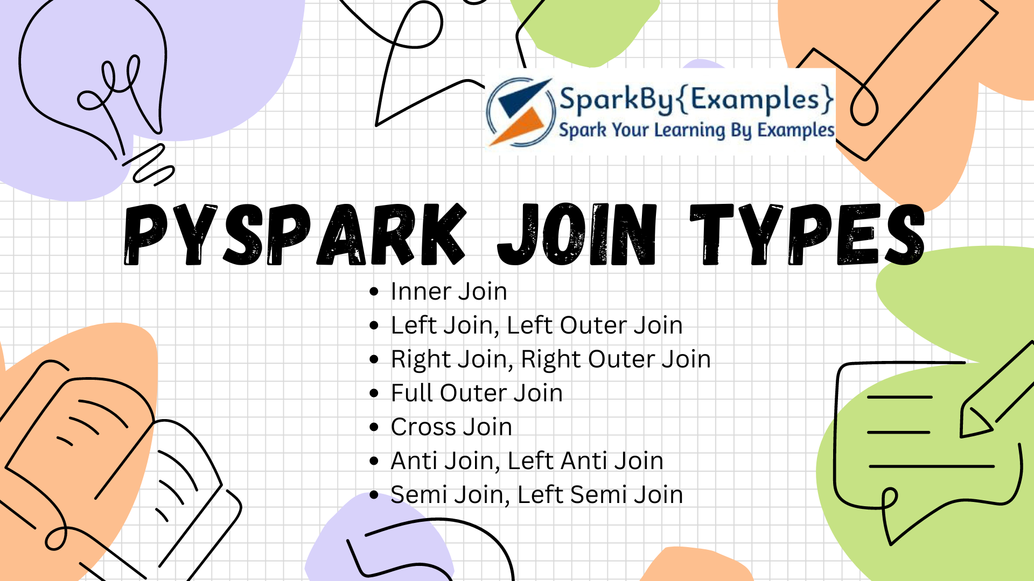
PySpark Join is used to combine two DataFrames and by chaining these you can join multiple DataFrames; it supports all basic join type operations available in traditional SQL like INNER, LEFT OUTER, RIGHT OUTER, LEFT ANTI, LEFT SEMI, CROSS, SELF JOIN. PySpark Joins are wider transformations that involve data shuffling across the network.
Advertisements
PySpark SQL Joins comes with more optimizations by default (thanks to DataFrames), but there are still some performance issues to consider while using it. Understanding how to effectively utilize PySpark joins is essential for conducting comprehensive data analysis, building data pipelines, and deriving valuable insights from large-scale datasets.
In this PySpark SQL Join, you will learn different Join syntaxes and use different Join types on two or more DataFrames and Datasets using examples.
- PySpark Join Syntax
- PySpark Join Types
- Inner Join DataFrame
- Full Outer Join DataFrame
- Left Outer Join DataFrame
- Right Outer Join DataFrame
- Left Anti Join DataFrame
- Left Semi Join DataFrame
- Self Join DataFrame
- Using SQL Expression

1. PySpark Join Syntax
PySpark SQL join has a below syntax and it can be accessed directly from DataFrame.

# Syntax
join(self, other, on=None, how=None)
join() operation takes parameters as below and returns DataFrame.
- param other: Right side of the join
- param on: a string for the join column name
- param how: default inner. Must be one of inner, cross, outer,full, full_outer, left, left_outer, right, right_outer,left_semi, and left_anti.
You can also write Join expression by adding where() and filter() methods on DataFrame and can have Join on multiple columns.

2. PySpark Join Types
Below are the different Join Types PySpark supports.
Join String | Equivalent SQL Join
inner | INNER JOIN
outer, full, fullouter, full_outer | FULL OUTER JOIN
left, leftouter, left_outer | LEFT JOIN
right, rightouter, right_outer | RIGHT JOIN
cross
anti, leftanti, left_anti
semi, leftsemi, left_semi
PySpark Join Types
Before diving into PySpark SQL Join illustrations, let’s initiate “emp” and “dept” DataFrames.The emp DataFrame contains the “emp_id” column with unique values, while the dept DataFrame contains the “dept_id” column with unique values. Additionally, the “emp_dept_id” from “emp” refers to the “dept_id” in the “dept” dataset.

# Prapare data
import pyspark
from pyspark.sql import SparkSession

emp = [(1,"Smith",-1,"2018","10","M",3000), \
(2,"Rose",1,"2010","20","M",4000), \
(3,"Williams",1,"2010","10","M",1000), \
(4,"Jones",2,"2005","10","F",2000), \
(5,"Brown",2,"2010","40","",-1), \
(6,"Brown",2,"2010","50","",-1) \
]
empColumns = ["emp_id","name","superior_emp_id","year_joined", \
"emp_dept_id","gender","salary"]

empDF = spark.createDataFrame(data=emp, schema = empColumns)
empDF.printSchema()
empDF.show(truncate=False)

dept = [("Finance",10), \
("Marketing",20), \
("Sales",30), \
("IT",40) \
]
deptColumns = ["dept_name","dept_id"]
deptDF = spark.createDataFrame(data=dept, schema = deptColumns)
deptDF.printSchema()
deptDF.show(truncate=False)
This yields the below output.

# Emp Dataset
+------+--------+---------------+-----------+-----------+------+------+
|emp_id|name |superior_emp_id|year_joined|emp_dept_id|gender|salary|
+------+--------+---------------+-----------+-----------+------+------+
|1 |Smith |-1 |2018 |10 |M |3000 |
|2 |Rose |1 |2010 |20 |M |4000 |
|3 |Williams|1 |2010 |10 |M |1000 |
|4 |Jones |2 |2005 |10 |F |2000 |
|5 |Brown |2 |2010 |40 | |-1 |
|6 |Brown |2 |2010 |50 | |-1 |
+------+--------+---------------+-----------+-----------+------+------+

# Dept Dataset
+---------+-------+
|dept_name|dept_id|
+---------+-------+
|Finance |10 |
|Marketing|20 |
|Sales |30 |
|IT |40 |
+---------+-------+

3. How Join works?
PySpark’s join operation combines data from two or more Datasets based on a common column or key. It is a fundamental operation in PySpark and is similar to SQL joins.
Common Key: In order to join two or more datasets we need a common key or a column on which you want to join. This key is used to join the matching rows from the datasets.
Partitioning: PySpark Datasets are distributed and partitioned across multiple nodes in a cluster. Ideally, data with the same join key should be located in the same partition. If the Datasets are not already partitioned on the join key, PySpark may perform a shuffle operation to redistribute the data, ensuring that rows with the same join key are on the same node. Shuffling can be an expensive operation, especially for large Datasets.
Join Type Specification: We can specify the type of join like inner join, full join, left join, etc., by specifying on “how” parameter of the .join() method. This parameter determines which rows should be included or excluded in the resulting Dataset.
Join Execution: PySpark performs the join by comparing the values in the common key column between the Datasets.
- Inner Join: Returns only the rows with matching keys in both DataFrames.
- Left Join: Returns all rows from the left DataFrame and matching rows from the right DataFrame.
- Right Join: Returns all rows from the right DataFrame and matching rows from the left DataFrame.
- Full Outer Join: Returns all rows from both DataFrames, including matching and non-matching rows.
- Left Semi Join: Returns all rows from the left DataFrame where there is a match in the right DataFrame.
- Left Anti Join: Returns all rows from the left DataFrame where there is no match in the right DataFrame.

4. PySpark Inner Join DataFrame
The default join in PySpark is the inner join, commonly used to retrieve data from two or more DataFrames based on a shared key. An Inner join combines two DataFrames based on the key (common column) provided and results in rows where there is a matching found. Rows from both DataFrames are dropped with a non-matching key.

# Inner join
empDF.join(deptDF,empDF.emp_dept_id == deptDF.dept_id,"inner") \
.show(truncate=False)
This example drops “emp_dept_id” with value 50 from “emp” And “dept_id” with value 30 from “dept” datasets. Following is the result of the above Join statement.

# Output
+------+--------+---------------+-----------+-----------+------+------+---------+-------+
|emp_id|name |superior_emp_id|year_joined|emp_dept_id|gender|salary|dept_name|dept_id|
+------+--------+---------------+-----------+-----------+------+------+---------+-------+
|1 |Smith |-1 |2018 |10 |M |3000 |Finance |10 |
|2 |Rose |1 |2010 |20 |M |4000 |Marketing|20 |
|3 |Williams|1 |2010 |10 |M |1000 |Finance |10 |
|4 |Jones |2 |2005 |10 |F |2000 |Finance |10 |
|5 |Brown |2 |2010 |40 | |-1 |IT |40 |
+------+--------+---------------+-----------+-----------+------+------+---------+-------+

5. PySpark Left Outer Join
Left a.k.a Leftouter join returns all rows from the left dataset regardless of match found on the right dataset when join expression doesn’t match, it assigns null for that record and drops records from right where match not found.

# Left outer join
empDF.join(deptDF,empDF.emp_dept_id == deptDF.dept_id,"left")
.show(truncate=False)
empDF.join(deptDF,empDF.emp_dept_id == deptDF.dept_id,"leftouter")
.show(truncate=False)
In our dataset, the record with “emp_dept_id” 50 does not have a corresponding entry in the “dept” dataset, resulting in null values in the “dept” columns (dept_name & dept_id). Additionally, the entry with “dept_id” 30 from the “dept” dataset is omitted from the results. Below is the outcome of the provided join expression.

# output
+------+--------+---------------+-----------+-----------+------+------+---------+-------+
|emp_id|name |superior_emp_id|year_joined|emp_dept_id|gender|salary|dept_name|dept_id|
+------+--------+---------------+-----------+-----------+------+------+---------+-------+
|1 |Smith |-1 |2018 |10 |M |3000 |Finance |10 |
|2 |Rose |1 |2010 |20 |M |4000 |Marketing|20 |
|3 |Williams|1 |2010 |10 |M |1000 |Finance |10 |
|4 |Jones |2 |2005 |10 |F |2000 |Finance |10 |
|5 |Brown |2 |2010 |40 | |-1 |IT |40 |
|6 |Brown |2 |2010 |50 | |-1 |null |null |
+------+--------+---------------+-----------+-----------+------+------+---------+-------+

6. Right Outer Join
Right a.k.a Rightouter join is opposite of left join, here it returns all rows from the right dataset regardless of math found on the left dataset, when join expression doesn’t match, it assigns null for that record and drops records from left where match not found.

# Right outer join
empDF.join(deptDF,empDF.emp_dept_id == deptDF.dept_id,"right") \
.show(truncate=False)
empDF.join(deptDF,empDF.emp_dept_id == deptDF.dept_id,"rightouter") \
.show(truncate=False)
In our example, the dataset on the right, containing “dept_id” with a value of 30, does not have a corresponding record in the left dataset “emp”. Consequently, this record contains null values for the columns from “emp”. Additionally, the record with “emp_dept_id” value 50 is dropped as no match was found in the left dataset. Below is the result of the aforementioned join expression.

# Output
+------+--------+---------------+-----------+-----------+------+------+---------+-------+
|emp_id|name |superior_emp_id|year_joined|emp_dept_id|gender|salary|dept_name|dept_id|
+------+--------+---------------+-----------+-----------+------+------+---------+-------+
|4 |Jones |2 |2005 |10 |F |2000 |Finance |10 |
|3 |Williams|1 |2010 |10 |M |1000 |Finance |10 |
|1 |Smith |-1 |2018 |10 |M |3000 |Finance |10 |
|2 |Rose |1 |2010 |20 |M |4000 |Marketing|20 |
|null |null |null |null |null |null |null |Sales |30 |
|5 |Brown |2 |2010 |40 | |-1 |IT |40 |
+------+--------+---------------+-----------+-----------+------+------+---------+-------+

7. PySpark Full Outer Join
Outer a.k.a full, fullouter join in PySpark combines the results of both left and right outer joins, ensuring that all records from both DataFrames are included in the resulting DataFrame. It includes all rows from both DataFrames and fills in missing values with nulls where there is no match. In other words, it merges the DataFrames based on a common key, but retains all rows from both DataFrames, even if there’s no match. This join type is useful when you want to preserve all the information from both datasets, regardless of whether there’s a match on the key or not.

# Full outer join
empDF.join(deptDF,empDF.emp_dept_id == deptDF.dept_id,"outer") \
.show(truncate=False)
empDF.join(deptDF,empDF.emp_dept_id == deptDF.dept_id,"full") \
.show(truncate=False)
empDF.join(deptDF,empDF.emp_dept_id == deptDF.dept_id,"fullouter") \
.show(truncate=False)
This code snippet performs a full outer join between two PySpark DataFrames, empDF and deptDF, based on the condition that emp_dept_id from empDF is equal to dept_id from deptDF.
In our “emp” dataset, the “emp_dept_id” with a value of 50 does not have a corresponding record in the “dept” dataset, resulting in null values in the “dept” columns. Similarly, the “dept_id” 30 does not have a record in the “emp” dataset, hence you observe null values in the “emp” columns. Below is the output of the provided join example.

# Output
+------+--------+---------------+-----------+-----------+------+------+---------+-------+
|emp_id|name |superior_emp_id|year_joined|emp_dept_id|gender|salary|dept_name|dept_id|
+------+--------+---------------+-----------+-----------+------+------+---------+-------+
|2 |Rose |1 |2010 |20 |M |4000 |Marketing|20 |
|5 |Brown |2 |2010 |40 | |-1 |IT |40 |
|1 |Smith |-1 |2018 |10 |M |3000 |Finance |10 |
|3 |Williams|1 |2010 |10 |M |1000 |Finance |10 |
|4 |Jones |2 |2005 |10 |F |2000 |Finance |10 |
|6 |Brown |2 |2010 |50 | |-1 |null |null |
|null |null |null |null |null |null |null |Sales |30 |
+------+--------+---------------+-----------+-----------+------+------+---------+-------+

8. Left Semi Join
A Left Semi Join in PySpark returns only the rows from the left DataFrame (the first DataFrame mentioned in the join operation) where there is a match with the right DataFrame (the second DataFrame). It does not include any columns from the right DataFrame in the resulting DataFrame. This join type is useful when you only want to filter rows from the left DataFrame based on whether they have a matching key in the right DataFrame.
Left Semi Join can also be achieved by selecting only the columns from the left dataset from the result of the inner join

# Left semi join
empDF.join(deptDF,empDF.emp_dept_id == deptDF.dept_id,"leftsemi") \
.show(truncate=False)
Below is the result of the above join expression.

# Output
+------+--------+---------------+-----------+-----------+------+------+
|emp_id|name |superior_emp_id|year_joined|emp_dept_id|gender|salary|
+------+--------+---------------+-----------+-----------+------+------+
|1 |Smith |-1 |2018 |10 |M |3000 |
|2 |Rose |1 |2010 |20 |M |4000 |
|3 |Williams|1 |2010 |10 |M |1000 |
|4 |Jones |2 |2005 |10 |F |2000 |
|5 |Brown |2 |2010 |40 | |-1 |
+------+--------+---------------+-----------+-----------+------+------+

9. Left Anti Join
A Left Anti Join in PySpark returns only the rows from the left DataFrame (the first DataFrame mentioned in the join operation) where there is no match with the right DataFrame (the second DataFrame). It excludes any rows from the left DataFrame that have a corresponding key in the right DataFrame. This join type is useful when you want to filter out rows from the left DataFrame that have matching keys in the right DataFrame.

# Left anti join
empDF.join(deptDF,empDF.emp_dept_id == deptDF.dept_id,"leftanti") \
.show(truncate=False)
Yields below output

# Output
+------+-----+---------------+-----------+-----------+------+------+
|emp_id|name |superior_emp_id|year_joined|emp_dept_id|gender|salary|
+------+-----+---------------+-----------+-----------+------+------+
|6 |Brown|2 |2010 |50 | |-1 |
+------+-----+---------------+-----------+-----------+------+------+

10. PySpark Self Join
Joins are not complete without a self join, Though there is no self-join type available i PySpark, we can use any of the above-explained join types to join DataFrame to itself. below example use inner self join.

# Self join
empDF.alias("emp1").join(empDF.alias("emp2"), \
col("emp1.superior_emp_id") == col("emp2.emp_id"),"inner") \
.select(col("emp1.emp_id"),col("emp1.name"), \
col("emp2.emp_id").alias("superior_emp_id"), \
col("emp2.name").alias("superior_emp_name")) \
.show(truncate=False)
Here, we are joining emp dataset with itself to find out the superior emp_id and name for all employees.

# Output
+------+--------+---------------+-----------------+
|emp_id|name |superior_emp_id|superior_emp_name|
+------+--------+---------------+-----------------+
|2 |Rose |1 |Smith |
|3 |Williams|1 |Smith |
|4 |Jones |2 |Rose |
|5 |Brown |2 |Rose |
|6 |Brown |2 |Rose |
+------+--------+---------------+-----------------+

11. Using SQL Expression
Alternatively, you can also use SQL query to join DataFrames/tables in PySpark. To do so, first, create a temporary view using createOrReplaceTempView(), then use the spark.sql() to execute the join query.

# Using spark.sql

empDF.createOrReplaceTempView("EMP")
deptDF.createOrReplaceTempView("DEPT")

joinDF = spark.sql("select * from EMP e, DEPT d where e.emp_dept_id == d.dept_id") \
.show(truncate=False)

joinDF2 = spark.sql("select * from EMP e INNER JOIN DEPT d ON e.emp_dept_id == d.dept_id") \
.show(truncate=False)

12. PySpark SQL Join on multiple DataFrames
When you need to join more than two tables, you either use SQL expression after creating a temporary view on the DataFrame or use the result of join operation to join with another DataFrame like chaining them. for example

# Join on multiple dataFrames
df1.join(df2,df1.id1 == df2.id2,"inner") \
.join(df3,df1.id1 == df3.id3,"inner")

13. PySpark SQL Join Complete Example

import pyspark
from pyspark.sql import SparkSession
from pyspark.sql.functions import col

spark = SparkSession.builder.appName('SparkByExamples.com').getOrCreate()

emp = [(1,"Smith",-1,"2018","10","M",3000), \
(2,"Rose",1,"2010","20","M",4000), \
(3,"Williams",1,"2010","10","M",1000), \
(4,"Jones",2,"2005","10","F",2000), \
(5,"Brown",2,"2010","40","",-1), \
(6,"Brown",2,"2010","50","",-1) \
]
empColumns = ["emp_id","name","superior_emp_id","year_joined", \
"emp_dept_id","gender","salary"]

empDF = spark.createDataFrame(data=emp, schema = empColumns)
empDF.printSchema()
empDF.show(truncate=False)

dept = [("Finance",10), \
("Marketing",20), \
("Sales",30), \
("IT",40) \
]
deptColumns = ["dept_name","dept_id"]
deptDF = spark.createDataFrame(data=dept, schema = deptColumns)
deptDF.printSchema()
deptDF.show(truncate=False)

empDF.join(deptDF,empDF.emp_dept_id == deptDF.dept_id,"inner") \
.show(truncate=False)

empDF.join(deptDF,empDF.emp_dept_id == deptDF.dept_id,"outer") \
.show(truncate=False)
empDF.join(deptDF,empDF.emp_dept_id == deptDF.dept_id,"full") \
.show(truncate=False)
empDF.join(deptDF,empDF.emp_dept_id == deptDF.dept_id,"fullouter") \
.show(truncate=False)

empDF.join(deptDF,empDF.emp_dept_id == deptDF.dept_id,"left") \
.show(truncate=False)
empDF.join(deptDF,empDF.emp_dept_id == deptDF.dept_id,"leftouter") \
.show(truncate=False)

empDF.join(deptDF,empDF.emp_dept_id == deptDF.dept_id,"right") \
.show(truncate=False)
empDF.join(deptDF,empDF.emp_dept_id == deptDF.dept_id,"rightouter") \
.show(truncate=False)

empDF.join(deptDF,empDF.emp_dept_id == deptDF.dept_id,"leftsemi") \
.show(truncate=False)

empDF.join(deptDF,empDF.emp_dept_id == deptDF.dept_id,"leftanti") \
.show(truncate=False)

empDF.alias("emp1").join(empDF.alias("emp2"), \
col("emp1.superior_emp_id") == col("emp2.emp_id"),"inner") \
.select(col("emp1.emp_id"),col("emp1.name"), \
col("emp2.emp_id").alias("superior_emp_id"), \
col("emp2.name").alias("superior_emp_name")) \
.show(truncate=False)

empDF.createOrReplaceTempView("EMP")
deptDF.createOrReplaceTempView("DEPT")

joinDF = spark.sql("select * from EMP e, DEPT d where e.emp_dept_id == d.dept_id") \
.show(truncate=False)

joinDF2 = spark.sql("select * from EMP e INNER JOIN DEPT d ON e.emp_dept_id == d.dept_id") \
.show(truncate=False)

Examples explained here are available at the GitHub project for reference.

14. Frequently asked questions on PySpark Joins
What is the default join in PySpark?
In PySpark the default join type is “inner” join when using with .join() method. If you don’t explicitly specify the join type using the “how” parameter, it will perform the inner join. One can change the join type using the how parameter of .join().
Is join expensive in PySpark?
Yes, Join in PySpark is expensive because of the data shuffling (wider transformation) that happens between the partitioned data in a cluster. It basically depends on the data size, data skew, cluster configuration, join type being performed, partitioning, and broadcast joins.
Can we join on multiple columns in PySpark?
Yes, we can join on multiple columns. Joining on multiple columns involves more join conditions with multiple keys for matching the rows between the datasets.It can be achieved by passing a list of column names as the join condition when using the .join() method.
How do I drop duplicate columns after joining PySpark?
PySpark distinct() function is used to drop/remove the duplicate rows (all columns) from Dataset and dropDuplicates() is used to drop rows based on selected (one or multiple) columns
What is the difference between the inner join and the left join?
The key difference is that an inner join includes only the rows with matching keys in both Datasets, while a left join includes all the rows from the left Dataset and matches them with rows from the right Dataset where there’s a match. Non-matching rows in the left Dataset in a left join are included with null values in the columns from the right Dataset.
What is the difference between left join and left outer join?
Both terms refer to the same type of join operation, and they can be used interchangeably. The “OUTER” keyword is optional when specifying a “LEFT JOIN.”

Conclusion
In conclusion, PySpark joins offer powerful capabilities for combining and analyzing data from multiple DataFrames. By leveraging these join operations, users can merge datasets based on common keys, filter rows based on matching or non-matching criteria, and enrich their analysis with comprehensive data insights. Understanding each join type and their implications on the resulting DataFrame is crucial for efficiently managing and manipulating data in PySpark.
Happy Learning !!

Related Articles
- PySpark Join Two or Multiple DataFrames
- PySpark Join Multiple Columns
- PySpark Broadcast Join with Example
- Spark RDD join with Examples
- PySpark Replace Empty Value With None/null on DataFrame
- PySpark show() – Display DataFrame Contents in Table
- PySpark – Loop/Iterate Through Rows in DataFrame
- PySpark Count Distinct from DataFrame
- PySpark – Drop One or Multiple Columns From DataFrame
- PySpark SQL Types (DataType) with Examples
- PySpark SparkContext Explained

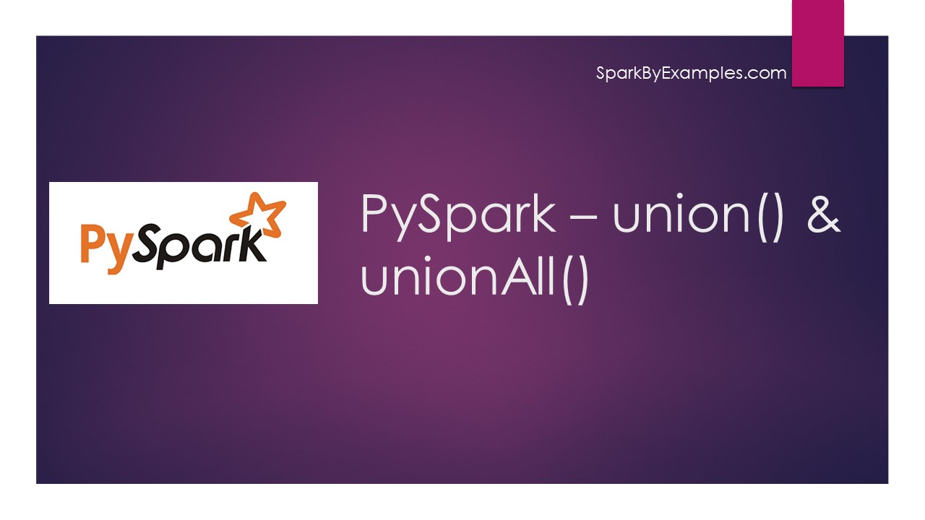
PySpark union() and unionAll() transformations are used to merge two or more DataFrame’s of the same schema or structure. In this PySpark article, I will explain both union transformations with PySpark examples.
Advertisements
Dataframe union() – union() method of the DataFrame is used to merge two DataFrame’s of the same structure/schema. The output includes all rows from both DataFrames and duplicates are retained. If schemas are not the same it returns an error. To deal with the DataFrames of different schemas we need to use unionByName() transformation.

Syntax

dataFrame1.union(dataFrame2)
DataFrame unionAll() – unionAll() is deprecated since Spark “2.0.0” version and replaced with union().

Syntax

dataFrame1.unionAll(dataFrame2)
Note: In other SQL languages, Union eliminates the duplicates but UnionAll merges two datasets including duplicate records. But, in PySpark both behave the same and recommend using DataFrame duplicate() function to remove duplicate rows.

First, let’s create two DataFrame with the same schema.
First DataFrame

# Imports
import pyspark
from pyspark.sql import SparkSession

spark = SparkSession.builder.appName('SparkByExamples.com').getOrCreate()

simpleData = [("James","Sales","NY",90000,34,10000), \
("Michael","Sales","NY",86000,56,20000), \
("Robert","Sales","CA",81000,30,23000), \
("Maria","Finance","CA",90000,24,23000) \
]

columns= ["employee_name","department","state","salary","age","bonus"]
df = spark.createDataFrame(data = simpleData, schema = columns)
df.printSchema()
df.show(truncate=False)
This yields the below schema and DataFrame output.

# Output
root
|-- employee_name: string (nullable = true)
|-- department: string (nullable = true)
|-- state: string (nullable = true)
|-- salary: long (nullable = true)
|-- age: long (nullable = true)
|-- bonus: long (nullable = true)

+-------------+----------+-----+------+---+-----+
|employee_name|department|state|salary|age|bonus|
+-------------+----------+-----+------+---+-----+
|James |Sales |NY |90000 |34 |10000|
|Michael |Sales |NY |86000 |56 |20000|
|Robert |Sales |CA |81000 |30 |23000|
|Maria |Finance |CA |90000 |24 |23000|
+-------------+----------+-----+------+---+-----+
Second DataFrame
Now, let’s create a second Dataframe with the new records and some records from the above Dataframe but with the same schema.

# Create DataFrame2
simpleData2 = [("James","Sales","NY",90000,34,10000), \
("Maria","Finance","CA",90000,24,23000), \
("Jen","Finance","NY",79000,53,15000), \
("Jeff","Marketing","CA",80000,25,18000), \
("Kumar","Marketing","NY",91000,50,21000) \
]
columns2= ["employee_name","department","state","salary","age","bonus"]

df2 = spark.createDataFrame(data = simpleData2, schema = columns2)

df2.printSchema()
df2.show(truncate=False)
This yields below output

# Output
+-------------+----------+-----+------+---+-----+
|employee_name|department|state|salary|age|bonus|
+-------------+----------+-----+------+---+-----+
|James |Sales |NY |90000 |34 |10000|
|Maria |Finance |CA |90000 |24 |23000|
|Jen |Finance |NY |79000 |53 |15000|
|Jeff |Marketing |CA |80000 |25 |18000|
|Kumar |Marketing |NY |91000 |50 |21000|
+-------------+----------+-----+------+---+-----+

Merge two or more DataFrames using union
DataFrame union() method merges two DataFrames and returns the new DataFrame with all rows from two Dataframes regardless of duplicate data.

# union() to merge two DataFrames
unionDF = df.union(df2)
unionDF.show(truncate=False)
As you see below it returns all records.

# Output
+-------------+----------+-----+------+---+-----+
|employee_name|department|state|salary|age|bonus|
+-------------+----------+-----+------+---+-----+
|James |Sales |NY |90000 |34 |10000|
|Michael |Sales |NY |86000 |56 |20000|
|Robert |Sales |CA |81000 |30 |23000|
|Maria |Finance |CA |90000 |24 |23000|
|James |Sales |NY |90000 |34 |10000|
|Maria |Finance |CA |90000 |24 |23000|
|Jen |Finance |NY |79000 |53 |15000|
|Jeff |Marketing |CA |80000 |25 |18000|
|Kumar |Marketing |NY |91000 |50 |21000|
+-------------+----------+-----+------+---+-----+

Merge DataFrames using unionAll
DataFrame unionAll() method is deprecated since PySpark “2.0.0” version and recommends using the union() method.

# unionAll() to merge two DataFrames
unionAllDF = df.unionAll(df2)
unionAllDF.show(truncate=False)
Returns the same output as above.

Merge without Duplicates
Since the union() method returns all rows without distinct records, we will use the distinct() function to return just one record when a duplicate exists.

# Remove duplicates after union() using distinct()
disDF = df.union(df2).distinct()
disDF.show(truncate=False)
Yields below output. As you see, this returns only distinct rows.

# Output
+-------------+----------+-----+------+---+-----+
|employee_name|department|state|salary|age|bonus|
+-------------+----------+-----+------+---+-----+
|James |Sales |NY |90000 |34 |10000|
|Maria |Finance |CA |90000 |24 |23000|
|Kumar |Marketing |NY |91000 |50 |21000|
|Michael |Sales |NY |86000 |56 |20000|
|Jen |Finance |NY |79000 |53 |15000|
|Jeff |Marketing |CA |80000 |25 |18000|
|Robert |Sales |CA |81000 |30 |23000|
+-------------+----------+-----+------+---+-----+

Complete Example of DataFrame Union()

# Imports
import pyspark
from pyspark.sql import SparkSession

spark = SparkSession.builder.appName('SparkByExamples.com').getOrCreate()

simpleData = [("James","Sales","NY",90000,34,10000), \
("Michael","Sales","NY",86000,56,20000), \
("Robert","Sales","CA",81000,30,23000), \
("Maria","Finance","CA",90000,24,23000) \
]

columns= ["employee_name","department","state","salary","age","bonus"]
df = spark.createDataFrame(data = simpleData, schema = columns)
df.printSchema()
df.show(truncate=False)

simpleData2 = [("James","Sales","NY",90000,34,10000), \
("Maria","Finance","CA",90000,24,23000), \
("Jen","Finance","NY",79000,53,15000), \
("Jeff","Marketing","CA",80000,25,18000), \
("Kumar","Marketing","NY",91000,50,21000) \
]
columns2= ["employee_name","department","state","salary","age","bonus"]

df2 = spark.createDataFrame(data = simpleData2, schema = columns2)

df2.printSchema()
df2.show(truncate=False)

unionDF = df.union(df2)
unionDF.show(truncate=False)
disDF = df.union(df2).distinct()
disDF.show(truncate=False)

unionAllDF = df.unionAll(df2)
unionAllDF.show(truncate=False)
This complete example is also available at the GitHub project.

Frequently Asked Questions on union()
Can we union() DataFrames that have different schemas?
The union() can be performed on the DataFrames that have the same schema and structure. If the schemas are different we may need to use unionByName() or make changes to the DataFrames to align to their schemas before performing union() transformation.
Does the union() transformation remove duplicates?
The union()transformation includes all rows from both DataFrames, including duplicates. If you want to remove duplicates, you can use the dropDuplicates transformation after performing the union() or apply distinct() to remove the duplicates.
How does union() handle NULL values?
union() retains NULL values from both DataFrames. If a column has a NULL value in one DataFrame and a non-NULL value in the corresponding column of the other DataFrame, both values will be included in the result.
Can we use union() to combine DataFrames with different ordering of columns?
Yes, the union() transformation aligns columns based on their names, not their positions. If the columns have the same names in both DataFrames, the ordering of columns does not matter.

Conclusion
In this PySpark article, you have learned how to merge two or more DataFrame’s of the same schema into a single DataFrame using the Union method and learned the unionAll() deprecates and uses duplicate() to duplicate the same elements.
Happy learning !!

Related Articles
- PySpark unionByName()
- PySpark distinct vs dropDuplicates
- Pyspark Select Distinct Rows
- PySpark repartition() – Explained with Examples
- PySpark SparkContext Explained
- PySpark RDD Transformations with examples
- PySpark – Create an Empty DataFrame & RDD
- PySpark Distinct to Drop Duplicate Rows

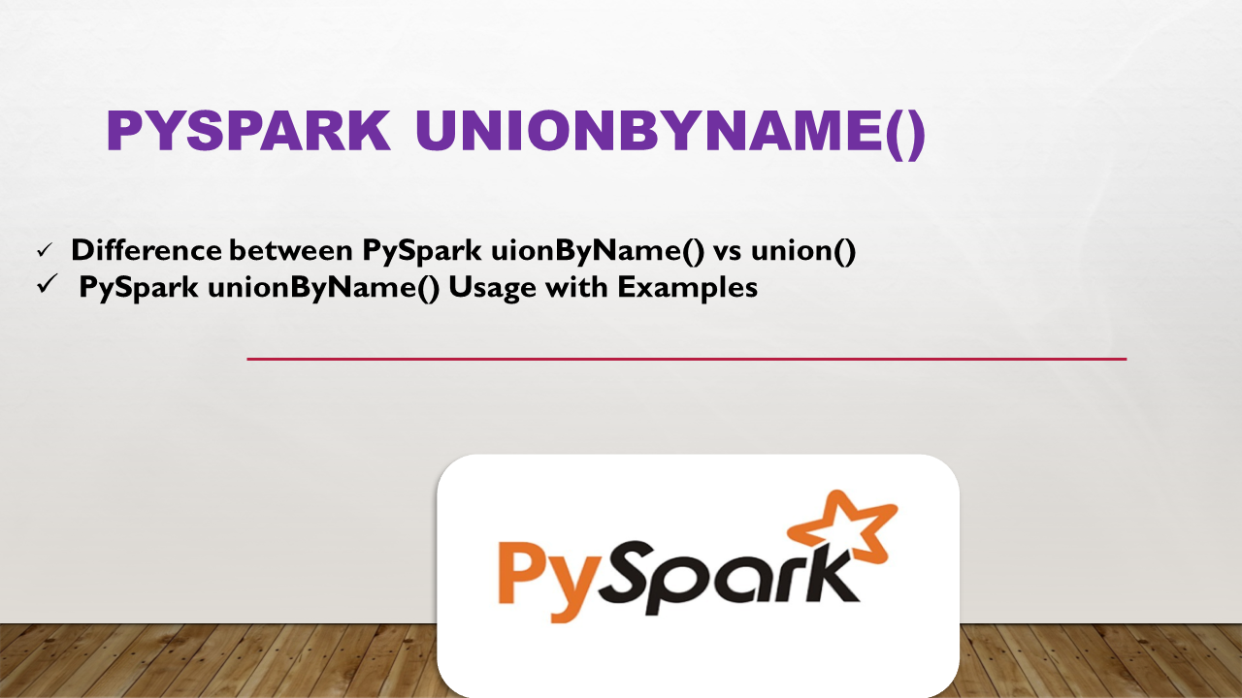
The pyspark.sql.DataFrame.unionByName() to merge/union two DataFrames with column names. In PySpark you can easily achieve this using unionByName() transformation, this function also takes param allowMissingColumns with the value True if you have a different number of columns on two DataFrames.
Advertisements

1. Syntax of unionByName()
Following is the syntax of the unionByName()

# unionByName() Syntax
unionByName(df, allowMissingColumns=True)

2. Difference between PySpark unionByName() vs union()
The difference between unionByName() function and union() is that this function
resolves columns by name (not by position). In other words, unionByName() is used to merge two DataFrames by column names instead of by position.
unionByName() also provides an argument allowMissingColumns to specify if you have a different column counts. In case you are using an older than Spark 3.1 version, use the below approach to merge DataFrames with different column names.

Related: PySpark Merge DataFrames with Different Columns (Python Example)

3. PySpark unionByName() Usage with Examples
PySpark unionByName() is used to union two DataFrames when you have column names in a different order or even if you have missing columns in any DataFrme, in other words, this function
resolves columns by name (not by position). First, let’s create DataFrames with the different number of columns.

from pyspark.sql import SparkSession
spark = SparkSession.builder.appName('SparkByExamples.com').getOrCreate()

# Create DataFrame df1 with columns name, and id
data = [("James",34), ("Michael",56), \
("Robert",30), ("Maria",24) ]

df1 = spark.createDataFrame(data = data, schema=["name","id"])
df1.printSchema()

# Create DataFrame df2 with columns name and id
data2=[(34,"James"),(45,"Maria"), \
(45,"Jen"),(34,"Jeff")]

df2 = spark.createDataFrame(data = data2, schema = ["id","name"])
df2.printSchema()
Yields below output.
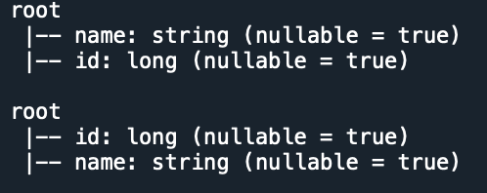
Now let’s use the PySpark unionByName() to union these two.

# unionByName() example
df3 = df1.unionByName(df2)
df3.printSchema
df3.show()
Yields below output.
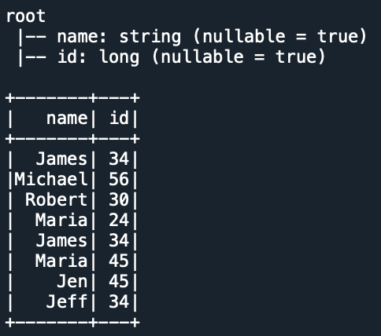

4. Use unionByName() with Different Number of Columns
In the above example we have two DataFrames with the same column names but in different order. If you have a different number of columns then use allowMissingColumns=True. When using this, the result of the DataFrmae contains null values for the columns that are missing on the DataFrame.
Note that param allowMissingColumns is available since Spark 3.1 version.

# Create DataFrames with different column names
df1 = spark.createDataFrame([[5, 2, 6]], ["col0", "col1", "col2"])
df2 = spark.createDataFrame([[6, 7, 3]], ["col1", "col2", "col3"])

# Using allowMissingColumns
df3 = df1.unionByName(df2, allowMissingColumns=True)
df3.printSchema
df3.show()
Yields below output.
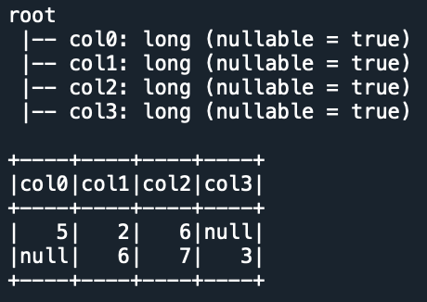

5. Complete Example of PySpark unionByName()

from pyspark.sql import SparkSession
spark = SparkSession.builder.appName('SparkByExamples.com').getOrCreate()

# Create DataFrame df1 with columns name, and id
data = [("James",34), ("Michael",56), \
("Robert",30), ("Maria",24) ]

df1 = spark.createDataFrame(data = data, schema=["name","id"])
df1.printSchema()

# Create DataFrame df2 with columns name and id
data2=[(34,"James"),(45,"Maria"), \
(45,"Jen"),(34,"Jeff")]

df2 = spark.createDataFrame(data = data2, schema = ["id","name"])
df2.printSchema()

# Using unionByName()
df3 = df1.unionByName(df2)
df3.printSchema()
df3.show()

# Using allowMissingColumns
df1 = spark.createDataFrame([[5, 2, 6]], ["col0", "col1", "col2"])
df2 = spark.createDataFrame([[6, 7, 3]], ["col1", "col2", "col3"])
df3 = df1.unionByName(df2, allowMissingColumns=True)
df3.printSchema()
df3.show()

6. Conclusion
In this article, you have learned what is PySpark unionByName() and how it is different from union(). unionByName() is used to merge or union two DataFrames with different column names and a different number of columns.
Happy Learning !!

Related Articles
- PySpark between() range of values
- PySpark Union and UnionAll Explained
- PySpark union two DataFrames
- PySpark Broadcast Variable
- PySpark Broadcast Join
- PySpark persist() Example
- PySpark lag() Function
- PySpark Random Sample with Example
- PySpark reduceByKey usage with example

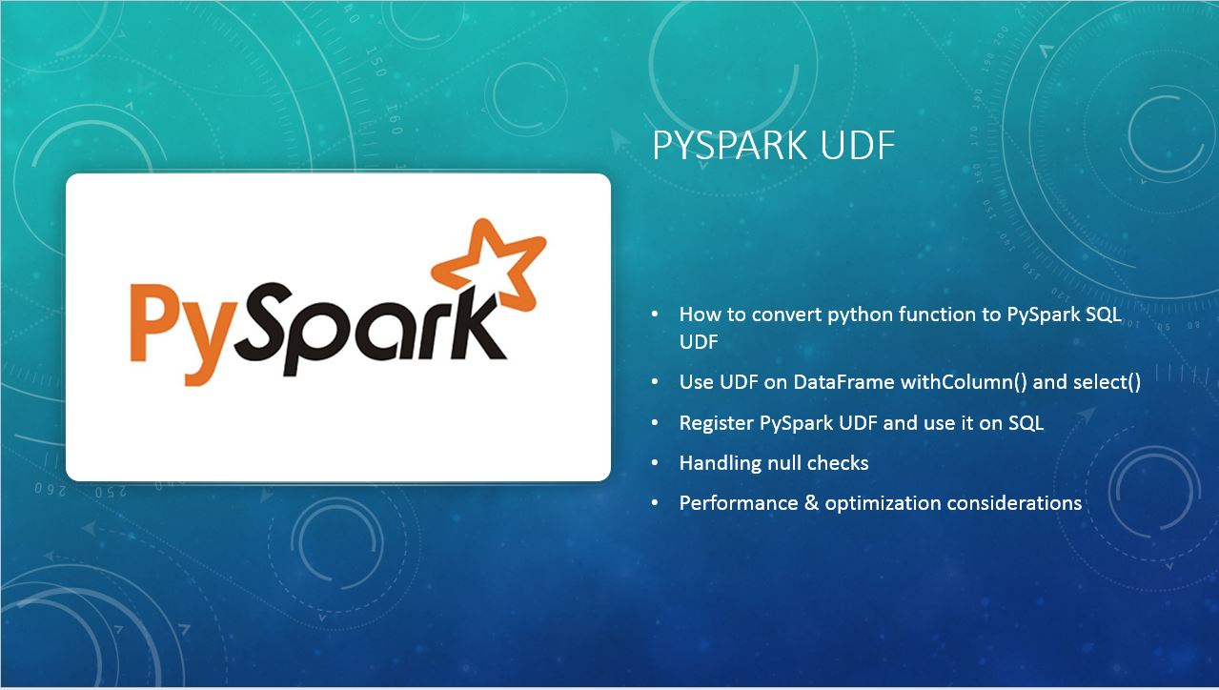
PySpark UDF Example
PySpark UDF (a.k.a User Defined Function) is the most useful feature of Spark SQL & DataFrame that is used to extend the PySpark build in capabilities. In this article, I will explain what is UDF? why do we need it and how to create and use it on DataFrame select(), withColumn() and SQL using PySpark (Spark with Python) examples.
Advertisements
Note: UDF’s are the most expensive operations hence use them only you have no choice and when essential. In the later section of the article, I will explain why using UDF’s is an expensive operation in detail.
Table of contents
- PySpark UDF Introduction
  - What is UDF?
  - Why do we need it?
- Create PySpark UDF (User Defined Function)
  - Create a DataFrame
  - Create a Python function
  - Convert python function to UDF
- Using UDF with DataFrame
  - Using UDF with DataFrame select()
  - Using UDF with DataFrame withColumn()
  - Registring UDF & Using it on SQL query
- Create UDF using annotation
- Special handling
  - Null check
  - Performance concern
- Complete Example

1. PySpark UDF Introduction

1.1 What is UDF?
UDF’s a.k.a User Defined Functions, If you are coming from SQL background, UDF’s are nothing new to you as most of the traditional RDBMS databases support User Defined Functions, these functions need to register in the database library and use them on SQL as regular functions.

PySpark UDF’s are similar to UDF on traditional databases. In PySpark, you create a function in a Python syntax and wrap it with PySpark SQL udf() or register it as udf and use it on DataFrame and SQL respectively.

1.2 Why do we need a UDF?
UDF’s are used to extend the functions of the framework and re-use these functions on multiple DataFrame’s. For example, you wanted to convert every first letter of a word in a name string to a capital case; PySpark build-in features don’t have this function hence you can create it a UDF and reuse this as needed on many Data Frames. UDF’s are once created they can be re-used on several DataFrame’s and SQL expressions.
Before you create any UDF, do your research to check if the similar function you wanted is already available in Spark SQL Functions. PySpark SQL provides several predefined common functions and many more new functions are added with every release. hence, It is best to check before you reinventing the wheel.
When you creating UDF’s you need to design them very carefully otherwise you will come across optimization & performance issues.

2. Create PySpark UDF

2.1 Create a DataFrame
Before we jump in creating a UDF, first let’s create a PySpark DataFrame.

from pyspark.sql import SparkSession

spark = SparkSession.builder.appName('SparkByExamples.com').getOrCreate()

columns = ["Seqno","Name"]
data = [("1", "john jones"),
("2", "tracey smith"),
("3", "amy sanders")]

df = spark.createDataFrame(data=data,schema=columns)

df.show(truncate=False)
Yields below output.

+-----+------------+
|Seqno|Names |
+-----+------------+
|1 |john jones |
|2 |tracey smith|
|3 |amy sanders |
+-----+------------+

2.2 Create a Python Function
The first step in creating a UDF is creating a Python function. Below snippet creates a function convertCase() which takes a string parameter and converts the first letter of every word to capital letter. UDF’s take parameters of your choice and returns a value.

def convertCase(str):
resStr=""
arr = str.split(" ")
for x in arr:
resStr= resStr + x[0:1].upper() + x[1:len(x)] + " "
return resStr
Note that there might be a better way to write this function. But for the sake of this article, I am not worried much about the performance and better ways.

2.3 Convert a Python function to PySpark UDF
Now convert this function convertCase() to UDF by passing the function to PySpark SQL udf(), this function is available at org.apache.spark.sql.functions.udf package. Make sure you import this package before using it.
PySpark SQL udf() function returns org.apache.spark.sql.expressions.UserDefinedFunction class object.

from pyspark.sql.functions import col, udf
from pyspark.sql.types import StringType

# Converting function to UDF
convertUDF = udf(lambda z: convertCase(z),StringType())
Note: The default type of the udf() is StringType hence, you can also write the above statement without return type.

# Converting function to UDF
# StringType() is by default hence not required
convertUDF = udf(lambda z: convertCase(z))

3. Using UDF with DataFrame

3.1 Using UDF with PySpark DataFrame select()
Now you can use convertUDF() on a DataFrame column as a regular build-in function.

df.select(col("Seqno"), \
convertUDF(col("Name")).alias("Name") ) \
.show(truncate=False)
This results below output.

+-----+-------------+
|Seqno|Name |
+-----+-------------+
|1 |John Jones |
|2 |Tracey Smith |
|3 |Amy Sanders |
+-----+-------------+

3.2 Using UDF with PySpark DataFrame withColumn()
You could also use udf on DataFrame withColumn() function, to explain this I will create another upperCase() function which converts the input string to upper case.

def upperCase(str):
return str.upper()
Let’s convert upperCase() python function to UDF and then use it with DataFrame withColumn(). Below example converts the values of “Name” column to upper case and creates a new column “Curated Name”

upperCaseUDF = udf(lambda z:upperCase(z),StringType())

df.withColumn("Cureated Name", upperCaseUDF(col("Name"))) \
.show(truncate=False)
This yields below output.

+-----+------------+-------------+
|Seqno|Name |Cureated Name|
+-----+------------+-------------+
|1 |john jones |JOHN JONES |
|2 |tracey smith|TRACEY SMITH |
|3 |amy sanders |AMY SANDERS |
+-----+------------+-------------+

3.3 Registering PySpark UDF & use it on SQL
In order to use convertCase() function on PySpark SQL, you need to register the function with PySpark by using spark.udf.register().

""" Using UDF on SQL """
spark.udf.register("convertUDF", convertCase,StringType())
df.createOrReplaceTempView("NAME_TABLE")
spark.sql("select Seqno, convertUDF(Name) as Name from NAME_TABLE") \
.show(truncate=False)
This yields the same output as 3.1 example.

4. Creating UDF using annotation
In the previous sections, you have learned creating a UDF is a 2 step process, first, you need to create a Python function, second convert function to UDF using SQL udf() function, however, you can avoid these two steps and create it with just a single step by using annotations.

@udf(returnType=StringType())
def upperCase(str):
return str.upper()

df.withColumn("Cureated Name", upperCase(col("Name"))) \
.show(truncate=False)
This results same output as section 3.2

5. Special Handling

5.1 Execution order
One thing to aware is in PySpark/Spark does not guarantee the order of evaluation of subexpressions meaning expressions are not guarantee to evaluated left-to-right or in any other fixed order. PySpark reorders the execution for query optimization and planning hence, AND, OR, WHERE and HAVING expression will have side effects.
So when you are designing and using UDF, you have to be very careful especially with null handling as these results runtime exceptions.

"""
No guarantee Name is not null will execute first
If convertUDF(Name) like '%John%' execute first then
you will get runtime error
"""
spark.sql("select Seqno, convertUDF(Name) as Name from NAME_TABLE " + \
"where Name is not null and convertUDF(Name) like '%John%'") \
.show(truncate=False)

5.2 Handling null check
UDF’s are error-prone when not designed carefully. for example, when you have a column that contains the value null on some records

""" null check """

columns = ["Seqno","Name"]
data = [("1", "john jones"),
("2", "tracey smith"),
("3", "amy sanders"),
('4',None)]

df2 = spark.createDataFrame(data=data,schema=columns)
df2.show(truncate=False)
df2.createOrReplaceTempView("NAME_TABLE2")

spark.sql("select convertUDF(Name) from NAME_TABLE2") \
.show(truncate=False)
Note that from the above snippet, record with “Seqno 4” has value “None” for “name” column. Since we are not handling null with UDF function, using this on DataFrame returns below error. Note that in Python None is considered null.

AttributeError: 'NoneType' object has no attribute 'split'

at org.apache.spark.api.python.BasePythonRunner$ReaderIterator.handlePythonException(PythonRunner.scala:456)
at org.apache.spark.sql.execution.python.PythonUDFRunner$$anon$1.read(PythonUDFRunner.scala:81)
at org.apache.spark.sql.execution.python.PythonUDFRunner$$anon$1.read(PythonUDFRunner.scala:64)
at org.apache.spark.api.python.BasePythonRunner$ReaderIterator.hasNext(PythonRunner.scala:410)
at org.apache.spark.InterruptibleIterator.hasNext(InterruptibleIterator.scala:37)
at scala.collection.Iterator$$anon$12.hasNext(Iterator.scala:440)
Below points to remember
- Its always best practice to check for null inside a UDF function rather than checking for null outside.
- In any case, if you can’t do a null check in UDF at lease use IF or CASE WHEN to check for null and call UDF conditionally.

spark.udf.register("_nullsafeUDF", lambda str: convertCase(str) if not str is None else "" , StringType())

spark.sql("select _nullsafeUDF(Name) from NAME_TABLE2") \
.show(truncate=False)

spark.sql("select Seqno, _nullsafeUDF(Name) as Name from NAME_TABLE2 " + \
" where Name is not null and _nullsafeUDF(Name) like '%John%'") \
.show(truncate=False)
This executes successfully without errors as we are checking for null/none while registering UDF.

5.3 Performance concern using UDF
UDFs are a black box to PySpark hence it can’t apply optimization and you will lose all the optimization PySpark does on Dataframe/Dataset. When possible you should use Spark SQL built-in functions as these functions provide optimization. Consider creating UDF only when the existing built-in SQL function doesn’t have it.

6. Complete PySpark UDF Example
Below is a complete UDF function example in Python

import pyspark
from pyspark.sql import SparkSession
from pyspark.sql.functions import col, udf
from pyspark.sql.types import StringType

spark = SparkSession.builder.appName('SparkByExamples.com').getOrCreate()

columns = ["Seqno","Name"]
data = [("1", "john jones"),
("2", "tracey smith"),
("3", "amy sanders")]

df = spark.createDataFrame(data=data,schema=columns)

df.show(truncate=False)

def convertCase(str):
resStr=""
arr = str.split(" ")
for x in arr:
resStr= resStr + x[0:1].upper() + x[1:len(x)] + " "
return resStr

""" Converting function to UDF """
convertUDF = udf(lambda z: convertCase(z))

df.select(col("Seqno"), \
convertUDF(col("Name")).alias("Name") ) \
.show(truncate=False)

def upperCase(str):
return str.upper()

upperCaseUDF = udf(lambda z:upperCase(z),StringType())

df.withColumn("Cureated Name", upperCaseUDF(col("Name"))) \
.show(truncate=False)

""" Using UDF on SQL """
spark.udf.register("convertUDF", convertCase,StringType())
df.createOrReplaceTempView("NAME_TABLE")
spark.sql("select Seqno, convertUDF(Name) as Name from NAME_TABLE") \
.show(truncate=False)

spark.sql("select Seqno, convertUDF(Name) as Name from NAME_TABLE " + \
"where Name is not null and convertUDF(Name) like '%John%'") \
.show(truncate=False)

""" null check """

columns = ["Seqno","Name"]
data = [("1", "john jones"),
("2", "tracey smith"),
("3", "amy sanders"),
('4',None)]

df2 = spark.createDataFrame(data=data,schema=columns)
df2.show(truncate=False)
df2.createOrReplaceTempView("NAME_TABLE2")

spark.udf.register("_nullsafeUDF", lambda str: convertCase(str) if not str is None else "" , StringType())

spark.sql("select _nullsafeUDF(Name) from NAME_TABLE2") \
.show(truncate=False)

spark.sql("select Seqno, _nullsafeUDF(Name) as Name from NAME_TABLE2 " + \
" where Name is not null and _nullsafeUDF(Name) like '%John%'") \
.show(truncate=False)
This example is also available at Spark GitHub project for reference.

Conclusion
In this article, you have learned the following
- PySpark UDF is a User Defined Function that is used to create a reusable function in Spark.
- Once UDF created, that can be re-used on multiple DataFrames and SQL (after registering).
- The default type of the udf() is StringType.
- You need to handle nulls explicitly otherwise you will see side-effects.

Related Articles
- PySpark apply Function to Column
- PySpark Add a New Column to DataFrame
- PySpark SQL Date and Timestamp Functions
- PySpark Aggregate Functions with Examples
- PySpark Window Functions
- PySpark – What is SparkSession?
- PySpark lit() – Add Literal or Constant to DataFrame
- PySpark between() range of values
- PySpark max() – Different Methods Explained
- PySpark sum() Columns Example
- PySpark union two DataFrames
- PySpark Broadcast Variable
- PySpark Broadcast Join
- PySpark persist() Example
- PySpark lag() Function
- PySpark Apply udf to Multiple Columns

Reference
- https://docs.databricks.com/spark/latest/spark-sql/udf-python.html
- http://spark.apache.org/docs/latest/api/python/_modules/pyspark/sql/udf.html
Tags: pyspark udf, Spark SQL UDF, udf

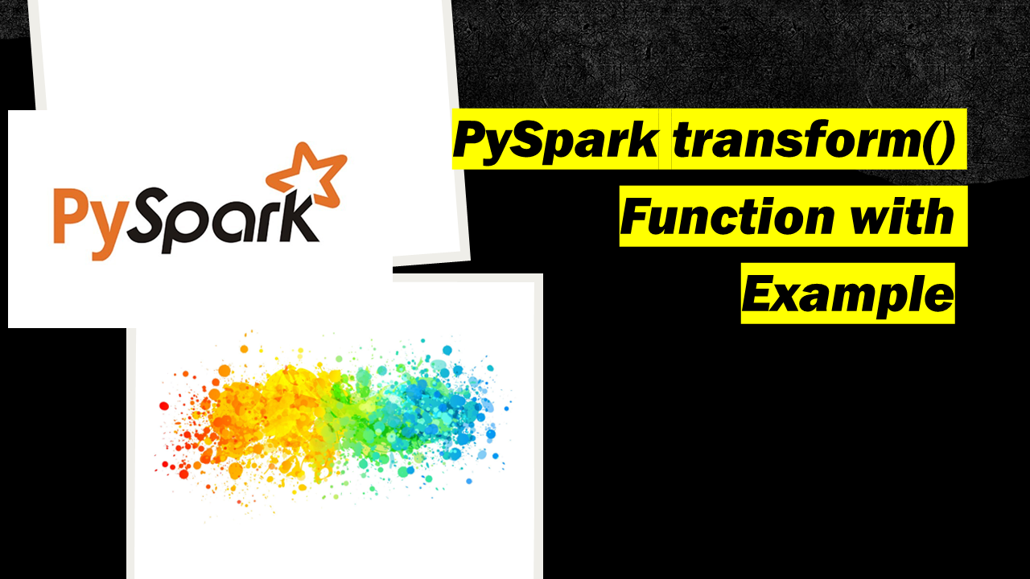
PySpark provides two transform() functions one with DataFrame and another in pyspark.sql.functions.
Advertisements
- pyspark.sql.DataFrame.transform() – Available since Spark 3.0
- pyspark.sql.functions.transform()
In this article, I will explain the syntax of these two functions and explain with examples. First, let’s create the DataFrame.

# Imports
from pyspark.sql import SparkSession

# Create SparkSession
spark = SparkSession.builder \
.appName('SparkByExamples.com') \
.getOrCreate()

# Prepare Data
simpleData = (("Java",4000,5), \
("Python", 4600,10), \
("Scala", 4100,15), \
("Scala", 4500,15), \
("PHP", 3000,20), \
)
columns= ["CourseName", "fee", "discount"]

# Create DataFrame
df = spark.createDataFrame(data = simpleData, schema = columns)
df.printSchema()
df.show(truncate=False)

1. PySpark DataFrame.transform()
The pyspark.sql.DataFrame.transform() is used to chain the custom transformations and this function returns the new DataFrame after applying the specified transformations.
This function always returns the same number of rows that exists on the input PySpark DataFrame.

1.1 Syntax
Following is the syntax of the pyspark.sql.DataFrame.transform() function

# Syntax
DataFrame.transform(func: Callable[[…], DataFrame], *args: Any, **kwargs: Any) → pyspark.sql.dataframe.DataFrame
The following are the parameters:
- func – Custom function to call.
- *args – Arguments to pass to func.
- *kwargs – Keyword arguments to pass to func.

1.2 Create Custom Functions
In the below snippet, I have created the three custom transformations to be applied to the DataFrame. These transformations are nothing but Python functions that take the DataFrame apply some changes and return the new DataFrame.
- to_upper_str_columns() – This function converts the CourseName column to upper case and updates the same column.
- reduce_price() – This function takes the argument and reduces the value from the fee and creates a new column.
- apply_discount() – This creates a new column with the discounted fee.

# Custom transformation 1
from pyspark.sql.functions import upper
def to_upper_str_columns(df):
return df.withColumn("CourseName",upper(df.CourseName))

# Custom transformation 2
def reduce_price(df,reduceBy):
return df.withColumn("new_fee",df.fee - reduceBy)

# Custom transformation 3
def apply_discount(df):
return df.withColumn("discounted_fee", \
df.new_fee - (df.new_fee * df.discount) / 100)

1.3 PySpark Apply DataFrame.transform()
Now, let’s chain these custom functions together and run them using PySpark DataFrame transform() function.

# PySpark transform() Usage
df2 = df.transform(to_upper_str_columns) \
.transform(reduce_price,1000) \
.transform(apply_discount)
Yields the below output.
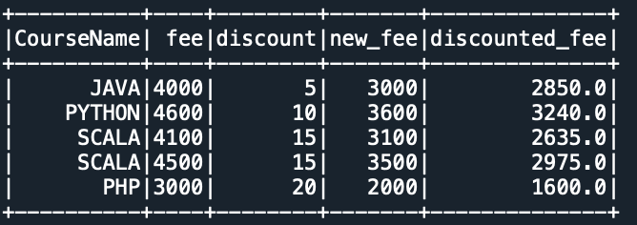
In case you wanted to select the columns either you can chain it with select() or create another custom function.

# custom function
def select_columns(df):
return df.select("CourseName","discounted_fee")

# Chain transformations
df2 = df.transform(to_upper_str_columns) \
.transform(reduce_price,1000) \
.transform(apply_discount) \
.transform(select_columns)
I will leave this to you to run and explore the output.

2. PySpark sql.functions.transform()
The PySpark sql.functions.transform() is used to apply the transformation on a column of type Array. This function applies the specified transformation on every element of the array and returns an object of ArrayType.

2.1 Syntax
Following is the syntax of the pyspark.sql.functions.transform() function

# Syntax
pyspark.sql.functions.transform(col, f)
The following are the parameters:
- col – ArrayType column
- f – Optional. Function to apply.

2.2 Example
Since our above DataFrame doesn’t contain ArrayType, I will create a new simple array to explain.

# Create DataFrame with Array
data = [
("James,,Smith",["Java","Scala","C++"],["Spark","Java"]),
("Michael,Rose,",["Spark","Java","C++"],["Spark","Java"]),
("Robert,,Williams",["CSharp","VB"],["Spark","Python"])
]
df = spark.createDataFrame(data=data,schema=["Name","Languages1","Languages2"])
df.printSchema()
df.show()

# using transform() function
from pyspark.sql.functions import upper
from pyspark.sql.functions import transform
df.select(transform("Languages1", lambda x: upper(x)).alias("languages1")) \
.show()
Yields below output.
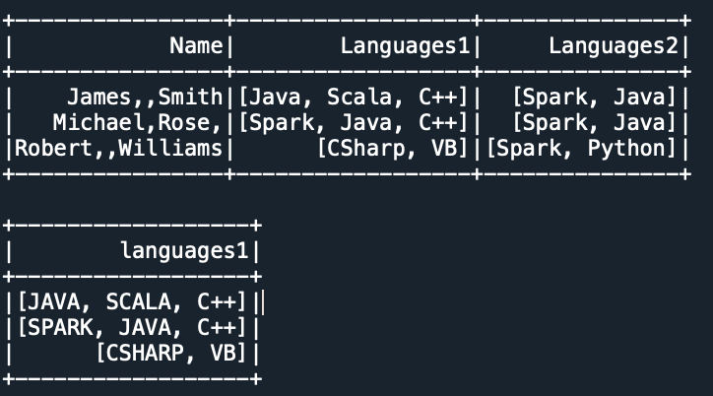

3. Complete Example
Following is the complete example of PySpark transform() function

# Imports
from pyspark.sql import SparkSession

# Create SparkSession
spark = SparkSession.builder \
.appName('SparkByExamples.com') \
.getOrCreate()

# Prepare Data
simpleData = (("Java",4000,5), \
("Python", 4600,10), \
("Scala", 4100,15), \
("Scala", 4500,15), \
("PHP", 3000,20), \
)
columns= ["CourseName", "fee", "discount"]

# Create DataFrame
df = spark.createDataFrame(data = simpleData, schema = columns)
df.printSchema()
df.show(truncate=False)

# Custom transformation 1
from pyspark.sql.functions import upper
def to_upper_str_columns(df):
return df.withColumn("CourseName",upper(df.CourseName))

# Custom transformation 2
def reduce_price(df,reduceBy):
return df.withColumn("new_fee",df.fee - reduceBy)

# Custom transformation 3
def apply_discount(df):
return df.withColumn("discounted_fee", \
df.new_fee - (df.new_fee * df.discount) / 100)

# transform() usage
df2 = df.transform(to_upper_str_columns) \
.transform(reduce_price,1000) \
.transform(apply_discount)

df2.show()

# Create DataFrame with Array
data = [
("James,,Smith",["Java","Scala","C++"],["Spark","Java"]),
("Michael,Rose,",["Spark","Java","C++"],["Spark","Java"]),
("Robert,,Williams",["CSharp","VB"],["Spark","Python"])
]
df = spark.createDataFrame(data=data,schema=["Name","Languages1","Languages2"])
df.printSchema()
df.show()

# using transform() SQL function
from pyspark.sql.functions import upper
from pyspark.sql.functions import transform
df.select(transform("Languages1", lambda x: upper(x)).alias("languages1")) \
.show()

4. Conclusion
In this article, you have learned the transform() function from pyspark.sql.DataFrame class and pyspark.sql.functions package.

Related Articles
- PySpark map() Transformation
- PySpark mapPartitions()
- PySpark Pandas UDF Example
- PySpark Apply Function to Column
- PySpark flatMap() Transformation
- PySpark RDD Transformations with examples
- PySpark between() range of values
- PySpark max() – Different Methods Explained
- PySpark sum() Columns Example
- PySpark union two DataFrames
- PySpark Broadcast Variable
- PySpark Broadcast Join
- PySpark persist() Example
- PySpark Apply udf to Multiple Columns
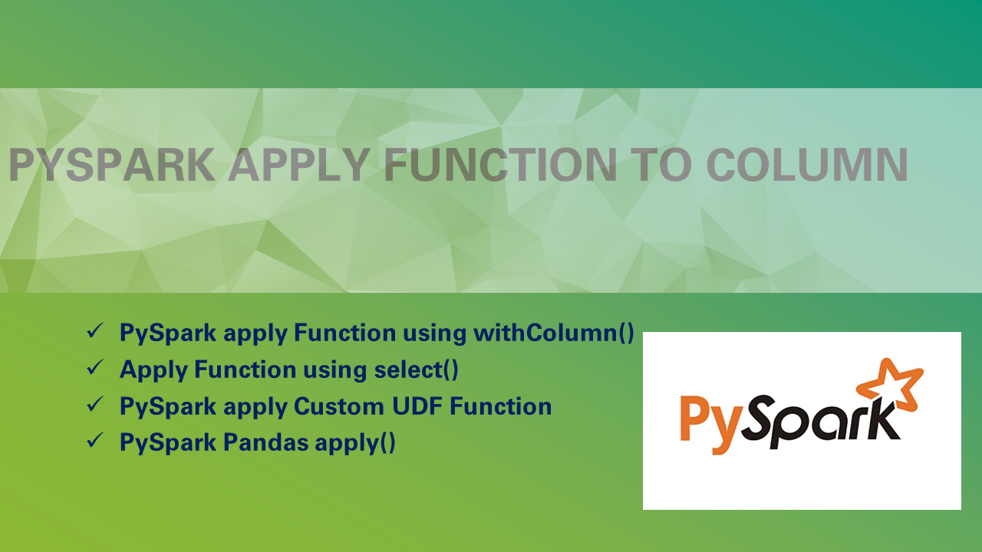
How to apply a function to a column in PySpark? By using withColumn(), sql(), select() you can apply a built-in function or custom function to a column. In order to apply a custom function, first you need to create a function and register the function as a UDF. Recent versions of PySpark provide a way to use Pandas API hence, you can also use pyspark.pandas.DataFrame.apply().
Advertisements
Related: Explain PySpark Pandas UDF with Examples
Let’s create a PySpark DataFrame.

from pyspark.sql import SparkSession

spark = SparkSession.builder.appName('SparkByExamples.com').getOrCreate()
columns = ["Seqno","Name"]
data = [("1", "john jones"),
("2", "tracey smith"),
("3", "amy sanders")]

df = spark.createDataFrame(data=data,schema=columns)

df.show(truncate=False)

1. PySpark apply Function using withColumn()
PySpark withColumn() is a transformation function that is used to apply a function to the column. The below example applies an upper() function to column df.Name.

# Apply function using withColumn
from pyspark.sql.functions import upper
df.withColumn("Upper_Name", upper(df.Name)) \
.show()
Yields below output.
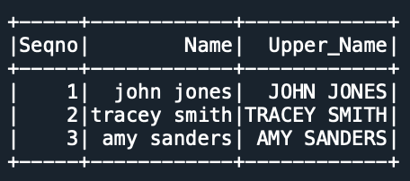

2. Apply Function using select()
The select() is used to select the columns from the PySpark DataFrame while selecting the columns you can also apply the function to a column.

# Apply function using select
df.select("Seqno","Name", upper(df.Name)) \
.show()
Yields the same output as above.

3. Apply Function to SQL
You can also apply the function to the column while running the SQL query on the PySpark DataFrame. In order to use SQL, make sure you create a temporary view using createOrReplaceTempView().

# Apply function using sql()
df.createOrReplaceTempView("TAB")
spark.sql("select Seqno, Name, UPPER(Name) from TAB") \
.show()
Yields the same output as above.

Using UDF
In this section, I will explain how to create a custom PySpark UDF function and apply this function to a column.
PySpark UDF (a.k.a User Defined Function) is the most useful feature of Spark SQL & DataFrame that is used to extend the PySpark built-in capabilities. Note that UDFs are the most expensive operations hence use them only if you have no choice and when essential.
Following are the steps to apply a custom UDF function on an SQL query.

4.1 Create Custom Function
First, create a python function. Though upper() is already available in the PySpark SQL function, to make the example simple, I would like to create one.

# Create custom function
def upperCase(str):
return str.upper()

4.2 Register UDF
Create a udf function by wrapping the above function with udf().

# Convert function to udf
from pyspark.sql.functions import col, udf
from pyspark.sql.types import StringType
upperCaseUDF = udf(lambda x:upperCase(x),StringType())

4.3 Apply Custom UDF to Column
Finally apply the function to the column by using withColumn(), select() and sql().

# Custom UDF with withColumn()
df.withColumn("Cureated Name", upperCaseUDF(col("Name"))) \
.show(truncate=False)

# Custom UDF with select()
df.select(col("Seqno"), \
upperCaseUDF(col("Name")).alias("Name") ) \
.show(truncate=False)

# Custom UDF with sql()
spark.udf.register("upperCaseUDF", upperCaseUDF)
df.createOrReplaceTempView("TAB")
spark.sql("select Seqno, Name, upperCaseUDF(Name) from TAB") \
.show()
Yields below output.
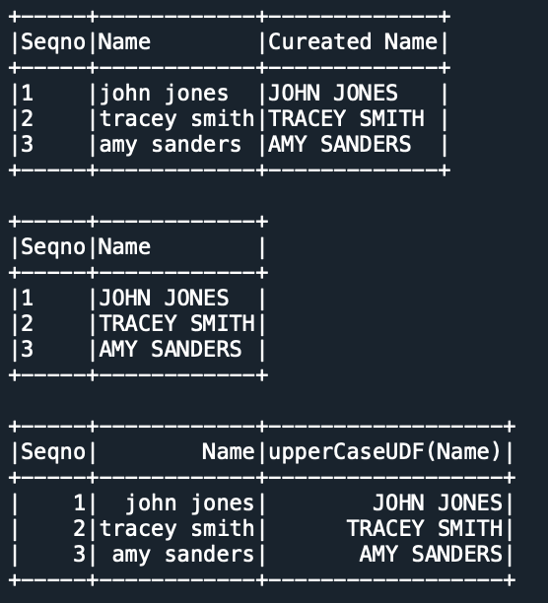

5. PySpark Pandas apply()
PySpark DataFrame doesn’t contain the apply() function however, we can leverage Pandas DataFrame.apply() by running Pandas API over PySpark.

# Imports
import pyspark.pandas as ps
import numpy as np

technologies = ({
'Fee' :[20000,25000,30000,22000,np.NaN],
'Discount':[1000,2500,1500,1200,3000]
})
# Create a DataFrame
psdf = ps.DataFrame(technologies)
print(psdf)

def add(data):
return data[0] + data[1]

addDF = psdf.apply(add,axis=1)
print(addDF)

6. Complete Example
Following is the complete example of applying a function to a column using withColumn(), SQL(), select() e.t.c

from pyspark.sql import SparkSession

spark = SparkSession.builder.appName('SparkByExamples.com').getOrCreate()
columns = ["Seqno","Name"]
data = [("1", "john jones"),
("2", "tracey smith"),
("3", "amy sanders")]

df = spark.createDataFrame(data=data,schema=columns)

df.show(truncate=False)

# Apply function using withColumn
from pyspark.sql.functions import upper
df.withColumn("Upper_Name", upper(df.Name)) \
.show()

# Apply function using select
df.select("Seqno","Name", upper(df.Name)) \
.show()

# Apply function using sql()
df.createOrReplaceTempView("TAB")
spark.sql("select Seqno, Name, UPPER(Name) from TAB") \
.show()

# Create custom function
def upperCase(str):
return str.upper()

# Convert function to udf
from pyspark.sql.functions import col, udf
from pyspark.sql.types import StringType
upperCaseUDF = udf(lambda x:upperCase(x),StringType())

# Custom UDF with withColumn()
df.withColumn("Cureated Name", upperCaseUDF(col("Name"))) \
.show(truncate=False)

# Custom UDF with select()
df.select(col("Seqno"), \
upperCaseUDF(col("Name")).alias("Name") ) \
.show(truncate=False)

# Custom UDF with sql()
spark.udf.register("upperCaseUDF", upperCaseUDF)
df.createOrReplaceTempView("TAB")
spark.sql("select Seqno, Name, upperCaseUDF(Name) from TAB") \
.show()

6. Conclusion
In this article, you have learned how to apply a built-in function to a PySpark column by using withColumn(), select() and spark.sql(). Also learned how to create a custom UDF function and apply this function to the column.

Related Articles
- PySpark between() range of values
- PySpark foreach() Example
- PySpark Pandas UDF Example
- PySpark transform() Function
- PySpark max() – Different Methods Explained
- PySpark sum() Columns Example
- PySpark union two DataFrames
- PySpark Broadcast Variable
- PySpark Broadcast Join
- PySpark persist() Example
- PySpark lag() Function
- PySpark Random Sample with Example
- PySpark reduceByKey usage with example
- PySpark Apply udf to Multiple Columns

How to apply a function to a column in PySpark? By using withColumn(), sql(), select() you can apply a built-in function or custom function to a column. In order to apply a custom function, first you need to create a function and register the function as a UDF. Recent versions of PySpark provide a way to use Pandas API hence, you can also use pyspark.pandas.DataFrame.apply().
Advertisements
Related: Explain PySpark Pandas UDF with Examples
Let’s create a PySpark DataFrame.

from pyspark.sql import SparkSession

spark = SparkSession.builder.appName('SparkByExamples.com').getOrCreate()
columns = ["Seqno","Name"]
data = [("1", "john jones"),
("2", "tracey smith"),
("3", "amy sanders")]

df = spark.createDataFrame(data=data,schema=columns)

df.show(truncate=False)

1. PySpark apply Function using withColumn()
PySpark withColumn() is a transformation function that is used to apply a function to the column. The below example applies an upper() function to column df.Name.

# Apply function using withColumn
from pyspark.sql.functions import upper
df.withColumn("Upper_Name", upper(df.Name)) \
.show()
Yields below output.

2. Apply Function using select()
The select() is used to select the columns from the PySpark DataFrame while selecting the columns you can also apply the function to a column.

# Apply function using select
df.select("Seqno","Name", upper(df.Name)) \
.show()
Yields the same output as above.

3. Apply Function to SQL
You can also apply the function to the column while running the SQL query on the PySpark DataFrame. In order to use SQL, make sure you create a temporary view using createOrReplaceTempView().

# Apply function using sql()
df.createOrReplaceTempView("TAB")
spark.sql("select Seqno, Name, UPPER(Name) from TAB") \
.show()
Yields the same output as above.

Using UDF
In this section, I will explain how to create a custom PySpark UDF function and apply this function to a column.
PySpark UDF (a.k.a User Defined Function) is the most useful feature of Spark SQL & DataFrame that is used to extend the PySpark built-in capabilities. Note that UDFs are the most expensive operations hence use them only if you have no choice and when essential.
Following are the steps to apply a custom UDF function on an SQL query.

4.1 Create Custom Function
First, create a python function. Though upper() is already available in the PySpark SQL function, to make the example simple, I would like to create one.

# Create custom function
def upperCase(str):
return str.upper()

4.2 Register UDF
Create a udf function by wrapping the above function with udf().

# Convert function to udf
from pyspark.sql.functions import col, udf
from pyspark.sql.types import StringType
upperCaseUDF = udf(lambda x:upperCase(x),StringType())

4.3 Apply Custom UDF to Column
Finally apply the function to the column by using withColumn(), select() and sql().

# Custom UDF with withColumn()
df.withColumn("Cureated Name", upperCaseUDF(col("Name"))) \
.show(truncate=False)

# Custom UDF with select()
df.select(col("Seqno"), \
upperCaseUDF(col("Name")).alias("Name") ) \
.show(truncate=False)

# Custom UDF with sql()
spark.udf.register("upperCaseUDF", upperCaseUDF)
df.createOrReplaceTempView("TAB")
spark.sql("select Seqno, Name, upperCaseUDF(Name) from TAB") \
.show()
Yields below output.

5. PySpark Pandas apply()
PySpark DataFrame doesn’t contain the apply() function however, we can leverage Pandas DataFrame.apply() by running Pandas API over PySpark.

# Imports
import pyspark.pandas as ps
import numpy as np

technologies = ({
'Fee' :[20000,25000,30000,22000,np.NaN],
'Discount':[1000,2500,1500,1200,3000]
})
# Create a DataFrame
psdf = ps.DataFrame(technologies)
print(psdf)

def add(data):
return data[0] + data[1]

addDF = psdf.apply(add,axis=1)
print(addDF)

6. Complete Example
Following is the complete example of applying a function to a column using withColumn(), SQL(), select() e.t.c

from pyspark.sql import SparkSession

spark = SparkSession.builder.appName('SparkByExamples.com').getOrCreate()
columns = ["Seqno","Name"]
data = [("1", "john jones"),
("2", "tracey smith"),
("3", "amy sanders")]

df = spark.createDataFrame(data=data,schema=columns)

df.show(truncate=False)

# Apply function using withColumn
from pyspark.sql.functions import upper
df.withColumn("Upper_Name", upper(df.Name)) \
.show()

# Apply function using select
df.select("Seqno","Name", upper(df.Name)) \
.show()

# Apply function using sql()
df.createOrReplaceTempView("TAB")
spark.sql("select Seqno, Name, UPPER(Name) from TAB") \
.show()

# Create custom function
def upperCase(str):
return str.upper()

# Convert function to udf
from pyspark.sql.functions import col, udf
from pyspark.sql.types import StringType
upperCaseUDF = udf(lambda x:upperCase(x),StringType())

# Custom UDF with withColumn()
df.withColumn("Cureated Name", upperCaseUDF(col("Name"))) \
.show(truncate=False)

# Custom UDF with select()
df.select(col("Seqno"), \
upperCaseUDF(col("Name")).alias("Name") ) \
.show(truncate=False)

# Custom UDF with sql()
spark.udf.register("upperCaseUDF", upperCaseUDF)
df.createOrReplaceTempView("TAB")
spark.sql("select Seqno, Name, upperCaseUDF(Name) from TAB") \
.show()

6. Conclusion
In this article, you have learned how to apply a built-in function to a PySpark column by using withColumn(), select() and spark.sql(). Also learned how to create a custom UDF function and apply this function to the column.

Related Articles
- PySpark between() range of values
- PySpark foreach() Example
- PySpark Pandas UDF Example
- PySpark transform() Function
- PySpark max() – Different Methods Explained
- PySpark sum() Columns Example
- PySpark union two DataFrames
- PySpark Broadcast Variable
- PySpark Broadcast Join
- PySpark persist() Example
- PySpark lag() Function
- PySpark Random Sample with Example
- PySpark reduceByKey usage with example
- PySpark Apply udf to Multiple Columns

- Naveen Nelamali
- Post category:PySpark
- Post last modified:May 16, 2024
- Reading time:13 mins read
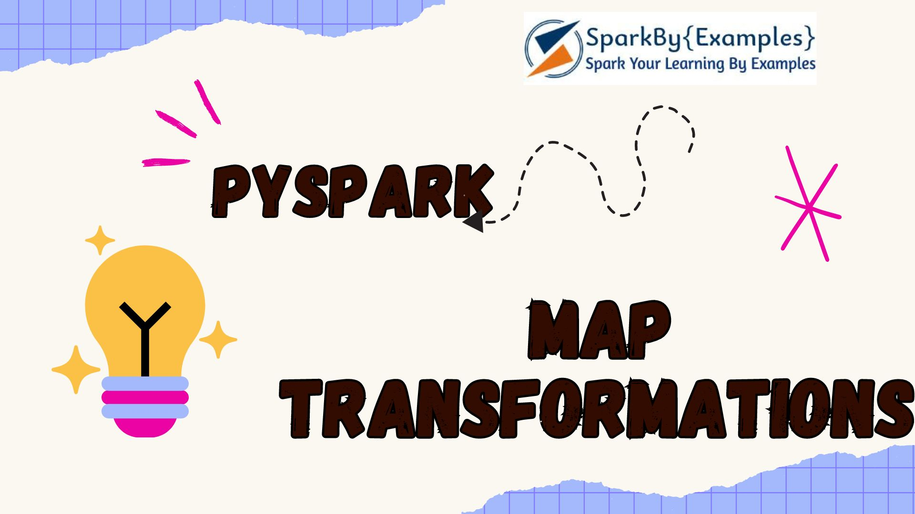
The map()in PySpark is a transformation function that is used to apply a function/lambda to each element of an RDD (Resilient Distributed Dataset) and return a new RDD consisting of the result.
Advertisements
When you have complex operations to apply on an RDD, the map() transformation is defacto function. You can use this for simple to complex operations like deriving a new element from exising data, or transforming the data, etc;
key Points:
- DataFrame doesn’t have map() transformation to use with DataFrame; hence, you need to convert DataFrame to RDD first.
- If you have a heavy initialization, use PySpark mapPartitions() transformation instead of map(); as with mapPartitions(), heavy initialization executes only once for each partition instead of every record.
Related: Spark map() vs mapPartitions() Explained with Examples

First, let’s create an RDD from the list.

# Imports
from pyspark.sql import SparkSession
spark = SparkSession.builder.master("local[1]") \
.appName("SparkByExamples.com").getOrCreate()

data = ["Project","Gutenberg’s","Alice’s","Adventures",
"in","Wonderland","Project","Gutenberg’s","Adventures",
"in","Wonderland","Project","Gutenberg’s"]

rdd=spark.sparkContext.parallelize(data)

map() Syntax
Syntax

# Syntax
map(f, preservesPartitioning=False)

PySpark RDD map() Example
Here’s how the map() transformation works:
- Function Application: You define a function that you want to apply to each element of the RDD.
- Function Application to RDD: You call the map() transformation on the RDD and pass the function as an argument to it.
- Transformation Execution: Spark applies the provided function to each element of the RDD in a distributed manner across the cluster.
- New RDD Creation: The map() transformation returns a new RDD containing the results of applying the function to each element of the original RDD.

# map() with rdd
rdd2=rdd.map(lambda x: (x,1))
for element in rdd2.collect():
print(element)
Here, We apply the map() transformation to each element x in the RDD rdd. The lambda function (lambda x: (x, 1)) takes each element x of the RDD rdd and returns a tuple (x, 1). So, for each element in rdd, the resulting RDD rdd2 contains a tuple where the original element x is paired with the integer 1.
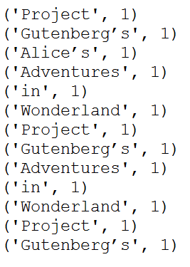

PySpark map() Example with DataFrame
PySpark DataFrame doesn’t have map() transformation to apply the lambda function, when you wanted to apply the custom transformation, you need to convert the DataFrame to RDD and apply the map() transformation. Let’s use another dataset to explain this.

data = [('James','Smith','M',30),
('Anna','Rose','F',41),
('Robert','Williams','M',62),
]

columns = ["firstname","lastname","gender","salary"]
df = spark.createDataFrame(data=data, schema = columns)
df.show()

# Output:
#+---------+--------+------+------+
#|firstname|lastname|gender|salary|
#+---------+--------+------+------+
#| James| Smith| M| 30|
#| Anna| Rose| F| 41|
#| Robert|Williams| M| 62|
#+---------+--------+------+------+
Use map() transfromation on DataFrame.

# Refering columns by index.
rdd2=df.rdd.map(lambda x:
(x[0]+","+x[1],x[2],x[3]*2)
)
df2=rdd2.toDF(["name","gender","new_salary"] )
df2.show()

# Output:
#+---------------+------+----------+
#| name|gender|new_salary|
#+---------------+------+----------+
#| James,Smith| M| 60|
#| Anna,Rose| F| 82|
#|Robert,Williams| M| 124|
#+---------------+------+----------+
The above example refers to the columns by index. The below example uses column names.

# Referring Column Names
rdd2=df.rdd.map(lambda x:
(x["firstname"]+","+x["lastname"],x["gender"],x["salary"]*2)
)
Another alternative

# Referring Column Names
rdd2=df.rdd.map(lambda x:
(x.firstname+","+x.lastname,x.gender,x.salary*2)
)

Using custom function on map() transformation
You can also create a function and use this function on map() transformation

# By Calling function
def func1(x):
firstName=x.firstname
lastName=x.lastname
name=firstName+","+lastName
gender=x.gender.lower()
salary=x.salary*2
return (name,gender,salary)

# Apply the func1 function using lambda
rdd2 = df.rdd.map(lambda x: func1(x))

#or
# Apply the func1 function to each element of the RDD using map()
rdd2 = df.rdd.map(func1)

Complete PySpark map() example
Below is a complete example of PySpark map() transformation.

from pyspark.sql import SparkSession
spark = SparkSession.builder.appName('SparkByExamples.com').getOrCreate()

data = ["Project",
"Gutenberg’s",
"Alice’s",
"Adventures",
"in",
"Wonderland",
"Project",
"Gutenberg’s",
"Adventures",
"in",
"Wonderland",
"Project",
"Gutenberg’s"]

rdd=spark.sparkContext.parallelize(data)

rdd2=rdd.map(lambda x: (x,1))
for element in rdd2.collect():
print(element)

data = [('James','Smith','M',30),
('Anna','Rose','F',41),
('Robert','Williams','M',62),
]

columns = ["firstname","lastname","gender","salary"]
df = spark.createDataFrame(data=data, schema = columns)
df.show()

rdd2=df.rdd.map(lambda x:
(x[0]+","+x[1],x[2],x[3]*2)
)
df2=rdd2.toDF(["name","gender","new_salary"] )
df2.show()

#Referring Column Names
rdd2=df.rdd.map(lambda x:
(x["firstname"]+","+x["lastname"],x["gender"],x["salary"]*2)
)

#Referring Column Names
rdd2=df.rdd.map(lambda x:
(x.firstname+","+x.lastname,x.gender,x.salary*2)
)

def func1(x):
firstName=x.firstname
lastName=x.lastname
name=firstName+","+lastName
gender=x.gender.lower()
salary=x.salary*2
return (name,gender,salary)

rdd2=df.rdd.map(lambda x: func1(x))

Frequently Asked Questions on map()
How does the map() transformation differ from other transformations, like flatMap() in PySpark?
The map() transformation applies a function on each element of the RDD independently, resulting in a new RDD with the same number of elements. Meanwhile, flatMap() can produce a variable number of output elements for each input element.
Can we apply Python lambda functions with the map() transformation in PySpark?
We can use Python lambda functions or regular functions with the map() transformation.
For example:
rdd = sc.parallelize([2,4,6])
even_square = rdd.map(lambda x: x**2)
How does the map() transformation handle null or missing values?
The map() transformation in PySpark processes each element independently, and by default, it does not handle the null or missing values. We need to handle these cases within the mapping function explicitly.
How to use the map() transformation with key-value pairs in PySpark?
For key-value pairs, we need to use the map() transformation with a function that operates on the values while preserving the keys.

Conclusion
In summary, you’ve learned how to use a map() transformation on every element within a PySpark RDD and have observed that it returns the same number of rows as the input RDD. This distinction is one of the differences between flatMap() transformation. Additionally, you’ve gained insight into leveraging map() on DataFrames by first converting them to RDDs.
Happy Learning !!

Related Articles
- PySpark Replace Column Values in DataFrame
- PySpark RDD Transformations with examples
- PySpark Convert DataFrame to RDD
- PySpark mapPartitions() Examples
- PySpark Convert DataFrame Columns to MapType (Dict)
- PySpark Convert Dictionary/Map to Multiple Columns
- PySpark Add a New Column to DataFrame
- PySpark flatMap() Transformation
Tags: map

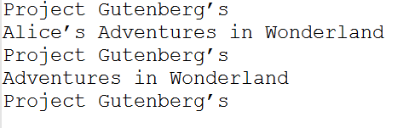
PySpark flatMap() is a transformation operation that flattens the RDD/DataFrame (array/map DataFrame columns) after applying the function on every element and returns a new PySpark RDD/DataFrame. In this article, you will learn the syntax and usage of the PySpark flatMap() with an example.
Advertisements
First, let’s create an RDD from the list.

data = ["Project Gutenberg’s",
"Alice’s Adventures in Wonderland",
"Project Gutenberg’s",
"Adventures in Wonderland",
"Project Gutenberg’s"]
rdd=spark.sparkContext.parallelize(data)
for element in rdd.collect():
print(element)
This yields the below output

flatMap() Syntax

flatMap(f, preservesPartitioning=False)

flatMap() Example
Now, let’s see with an example of how to apply a flatMap() transformation on RDD. In the below example, first, it splits each record by space in an RDD and finally flattens it. Resulting RDD consists of a single word on each record.

rdd2=rdd.flatMap(lambda x: x.split(" "))
for element in rdd2.collect():
print(element)
This yields below output.

Project
Gutenberg’s
Alice’s
Adventures
in
Wonderland
Project
Gutenberg’s
Adventures
in
Wonderland
Project
Gutenberg’s

Complete PySpark flatMap() example
Below is the complete example of flatMap() function that works with RDD.

from pyspark.sql import SparkSession
spark = SparkSession.builder.appName('SparkByExamples.com').getOrCreate()

data = ["Project Gutenberg’s",
"Alice’s Adventures in Wonderland",
"Project Gutenberg’s",
"Adventures in Wonderland",
"Project Gutenberg’s"]
rdd=spark.sparkContext.parallelize(data)
for element in rdd.collect():
print(element)

#Flatmap
rdd2=rdd.flatMap(lambda x: x.split(" "))
for element in rdd2.collect():
print(element)

Using flatMap() transformation on DataFrame
Unfortunately, PySpark DataFame doesn’t have flatMap() transformation however, DataFrame has explode() SQL function that is used to flatten the column. Below is a complete example.

import pyspark
from pyspark.sql import SparkSession
spark = SparkSession.builder.appName('pyspark-by-examples').getOrCreate()

arrayData = [
('James',['Java','Scala'],{'hair':'black','eye':'brown'}),
('Michael',['Spark','Java',None],{'hair':'brown','eye':None}),
('Robert',['CSharp',''],{'hair':'red','eye':''}),
('Washington',None,None),
('Jefferson',['1','2'],{})]
df = spark.createDataFrame(data=arrayData, schema = ['name','knownLanguages','properties'])

from pyspark.sql.functions import explode
df2 = df.select(df.name,explode(df.knownLanguages))
df2.printSchema()
df2.show()
This example flattens the array column “knownLanguages” and yields below output

root
|-- name: string (nullable = true)
|-- col: string (nullable = true)

+---------+------+
| name| col|
+---------+------+
| James| Java|
| James| Scala|
| Michael| Spark|
| Michael| Java|
| Michael| null|
| Robert|CSharp|
| Robert| |
|Jefferson| 1|
|Jefferson| 2|
+---------+------+

Conclusion
In conclusion, you have learned how to apply a PySpark flatMap() transformation to flattens the array or map columns and also learned how to use alternatives for DataFrame.

Related Articles
- PySpark Convert DataFrame Columns to MapType (Dict)
- PySpark Convert Dictionary/Map to Multiple Columns
- How to Convert PySpark Column to List?
- PySpark map() Transformation
- Dynamic way of doing ETL through Pyspark
- PySpark RDD Transformations with examples
- PySpark distinct vs dropDuplicates
- Pyspark Select Distinct Rows
Happy Learning !!
Tags: flatMap


PySpark foreach() is an action operation that is available in RDD, DataFram to iterate/loop over each element in the DataFrmae, It is similar to for with advanced concepts. This is different than other actions as foreach() function doesn’t return a value instead it executes the input function on each element of an RDD, DataFrame
Advertisements

1. PySpark DataFrame foreach()

1.1 foreach() Syntax
Following is the syntax of the foreach() function

# Syntax
DataFrame.foreach(f)

1.2 PySpark foreach() Usage
When foreach() applied on PySpark DataFrame, it executes a function specified in for each element of DataFrame. This operation is mainly used if you wanted to manipulate accumulators, save the DataFrame results to RDBMS tables, Kafka topics, and other external sources.
In this example, to make it simple we just print the DataFrame to the console.

# Import
from pyspark.sql import SparkSession

# Create SparkSession
spark = SparkSession.builder.appName('SparkByExamples.com') \
.getOrCreate()

# Prepare Data
columns = ["Seqno","Name"]
data = [("1", "john jones"),
("2", "tracey smith"),
("3", "amy sanders")]

# Create DataFrame
df = spark.createDataFrame(data=data,schema=columns)
df.show()

# foreach() Example
def f(df):
print(df.Seqno)
df.foreach(f)
Using foreach() to update the accumulator shared variable.

# foreach() with accumulator Example
accum=spark.sparkContext.accumulator(0)
df.foreach(lambda x:accum.add(int(x.Seqno)))
print(accum.value) #Accessed by driver

2. PySpark RDD foreach() Usage
The foreach() on RDD behaves similarly to DataFrame equivalent, hence the same syntax and it is also used to manipulate accumulators from RDD, and write external data sources.

2.1 Syntax

# Syntax
RDD.foreach(f: Callable[[T], None]) → None

2.2 RDD foreach() Example

# foreach() with RDD example
accum=spark.sparkContext.accumulator(0)
rdd=spark.sparkContext.parallelize([1,2,3,4,5])
rdd.foreach(lambda x:accum.add(x))
print(accum.value) #Accessed by driver

Conclusion
In conclusion, PySpark foreach() is an action operation of RDD and DataFrame which doesn’t have any return type and is used to manipulate the accumulator and write any external data sources.

Related Articles
- PySpark map() Transformation
- PySpark mapPartitions()
- PySpark Pandas UDF Example
- PySpark between() range of values
- PySpark max() – Different Methods Explained
- PySpark sum() Columns Example
- PySpark union two DataFrames
- PySpark Broadcast Variable
- PySpark Broadcast Join
- PySpark persist() Example
- PySpark lag() Function
- PySpark Random Sample with Example
- PySpark Apply Function to Column
- PySpark Apply udf to Multiple Columns
Happy Learning !!
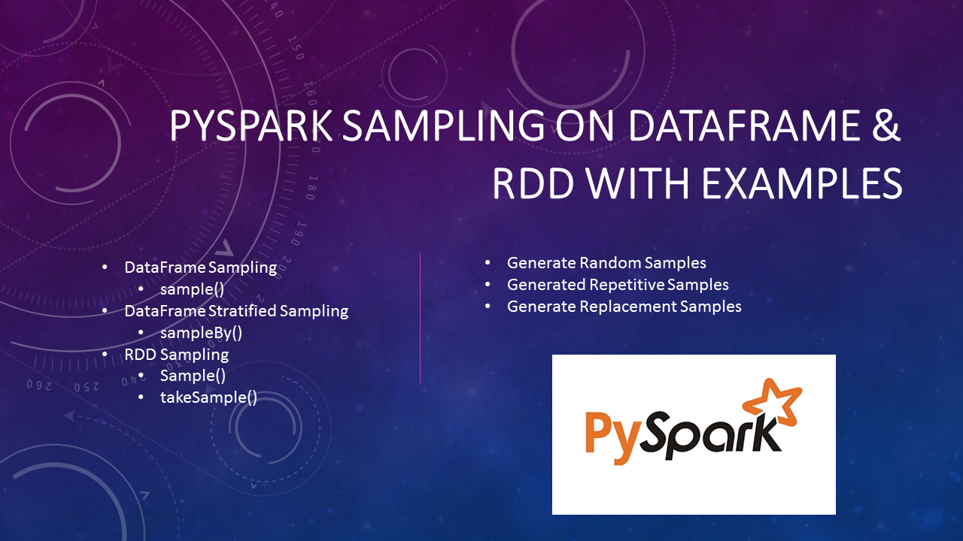
PySpark provides a pyspark.sql.DataFrame.sample(), pyspark.sql.DataFrame.sampleBy(), RDD.sample(), and RDD.takeSample() methods to get the random sampling subset from the large dataset, In this article I will explain with Python examples.
Advertisements
If you are working as a Data Scientist or Data analyst you are often required to analyze a large dataset/file with billions or trillions of records, processing these large datasets takes some time hence during the analysis phase it is recommended to use a random subset sample from the large files.
Related: Spark SQL Sampling with Scala Examples

1. PySpark SQL sample() Usage & Examples
PySpark sampling (pyspark.sql.DataFrame.sample()) is a mechanism to get random sample records from the dataset, this is helpful when you have a larger dataset and wanted to analyze/test a subset of the data for example 10% of the original file.

Below is the syntax of the sample() function.

sample(withReplacement, fraction, seed=None)
fraction – Fraction of rows to generate, range [0.0, 1.0]. Note that it doesn’t guarantee to provide the exact number of the fraction of records.
seed – Seed for sampling (default a random seed). Used to reproduce the same random sampling.
withReplacement – Sample with replacement or not (default False).
Let’s see some examples.

1.1 Using fraction to get a random sample in PySpark
By using fraction between 0 to 1, it returns the approximate number of the fraction of the dataset. For example, 0.1 returns 10% of the rows. However, this does not guarantee it returns the exact 10% of the records.
Note: If you run these examples on your system, you may see different results.

from pyspark.sql import SparkSession
spark = SparkSession.builder \
.master("local[1]") \
.appName("SparkByExamples.com") \
.getOrCreate()

df=spark.range(100)
print(df.sample(0.06).collect())
//Output: [Row(id=0), Row(id=2), Row(id=17), Row(id=25), Row(id=26), Row(id=44), Row(id=80)]
My DataFrame has 100 records and I wanted to get 6% sample records which are 6 but the sample() function returned 7 records. This proves the sample function doesn’t return the exact fraction specified.

1.2 Using seed to reproduce the same Samples in PySpark
Every time you run a sample() function it returns a different set of sampling records, however sometimes during the development and testing phase you may need to regenerate the same sample every time as you need to compare the results from your previous run. To get consistent same random sampling uses the same slice value for every run. Change slice value to get different results.

print(df.sample(0.1,123).collect())
//Output: 36,37,41,43,56,66,69,75,83

print(df.sample(0.1,123).collect())
//Output: 36,37,41,43,56,66,69,75,83

print(df.sample(0.1,456).collect())
//Output: 19,21,42,48,49,50,75,80
Here, first 2 examples I have used seed value 123 hence the sampling results are the same and for the last example, I have used 456 as a seed value generate different sampling records.

1.3 Sample withReplacement (May contain duplicates)
some times you may need to get a random sample with repeated values. By using the value true, results in repeated values.

print(df.sample(True,0.3,123).collect()) //with Duplicates
//Output: 0,5,9,11,14,14,16,17,21,29,33,41,42,52,52,54,58,65,65,71,76,79,85,96
print(df.sample(0.3,123).collect()) // No duplicates
//Output: 0,4,17,19,24,25,26,36,37,41,43,44,53,56,66,68,69,70,71,75,76,78,83,84,88,94,96,97,98
On first example, values 14, 52 and 65 are repeated values.

1.4 Stratified sampling in PySpark
You can get Stratified sampling in PySpark without replacement by using sampleBy() method. It returns a sampling fraction for each stratum. If a stratum is not specified, it takes zero as the default.
sampleBy() Syntax

sampleBy(col, fractions, seed=None)
col – column name from DataFrame
fractions – It’s Dictionary type takes key and value.
sampleBy() Example

df2=df.select((df.id % 3).alias("key"))
print(df2.sampleBy("key", {0: 0.1, 1: 0.2},0).collect())
//Output: [Row(key=0), Row(key=1), Row(key=1), Row(key=1), Row(key=0), Row(key=1), Row(key=1), Row(key=0), Row(key=1), Row(key=1), Row(key=1)]

2. PySpark RDD Sample
PySpark RDD also provides sample() function to get a random sampling, it also has another signature takeSample() that returns an Array[T].
RDD sample() Syntax & Example
PySpark RDD sample() function returns the random sampling similar to DataFrame and takes a similar types of parameters but in a different order. Since I’ve already covered the explanation of these parameters on DataFrame, I will not be repeating the explanation on RDD, If not already read I recommend reading the DataFrame section above.
sample() of RDD returns a new RDD by selecting random sampling. Below is a syntax.

sample(self, withReplacement, fraction, seed=None)
Below is an example of RDD sample() function

rdd = spark.sparkContext.range(0,100)
print(rdd.sample(False,0.1,0).collect())
//Output: [24, 29, 41, 64, 86]
print(rdd.sample(True,0.3,123).collect())
//Output: [0, 11, 13, 14, 16, 18, 21, 23, 27, 31, 32, 32, 48, 49, 49, 53, 54, 72, 74, 77, 77, 83, 88, 91, 93, 98, 99]
RDD takeSample() Syntax & Example
RDD takeSample() is an action hence you need to careful when you use this function as it returns the selected sample records to driver memory. Returning too much data results in an out-of-memory error similar to collect().
Syntax of RDD takeSample() .

takeSample(self, withReplacement, num, seed=None)
Example of RDD takeSample()

print(rdd.takeSample(False,10,0))
//Output: [58, 1, 96, 74, 29, 24, 32, 37, 94, 91]
print(rdd.takeSample(True,30,123))
//Output: [43, 65, 39, 18, 84, 86, 25, 13, 40, 21, 79, 63, 7, 32, 26, 71, 23, 61, 83, 60, 22, 35, 84, 22, 0, 88, 16, 40, 65, 84]

Conclusion
In summary, PySpark sampling can be done on RDD and DataFrame. In order to do sampling, you need to know how much data you wanted to retrieve by specifying fractions.
Use seed to regenerate the same sampling multiple times. and
Use withReplacement if you are okay to repeat the random records.
Thanks for reading. If you recognize my effort or like articles here please do comment or provide any suggestions for improvements in the comments sections!

Related Articles
- PySpark RDD Transformations with examples
- PySpark Read and Write SQL Server Table
- PySpark Read and Write MySQL Database Table
- PySpark createOrReplaceTempView() Explained
- PySpark cache() Explained.
- PySpark Shell Command Usage with Examples
- PySpark RDD Actions with examples
- PySpark mapPartitions() Examples

Reference
- https://www.dummies.com/programming/r/how-to-take-samples-from-data-in-r/

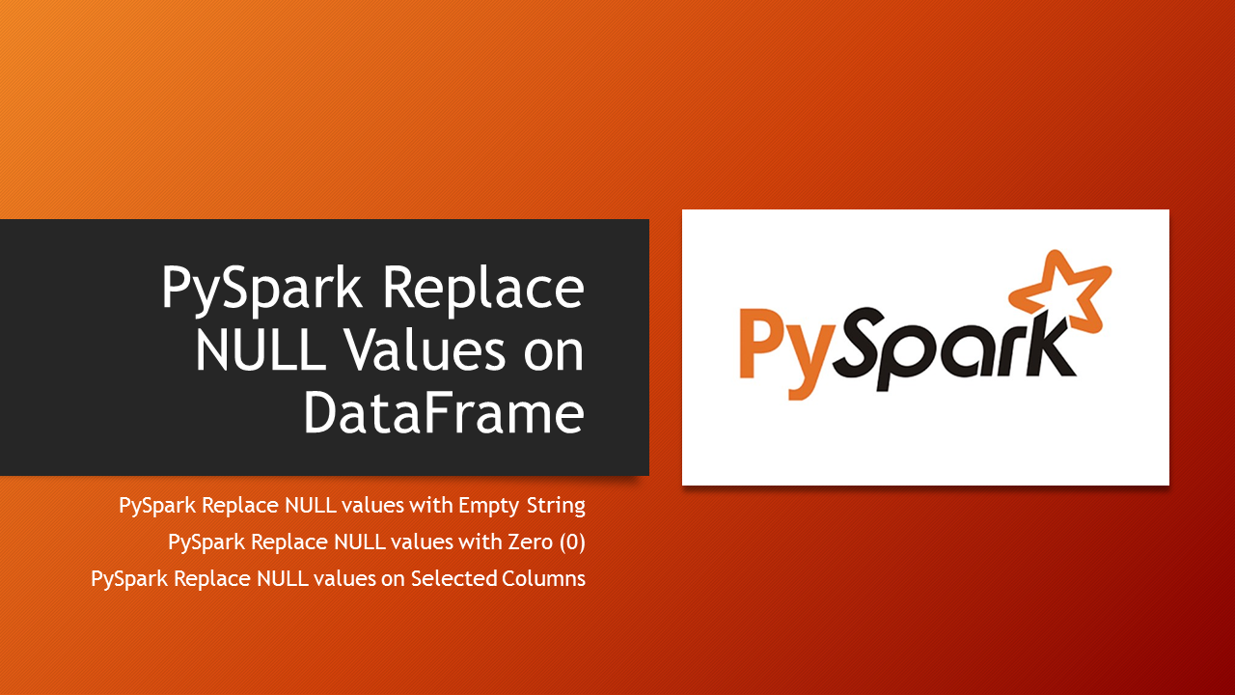
In PySpark,fillna() from DataFrame class or fill() from DataFrameNaFunctions is used to replace NULL/None values on all or selected multiple columns with either zero(0), empty string, space, or any constant literal values.
Advertisements
While working on PySpark DataFrame we often need to replace null values since certain operations on null values return errors. Hence, we need to graciously handle nulls as the first step before processing. Also, while writing to a file, it’s always best practice to replace null values, not doing this results in nulls on the output file.
As part of the cleanup, sometimes you may need to Drop Rows with NULL/None Values in PySpark DataFrame and Filter Rows by checking IS NULL/NOT NULL conditions.
In this article, I will use both fill() and fillna() to replace null/none values with an empty string, constant value, and zero(0) on Dataframe columns integer, string with Python examples.

- PySpark fillna() and fill() Syntax
- Replace NULL/None Values with Zero (0)
- Replace NULL/None Values with Empty String
Before we start, Let’s read a CSV into PySpark DataFrame file, Note that the reading process automatically assigns null values for missing data.
The file we are using here is available at GitHub small_zipcode.csv

# Create SparkSession and read csv
from pyspark.sql import SparkSession
spark = SparkSession.builder \
.master("local[1]") \
.appName("SparkByExamples.com") \
.getOrCreate()

filePath="resources/small_zipcode.csv"
df = spark.read.options(header='true', inferSchema='true') \
.csv(filePath)

df.printSchema()
df.show(truncate=False)
This yields the below output. Note that the columns city, and population have null values.

# Output
+---+-------+--------+-------------------+-----+----------+
|id |zipcode|type |city |state|population|
+---+-------+--------+-------------------+-----+----------+
|1 |704 |STANDARD|null |PR |30100 |
|2 |704 |null |PASEO COSTA DEL SUR|PR |null |
|3 |709 |null |BDA SAN LUIS |PR |3700 |
|4 |76166 |UNIQUE |CINGULAR WIRELESS |TX |84000 |
|5 |76177 |STANDARD|null |TX |null |
+---+-------+--------+-------------------+-----+----------+
Now, let’s see how to replace these null values.

PySpark fillna() & fill() Syntax
PySpark provides DataFrame.fillna() and DataFrameNaFunctions.fill() to replace NULL/None values. These two are aliases of each other and returns the same results.

fillna(value, subset=None)
fill(value, subset=None)
- value – Value should be the data type of int, long, float, string, or dict. Value specified here will be replaced with NULL/None values.
- subset – This is optional, when used it should be the subset of the column names where you wanted to replace NULL/None values.

PySpark Replace NULL/None Values with Zero (0)
PySpark fill(value:Long) signatures that are available in DataFrameNaFunctions is used to replace NULL/None values with numeric values either zero(0) or any constant value for all integer and long datatype columns of PySpark DataFrame or Dataset.

#Replace 0 for null for all integer columns
df.na.fill(value=0).show()

#Replace 0 for null on only population column
df.na.fill(value=0,subset=["population"]).show()
Above both statements yield the same output, since we have just an integer column population with null values Note that it replaces only Integer columns since our value is 0.

# Output
+---+-------+--------+-------------------+-----+----------+
|id |zipcode|type |city |state|population|
+---+-------+--------+-------------------+-----+----------+
|1 |704 |STANDARD|null |PR |30100 |
|2 |704 |null |PASEO COSTA DEL SUR|PR |0 |
|3 |709 |null |BDA SAN LUIS |PR |3700 |
|4 |76166 |UNIQUE |CINGULAR WIRELESS |TX |84000 |
|5 |76177 |STANDARD|null |TX |0 |
+---+-------+--------+-------------------+-----+----------+

PySpark Replace Null/None Value with Empty String
Now let’s see how to replace NULL/None values with an empty string or any constant values String on all DataFrame String columns.

df.na.fill("").show(false)
Yields below output. This replaces all String type columns with empty/blank string for all NULL values.

# Output
+---+-------+--------+-------------------+-----+----------+
|id |zipcode|type |city |state|population|
+---+-------+--------+-------------------+-----+----------+
|1 |704 |STANDARD| |PR |30100 |
|2 |704 | |PASEO COSTA DEL SUR|PR |null |
|3 |709 | |BDA SAN LUIS |PR |3700 |
|4 |76166 |UNIQUE |CINGULAR WIRELESS |TX |84000 |
|5 |76177 |STANDARD| |TX |null |
+---+-------+--------+-------------------+-----+----------+
Now, let’s replace NULLs on specific columns, below example replace a column type with an empty string and a column city with the value “unknown”.

df.na.fill("unknown",["city"]) \
.na.fill("",["type"]).show()
Yields below output. This replaces null values with an empty string for type column and replaces with a constant value “unknown” for city column.

# Output
+---+-------+--------+-------------------+-----+----------+
|id |zipcode|type |city |state|population|
+---+-------+--------+-------------------+-----+----------+
|1 |704 |STANDARD|unknown |PR |30100 |
|2 |704 | |PASEO COSTA DEL SUR|PR |null |
|3 |709 | |BDA SAN LUIS |PR |3700 |
|4 |76166 |UNIQUE |CINGULAR WIRELESS |TX |84000 |
|5 |76177 |STANDARD|unknown |TX |null |
+---+-------+--------+-------------------+-----+----------+
Alternatively, write the above statement as below.

df.na.fill({"city": "unknown", "type": ""}) \
.show()

Complete Code
Below is the complete code with a python example. You can use it by copying it from here or using GitHub to download the source code.

from pyspark.sql import SparkSession
spark = SparkSession.builder \
.master("local[1]") \
.appName("SparkByExamples.com") \
.getOrCreate()

filePath="resources/small_zipcode.csv"
df = spark.read.options(header='true', inferSchema='true') \
.csv(filePath)

df.printSchema()
df.show(truncate=False)

df.fillna(value=0).show()
df.fillna(value=0,subset=["population"]).show()
df.na.fill(value=0).show()
df.na.fill(value=0,subset=["population"]).show()

df.fillna(value="").show()
df.na.fill(value="").show()

df.fillna("unknown",["city"]) \
.fillna("",["type"]).show()

df.fillna({"city": "unknown", "type": ""}) \
.show()

df.na.fill("unknown",["city"]) \
.na.fill("",["type"]).show()

df.na.fill({"city": "unknown", "type": ""}) \
.show()

Frequently Asked Questions on fillna() and fill()
What is the difference between fillna() and fill() in PySpark?
In PySpark both fillna() and fill() are used to replace missing or null values of a DataFrame. Functionally they both perform same. One can choose either of these based on preference. These are used mainly for handling missing data in PySpark.
What happens if I use fillna() on a non-existent column?
If you use fillna() on a column that doesn’t exist in the DataFrame, it will not raise an error. The method will simply have no effect on the DataFrame.
Can I fill in missing values with different replacement values for different columns?
we can specify different replacement values for different columns when using fillna().
Example
df.fillna({"zipcode":0,"population":50000}) will fill in missing values in the “zipcode” column with 0 and in the “population” column with 50000.
Are there any performance considerations while using fillna() on large DataFrames?
Filling missing values with fillna() can be resource-intensive for large DataFrames. It’s essential to consider the performance impact, especially when working with big data. Optimize your code and use appropriate caching or storage strategies to improve performance.

Conclusion
In this PySpark article, you have learned how to replace null/None values with zero or an empty string on integer and string columns respectively using fill() and fillna() transformation functions.
Happy Learning !!

Related Articles
- PySpark Group by on Multiple Columns
- PySpark Drop Rows with NULL or None Values
- PySpark Parse JSON from String Column | TEXT File
- PySpark Replace Empty Value With None/null on Data Frame
- PySpark count() – Different Methods Explained
- PySpark isNull() & isNotNull()
- PySpark Add a New Column to DataFrame
- PySpark – Find Count of null, None, NaN Values
- PySpark How to Filter Rows with NULL Values

Reference:
- https://spark.apache.org/docs/3.0.0/api/python/pyspark.sql.html
Tags: NULL


PySpark pivot() function is used to rotate/transpose the data from one column into multiple Dataframe columns and back using unpivot(). Pivot() It is an aggregation where one of the grouping columns values is transposed into individual columns with distinct data.
Advertisements

Syntax

pivot_df = original_df.groupBy("grouping_column").pivot("pivot_column").agg({"agg_column": "agg_function"})
grouping_column: The column used for grouping.
pivot_column: The column whose distinct values become new columns.
agg_column: The column for which aggregation is applied (e.g., using a function like sum, avg, etc.).

This tutorial describes and provides a PySpark example on how to create a Pivot table on DataFrame and Unpivot back.
- Pivot PySpark DataFrame
- Pivot Performance improvement in PySpark 2.0
- Unpivot PySpark DataFrame
- Pivot or Transpose without aggregation
Let’s create a PySpark DataFrame to work with.

# Imports
import pyspark
from pyspark.sql import SparkSession
from pyspark.sql.functions import expr
#Create spark session
data = [("Banana",1000,"USA"), ("Carrots",1500,"USA"), ("Beans",1600,"USA"), \
("Orange",2000,"USA"),("Orange",2000,"USA"),("Banana",400,"China"), \
("Carrots",1200,"China"),("Beans",1500,"China"),("Orange",4000,"China"), \
("Banana",2000,"Canada"),("Carrots",2000,"Canada"),("Beans",2000,"Mexico")]

columns= ["Product","Amount","Country"]
df = spark.createDataFrame(data = data, schema = columns)
df.printSchema()
df.show(truncate=False)
DataFrame ‘df’ consists of 3 columns Product, Amount, and Country as shown below.

# Output
root
|-- Product: string (nullable = true)
|-- Amount: long (nullable = true)
|-- Country: string (nullable = true)

+-------+------+-------+
|Product|Amount|Country|
+-------+------+-------+
|Banana |1000 |USA |
|Carrots|1500 |USA |
|Beans |1600 |USA |
|Orange |2000 |USA |
|Orange |2000 |USA |
|Banana |400 |China |
|Carrots|1200 |China |
|Beans |1500 |China |
|Orange |4000 |China |
|Banana |2000 |Canada |
|Carrots|2000 |Canada |
|Beans |2000 |Mexico |
+-------+------+-------+

Pivot PySpark DataFrame
PySpark SQL provides pivot() function to rotate the data from one column into multiple columns. It is an aggregation where one of the grouping columns values is transposed into individual columns with distinct data. To get the total amount exported to each country of each product, will do group by Product, pivot by Country, and the sum of Amount.

# Applying pivot()
pivotDF = df.groupBy("Product").pivot("Country").sum("Amount")
pivotDF.printSchema()
pivotDF.show(truncate=False)
This will transpose the countries from DataFrame rows into columns and produces the below output. where ever data is not present, it represents as null by default.

# Output
root
|-- Product: string (nullable = true)
|-- Canada: long (nullable = true)
|-- China: long (nullable = true)
|-- Mexico: long (nullable = true)
|-- USA: long (nullable = true)

+-------+------+-----+------+----+
|Product|Canada|China|Mexico|USA |
+-------+------+-----+------+----+
|Orange |null |4000 |null |4000|
|Beans |null |1500 |2000 |1600|
|Banana |2000 |400 |null |1000|
|Carrots|2000 |1200 |null |1500|
+-------+------+-----+------+----+

Pivot Performance improvement in PySpark 2.0
version 2.0 on-wards performance has been improved on Pivot, however, if you are using the lower version; note that pivot is a very expensive operation hence, it is recommended to provide column data (if known) as an argument to function as shown below.

countries = ["USA","China","Canada","Mexico"]
pivotDF = df.groupBy("Product").pivot("Country", countries).sum("Amount")
pivotDF.show(truncate=False)
Another approach is to do two-phase aggregation. PySpark 2.0 uses this implementation in order to improve the performance Spark-13749

pivotDF = df.groupBy("Product","Country") \
.sum("Amount") \
.groupBy("Product") \
.pivot("Country") \
.sum("sum(Amount)") \
pivotDF.show(truncate=False)
The above two examples return the same output but with better performance.

Unpivot PySpark DataFrame
Unpivot is a reverse operation, we can achieve by rotating column values into rows values. PySpark SQL doesn’t have unpivot function hence will use the stack() function. Below code converts column countries to row.

# Applying unpivot()
from pyspark.sql.functions import expr
unpivotExpr = "stack(3, 'Canada', Canada, 'China', China, 'Mexico', Mexico) as (Country,Total)"
unPivotDF = pivotDF.select("Product", expr(unpivotExpr)) \
.where("Total is not null")
unPivotDF.show(truncate=False)
unPivotDF.show()
It converts pivoted column “country” to rows.

# Output
+-------+-------+-----+
|Product|Country|Total|
+-------+-------+-----+
| Orange| China| 4000|
| Beans| China| 1500|
| Beans| Mexico| 2000|
| Banana| Canada| 2000|
| Banana| China| 400|
|Carrots| Canada| 2000|
|Carrots| China| 1200|
+-------+-------+-----+

Complete Example
The complete code can be downloaded from GitHub

import pyspark
from pyspark.sql import SparkSession
from pyspark.sql.functions import expr
spark = SparkSession.builder.appName('SparkByExamples.com').getOrCreate()

data = [("Banana",1000,"USA"), ("Carrots",1500,"USA"), ("Beans",1600,"USA"), \
("Orange",2000,"USA"),("Orange",2000,"USA"),("Banana",400,"China"), \
("Carrots",1200,"China"),("Beans",1500,"China"),("Orange",4000,"China"), \
("Banana",2000,"Canada"),("Carrots",2000,"Canada"),("Beans",2000,"Mexico")]

columns= ["Product","Amount","Country"]
df = spark.createDataFrame(data = data, schema = columns)
df.printSchema()
df.show(truncate=False)

pivotDF = df.groupBy("Product").pivot("Country").sum("Amount")
pivotDF.printSchema()
pivotDF.show(truncate=False)

pivotDF = df.groupBy("Product","Country") \
.sum("Amount") \
.groupBy("Product") \
.pivot("Country") \
.sum("sum(Amount)")
pivotDF.printSchema()
pivotDF.show(truncate=False)

""" unpivot """
unpivotExpr = "stack(3, 'Canada', Canada, 'China', China, 'Mexico', Mexico) as (Country,Total)"
unPivotDF = pivotDF.select("Product", expr(unpivotExpr)) \
.where("Total is not null")
unPivotDF.show(truncate=False)

Frequently Asked Questions on pivot() and unpivot()
Can we do PySpark DataFrame transpose or pivot without aggregation?
Of course you can, but unfortunately, you can’t achieve using the Pivot function. However, pivoting or transposing the DataFrame structure without aggregation from rows to columns and columns to rows can be easily done using PySpark and Scala hack. please refer to stackoverflow example.
What happens if there are duplicate entries for the pivot column?
The pivot operation requires unique combinations of grouping and pivot columns. If there are duplicate entries, you may need to perform an aggregation (e.g., using agg parameter) to resolve the conflict.
How does the pivot operation handle missing values?
The pivot operation fills missing values with null. If you need to handle missing values differently, you can use methods like fillna or na.drop on the pivoted DataFrame.

Conclusion:
We have seen how to Pivot DataFrame with PySpark example and Unpivot it back using SQL functions. And also saw how PySpark 2.0 changes have improved performance by doing two-phase aggregation.
Happy Learning !!

Related Articles
- PySpark Groupby Explained with Example
- What is PySpark DataFrame?
- PySpark DataFrame groupBy and Sort by Descending Order
- PySpark alias() Column & DataFrame Examples
- PySpark Replace Column Values in DataFrame
- PySpark Create DataFrame From Dictionary (Dict)
- PySpark Get the Size or Shape of a DataFrame

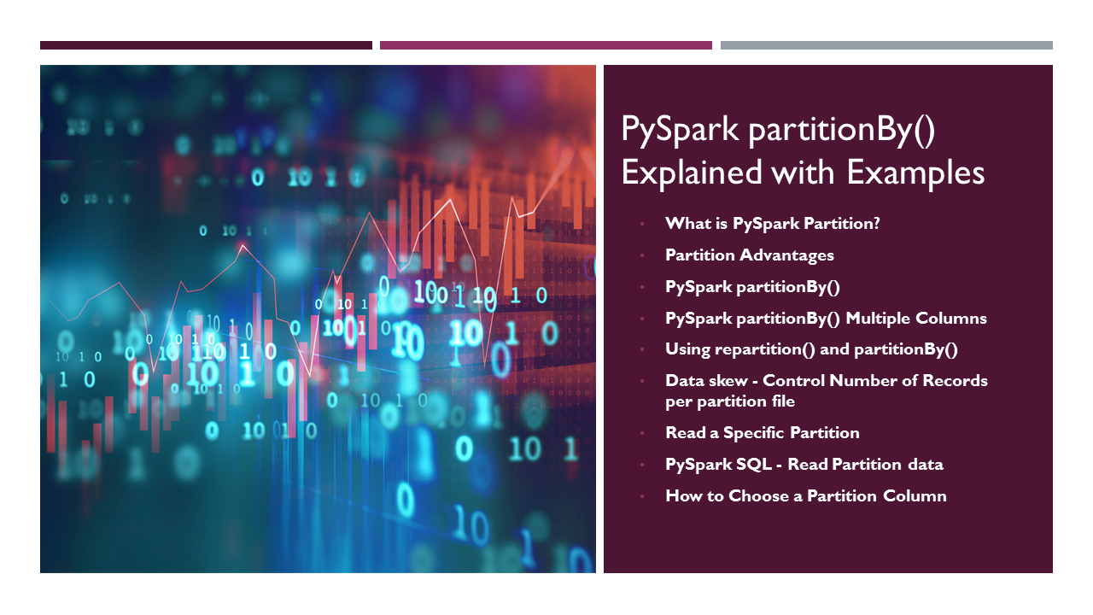
PySpark partitionBy() is a function of pyspark.sql.DataFrameWriter class which is used to partition the large dataset (DataFrame) into smaller files based on one or multiple columns while writing to disk, let’s see how to use this with Python examples.
Advertisements
Partitioning the data on the file system is a way to improve the performance of the query when dealing with a large dataset, for example Data lake.

1. What is PySpark Partition?
PySpark partition is a way to split a large dataset into smaller datasets based on one or more partition keys. When you create a DataFrame from a file/table, based on certain parameters PySpark creates the DataFrame with a certain number of partitions in memory. This is one of the main advantages of PySpark DataFrame over Pandas DataFrame. Transformations on partitioned data run faster as they execute transformations parallelly for each partition.
PySpark supports partition in two ways; partition in memory (DataFrame) and partition on the disk (File system).

Partition in memory: You can partition or repartition the DataFrame by calling repartition() or coalesce() transformations.
Partition on disk: While writing the PySpark DataFrame back to disk, you can choose how to partition the data based on columns using partitionBy() of pyspark.sql.DataFrameWriter. This is similar to Hives partitions scheme.

2. Partition Advantages
As you are aware PySpark is designed to process large datasets 100x faster than the traditional processing, this wouldn’t have been possible without partition. Below are some of the advantages of using PySpark partitions on memory or on disk.
- Fast access to the data
- Provides the ability to perform an operation on a smaller dataset
Partition at rest (disk) is a feature of many databases and data processing frameworks and it is key to make jobs work at scale.

3. Create DataFrame
Let’s Create a DataFrame by reading a CSV file. Follow Github zipcodes.csv file to download the CSV file.

# Create DataFrame by reading CSV file
df=spark.read.option("header",True) \
.csv("/tmp/resources/simple-zipcodes.csv")
df.printSchema()

#Display below schema
root
|-- RecordNumber: string (nullable = true)
|-- Country: string (nullable = true)
|-- City: string (nullable = true)
|-- Zipcode: string (nullable = true)
|-- state: string (nullable = true)
From the above DataFrame, I will be using state as a partition key for our examples below.

4. PySpark partitionBy()
In PySpark, the partitionBy() transformation is used to partition data in an RDD or DataFrame based on the specified partitioner. It is typically applied after certain operations such as groupBy() or join() to control the distribution of data across partitions.
The partitionBy() is available in DataFrameWriter class hence, it is used to write the partition data to the disk.

# Syntax partitionBy
partitionBy(self, *cols)
When you write PySpark DataFrame to disk by calling partitionBy(), PySpark splits the records based on the partition column and stores each partition data into a sub-directory.

# partitionBy() Example
df.write.option("header",True) \
.partitionBy("state") \
.mode("overwrite") \
.csv("/tmp/zipcodes-state")
My data has six states; hence, it created six directories on disk. The name of the sub-directory would be the partition column and its value (partition column=value).
Note: When writing the data as partitions, PySpark eliminates the partition column on the data file and adds the partition column and value to the folder name, saving some storage space.To validate this, open any partition file in a text editor and check.
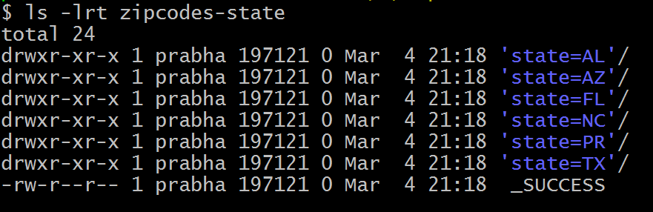partitionBy(“state”) example output
On each directory, you may see one or more part files (since our dataset is small, all records for each state are kept in a single part file). You can change this behavior by repartition() the data in memory first. Specify the number of partitions (part files) you would want for each state as an argument to the repartition() method.

5. PySpark partitionBy() Multiple Columns
You can also create partitions on multiple columns using PySpark partitionBy(). Just pass the columns you want to partition as arguments to this method.

#partitionBy() multiple columns
df.write.option("header",True) \
.partitionBy("state","city") \
.mode("overwrite") \
.csv("/tmp/zipcodes-state")
It creates a folder hierarchy for each partition; we have mentioned the first partition as state followed by city hence, it creates a city folder inside the state folder (one folder for each city in a state).
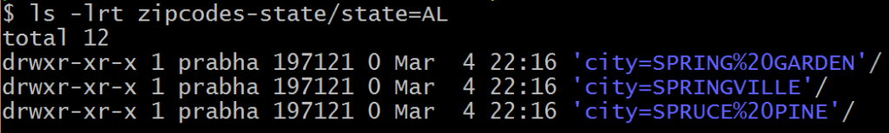partitonBy(“state”,”city”) multiple columns

6. Using repartition() and partitionBy() together
The repartition() is used to increase or decrease the number of partitions in memory and when you use it with partitionBy(), it further breaks down into multiple partitions based on column data.

#Use repartition() and partitionBy() together
dfRepart.repartition(2)
.write.option("header",True) \
.partitionBy("state") \
.mode("overwrite") \
.csv("c:/tmp/zipcodes-state-more")
Upon inspection of the folder where the data is written, you’ll observe that there are only two partition files for each state. Given that the dataset encompasses six unique states and there are two memory partitions allocated for each state, the code generates a maximum of 12 partition files.
Note: As the total number of zip codes varies significantly for each US state, with California and Texas containing numerous zip codes while Delaware has relatively few, a data skew arises. This skew results in unequal distribution of rows across partition files, with some containing a large number of rows and others containing only a few.

7. Data Skew – Control Number of Records per Partition File
Use option maxRecordsPerFile if you want to control the number of records for each partition. This is particularly helpful when your data is skewed (Having some partitions with very low records and other partitions with a high number of records).

#partitionBy() control number of partitions
df.write.option("header",True) \
.option("maxRecordsPerFile", 2) \
.partitionBy("state") \
.mode("overwrite") \
.csv("/tmp/zipcodes-state")
The above example creates multiple part files for each state and each part file contains just 2 records.

8. Read a Specific Partition
Reads are much faster on partitioned data. This code snippet retrieves the data from a specific partition "state=AL and city=SPRINGVILLE". Here, It just reads the data from that specific folder instead of scanning a whole file (when not partitioned).

# Reading from partitioned data
dfSinglePart=spark.read.option("header",True) \
.csv("c:/tmp/zipcodes-state/state=AL/city=SPRINGVILLE")
dfSinglePart.printSchema()
dfSinglePart.show()

#Displays
root
|-- RecordNumber: string (nullable = true)
|-- Country: string (nullable = true)
|-- Zipcode: string (nullable = true)

+------------+-------+-------+
|RecordNumber|Country|Zipcode|
+------------+-------+-------+
| 54355| US| 35146|
+------------+-------+-------+
While reading specific Partition data into DataFrame, it does not keep the partition columns on DataFrame hence, you printSchema() and DataFrame is missing state and city columns.

9. PySpark SQL – Read Partition Data
This is an example of how to write a Spark DataFrame by preserving the partition columns on DataFrame.

# Read from partitioned data using sql
parqDF = spark.read.option("header",True) \
.csv("/tmp/zipcodes-state")
parqDF.createOrReplaceTempView("ZIPCODE")
spark.sql("select * from ZIPCODE where state='AL' and city = 'SPRINGVILLE'") \
.show()

#Display
+------------+-------+-------+-----+-----------+
|RecordNumber|Country|Zipcode|state| city|
+------------+-------+-------+-----+-----------+
| 54355| US| 35146| AL|SPRINGVILLE|
+------------+-------+-------+-----+-----------+
The execution of this query is also significantly faster than the query without partition. It filters the data first on state and then applies filters to the city column without scanning the entire dataset.

10. How to Choose a Partition Column When Writing to File System?
When creating partitions you have to be very cautious with the number of partitions you would create, as having too many partitions creates too many sub-directories on HDFS which brings unnecessary and overhead to NameNode (if you are using Hadoop) since it must keep all metadata for the file system in memory.
Consider a scenario where you possess a US census table featuring zip codes, cities, states, and additional columns. Employing state as a partition key divides the table into approximately 50 partitions. Consequently, when seeking a zip code within a specific state (e.g., state=’CA’ and zipCode=’92704′), the process is expedited as it solely necessitates scanning within the directory associated with the ‘CA’ state partition.
Partition on zipcode may not be a good option as you might end up with too many partitions.
Another good example of partition is in the Date column. Ideally, you should partition on Year/Month but not on a date.

11. Frequently Asked Questions on partitionBy()
How is partitionBy() different from groupBy() in PySpark?
partitionBy() is used for physically organizing data on disk when writing to a file system, while groupBy() is used for the logical grouping of data within a DataFrame.
Can I use multiple columns with partitionBy()?
Yes, We can specify multiple columns in the partitionBy() function to create a hierarchical directory structure. For example:
df.write.partitionBy(“column1”, “column2”).parquet(“/path/to/output”)
How does partitioning affect query performance?
Partitioning can significantly improve query performance, especially when querying specific subsets of data. It helps skip irrelevant data when reading, reducing the amount of data that needs to be processed.

Conclusion
While you are create Data Lake out of Azure, HDFS or AWS you need to understand how to partition your data at rest (File system/disk), PySpark partitionBy() and repartition() help you partition the data and eliminating the Data Skew on your large datasets.
Hope this give you better idea on partitions in PySpark.
Happy Learning !!

Related Articles
- PySpark repartition() – Explained with Examples
- PySpark mapPartitions() Examples
- PySpark repartition() vs partitionBy()
- PySpark Repartition() vs Coalesce()
- PySpark cache() Explained.
- PySpark Shell Command Usage with Examples
- PySpark Find Maximum Row per Group in DataFrame
- PySpark – Loop/Iterate Through Rows in DataFrame

References
- https://spark.apache.org/docs/2.4.0/api/python/pyspark.sql.html?highlight=partition
Tags: partitionBy()

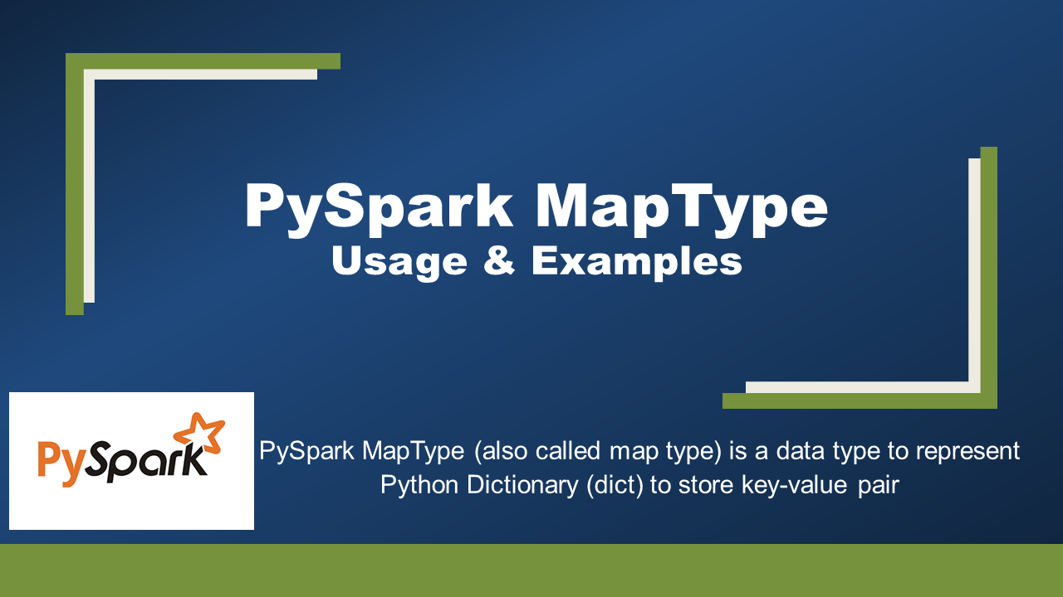
PySpark MapType (also called map type) is a data type to represent Python Dictionary (dict) to store key-value pair, a MapType object comprises three fields, keyType (a DataType), valueType (a DataType) and valueContainsNull (a BooleanType).
Advertisements
What is PySpark MapType
PySpark MapType is used to represent map key-value pair similar to python Dictionary (Dict), it extends DataType class which is a superclass of all types in PySpark and takes two mandatory arguments keyType and valueType of type DataType and one optional boolean argument valueContainsNull. keyType and valueType can be any type that extends the DataType class. for e.g StringType, IntegerType, ArrayType, MapType, StructType (struct) e.t.c.

1. Create PySpark MapType
In order to use MapType data type first, you need to import it from pyspark.sql.types.MapType and use MapType() constructor to create a map object.

from pyspark.sql.types import StringType, MapType
mapCol = MapType(StringType(),StringType(),False)
MapType Key Points:

- The First param keyType is used to specify the type of the key in the map.
- The Second param valueType is used to specify the type of the value in the map.
- Third parm valueContainsNull is an optional boolean type that is used to specify if the value of the second param can accept Null/None values.
- The key of the map won’t accept None/Null values.
- PySpark provides several SQL functions to work with MapType.

2. Create MapType From StructType
Let’s see how to create a MapType by using PySpark StructType & StructField, StructType() constructor takes list of StructField, StructField takes a fieldname and type of the value.

from pyspark.sql.types import StructField, StructType, StringType, MapType
schema = StructType([
StructField('name', StringType(), True),
StructField('properties', MapType(StringType(),StringType()),True)
])
Now let’s create a DataFrame by using above StructType schema.

from pyspark.sql import SparkSession
spark = SparkSession.builder.appName('SparkByExamples.com').getOrCreate()
dataDictionary = [
('James',{'hair':'black','eye':'brown'}),
('Michael',{'hair':'brown','eye':None}),
('Robert',{'hair':'red','eye':'black'}),
('Washington',{'hair':'grey','eye':'grey'}),
('Jefferson',{'hair':'brown','eye':''})
]
df = spark.createDataFrame(data=dataDictionary, schema = schema)
df.printSchema()
df.show(truncate=False)
df.printSchema() yields the Schema and df.show() yields the DataFrame output.

root
|-- Name: string (nullable = true)
|-- properties: map (nullable = true)
| |-- key: string
| |-- value: string (valueContainsNull = true)

+----------+-----------------------------+
|Name |properties |
+----------+-----------------------------+
|James |[eye -> brown, hair -> black]|
|Michael |[eye ->, hair -> brown] |
|Robert |[eye -> black, hair -> red] |
|Washington|[eye -> grey, hair -> grey] |
|Jefferson |[eye -> , hair -> brown] |
+----------+-----------------------------+

3. Access PySpark MapType Elements
Let’s see how to extract the key and values from the PySpark DataFrame Dictionary column. Here I have used PySpark map transformation to read the values of properties (MapType column)

df3=df.rdd.map(lambda x: \
(x.name,x.properties["hair"],x.properties["eye"])) \
.toDF(["name","hair","eye"])
df3.printSchema()
df3.show()

root
|-- name: string (nullable = true)
|-- hair: string (nullable = true)
|-- eye: string (nullable = true)

+----------+-----+-----+
| name| hair| eye|
+----------+-----+-----+
| James|black|brown|
| Michael|brown| null|
| Robert| red|black|
|Washington| grey| grey|
| Jefferson|brown| |
+----------+-----+-----+
Let’s use another way to get the value of a key from Map using getItem() of Column type, this method takes a key as an argument and returns a value.

df.withColumn("hair",df.properties.getItem("hair")) \
.withColumn("eye",df.properties.getItem("eye")) \
.drop("properties") \
.show()

df.withColumn("hair",df.properties["hair"]) \
.withColumn("eye",df.properties["eye"]) \
.drop("properties") \
.show()

4. Functions
Below are some of the MapType Functions with examples.

4.1 – explode

from pyspark.sql.functions import explode
df.select(df.name,explode(df.properties)).show()

+----------+----+-----+
| name| key|value|
+----------+----+-----+
| James| eye|brown|
| James|hair|black|
| Michael| eye| null|
| Michael|hair|brown|
| Robert| eye|black|
| Robert|hair| red|
|Washington| eye| grey|
|Washington|hair| grey|
| Jefferson| eye| |
| Jefferson|hair|brown|
+----------+----+-----+

4.2 map_keys() – Get All Map Keys

from pyspark.sql.functions import map_keys
df.select(df.name,map_keys(df.properties)).show()

+----------+--------------------+
| name|map_keys(properties)|
+----------+--------------------+
| James| [eye, hair]|
| Michael| [eye, hair]|
| Robert| [eye, hair]|
|Washington| [eye, hair]|
| Jefferson| [eye, hair]|
+----------+--------------------+
In case if you wanted to get all map keys as Python List. WARNING: This runs very slow.

from pyspark.sql.functions import explode,map_keys
keysDF = df.select(explode(map_keys(df.properties))).distinct()
keysList = keysDF.rdd.map(lambda x:x[0]).collect()
print(keysList)
#['eye', 'hair']

4.3 map_values() – Get All map Values

from pyspark.sql.functions import map_values
df.select(df.name,map_values(df.properties)).show()

+----------+----------------------+
| name|map_values(properties)|
+----------+----------------------+
| James| [brown, black]|
| Michael| [, brown]|
| Robert| [black, red]|
|Washington| [grey, grey]|
| Jefferson| [, brown]|
+----------+----------------------+

Conclusion
MapType is a map data structure that is used to store key key-value pairs similar to Python Dictionary (Dic), keys and values type of map should be of a type that extends DataType. Key won’t accept null/None values whereas map of the key can have None/Null value.

Related Articles
- Convert DataFrame Columns to Map in PySpark
- PySpark StructType & StructField Explained with Examples
- Convert StructType to Map in PySpark
- Convert Dictionary/Map to Multiple Columns in PySpark
- Create PySpark DataFrame From List of Dictionary (Dict) Objects
- PySpark Convert DataFrame Columns to MapType (Dict)
- PySpark Convert StructType (struct) to Dictionary/MapType (map)

PySpark SQL Functions

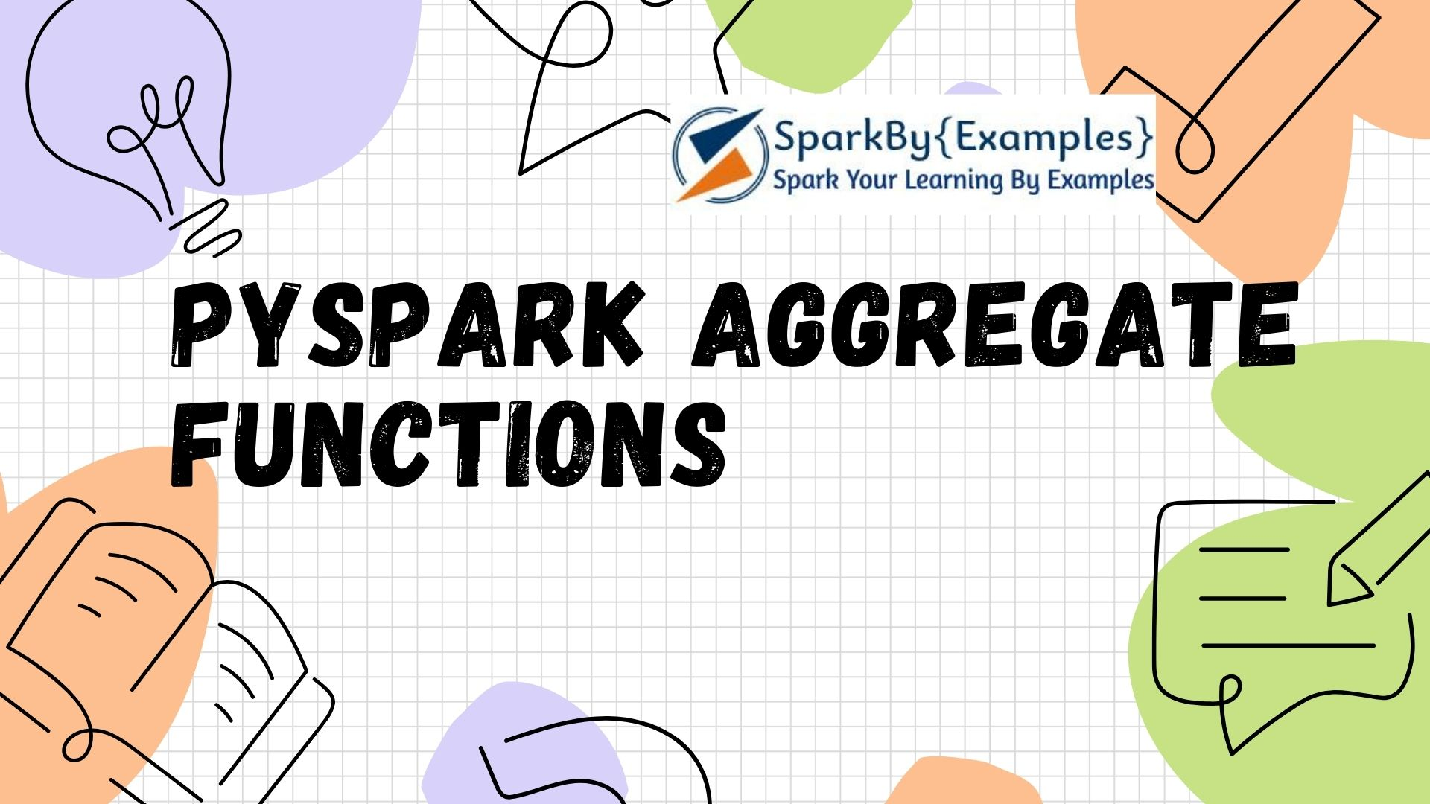
Aggregate functions in PySpark are essential for summarizing data across distributed datasets. They allow computations like sum, average, count, maximum, and minimum to be performed efficiently in parallel across multiple nodes in a cluster.
Advertisements
These functions are primarily used with large datasets to get single values or smaller result sets, providing insights into the dataset’s characteristics. Aggregate functions operate on a group of rows and calculate a single return value for every group. All these aggregate functions accept input as, Column type or column name as a string and several other arguments based on the function.

PySpark Aggregate Functions
PySpark SQL Aggregate functions are grouped as “agg_funcs” in Pyspark. Below is a list of functions defined under this group. Click on each link to learn with example.
- approx_count_distinct
- avg
- collect_list
- collect_set
- countDistinct
- count
- grouping
- first
- last
- kurtosis
- max
- min
- mean
- skewness
- stddev
- stddev_samp
- stddev_pop
- sum
- sumDistinct
- variance, var_samp, var_pop

PySpark Aggregate Functions Examples
First, let’s create a DataFrame to work with PySpark aggregate functions. All examples provided here are also available at PySpark Examples GitHub project.

simpleData = [("James", "Sales", 3000),
("Michael", "Sales", 4600),
("Robert", "Sales", 4100),
("Maria", "Finance", 3000),
("James", "Sales", 3000),
("Scott", "Finance", 3300),
("Jen", "Finance", 3900),
("Jeff", "Marketing", 3000),
("Kumar", "Marketing", 2000),
("Saif", "Sales", 4100)
]
schema = ["employee_name", "department", "salary"]
df = spark.createDataFrame(data=simpleData, schema = schema)
df.printSchema()
df.show(truncate=False)
Yields below output.

# Output
+-------------+----------+------+
|employee_name|department|salary|
+-------------+----------+------+
| James| Sales| 3000|
| Michael| Sales| 4600|
| Robert| Sales| 4100|
| Maria| Finance| 3000|
| James| Sales| 3000|
| Scott| Finance| 3300|
| Jen| Finance| 3900|
| Jeff| Marketing| 3000|
| Kumar| Marketing| 2000|
| Saif| Sales| 4100|
+-------------+----------+------+
Now let’s see how to aggregate data in PySpark.

approx_count_distinct Aggregate Function
In PySpark approx_count_distinct() function returns the count of distinct items in a group.

# approx_count_distinct()
print("approx_count_distinct: " + \
str(df.select(approx_count_distinct("salary")).collect()[0][0]))

# Prints approx_count_distinct: 6

avg (average) Aggregate Function
avg() function returns the average of values in the input column.

# avg
print("avg: " + str(df.select(avg("salary")).collect()[0][0]))

# Prints avg: 3400.0

collect_list Aggregate Function
collect_list() function returns all values from an input column with duplicates.

# collect_list
df.select(collect_list("salary")).show(truncate=False)

+------------------------------------------------------------+
|collect_list(salary) |
+------------------------------------------------------------+
|[3000, 4600, 4100, 3000, 3000, 3300, 3900, 3000, 2000, 4100]|
+------------------------------------------------------------+

collect_set Aggregate Function
collect_set() function returns all values from an input column with duplicate values eliminated.

# collect_set
df.select(collect_set("salary")).show(truncate=False)

+------------------------------------+
|collect_set(salary) |
+------------------------------------+
|[4600, 3000, 3900, 4100, 3300, 2000]|
+------------------------------------+

countDistinct Aggregate Function
countDistinct() function returns the number of distinct elements in a columns

# countDistinct
df2 = df.select(countDistinct("department", "salary"))
df2.show(truncate=False)
print("Distinct Count of Department & Salary: "+str(df2.collect()[0][0]))

count function
count() function returns number of elements in a column.

print("count: "+str(df.select(count("salary")).collect()[0]))

Prints county: 10

grouping function
grouping() Indicates whether a given input column is aggregated or not. returns 1 for aggregated or 0 for not aggregated in the result. If you try grouping directly on the salary column you will get below error.

Exception in thread "main" org.apache.spark.sql.AnalysisException:
// grouping() can only be used with GroupingSets/Cube/Rollup

first function
first() function returns the first element in a column when ignoreNulls is set to true, it returns the first non-null element.

# first
df.select(first("salary")).show(truncate=False)

+--------------------+
|first(salary, false)|
+--------------------+
|3000 |
+--------------------+

last function
last() function returns the last element in a column. when ignoreNulls is set to true, it returns the last non-null element.

# last
df.select(last("salary")).show(truncate=False)

+-------------------+
|last(salary, false)|
+-------------------+
|4100 |
+-------------------+

kurtosis function
kurtosis() function returns the kurtosis of the values in a group.

df.select(kurtosis("salary")).show(truncate=False)

+-------------------+
|kurtosis(salary) |
+-------------------+
|-0.6467803030303032|
+-------------------+

max function
max() function returns the maximum value in a column.

df.select(max("salary")).show(truncate=False)

+-----------+
|max(salary)|
+-----------+
|4600 |
+-----------+

min function
min() function

df.select(min("salary")).show(truncate=False)

+-----------+
|min(salary)|
+-----------+
|2000 |
+-----------+

mean function
mean() function returns the average of the values in a column. Alias for Avg

df.select(mean("salary")).show(truncate=False)

+-----------+
|avg(salary)|
+-----------+
|3400.0 |
+-----------+

skewness function
skewness() function returns the skewness of the values in a group.

df.select(skewness("salary")).show(truncate=False)

+--------------------+
|skewness(salary) |
+--------------------+
|-0.12041791181069571|
+--------------------+

stddev(), stddev_samp() and stddev_pop()
stddev() alias for stddev_samp.
stddev_samp() function returns the sample standard deviation of values in a column.
stddev_pop() function returns the population standard deviation of the values in a column.

df.select(stddev("salary"), stddev_samp("salary"), \
stddev_pop("salary")).show(truncate=False)

+-------------------+-------------------+------------------+
|stddev_samp(salary)|stddev_samp(salary)|stddev_pop(salary)|
+-------------------+-------------------+------------------+
|765.9416862050705 |765.9416862050705 |726.636084983398 |
+-------------------+-------------------+------------------+

sum function
sum() function Returns the sum of all values in a column.

df.select(sum("salary")).show(truncate=False)

+-----------+
|sum(salary)|
+-----------+
|34000 |
+-----------+

sumDistinct function
sumDistinct() function returns the sum of all distinct values in a column.

df.select(sumDistinct("salary")).show(truncate=False)

+--------------------+
|sum(DISTINCT salary)|
+--------------------+
|20900 |
+--------------------+

variance(), var_samp(), var_pop()
variance() alias for var_samp
var_samp() function returns the unbiased variance of the values in a column.
var_pop() function returns the population variance of the values in a column.

df.select(variance("salary"),var_samp("salary"),var_pop("salary")) \
.show(truncate=False)

+-----------------+-----------------+---------------+
|var_samp(salary) |var_samp(salary) |var_pop(salary)|
+-----------------+-----------------+---------------+
|586666.6666666666|586666.6666666666|528000.0 |
+-----------------+-----------------+---------------+

Source code of PySpark Aggregate examples

# Imports
import pyspark
from pyspark.sql import SparkSession
from pyspark.sql.functions import approx_count_distinct,collect_list
from pyspark.sql.functions import collect_set,sum,avg,max,countDistinct,count
from pyspark.sql.functions import first, last, kurtosis, min, mean, skewness
from pyspark.sql.functions import stddev, stddev_samp, stddev_pop, sumDistinct
from pyspark.sql.functions import variance,var_samp, var_pop

spark = SparkSession.builder.appName('SparkByExamples.com').getOrCreate()

simpleData = [("James", "Sales", 3000),
("Michael", "Sales", 4600),
("Robert", "Sales", 4100),
("Maria", "Finance", 3000),
("James", "Sales", 3000),
("Scott", "Finance", 3300),
("Jen", "Finance", 3900),
("Jeff", "Marketing", 3000),
("Kumar", "Marketing", 2000),
("Saif", "Sales", 4100)
]
schema = ["employee_name", "department", "salary"]

df = spark.createDataFrame(data=simpleData, schema = schema)
df.printSchema()
df.show(truncate=False)

print("approx_count_distinct: " + \
str(df.select(approx_count_distinct("salary")).collect()[0][0]))

print("avg: " + str(df.select(avg("salary")).collect()[0][0]))

df.select(collect_list("salary")).show(truncate=False)

df.select(collect_set("salary")).show(truncate=False)

df2 = df.select(countDistinct("department", "salary"))
df2.show(truncate=False)
print("Distinct Count of Department & Salary: "+str(df2.collect()[0][0]))

print("count: "+str(df.select(count("salary")).collect()[0]))
df.select(first("salary")).show(truncate=False)
df.select(last("salary")).show(truncate=False)
df.select(kurtosis("salary")).show(truncate=False)
df.select(max("salary")).show(truncate=False)
df.select(min("salary")).show(truncate=False)
df.select(mean("salary")).show(truncate=False)
df.select(skewness("salary")).show(truncate=False)
df.select(stddev("salary"), stddev_samp("salary"), \
stddev_pop("salary")).show(truncate=False)
df.select(sum("salary")).show(truncate=False)
df.select(sumDistinct("salary")).show(truncate=False)
df.select(variance("salary"),var_samp("salary"),var_pop("salary")) \
.show(truncate=False)

Conclusion
In this article, I’ve consolidated and listed all PySpark Aggregate functions with Python examples and also learned the benefits of using PySpark SQL functions. Additionally, aggregate functions are often used in conjunction with group-by operations to perform calculations on grouped data. Overall, aggregate functions facilitate data analysis tasks, enabling users to derive meaningful insights and make informed decisions based on the summarized information.
Happy Learning !!

Related Articles
- PySpark String Functions with Examples
- PySpark JSON Functions with Examples
- PySpark SQL Date and Timestamp Functions
- PySpark Column Class | Operators & Functions
- PySpark Window Functions
- PySpark Groupby Agg (aggregate) – Explained.
- PySpark Get Number of Rows and Columns
- PySpark count() – Different Methods Explained
- PySpark Groupby Count Distinct
- PySpark Groupby on Multiple Columns
- PySpark GroupBy Count – Explained
- PySpark printSchema() Example
- PySpark Column alias after groupBy() Example
- PySpark DataFrame groupBy and Sort by Descending Order

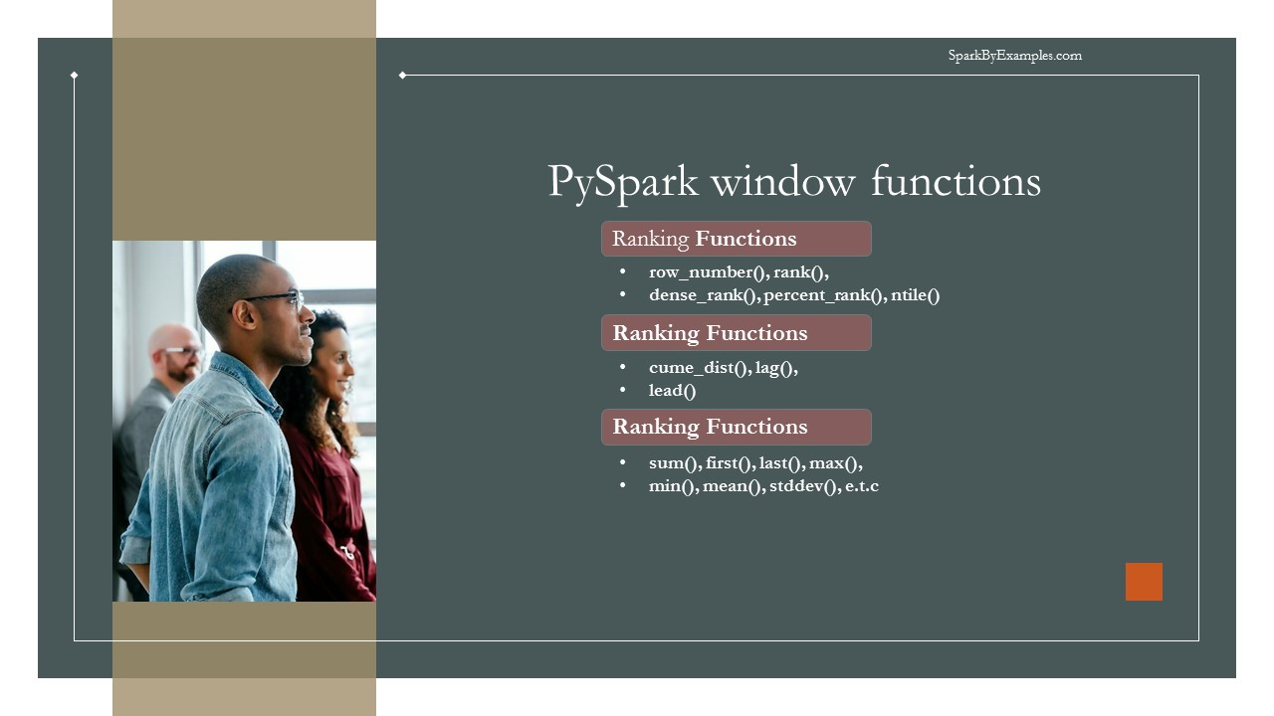
PySpark Window functions are used to calculate results, such as the rank, row number, etc., over a range of input rows. In this article, I’ve explained the concept of window functions, syntax, and finally how to use them with PySpark SQL and PySpark DataFrame API. These are handy when making aggregate operations in a specific window frame on DataFrame columns. You can also create UDF to achieve similar functionality but there is a catch.
Advertisements
Related: PySpark SQL Functions Explained with Examples
Whenever feasible, consider utilizing standard libraries like window functions as they offer enhanced safety during compile-time, handle null values more effectively, and often deliver better performance compared to user-defined functions (UDFs). If performance is critical for your application, it’s advisable to minimize the use of custom UDFs as they do not guarantee optimal performance.

1. Window Functions
PySpark Window functions operate on a group of rows (like frame, partition) and return a single value for every input row. PySpark SQL supports three kinds of window functions:

- ranking functions
- analytic functions
- aggregate functions
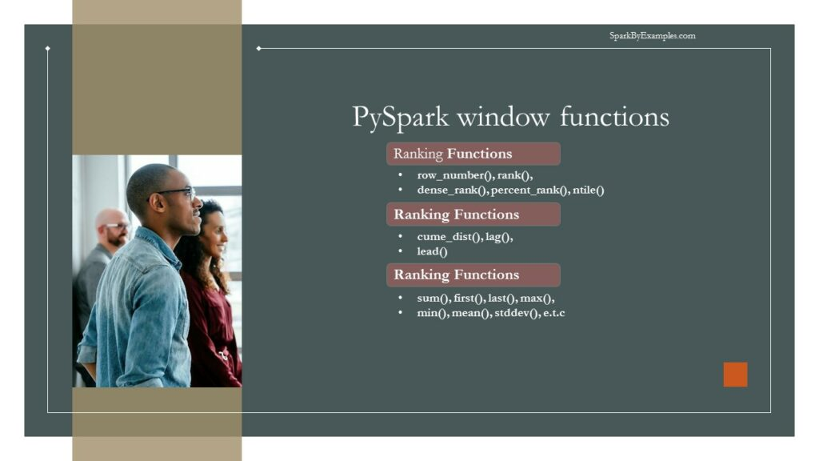PySpark Window Functions
The table below defines Ranking and Analytic functions; for aggregate functions, we can use any existing aggregate functions as a window function.
To operate on a group, first, we need to partition the data using Window.partitionBy() , and for row number and rank function, we need to additionally order by on partition data using orderBy clause.
WINDOW FUNCTIONS USAGE & SYNTAX | PYSPARK WINDOW FUNCTIONS DESCRIPTION
row_number() | Returns a sequential number starting from 1 within a window partition
rank() | Returns the rank of rows within a window partition, with gaps.
percent_rank() | Returns the percentile rank of rows within a window partition.
dense_rank() | Returns the rank of rows within a window partition without any gaps. Where as Rank() returns rank with gaps.
ntile(n) | Returns the ntile id in a window partition
cume_dist() | Returns the cumulative distribution of values within a window partition
lag(e, offset)  lag(columnname, offset)  lag(columnname, offset, defaultvalue) | In PySpark, the lag() function retrieves the value of a column from a preceding row within the same window. It enables users to compare values across adjacent rows and perform calculations based on the difference or relationship between consecutive values in a DataFrame.
lead(columnname, offset)  lead(columnname, offset)  lead(columnname, offset, defaultvalue) | The lead() function in PySpark retrieves the value of a column from a succeeding row within the same window. It enables users to access values ahead of the current row and perform comparisons or calculations based on future values in a DataFrame.
PySpark Window Functions
Before we start with an example, let’s create a PySpark DataFrame to work with.

# Create SparkSession
spark = SparkSession.builder.appName('SparkByExamples.com').getOrCreate()

simpleData = (("James", "Sales", 3000), \
("Michael", "Sales", 4600), \
("Robert", "Sales", 4100), \
("Maria", "Finance", 3000), \
("James", "Sales", 3000), \
("Scott", "Finance", 3300), \
("Jen", "Finance", 3900), \
("Jeff", "Marketing", 3000), \
("Kumar", "Marketing", 2000),\
("Saif", "Sales", 4100) \
)

columns= ["employee_name", "department", "salary"]
df = spark.createDataFrame(data = simpleData, schema = columns)
df.printSchema()
df.show(truncate=False)
Yields below output

# Output:
root
|-- employee_name: string (nullable = true)
|-- department: string (nullable = true)
|-- salary: long (nullable = true)

+-------------+----------+------+
|employee_name|department|salary|
+-------------+----------+------+
|James |Sales |3000 |
|Michael |Sales |4600 |
|Robert |Sales |4100 |
|Maria |Finance |3000 |
|James |Sales |3000 |
|Scott |Finance |3300 |
|Jen |Finance |3900 |
|Jeff |Marketing |3000 |
|Kumar |Marketing |2000 |
|Saif |Sales |4100 |
+-------------+----------+------+

2. PySpark Window Ranking functions
PySpark’s Window Ranking functions, like row_number(), rank(), and dense_rank(), assign sequential numbers to DataFrame rows based on specified criteria within defined partitions. These functions enable sorting and ranking operations, identifying row positions in partitions based on specific orderings.
The row_number() assigns unique sequential numbers, rank() provides the ranking with gaps, and dense_rank() offers ranking without gaps. They’re valuable in selecting top elements within groups and bottom elements within groups, facilitating analysis of data distributions, and identifying the highest or lowest values within partitions in PySpark DataFrames.

2.1 row_number Window Function
row_number() window function gives the sequential row number starting from 1 to the result of each window partition.

# row_number() example
from pyspark.sql.window import Window
from pyspark.sql.functions import row_number
windowSpec = Window.partitionBy("department").orderBy("salary")

df.withColumn("row_number",row_number().over(windowSpec)) \
.show(truncate=False)
Yields below output.

# Output:
+-------------+----------+------+----------+
|employee_name|department|salary|row_number|
+-------------+----------+------+----------+
|James |Sales |3000 |1 |
|James |Sales |3000 |2 |
|Robert |Sales |4100 |3 |
|Saif |Sales |4100 |4 |
|Michael |Sales |4600 |5 |
|Maria |Finance |3000 |1 |
|Scott |Finance |3300 |2 |
|Jen |Finance |3900 |3 |
|Kumar |Marketing |2000 |1 |
|Jeff |Marketing |3000 |2 |
+-------------+----------+------+----------+

2.2 rank Window Function
rank() window function provides a rank to the result within a window partition. This function leaves gaps in rank when there are ties.

# rank() example
from pyspark.sql.functions import rank
df.withColumn("rank",rank().over(windowSpec)) \
.show()
Yields below output.

# Output:
+-------------+----------+------+----+
|employee_name|department|salary|rank|
+-------------+----------+------+----+
| James| Sales| 3000| 1|
| James| Sales| 3000| 1|
| Robert| Sales| 4100| 3|
| Saif| Sales| 4100| 3|
| Michael| Sales| 4600| 5|
| Maria| Finance| 3000| 1|
| Scott| Finance| 3300| 2|
| Jen| Finance| 3900| 3|
| Kumar| Marketing| 2000| 1|
| Jeff| Marketing| 3000| 2|
+-------------+----------+------+----+
This is the same as the RANK function in SQL.

2.3 dense_rank Window Function
dense_rank() window function is used to get the result with rank of rows within a window partition without any gaps. This is similar to rank() function difference being rank function leaves gaps in rank when there are ties.

# dense_rank() example
from pyspark.sql.functions import dense_rank
df.withColumn("dense_rank",dense_rank().over(windowSpec)) \
.show()
Yields below output.

# Output:
+-------------+----------+------+----------+
|employee_name|department|salary|dense_rank|
+-------------+----------+------+----------+
| James| Sales| 3000| 1|
| James| Sales| 3000| 1|
| Robert| Sales| 4100| 2|
| Saif| Sales| 4100| 2|
| Michael| Sales| 4600| 3|
| Maria| Finance| 3000| 1|
| Scott| Finance| 3300| 2|
| Jen| Finance| 3900| 3|
| Kumar| Marketing| 2000| 1|
| Jeff| Marketing| 3000| 2|
+-------------+----------+------+----------+
This is the same as the DENSE_RANK function in SQL.

2.4 percent_rank Window Function

# percent_rank() Example
from pyspark.sql.functions import percent_rank
df.withColumn("percent_rank",percent_rank().over(windowSpec)) \
.show()
Yields below output.

# Output:
+-------------+----------+------+------------+
|employee_name|department|salary|percent_rank|
+-------------+----------+------+------------+
| James| Sales| 3000| 0.0|
| James| Sales| 3000| 0.0|
| Robert| Sales| 4100| 0.5|
| Saif| Sales| 4100| 0.5|
| Michael| Sales| 4600| 1.0|
| Maria| Finance| 3000| 0.0|
| Scott| Finance| 3300| 0.5|
| Jen| Finance| 3900| 1.0|
| Kumar| Marketing| 2000| 0.0|
| Jeff| Marketing| 3000| 1.0|
+-------------+----------+------+------------+
This is the same as the PERCENT_RANK function in SQL.

2.5 ntile Window Function
ntile() window function returns the relative rank of result rows within a window partition. In the below example we have used 2 as an argument to ntile hence it returns ranking between 2 values (1 and 2)

#ntile() Example
from pyspark.sql.functions import ntile
df.withColumn("ntile",ntile(2).over(windowSpec)) \
.show()
Yields below output.

# Output:
+-------------+----------+------+-----+
|employee_name|department|salary|ntile|
+-------------+----------+------+-----+
| James| Sales| 3000| 1|
| James| Sales| 3000| 1|
| Robert| Sales| 4100| 1|
| Saif| Sales| 4100| 2|
| Michael| Sales| 4600| 2|
| Maria| Finance| 3000| 1|
| Scott| Finance| 3300| 1|
| Jen| Finance| 3900| 2|
| Kumar| Marketing| 2000| 1|
| Jeff| Marketing| 3000| 2|
+-------------+----------+------+-----+
This is the same as the NTILE function in SQL.

3. PySpark Window Analytic Functions

3.1 cume_dist Window Function
cume_dist(): This function computes the cumulative distribution of a value within a window partition. It calculates the relative rank of a value within the partition. The result ranges from 0 to 1, where a value of 0 indicates the lowest value in the partition, and 1 indicates the highest. It’s useful for understanding the distribution of values compared to others within the same partition.
This is the same as the DENSE_RANK function in SQL.

# cume_dist() Example
from pyspark.sql.functions import cume_dist
df.withColumn("cume_dist",cume_dist().over(windowSpec)) \
.show()

# Output:
+-------------+----------+------+------------------+
|employee_name|department|salary| cume_dist|
+-------------+----------+------+------------------+
| James| Sales| 3000| 0.4|
| James| Sales| 3000| 0.4|
| Robert| Sales| 4100| 0.8|
| Saif| Sales| 4100| 0.8|
| Michael| Sales| 4600| 1.0|
| Maria| Finance| 3000|0.3333333333333333|
| Scott| Finance| 3300|0.6666666666666666|
| Jen| Finance| 3900| 1.0|
| Kumar| Marketing| 2000| 0.5|
| Jeff| Marketing| 3000| 1.0|
+-------------+----------+------+------------------+

3.2 lag Window Function
This is the same as the LAG function in SQL. The lag() function allows you to access a previous row’s value within the partition based on a specified offset. It retrieves the column value from the previous row, which can be helpful for comparative analysis or calculating differences between consecutive rows.

# lag() Example
from pyspark.sql.functions import lag
df.withColumn("lag",lag("salary",2).over(windowSpec)) \
.show()

# Output:
+-------------+----------+------+----+
|employee_name|department|salary| lag|
+-------------+----------+------+----+
| James| Sales| 3000|null|
| James| Sales| 3000|null|
| Robert| Sales| 4100|3000|
| Saif| Sales| 4100|3000|
| Michael| Sales| 4600|4100|
| Maria| Finance| 3000|null|
| Scott| Finance| 3300|null|
| Jen| Finance| 3900|3000|
| Kumar| Marketing| 2000|null|
| Jeff| Marketing| 3000|null|
+-------------+----------+------+----+

3.3 lead Window Function
This is the same as the LEAD function in SQL. Similar to lag(), the lead() function retrieves the column value from the following row within the partition based on a specified offset. It helps in accessing subsequent row values for comparison or predictive analysis.

# lead() Example
from pyspark.sql.functions import lead
df.withColumn("lead",lead("salary",2).over(windowSpec)) \
.show()

# Output:
+-------------+----------+------+----+
|employee_name|department|salary|lead|
+-------------+----------+------+----+
| James| Sales| 3000|4100|
| James| Sales| 3000|4100|
| Robert| Sales| 4100|4600|
| Saif| Sales| 4100|null|
| Michael| Sales| 4600|null|
| Maria| Finance| 3000|3900|
| Scott| Finance| 3300|null|
| Jen| Finance| 3900|null|
| Kumar| Marketing| 2000|null|
| Jeff| Marketing| 3000|null|
+-------------+----------+------+----+

4. PySpark Window Aggregate Functions
PySpark’s window aggregate functions, such as sum(), avg(), and min(), compute aggregated values within specified window partitions. These functions perform calculations across rows related to each row in the partition, enabling cumulative or comparative analyses within specific groupings.
They allow computation of running totals, averages, minimums, or other aggregations over defined windows, assisting in tasks like calculating moving averages, cumulative sums, or identifying extreme values within subsets of data in PySpark DataFrames. These functions offer insights into data trends, patterns, and statistical summaries within specified groupings or orderings.
In this section, I will explain how to calculate sum, min, max for each department using PySpark SQL Aggregate window functions and WindowSpec. When working with Aggregate functions, we don’t need to use order by clause.

# Aggregate functions examples
windowSpecAgg = Window.partitionBy("department")
from pyspark.sql.functions import col,avg,sum,min,max,row_number
df.withColumn("row",row_number().over(windowSpec)) \
.withColumn("avg", avg(col("salary")).over(windowSpecAgg)) \
.withColumn("sum", sum(col("salary")).over(windowSpecAgg)) \
.withColumn("min", min(col("salary")).over(windowSpecAgg)) \
.withColumn("max", max(col("salary")).over(windowSpecAgg)) \
.where(col("row")==1).select("department","avg","sum","min","max") \
.show()
This yields below output

# Output:
+----------+------+-----+----+----+
|department| avg| sum| min| max|
+----------+------+-----+----+----+
| Sales|3760.0|18800|3000|4600|
| Finance|3400.0|10200|3000|3900|
| Marketing|2500.0| 5000|2000|3000|
+----------+------+-----+----+----+

Source Code of Window Functions Example

import pyspark
from pyspark.sql import SparkSession

spark = SparkSession.builder.appName('SparkByExamples.com').getOrCreate()

simpleData = (("James", "Sales", 3000), \
("Michael", "Sales", 4600), \
("Robert", "Sales", 4100), \
("Maria", "Finance", 3000), \
("James", "Sales", 3000), \
("Scott", "Finance", 3300), \
("Jen", "Finance", 3900), \
("Jeff", "Marketing", 3000), \
("Kumar", "Marketing", 2000),\
("Saif", "Sales", 4100) \
)

columns= ["employee_name", "department", "salary"]

df = spark.createDataFrame(data = simpleData, schema = columns)

df.printSchema()
df.show(truncate=False)

from pyspark.sql.window import Window
from pyspark.sql.functions import row_number
windowSpec = Window.partitionBy("department").orderBy("salary")

df.withColumn("row_number",row_number().over(windowSpec)) \
.show(truncate=False)

from pyspark.sql.functions import rank
df.withColumn("rank",rank().over(windowSpec)) \
.show()

from pyspark.sql.functions import dense_rank
df.withColumn("dense_rank",dense_rank().over(windowSpec)) \
.show()

from pyspark.sql.functions import percent_rank
df.withColumn("percent_rank",percent_rank().over(windowSpec)) \
.show()

from pyspark.sql.functions import ntile
df.withColumn("ntile",ntile(2).over(windowSpec)) \
.show()

from pyspark.sql.functions import cume_dist
df.withColumn("cume_dist",cume_dist().over(windowSpec)) \
.show()

from pyspark.sql.functions import lag
df.withColumn("lag",lag("salary",2).over(windowSpec)) \
.show()

from pyspark.sql.functions import lead
df.withColumn("lead",lead("salary",2).over(windowSpec)) \
.show()

windowSpecAgg = Window.partitionBy("department")
from pyspark.sql.functions import col,avg,sum,min,max,row_number
df.withColumn("row",row_number().over(windowSpec)) \
.withColumn("avg", avg(col("salary")).over(windowSpecAgg)) \
.withColumn("sum", sum(col("salary")).over(windowSpecAgg)) \
.withColumn("min", min(col("salary")).over(windowSpecAgg)) \
.withColumn("max", max(col("salary")).over(windowSpecAgg)) \
.where(col("row")==1).select("department","avg","sum","min","max") \
.show()
The complete source code is available at PySpark Examples GitHub for reference.

Conclusion
In this tutorial, you have learned what PySpark SQL Window functions, their syntax, and how to use them with aggregate functions, along with several examples in Scala.

Related Articles
- PySpark Add New Column with Row Number
- PySpark UDF (User Defined Function)
- PySpark JSON Functions with Examples
- PySpark Aggregate Functions with Examples
- PySpark Where Filter Function | Multiple Conditions
- PySpark String Functions with Examples
- PySpark Column Class | Operators & Functions

References
In conclusion, PySpark Window functions are analytical functions that operate on a subset of rows, known as a window, within a larger result set. They are essential for performing advanced data analysis tasks, such as calculating running totals, rankings, moving averages, and aggregations, while retaining the context of individual rows.
Window functions enable partitioning, ordering, and framing of data within the window, allowing for precise control over the computation of results. By providing insights into data trends, patterns, and relationships across different segments, window functions empower analysts and data scientists to derive deeper insights and make informed decisions from their datasets.
Happy Learning !!
Tags: aggregate functions, analytic functions, over, rank, ranking functions, row

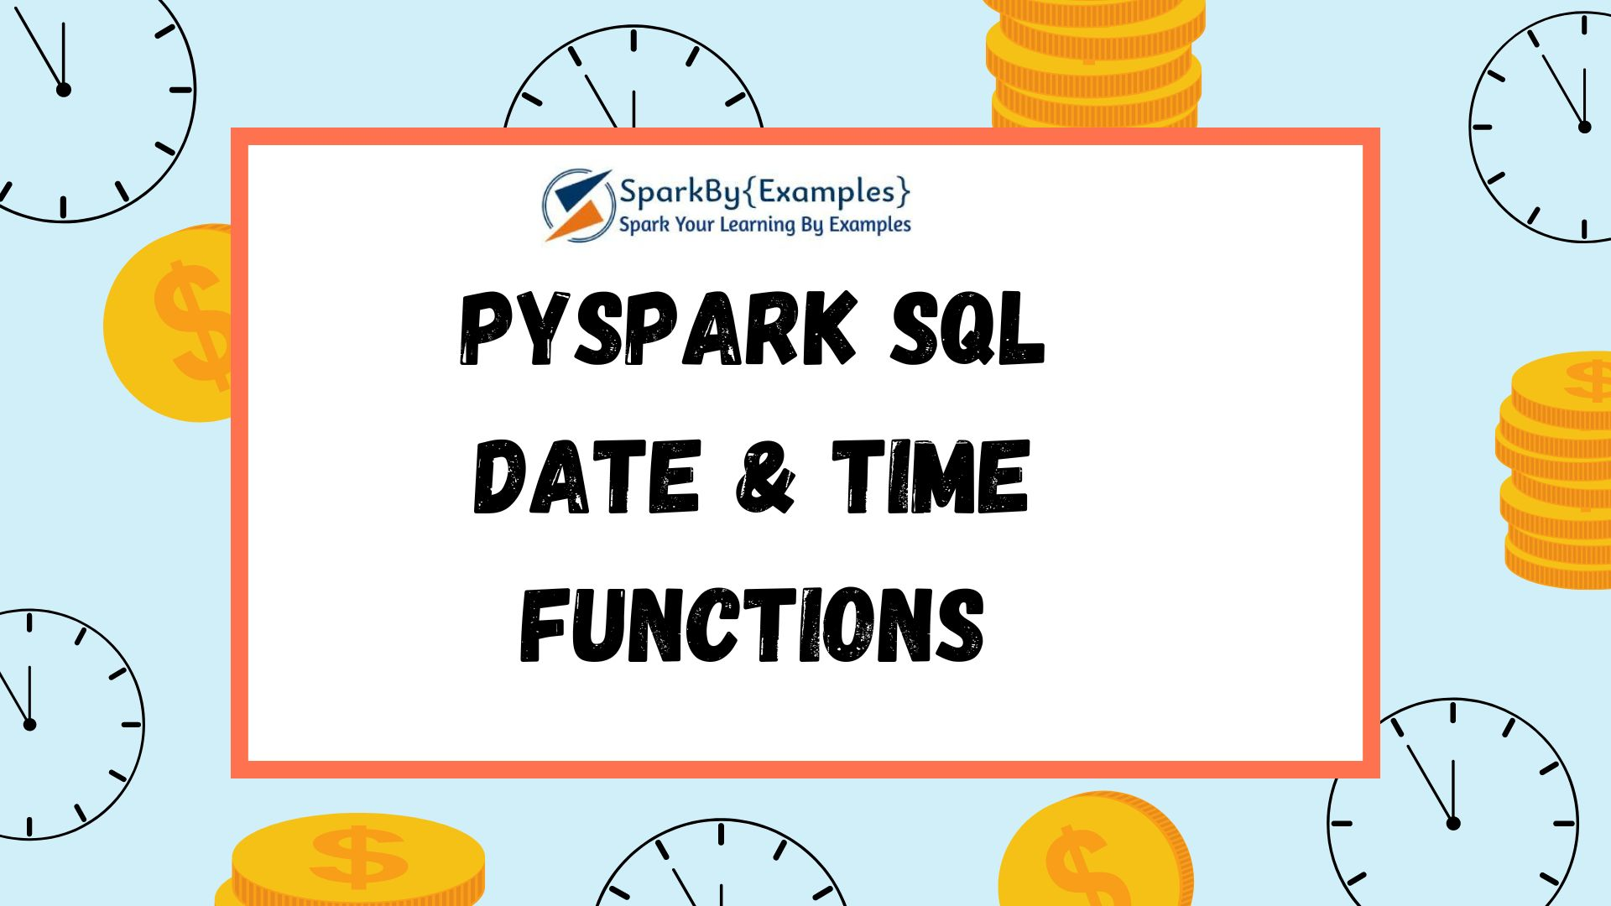
PySpark Date and Timestamp Functions are supported on DataFrame and SQL queries and they work similarly to traditional SQL, Date and Time are very important if you are using PySpark for ETL. Most of all these functions accept input as, Date type, Timestamp type, or String. If a String used, it should be in a default format that can be cast to date.
Advertisements
- DateType default format is yyyy-MM-dd
- TimestampType default format is yyyy-MM-dd HH:mm:ss.SSSS
- Returns null if the input is a string that can not be cast to Date or Timestamp.
PySpark SQL provides several Date & Timestamp functions hence keep an eye on and understand these. Always you should choose these functions instead of writing your own functions (UDF) as these functions are compile-time safe, handles null, and perform better when compared to PySpark UDF. If your PySpark application is critical on performance try to avoid using custom UDF at all costs as these are not guarantee performance.
For readable purposes, I’ve grouped these functions into the following groups.
- Date Functions
- Timestamp Functions
- Date and Timestamp Window Functions
Before you use any examples below, make sure you Create PySpark Sparksession and import SQL functions.

from pyspark.sql.functions import *

PySpark SQL Date Functions
Below are some of the PySpark SQL Date functions, these functions operate on the just Date.
The default format of the PySpark Date is yyyy-MM-dd.
PYSPARK DATE FUNCTION | DATE FUNCTION DESCRIPTION
current_date() | Returns the current date as a DateType object. This function does not take any arguments and simply returns the current date based on the system clock where the PySpark application is running.
date_format() | It is used to format a date or timestamp column in a DataFrame to a specified date or time format pattern.
to_date() | It converts a string column representing a date or timestamp into a date type column in a DataFrame
add_months() | It is used to add or subtract a specified number of months to a date or timestamp column in a DataFrame. It takes two arguments: the column representing the date or timestamp, and the number of months to add or subtract.
date_add(column, days)  date_sub(column, days) | date_add() is used to add a specified number of days to a date column  date_sub() is used to subtract a specified number of days from a date column
datediff(end, start) | It is used to calculate the difference in days between two date columns in a DataFrame. It takes two arguments: the two date columns to calculate the difference between.
months_between(end, start) | It is used to calculate the difference in months between two date or timestamp columns in a DataFrame. It takes two arguments: the two date or timestamp columns to calculate the difference between them.  If both inputs share the same day of the month or are both the last day of their respective months, a whole number is returned. Otherwise, the difference is computed under the assumption of 31 days per month.
months_between(end, start, roundOff) | The result is rounded off to 8 digits when `roundOff` is set to true, it is not rounded otherwise.
next_day(column, dayOfWeek) | It is used to find the first occurrence of a specified day of the week that comes after a given date. It takes two arguments, the date column representing the reference date, and the day of the week specified as a string (e.g., ‘Monday’, ‘Tuesday’, etc.).
trunc(column, format) | Truncate a date or timestamp column in a DataFrame to a specified level of granularity. For example, trunc(df['date_column'], 'month') would truncate the dates in the “date_column” of DataFrame “df” to the first day of the month, effectively removing the day component and retaining only the month and year.
date_trunc(format, timestamp) | Truncate a timestamp column in a DataFrame to a specified level of granularity, while preserving the timestamp type. It takes two arguments: the column representing the timestamp to be truncated, and the level of granularity to which the timestamp should be truncated.
year(column) | Returns the year from a given date or timestamp.
quarter(column) | Returns the quarter as an integer from a given date or timestamp.
month(column) | Returns the month as an integer from a given date or timestamp
dayofweek(column) | Extract the day of the week from a date or timestamp column in a DataFrame. Monday is represented by 1, Tuesday by 2, and so on until Sunday, which is represented by 7.
dayofmonth(column) | Extracts the day of the month from a given date or timestamp.
dayofyear(column) | Extracts the day of the year from a given date or timestamp.
weekofyear(column) | Extract the week number from a date or timestamp column in a DataFrame.
last_day(column) | Return the last day of the month for a given date or timestamp column.The result is a date column where each date corresponds to the last day of the month for the original dates in the specified column.
from_unixtime(column) | Convert a Unix timestamp (represented as the number of seconds since the Unix epoch) to a timestamp column
unix_timestamp() | It is used to convert a string representing a date or timestamp to a Unix timestamp (i.e., the number of seconds since the Unix epoch). It takes two arguments: the column containing the string representation of the date or timestamp, and the format string specifying the format of the input string.

PySpark SQL Timestamp Functions
Below are some of the PySpark SQL Timestamp functions, these functions operate on both date and timestamp values.
The default format of the Spark Timestamp is yyyy-MM-dd HH:mm:ss.SSSS
PYSPARK TIMESTAMP FUNCTION SIGNATURE | TIMESTAMP FUNCTION DESCRIPTION
current_timestamp() | It is used to retrieve the current timestamp at the time of execution within the PySpark application. It does not require any arguments. When called, it returns the current timestamp with timezone information as a timestamp type.
hour(column) | Return the hours from a timestamp column
minute(column) | Return the hours from a timestamp column
second(column) | Return the seconds from a timestamp column
to_timestamp(column)  to_timestamp(column, fmt) | Convert a string column representing a date or timestamp to a timestamp column in a DataFrame. It takes two arguments: the column containing the string representation of the date or timestamp, and the format string specifying the format of the input string.

Date and Timestamp Window Functions
Below are PySpark Data and Timestamp window functions.
DATE & TIME WINDOW FUNCTION SYNTAX | DATE & TIME WINDOW FUNCTION DESCRIPTION
window(timeColumn, windowDuration,  slideDuration, startTime) | Bucketize rows into one or more time windows given a timestamp specifying column. Window starts are inclusive but the window ends are exclusive, e.g. 12:05 will be in the window [12:05,12:10) but not in [12:00,12:05). Windows can support microsecond precision. Windows in the order of months are not supported.
window(timeColumn, windowDuration, slideDuration) | Bucketize rows into one or more time windows given a timestamp specifying column. Window starts are inclusive but the window ends are exclusive, e.g. 12:05 will be in the window [12:05,12:10) but not in [12:00,12:05). Windows can support microsecond precision. Windows in the order of months are not supported. The windows start beginning at 1970-01-01 00:00:00 UTC
window(timeColumn, windowDuration) | Generates tumbling time windows given a timestamp specifying column. Window starts are inclusive but the window ends are exclusive, e.g. 12:05 will be in the window [12:05,12:10) but not in [12:00,12:05). Windows can support microsecond precision. Windows in the order of months are not supported. The windows start beginning at 1970-01-01 00:00:00 UTC.

PySpark SQL Date and Timestamp Functions Examples
Following are the most used PySpark SQL Date and Timestamp Functions with examples, you can use these on DataFrame and SQL expressions.

from pyspark.sql import SparkSession
from pyspark.sql.functions import *

# Create SparkSession
spark = SparkSession.builder \
.appName('SparkByExamples.com') \
.getOrCreate()
data=[["1","2020-02-01"],["2","2019-03-01"],["3","2021-03-01"]]
df=spark.createDataFrame(data,["id","input"])
df.show()

#Result
+---+----------+
| id|input |
+---+----------+
| 1|2020-02-01|
| 2|2019-03-01|
| 3|2021-03-01|
+---+----------+

current_date()
Use current_date() to get the current system date. By default, the data will be returned in yyyy-dd-mm format.

#current_date()
df.select(current_date().alias("current_date")
).show(1)

#Result
+------------+
|current_date|
+------------+
| 2021-02-22|
+------------+

date_format()
The below example uses date_format() to parses the date and converts from yyyy-dd-mm to MM-dd-yyyy format.

#date_format()
df.select(col("input"),
date_format(col("input"), "MM-dd-yyyy").alias("date_format")
).show()

#Result
+----------+-----------+
|input |date_format|
+----------+-----------+
|2020-02-01| 02-01-2020|
|2019-03-01| 03-01-2019|
|2021-03-01| 03-01-2021|
+----------+-----------+

to_date()
Below example converts string in date format yyyy-MM-dd to a DateType yyyy-MM-dd using to_date(). You can also use this to convert into any specific format. PySpark supports all patterns supports on Java DateTimeFormatter.

#to_date()
df.select(col("input"),
to_date(col("input"), "yyy-MM-dd").alias("to_date")
).show()

#Result
+----------+----------+
| input| to_date|
+----------+----------+
|2020-02-01|2020-02-01|
|2019-03-01|2019-03-01|
|2021-03-01|2021-03-01|
+----------+----------+

datediff()
The below example returns the difference between two dates using datediff().

#datediff()
df.select(col("input"),
datediff(current_date(),col("input")).alias("datediff")
).show()

#Result
+----------+--------+
| input|datediff|
+----------+--------+
|2020-02-01| 387|
|2019-03-01| 724|
|2021-03-01| -7|
+----------+--------+

months_between()
The below example returns the months between two dates using months_between().

#months_between()
df.select(col("input"),
months_between(current_date(),col("input")).alias("months_between")
).show()

#Result
+----------+--------------+
| input|months_between|
+----------+--------------+
|2020-02-01| 12.67741935|
|2019-03-01| 23.67741935|
|2021-03-01| -0.32258065|
+----------+--------------+

trunc()
The below example truncates the date at a specified unit using trunc().

#trunc()
df.select(col("input"),
trunc(col("input"),"Month").alias("Month_Trunc"),
trunc(col("input"),"Year").alias("Month_Year"),
trunc(col("input"),"Month").alias("Month_Trunc")
).show()

#Result
+----------+-----------+----------+-----------+
| input|Month_Trunc|Month_Year|Month_Trunc|
+----------+-----------+----------+-----------+
|2020-02-01| 2020-02-01|2020-01-01| 2020-02-01|
|2019-03-01| 2019-03-01|2019-01-01| 2019-03-01|
|2021-03-01| 2021-03-01|2021-01-01| 2021-03-01|
+----------+-----------+----------+-----------+

add_months() , date_add(), date_sub()
Here we are adding and subtracting date and month from a given input.

#add_months() , date_add(), date_sub()
df.select(col("input"),
add_months(col("input"),3).alias("add_months"),
add_months(col("input"),-3).alias("sub_months"),
date_add(col("input"),4).alias("date_add"),
date_sub(col("input"),4).alias("date_sub")
).show()

#Result
+----------+----------+----------+----------+----------+
| input|add_months|sub_months| date_add| date_sub|
+----------+----------+----------+----------+----------+
|2020-02-01|2020-05-01|2019-11-01|2020-02-05|2020-01-28|
|2019-03-01|2019-06-01|2018-12-01|2019-03-05|2019-02-25|
|2021-03-01|2021-06-01|2020-12-01|2021-03-05|2021-02-25|
+----------+----------+----------+----------+----------+

year(), month(), month(),next_day(), weekofyear()

df.select(col("input"),
year(col("input")).alias("year"),
month(col("input")).alias("month"),
next_day(col("input"),"Sunday").alias("next_day"),
weekofyear(col("input")).alias("weekofyear")
).show()

#Result
+----------+----+-----+----------+----------+
| input|year|month| next_day|weekofyear|
+----------+----+-----+----------+----------+
|2020-02-01|2020| 2|2020-02-02| 5|
|2019-03-01|2019| 3|2019-03-03| 9|
|2021-03-01|2021| 3|2021-03-07| 9|
+----------+----+-----+----------+----------+

dayofweek(), dayofmonth(), dayofyear()

df.select(col("input"),
dayofweek(col("input")).alias("dayofweek"),
dayofmonth(col("input")).alias("dayofmonth"),
dayofyear(col("input")).alias("dayofyear"),
).show()

#Result
+----------+---------+----------+---------+
| input|dayofweek|dayofmonth|dayofyear|
+----------+---------+----------+---------+
|2020-02-01| 7| 1| 32|
|2019-03-01| 6| 1| 60|
|2021-03-01| 2| 1| 60|
+----------+---------+----------+---------+

current_timestamp()
Following are the Timestamp Functions that you can use on SQL and on DataFrame. Let’s learn these with examples.
Let’s create a test data.

data=[["1","02-01-2020 11 01 19 06"],["2","03-01-2019 12 01 19 406"],["3","03-01-2021 12 01 19 406"]]
df2=spark.createDataFrame(data,["id","input"])
df2.show(truncate=False)

#Result
+---+-----------------------+
|id |input |
+---+-----------------------+
|1 |02-01-2020 11 01 19 06 |
|2 |03-01-2019 12 01 19 406|
|3 |03-01-2021 12 01 19 406|
+---+-----------------------+
Below example returns the current timestamp in spark default format yyyy-MM-dd HH:mm:ss

#current_timestamp()
df2.select(current_timestamp().alias("current_timestamp")
).show(1,truncate=False)

#Result
+-----------------------+
|current_timestamp |
+-----------------------+
|2021-02-22 20:13:29.673|
+-----------------------+

to_timestamp()
Converts string timestamp to Timestamp type format.

#to_timestamp()
df2.select(col("input"),
to_timestamp(col("input"), "MM-dd-yyyy HH mm ss SSS").alias("to_timestamp")
).show(truncate=False)

#Result
+-----------------------+-----------------------+
|input |to_timestamp |
+-----------------------+-----------------------+
|02-01-2020 11 01 19 06 |2020-02-01 11:01:19.06 |
|03-01-2019 12 01 19 406|2019-03-01 12:01:19.406|
|03-01-2021 12 01 19 406|2021-03-01 12:01:19.406|
+-----------------------+-----------------------+

hour(), Minute() and second()

#hour, minute,second
data=[["1","2020-02-01 11:01:19.06"],["2","2019-03-01 12:01:19.406"],["3","2021-03-01 12:01:19.406"]]
df3=spark.createDataFrame(data,["id","input"])

df3.select(col("input"),
hour(col("input")).alias("hour"),
minute(col("input")).alias("minute"),
second(col("input")).alias("second")
).show(truncate=False)

#Result
+-----------------------+----+------+------+
|input |hour|minute|second|
+-----------------------+----+------+------+
|2020-02-01 11:01:19.06 |11 |1 |19 |
|2019-03-01 12:01:19.406|12 |1 |19 |
|2021-03-01 12:01:19.406|12 |1 |19 |
+-----------------------+----+------+------+

Conclusion:
In this post, I’ve consolidated the complete list of Date and Timestamp Functions with a description and example of some commonly used. You can find the complete list on the following blog.
Happy Learning !!

Related Articles
- PySpark String Functions with Examples
- PySpark JSON Functions with Examples
- PySpark Column Class | Operators & Functions
- PySpark Aggregate Functions With Examples
- PySpark Window Functions With Examples
- PySpark SQL expr() (Expression ) Function
- PySpark SQL – Working with Unix Time | Timestamp
- PySpark SQL Types (DataType) with Examples

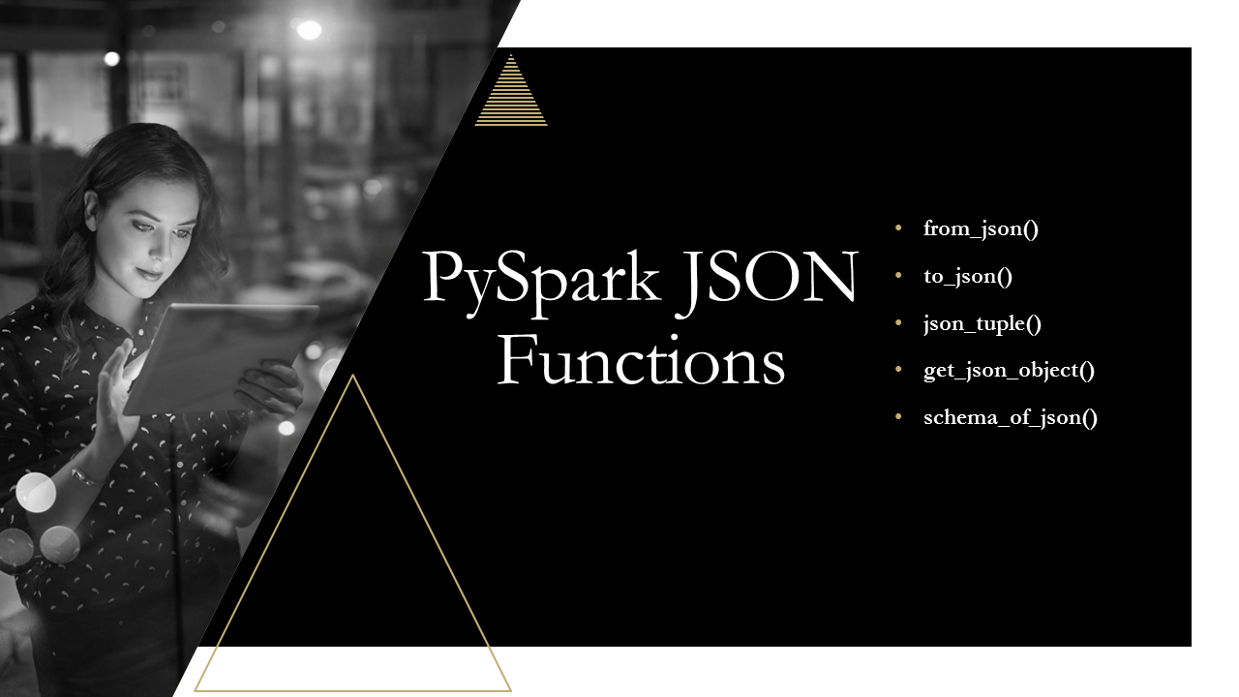
In PySpark, the JSON functions allow you to work with JSON data within DataFrames. These functions help you parse, manipulate, and extract data from JSON columns or strings. These functions can also be used to convert JSON to a struct, map type, etc. I will explain the most used JSON SQL functions with Python examples in this article.
Advertisements

1. PySpark JSON Functions
JSON Functions | Description
from_json() | Converts JSON string into Struct type or Map type.
to_json() | Converts MapType or Struct type to JSON string.
json_tuple() | Extract the Data from JSON and create them as a new columns.
get_json_object() | Extracts JSON element from a JSON string based on json path specified.
schema_of_json() | Create schema string from JSON string
PySpark JSON Functions

1.1. Create DataFrame with Column containing JSON String
To explain these JSON functions first, let’s create a DataFrame with a column containing JSON string.

from pyspark.sql import SparkSession,Row
spark = SparkSession.builder.appName('SparkByExamples.com').getOrCreate()

jsonString="""{"Zipcode":704,"ZipCodeType":"STANDARD","City":"PARC PARQUE","State":"PR"}"""
df=spark.createDataFrame([(1, jsonString)],["id","value"])
df.show(truncate=False)

//+---+--------------------------------------------------------------------------+
//|id |value |
//+---+--------------------------------------------------------------------------+
//|1 |{"Zipcode":704,"ZipCodeType":"STANDARD","City":"PARC PARQUE","State":"PR"}|
//+---+--------------------------------------------------------------------------+

2. PySpark JSON Functions Examples

2.1. from_json()
PySpark from_json() function is used to convert JSON string into Struct type or Map type. The below example converts JSON string to Map key-value pair. I will leave it to you to convert to struct type. Refer, Convert JSON string to Struct type column.

#Convert JSON string column to Map type
from pyspark.sql.types import MapType,StringType
from pyspark.sql.functions import from_json
df2=df.withColumn("value",from_json(df.value,MapType(StringType(),StringType())))
df2.printSchema()
df2.show(truncate=False)

//root
// |-- id: integer (nullable = false)
// |-- value: map (nullable = true)
// | |-- key: string
// | |-- value: string (valueContainsNull = true)

//+---+---------------------------------------------------------------------------+
//|id |value |
//+---+---------------------------------------------------------------------------+
//|1 |[Zipcode -> 704, ZipCodeType -> STANDARD, City -> PARC PARQUE, State -> PR]|
//+---+---------------------------------------------------------------------------+

2.2. to_json()
to_json() function is used to convert DataFrame columns MapType or Struct type to JSON string. Here, I am using df2 that created from above from_json() example.

from pyspark.sql.functions import to_json,col
df2.withColumn("value",to_json(col("value"))) \
.show(truncate=False)

//+---+----------------------------------------------------------------------------+
//|id |value |
//+---+----------------------------------------------------------------------------+
//|1 |{"Zipcode":"704","ZipCodeType":"STANDARD","City":"PARC PARQUE","State":"PR"}|
//+---+----------------------------------------------------------------------------+

2.3. json_tuple()
Function json_tuple() is used the query or extract the elements from JSON column and create the result as a new columns.

from pyspark.sql.functions import json_tuple
df.select(col("id"),json_tuple(col("value"),"Zipcode","ZipCodeType","City")) \
.toDF("id","Zipcode","ZipCodeType","City") \
.show(truncate=False)

//+---+-------+-----------+-----------+
//|id |Zipcode|ZipCodeType|City |
//+---+-------+-----------+-----------+
//|1 |704 |STANDARD |PARC PARQUE|
//+---+-------+-----------+-----------+

2.4. get_json_object()
get_json_object() is used to extract the JSON string based on path from the JSON column.

from pyspark.sql.functions import get_json_object
df.select(col("id"),get_json_object(col("value"),"$.ZipCodeType").alias("ZipCodeType")) \
.show(truncate=False)

//+---+-----------+
//|id |ZipCodeType|
//+---+-----------+
//|1 |STANDARD |
//+---+-----------+

2.5. schema_of_json()
Use schema_of_json() to create schema string from JSON string column.

from pyspark.sql.functions import schema_of_json,lit
schemaStr=spark.range(1) \
.select(schema_of_json(lit("""{"Zipcode":704,"ZipCodeType":"STANDARD","City":"PARC PARQUE","State":"PR"}"""))) \
.collect()[0][0]
print(schemaStr)

//struct<City:string,State:string,ZipCodeType:string,Zipcode:bigint>

3. Complete Example of PySpark JSON Functions

from pyspark.sql import SparkSession,Row
spark = SparkSession.builder.appName('SparkByExamples.com').getOrCreate()

jsonString="""{"Zipcode":704,"ZipCodeType":"STANDARD","City":"PARC PARQUE","State":"PR"}"""
df=spark.createDataFrame([(1, jsonString)],["id","value"])
df.show(truncate=False)

#Convert JSON string column to Map type
from pyspark.sql.types import MapType,StringType
from pyspark.sql.functions import from_json
df2=df.withColumn("value",from_json(df.value,MapType(StringType(),StringType())))
df2.printSchema()
df2.show(truncate=False)

from pyspark.sql.functions import to_json,col
df2.withColumn("value",to_json(col("value"))) \
.show(truncate=False)

from pyspark.sql.functions import json_tuple
df.select(col("id"),json_tuple(col("value"),"Zipcode","ZipCodeType","City")) \
.toDF("id","Zipcode","ZipCodeType","City") \
.show(truncate=False)

from pyspark.sql.functions import get_json_object
df.select(col("id"),get_json_object(col("value"),"$.ZipCodeType").alias("ZipCodeType")) \
.show(truncate=False)

from pyspark.sql.functions import schema_of_json,lit
schemaStr=spark.range(1) \
.select(schema_of_json(lit("""{"Zipcode":704,"ZipCodeType":"STANDARD","City":"PARC PARQUE","State":"PR"}"""))) \
.collect()[0][0]
print(schemaStr)

Related Article
- PySpark collect_list() and collect_set() functions
- PySpark String Functions with Examples
- PySpark SQL Date and Timestamp Functions
- PySpark Column Class | Operators & Functions
- PySpark Window Functions
- PySpark Aggregate Functions with Examples
- PySpark Apply udf to Multiple Columns
- PySpark printSchema() to String or JSON
- PySpark Parse JSON from String Column | TEXT File
- PySpark Read JSON file into DataFrame
- PySpark Read Multiple Lines (multiline) JSON File
- PySpark Write to CSV File
- PySpark printSchema() Example
- PySpark Retrieve DataType & Column Names of DataFrame

References
- https://spark.apache.org/docs/latest/api/java/org/apache/spark/sql/functions.html

